UNITED STATES
SECURITIES AND EXCHANGE COMMISSION
Washington, D.C. 20549
Form 8-K
CURRENT REPORT
Pursuant to Section 13 OR 15(d) of the Securities Exchange Act of 1934
Date of Report (Date of earliest event reported): August 7, 2026
ECHOSTAR CORPORATION
(Exact name of registrant as specified in its charter)
​
001-33807
(Commission File Number)
​

​ | ​ | ​
Nevada | ​ | 26-1232727
(State or other jurisdiction of incorporation or organization) | ​ | (I.R.S. Employer Identification No.)
​ | ​ | ​
9601 South Meridian Boulevard | ​ | ​
Englewood, Colorado | ​ | 80112
(Address of principal executive offices) | ​ | (Zip code)
(303) 723-1000
(Registrant’s telephone number, including area code)
​
Securities registered pursuant to Section 12(b) of the Act:

 | ​ |  | ​
Title of each class | ​ | Trading Symbol(s) | ​ | Name of each exchange on which registered
Class A common stock, $0.001 par value | ​ | ECHO | ​ | The Nasdaq Stock Market L.L.C.
​
​
HUGHES SATELLITE SYSTEMS CORPORATION
​
(Exact name of registrant as specified in its charter)
​
333-179121
​
(Commission File Number)
​

​ | ​ | ​
Colorado | ​ | 45-0897865
(State or other jurisdiction of incorporation or organization) | ​ | (I.R.S. Employer Identification No.)
​ | ​ | ​
9601 South Meridian Boulevard | ​ | ​
Englewood, Colorado | ​ | 80112
(Address of principal executive offices) | ​ | (Zip code)
(303) 723-1000
​
(Registrant’s telephone number, including area code)
​
Securities registered pursuant to Section 12(b) of the Act: None
Check the appropriate box below if the Form 8-K filing is intended to simultaneously satisfy the filing obligation of the registrant under any of the following provisions:
​ | ​ | ​
​ | ​ | ​
☐ |  | Written communications pursuant to Rule 425 under the Securities Act (17 CFR 230.425)
​ | ​ | ​
☐ |  | Soliciting material pursuant to Rule 14a-12 under the Exchange Act (17 CFR 240.14a-12)
​ | ​ | ​
☐ |  | Pre-commencement communications pursuant to Rule 14d-2(b) under the Exchange Act (17 CFR 240.14d-2(b))
​ | ​ | ​
☐ |  | Pre-commencement communications pursuant to Rule 13e-4(c) under the Exchange Act (17 CFR 240.13e-4(c))

Indicate by check mark whether the registrant is an emerging growth company as defined in Rule 405 of the Securities Act of 1933 (§230.405 of this chapter) or Rule 12b-2 of the Securities Exchange Act of 1934 (§240.12b-2 of this chapter).
Emerging growth company ☐
​
If an emerging growth company, indicate by check mark if the registrant has elected not to use the extended transition period for complying with any new or revised financial accounting standards provided pursuant to Section 13(a) of the Exchange Act. ☐
​

​
​
Item 7.01. | Regulation FD Disclosure.
​
Cleansing Materials
In connection with confidential discussions by management of Hughes Satellite Systems Corporation (“HSSC”) with certain holders of HSSC’s 5.25% Senior Secured Notes due 2026 and its 6.625% Senior Notes due 2026 (the “Funded Debt Obligations”), HSSC entered into confidentiality agreements (the “Confidentiality Agreements”) that facilitated its ability to engage in discussions with such holders regarding one or more potential transactions involving the Funded Debt Obligations. Such discussions failed to achieve an agreement with respect to a potential transaction.
Pursuant to the Confidentiality Agreements, HSSC agreed to publicly disclose certain confidential information previously disclosed to such holders of Funded Debt Obligations (collectively, the “Cleansing Materials”) upon the occurrence of certain events set forth in the Confidentiality Agreements. The Cleansing Materials attached as Exhibits 99.1, 99.2, 99.3 and 99.4 hereto are being furnished in satisfaction of HSSC’s public disclosure obligations under the Confidentiality Agreements.
The Cleansing Materials were prepared solely to facilitate discussions with the holders of Funded Debt Obligations, was not prepared with a view toward public disclosure, and should not be relied upon to make an investment decision with respect to us or our securities. The Cleansing Materials reflect assumptions and plans from the fourth quarter of 2025 under various assumptions as of the date of such materials, and many of such assumptions and plans may have changed since that time. The Cleansing Materials should not be regarded as an indication that EchoStar Corporation, HSSC or any third party considers the Cleansing Materials to be material non-public information or a reliable prediction of future events, and the Cleansing Materials should not be relied upon as such. Neither EchoStar Corporation, HSSC nor any third party makes any representation to any person regarding the accuracy or completeness of any of the information contained in the Cleansing Materials or undertakes any obligation to update the Cleansing Materials to reflect circumstances existing after the dates when the Cleansing Materials were prepared or conveyed or to reflect the occurrence of future events, even if any or all of the assumptions underlying the Cleansing Materials becomes or is shown to be incorrect.
The information set forth in this Current Report and the exhibit attached hereto are not an offer to sell or exchange, or solicitation of an offer to buy or exchange, any securities, or a solicitation of consents with respect to any of our securities.
The information included in this Current Report under Item 7.01 and Exhibits 99.1, 99.2, 99.3 and 99.4 attached hereto are being furnished and shall not be deemed “filed” for purposes of Section 18 of the U.S. Securities Exchange Act of 1934, as amended (the “Exchange Act”), or otherwise subject to the liabilities of that Section, nor shall it be deemed incorporated by reference into any filing under the Exchange Act or the U.S. Securities Act of 1933, as amended, regardless of any general incorporation language in such filings.
Warning Concerning Forward-Looking Statements
This Current Report contains statements that constitute forward-looking statements within the meaning of the Private Securities Litigation Reform Act of 1995 and other securities laws. Whenever we use words such as “believe”, “expect”, “anticipate”, “intend”, “plan”, “estimate”, “will”, “may” and negatives or derivatives of these or similar expressions, we are making forward-looking statements. These forward-looking statements are based upon our present intent, beliefs or expectations, but forward-looking statements are not guaranteed to occur and may not occur. Actual results may differ materially from those contained in or implied by our forward-looking statements as a result of various factors. Further, our actual results may differ from the financial projections, prospective financial information and forecasts included in the Cleansing Materials.
The information contained in our periodic and current reports filed with the U.S. Securities and Exchange Commission (the “SEC”), including under the heading “Risk Factors” therein or incorporated therein, also identifies important factors that could cause our actual results to differ materially from those stated in or implied by our forward-looking statements. Our filings with the SEC are available on the SEC’s website at www.sec.gov.
You should not place undue reliance upon any forward-looking statements.
Except as required by law, we do not intend to update or change any forward-looking statements as a result of new information, future events, or otherwise.
​
​
​
​
Item 9.01. Financial Statements and Exhibits.
Exhibit No. |  | Description
​ | Exhibit 99.1 | HSSC Cleansing Material – Presentation.
​ | Exhibit 99.2 | HSSC Cleansing Material – Q4 2025 Model with allocated BSS.
​ | Exhibit 99.3 | HSSC Cleansing Material – Q4 2025 Model without J3 lease payment.
​ | Exhibit 99.4 | HSSC Cleansing Material – Q4 2025 Model with J3 lease payment.
Exhibit 104 |  | Cover Page Interactive Data File (embedded within the Inline XBRL document).
​
​
​
​
​
​
​
SIGNATURES
Pursuant to the requirements of the Securities Exchange Act of 1934, the registrant has duly caused this report to be signed on its behalf by the undersigned hereunto duly authorized.
​
​ | ​ | ​ | ​
​ | ECHOSTAR CORPORATION  HUGHES SATELLITE SYSTEMS CORPORATION
Date: August 7, 2026 | By: | /s/ Jeffrey H. Blum
Jeffrey H. Blum
ActingChief Legal Officer and Secretary
 |  | ​
 |  | ​
 |  | ​
 |  | ​
​
​
​
​
​
Exhibit 99.1
 | 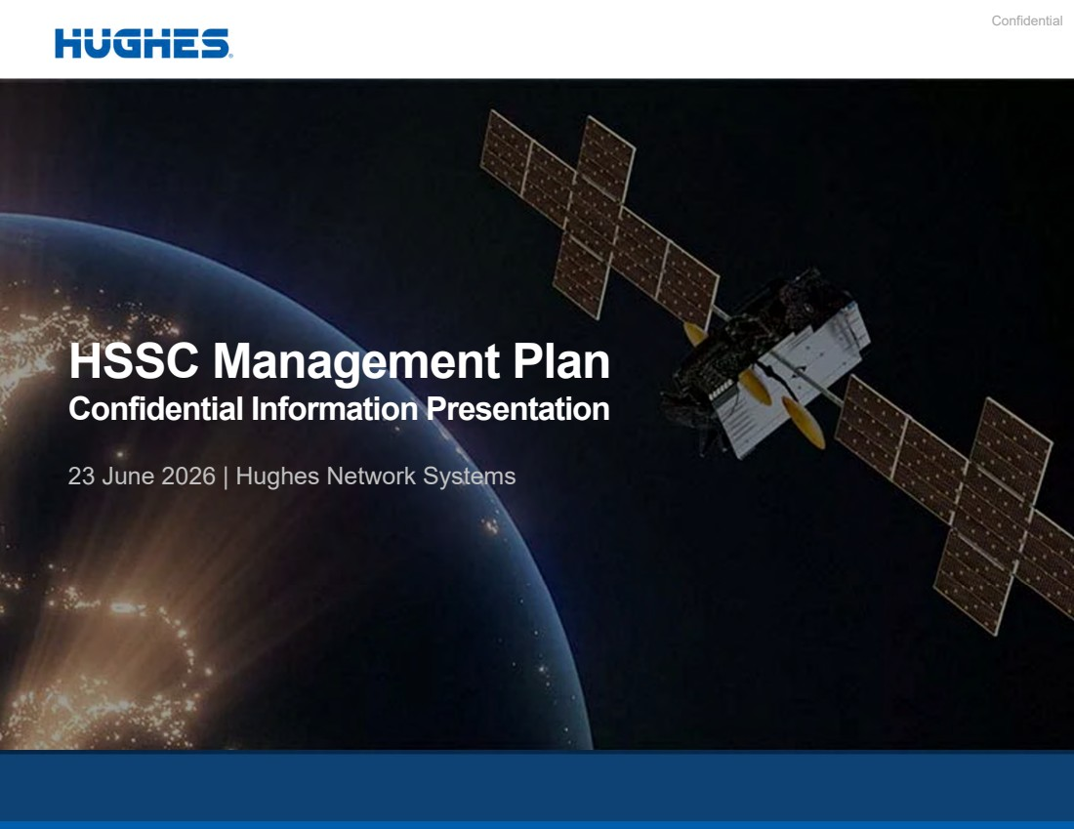 | Confidential HSSC Management Plan Confidential Information Presentation 23 June 2026 | Hughes Network Systems
 | 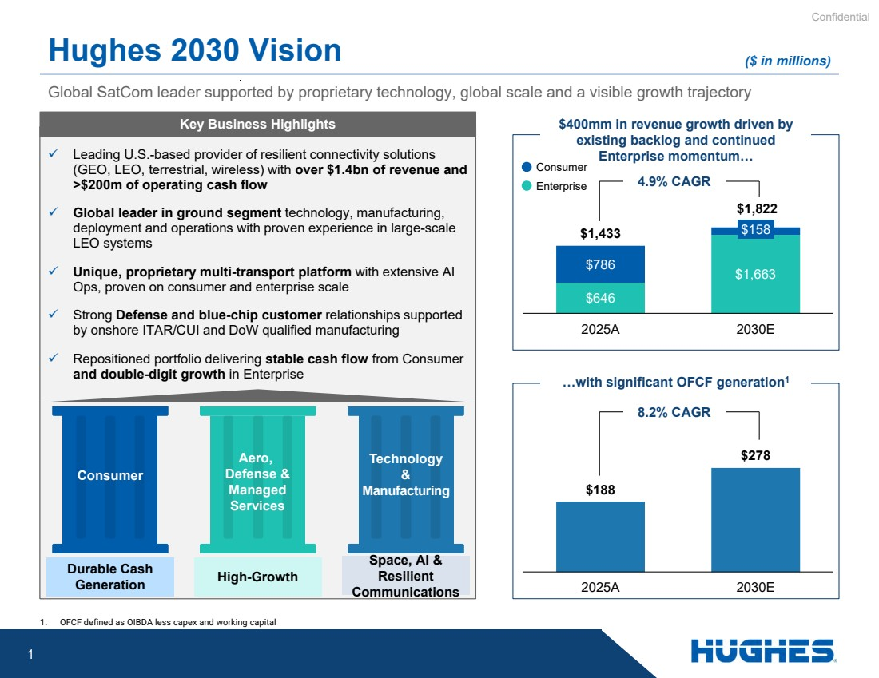 | Confidential 1 Global SatCom leader supported by proprietary technology, global scale and a visible growth trajectory Hughes 2030 Vision ✓ Leading U.S.-based provider of resilient connectivity solutions (GEO, LEO, terrestrial, wireless) with over $1.4bn of revenue and >$200m of operating cash flow ✓ Global leader in ground segment technology, manufacturing, deployment and operations with proven experience in large-scale LEO systems ✓ Unique, proprietary multi-transport platform with extensive AI Ops, proven on consumer and enterprise scale ✓ Strong Defense and blue-chip customer relationships supported by onshore ITAR/CUI and DoW qualified manufacturing ✓ Repositioned portfolio delivering stable cash flow from Consumer and double-digit growth in Enterprise Durable Cash Generation Space, AI & Resilient Communications Technology & Manufacturing High-Growth Aero, Defense & Managed Services Consumer $400mm in revenue growth driven by existing backlog and continued Enterprise momentum… $646 $1,663 $786 $158 $1,433 $1,822 2025A 2030E …with significant OFCF generation1 $188 $278 2025A 2030E 4.9% CAGR 8.2% CAGR ($ in millions) 1. OFCF defined as OIBDA less capex and working capital Consumer Enterprise Key Business Highlights
 | 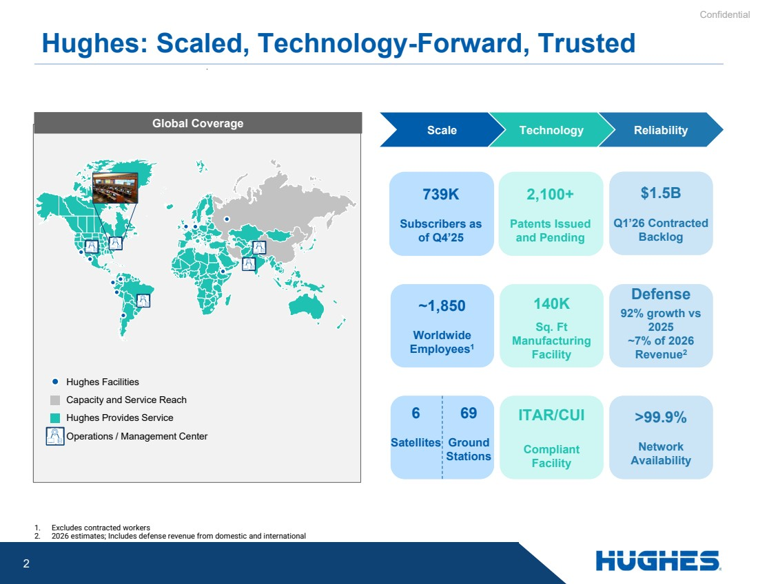 | Confidential 2 Hughes: Scaled, Technology-Forward, Trusted Scale Technology Reliability Hughes Facilities Capacity and Service Reach Hughes Provides Service Operations / Management Center 2,100+ Patents Issued and Pending $1.5B Q1’26 Contracted Backlog 739K Subscribers as of Q4’25 Defense 92% growth vs 2025 ~7% of 2026 Revenue2 Defense 92% growth vs 2025 ~7% of 2026 Revenue2 ~1,850 Worldwide Employees1 140K Sq. Ft Manufacturing Facility 1. Excludes contracted workers 2. 2026 estimates; Includes defense revenue from domestic and international >99.9% Network Availability ITAR/CUI Compliant Facility 6 Satellites 69 Ground Stations Global Coverage
 |  | Confidential 3
 |  | Confidential 4
 |  | Confidential 5 Experienced Leadership Team Paul Gaske Chief Operating Officer Ramesh Ramaswamy EVP & General Manager International Division Dr. Charles Barnett SVP Hughes Engineering Dan Rasmussen SVP & General Manager, North America Enterprise Division  Leads all revenue-generating activities across Hughes globally  Joined Hughes in 1977 as a digital design engineer, held roles in engineering, marketing and business management  Oversees international broadband operations  Previously held senior roles in engineering, operations, sales and marketing at Hughes  Leads engineering and technology development organization  Has a broad technical background in wired/wireless terrestrial and satellite communications  Career spanning over 40 years  Leads the Enterprise segment, overseeing sales, solution delivery and program operations across N.A.  Played critical role in expanding Hughes managed services portfolio Jeff Boggs SVP Hughes Finance and Accounting  Responsible for P&L, balance sheet and cash performance for global operations  Joined Hughes Space and Communications in 1985, held financial roles within satellite manufacturing, International new business, DOD and Commercial Programs Deep industry knowledge and proven ability to deliver growth Hossein Memarsadeghi SVP & General Manager, North America Consumer Division  Leads the consumer segment, oversees sales, marketing, distribution, business operations and service management, as well as satellite fleet and infrastructure operations and management  Previously held engineering, service delivery, launch, product, program and business management roles at Hughes
 | 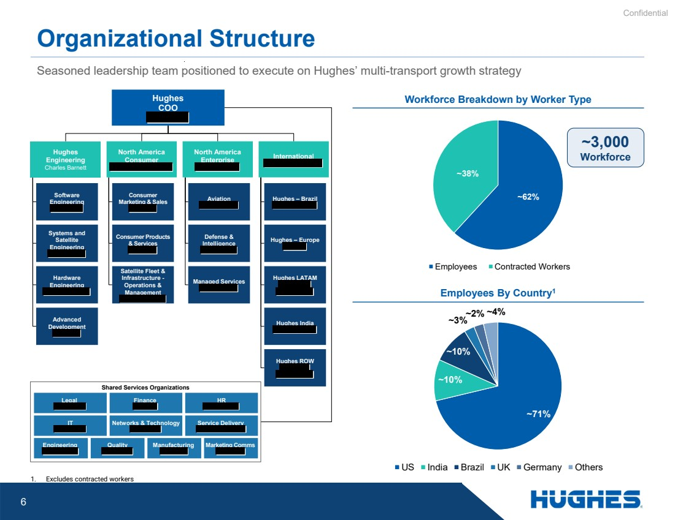 | Confidential 6 Seasoned leadership team positioned to execute on Hughes’ multi-transport growth strategy Organizational Structure Hughes COO Shared Services Organizations Legal Finance HR IT Networks & Technology Service Delivery Engineering Quality Manufacturing Marketing Comms Systems and Satellite Engineering Software Engineering Hardware Engineering Advanced Development Consumer Marketing & Sales Consumer Products & Services Satellite Fleet & Infrastructure - Operations & Management Aviation Defense & Intelligence Managed Services Hughes – Brazil Hughes – Europe Hughes LATAM Hughes India Hughes ROW Workforce Breakdown by Worker Type Employees By Country1 ~62% ~38% Employees Contracted Workers ~3,000 Workforce Hughes Engineering Charles Barnett North America Consumer North America Enterprise International 1. Excludes contracted workers ~71% ~10% ~10% ~3%~2% ~4% US India Brazil UK Germany Others
 | 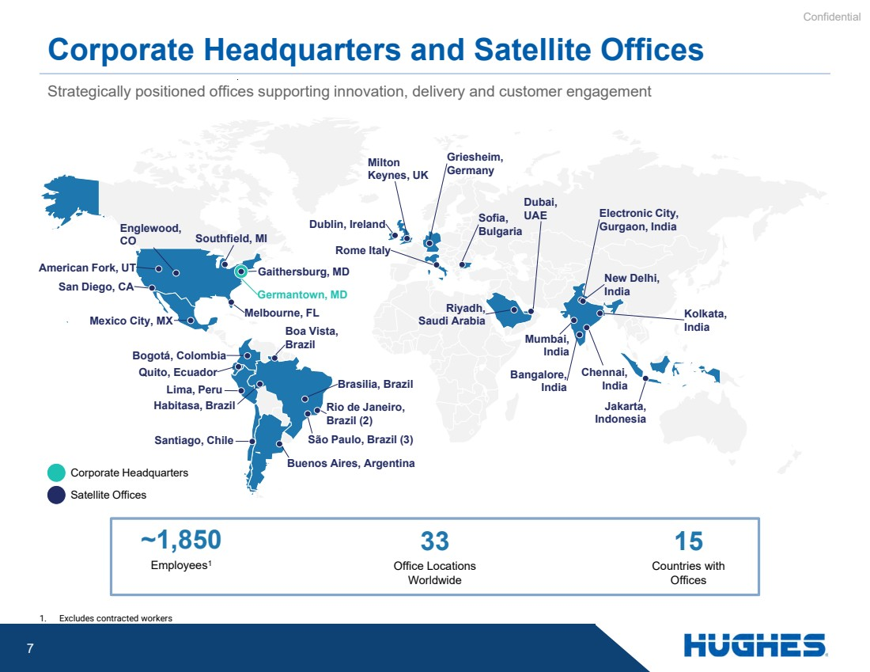 | Confidential 7 Corporate Headquarters and Satellite Offices Strategically positioned offices supporting innovation, delivery and customer engagement ~1,850 Employees1 33 Office Locations Worldwide 15 Countries with Offices Corporate Headquarters Satellite Offices San Diego, CA American Fork, UT Germantown, MD Southfield, MI Englewood, CO Mexico City, MX Bogotá, Colombia Lima, Peru Santiago, Chile Quito, Ecuador São Paulo, Brazil (3) Boa Vista, Brazil Habitasa, Brazil Brasilia, Brazil Rio de Janeiro, Brazil (2) Gaithersburg, MD Electronic City, Gurgaon, India Bangalore, India New Delhi, India Kolkata, India Chennai, India Mumbai, India Dublin, Ireland Milton Keynes, UK Griesheim, Germany Rome Italy Sofia, Bulgaria Dubai, UAE Jakarta, Indonesia Melbourne, FL Riyadh, Saudi Arabia Buenos Aires, Argentina 1. Excludes contracted workers
 | 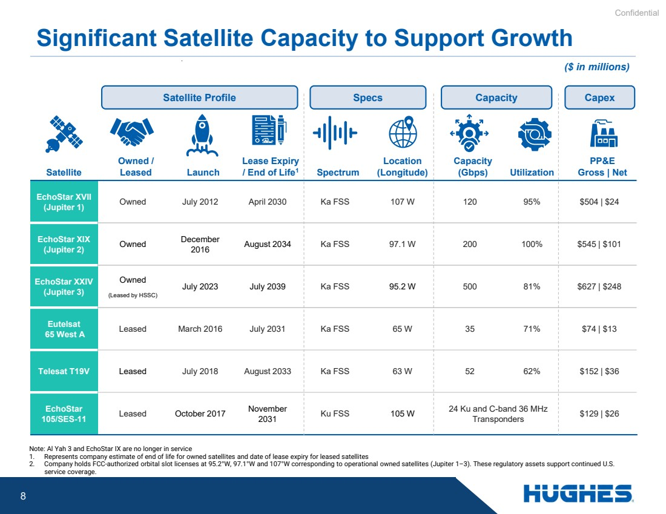 | Confidential 8 Significant Satellite Capacity to Support Growth Note: Al Yah 3 and EchoStar IX are no longer in service 1. Represents company estimate of end of life for owned satellites and date of lease expiry for leased satellites 2. Company holds FCC-authorized orbital slot licenses at 95.2°W, 97.1°W and 107°W corresponding to operational owned satellites (Jupiter 1–3). These regulatory assets support continued U.S. service coverage. PP&E Utilization Gross | Net Capacity (Gbps) Location Spectrum (Longitude) Lease Expiry / End of Life Launch 1 Owned / Satellite Leased Owned July 2012 April 2030 Ka FSS 107 W 120 95% $504 | $24 EchoStar XVII (Jupiter 1) August 2034 Ka FSS 97.1 W 200 100% $545 | $101 December 2016 Owned EchoStar XIX (Jupiter 2) July 2023 July 2039 Ka FSS 95.2 W 500 81% $627 | $248 Owned (Leased by HSSC) EchoStar XXIV (Jupiter 3) Leased March 2016 July 2031 Ka FSS 65 W 35 71% $74 | $13 Eutelsat 65 West A Telesat T19V Leased July 2018 August 2033 Ka FSS 63 W 52 62% $152 | $36 $129 | $26 24 Ku and C-band 36 MHz Transponders Ku FSS 105 W November 2031 Leased October 2017 EchoStar 105/SES-11 Satellite Profile Specs Capacity Capex ($ in millions)
 | 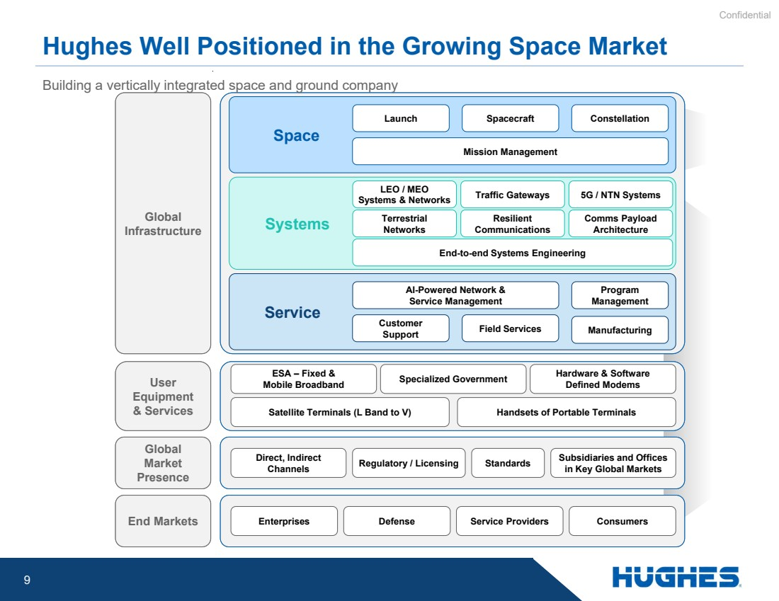 | Confidential 9 Hughes Well Positioned in the Growing Space Market Global Infrastructure Space Launch Spacecraft Constellation Mission Management User Equipment & Services Global Market Presence End Markets Systems Service Traffic Gateways LEO / MEO Systems & Networks Terrestrial Networks 5G / NTN Systems Manufacturing Customer Support Program Management Field Services AI-Powered Network & Service Management ESA – Fixed & Mobile Broadband Specialized Government Hardware & Software Defined Modems Direct, Indirect Channels Regulatory / Licensing Standards Subsidiaries and Offices in Key Global Markets Enterprises Defense Service Providers Consumers Building a vertically integrated space and ground company Satellite Terminals (L Band to V) Handsets of Portable Terminals Resilient Communications Comms Payload Architecture End-to-end Systems Engineering
 | 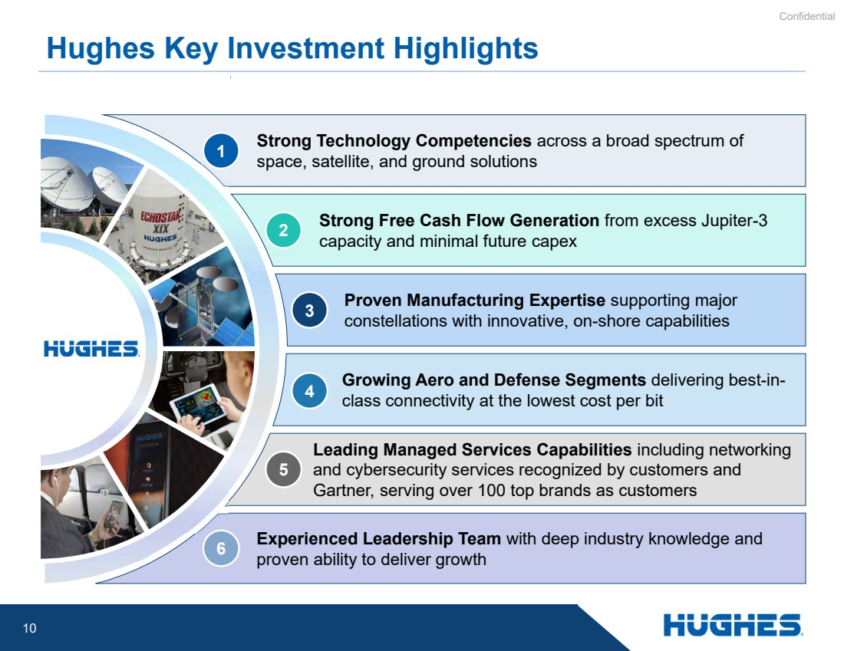 | Confidential 10 Proven Manufacturing Expertise supporting major constellations with innovative, on-shore capabilities Strong Free Cash Flow Generation from excess Jupiter-3 capacity and minimal future capex Strong Technology Competencies across a broad spectrum of space, satellite, and ground solutions Growing Aero and Defense Segments delivering best-in-class connectivity at the lowest cost per bit Leading Managed Services Capabilities including networking and cybersecurity services recognized by customers and Gartner, serving over 100 top brands as customers Experienced Leadership Team with deep industry knowledge and proven ability to deliver growth Hughes Key Investment Highlights 1 2 3 4 5 6
 | 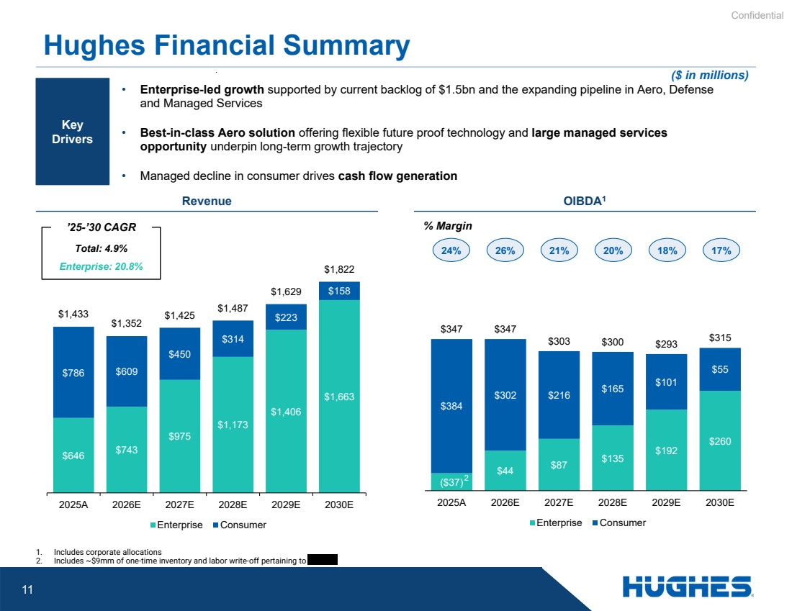 | Confidential 11 ($37) $44 $87 $135 $192 $260 $384 $302 $216 $165 $101 $55 $347 $347 $303 $300 $293 $315 2025A 2026E 2027E 2028E 2029E 2030E Enterprise Consumer $646 $743 $975 $1,173 $1,406 $1,663 $786 $609 $450 $314 $223 $158 $1,433 $1,352 $1,425 $1,487 $1,629 $1,822 2025A 2026E 2027E 2028E 2029E 2030E Enterprise Consumer 1. Includes corporate allocations 2. Includes ~$9mm of one-time inventory and labor write-off pertaining to Hughes Financial Summary Revenue OIBDA1 • Enterprise-led growth supported by current backlog of $1.5bn and the expanding pipeline in Aero, Defense and Managed Services • Best-in-class Aero solution offering flexible future proof technology and large managed services opportunity underpin long-term growth trajectory • Managed decline in consumer drives cash flow generation Total: 4.9% Enterprise: 20.8% 24% 26% 21% 20% 18% 17% % Margin Key Drivers ’25-’30 CAGR ($ in millions) 2
 | 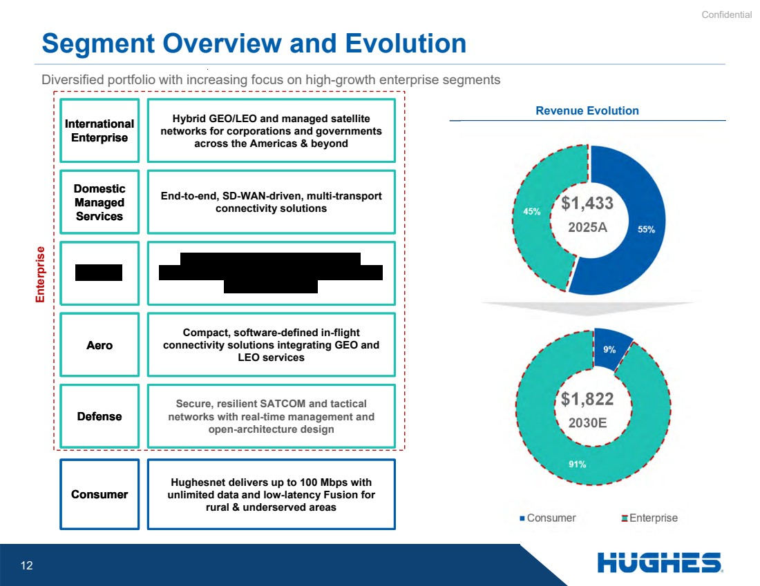 | Confidential 12 Diversified portfolio with increasing focus on high-growth enterprise segments Segment Overview and Evolution Revenue Evolution International Enterprise Domestic Managed Services Aero Defense Hybrid GEO/LEO and managed satellite networks for corporations and governments across the Americas & beyond End-to-end, SD-WAN-driven, multi-transport connectivity solutions Compact, software-defined in-flight connectivity solutions integrating GEO and LEO services Secure, resilient SATCOM and tactical networks with real-time management and open-architecture design $1,433 2025A Enterprise $1,822 2030E Consumer Hughesnet delivers up to 100 Mbps with unlimited data and low-latency Fusion for rural & underserved areas
 | 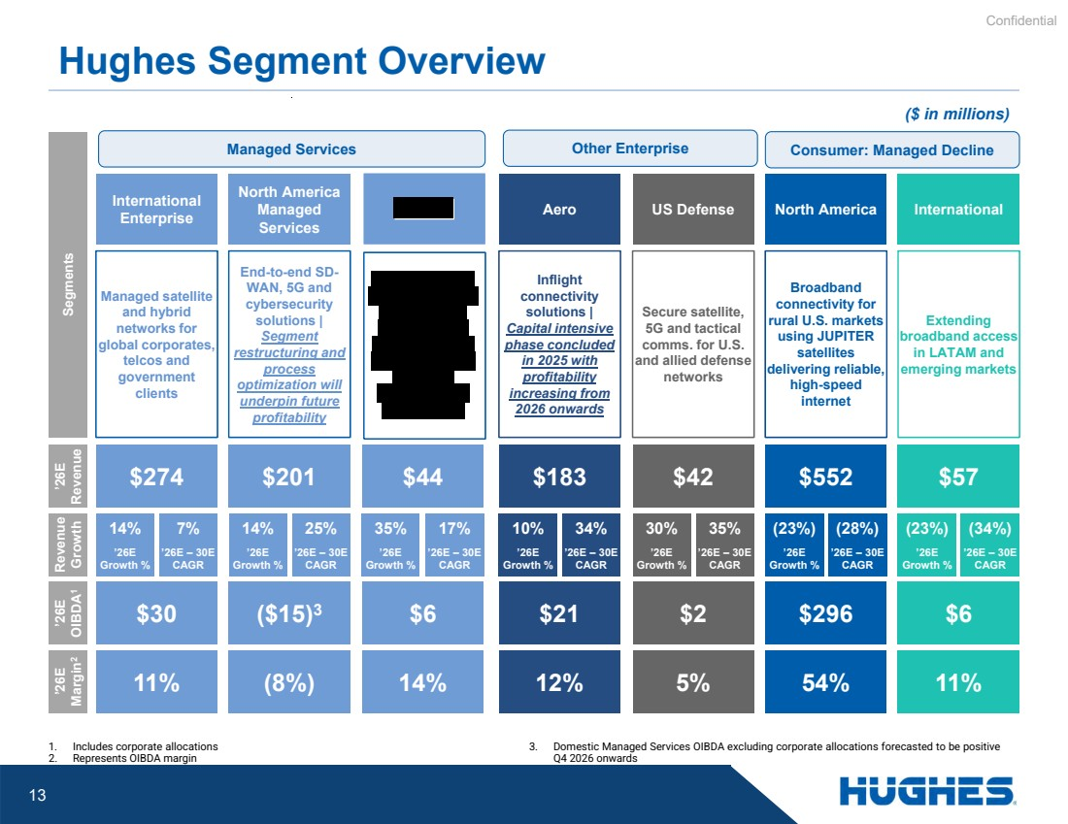 | Confidential 13 Hughes Segment Overview Managed Services Consumer: Managed Decline ($ in millions) Segments ’26E Revenue Revenue Growth ’26E OIBDA 1 ’26E Margin 2 North America $552 Broadband connectivity for rural U.S. markets using JUPITER satellites delivering reliable, high-speed internet (28%) ’26E – 30E CAGR (23%) ’26E Growth % $296 54% International Extending broadband access in LATAM and emerging markets $57 (34%) ’26E – 30E CAGR (23%) ’26E Growth % $6 11% International Enterprise Managed satellite and hybrid networks for global corporates, telcos and government clients $274 7% ’26E – 30E CAGR 14% ’26E Growth % $30 11% North America Managed Services End-to-end SD-WAN, 5G and cybersecurity solutions | Segment restructuring and process optimization will underpin future profitability $201 25% ’26E – 30E CAGR 14% ’26E Growth % ($15)3 (8%) US Defense Secure satellite, 5G and tactical comms. for U.S. and allied defense networks $42 35% ’26E – 30E CAGR 30% ’26E Growth % $2 5% $44 17% ’26E – 30E CAGR 35% ’26E Growth % $6 14% 1. Includes corporate allocations 2. Represents OIBDA margin 3. Domestic Managed Services OIBDA excluding corporate allocations forecasted to be positive Q4 2026 onwards Aero Inflight connectivity solutions | Capital intensive phase concluded in 2025 with profitability increasing from 2026 onwards $183 34% ’26E – 30E CAGR 10% ’26E Growth % $21 12% Other Enterprise
 | 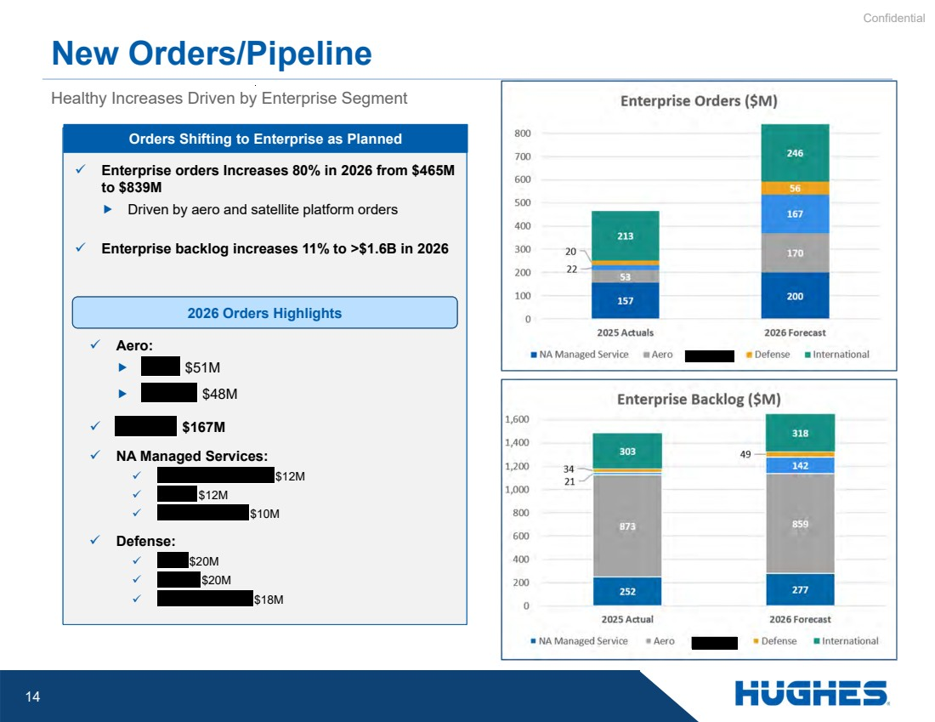 | Confidential 14 Healthy Increases Driven by Enterprise Segment New Orders/Pipeline ✓ Enterprise orders Increases 80% in 2026 from $465M to $839M  Driven by aero and satellite platform orders ✓ Enterprise backlog increases 11% to >$1.6B in 2026 Orders Shifting to Enterprise as Planned 2026 Orders Highlights ✓ Aero:  $51M  $48M ✓ $167M ✓ NA Managed Services: ✓ $12M ✓ $12M ✓ $10M ✓ Defense: ✓ $20M ✓ $20M ✓ $18M
 | 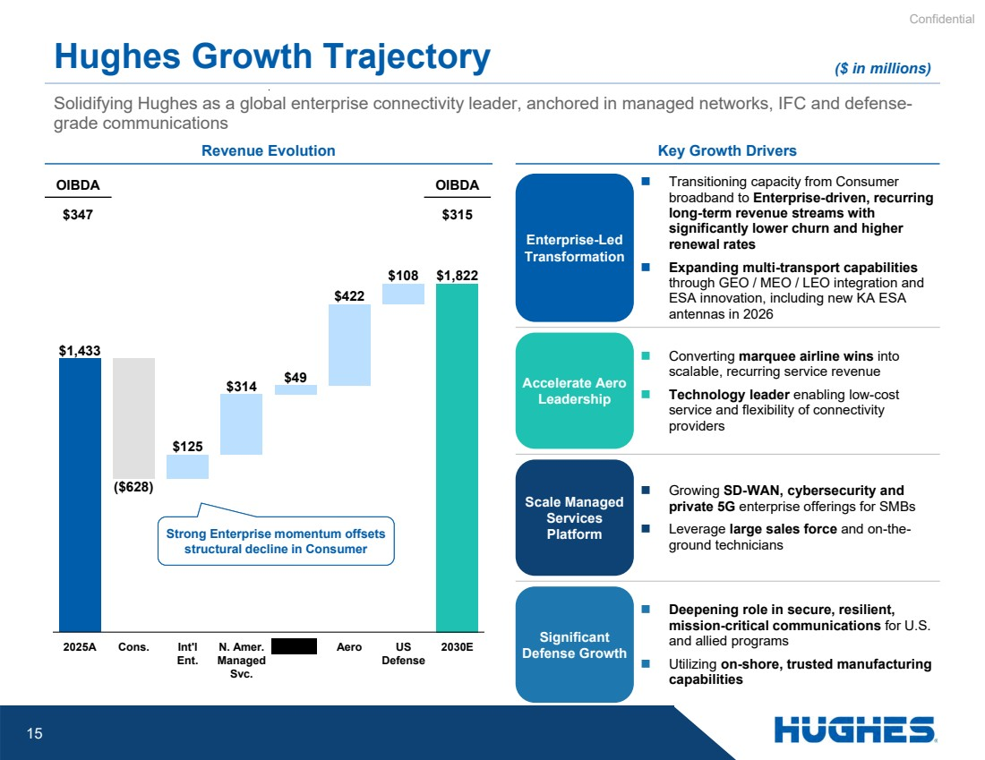 | Confidential 15 Solidifying Hughes as a global enterprise connectivity leader, anchored in managed networks, IFC and defense-grade communications Hughes Growth Trajectory Revenue Evolution Key Growth Drivers $1,433 ($628) $125 $314 $49 $422 $108 $1,822 2025A Cons. Int'l Ent. N. Amer. Managed Svc. Aero US Defense 2030E Enterprise-Led Transformation  Transitioning capacity from Consumer broadband to Enterprise-driven, recurring long-term revenue streams with significantly lower churn and higher renewal rates  Expanding multi-transport capabilities through GEO / MEO / LEO integration and ESA innovation, including new KA ESA antennas in 2026 Accelerate Aero Leadership  Converting marquee airline wins into scalable, recurring service revenue  Technology leader enabling low-cost service and flexibility of connectivity providers Scale Managed Services Platform  Growing SD-WAN, cybersecurity and private 5G enterprise offerings for SMBs  Leverage large sales force and on-the-ground technicians Significant Defense Growth  Deepening role in secure, resilient, mission-critical communications for U.S. and allied programs  Utilizing on-shore, trusted manufacturing capabilities OIBDA OIBDA $347 $315 Strong Enterprise momentum offsets structural decline in Consumer ($ in millions)
 | 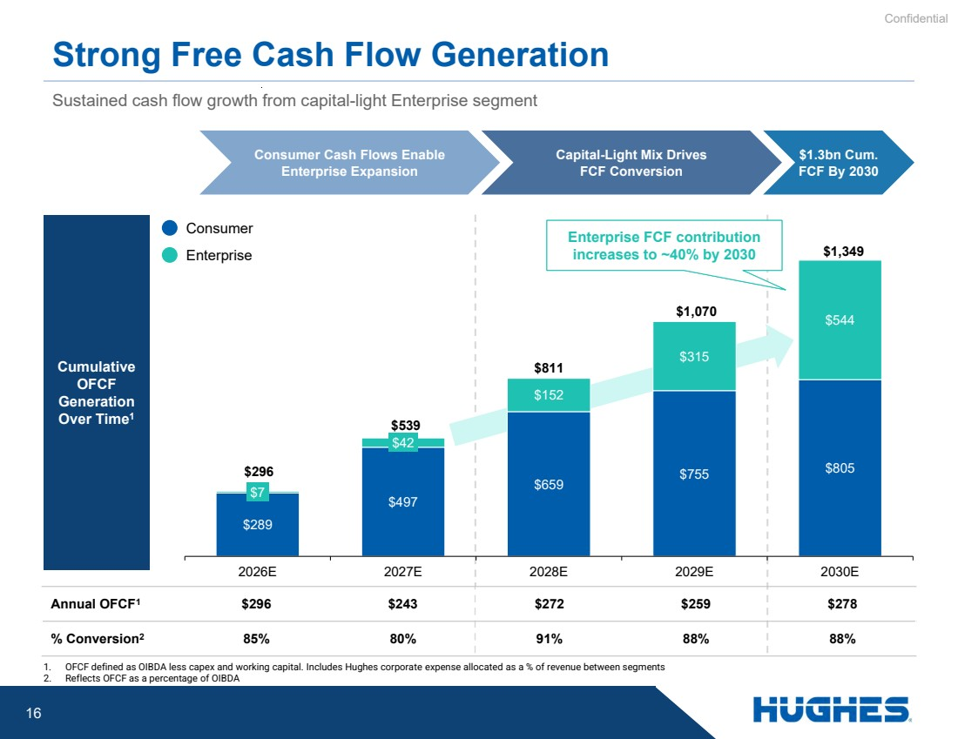 | Confidential 16 Strong Free Cash Flow Generation Sustained cash flow growth from capital-light Enterprise segment Consumer Cash Flows Enable Enterprise Expansion Capital-Light Mix Drives FCF Conversion $1.3bn Cum. FCF By 2030 1. OFCF defined as OIBDA less capex and working capital. Includes Hughes corporate expense allocated as a % of revenue between segments 2. Reflects OFCF as a percentage of OIBDA Enterprise FCF contribution increases to ~40% by 2030 Cumulative OFCF Generation Over Time1 Annual OFCF $296 $243 $272 $259 $278 1 % Conversion2 85% 80% 91% 88% 88% Consumer Enterprise $289 $497 $659 $755 $805 $7 $42 $152 $315 $544 $296 $539 $811 $1,070 $1,349 2026E 2027E 2028E 2029E 2030E
 | 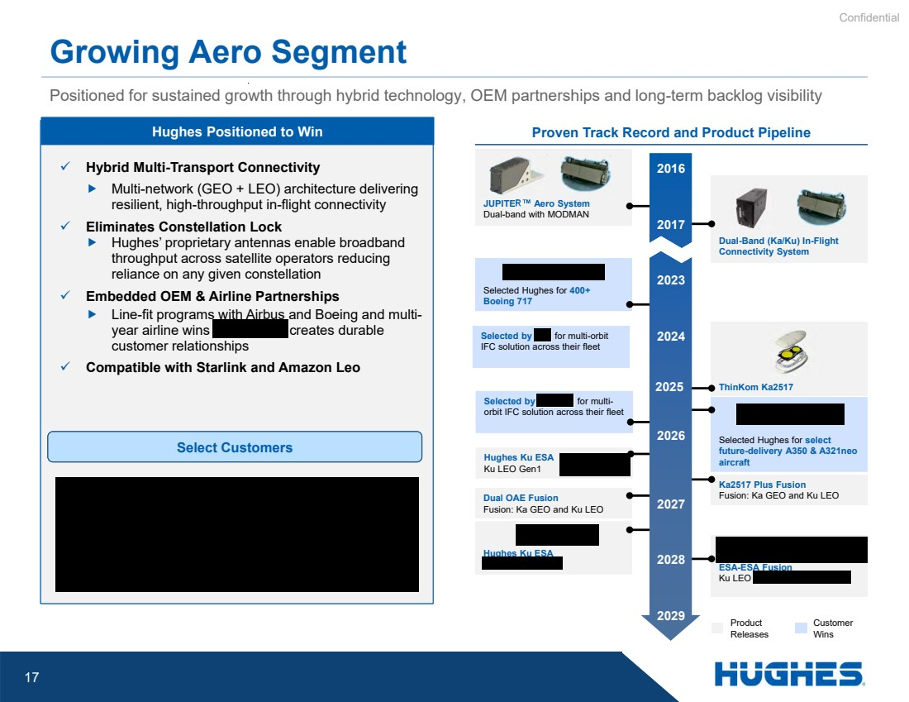 | Confidential 17 Positioned for sustained growth through hybrid technology, OEM partnerships and long-term backlog visibility Growing Aero Segment Proven Track Record and Product Pipeline ThinKom Ka2517 Dual-Band (Ka/Ku) In-Flight Connectivity System Selected Hughes for select future-delivery A350 & A321neo aircraft JUPITER Aero System Dual-band with MODMAN Selected Hughes for 400+ Boeing 717 Selected by for multi-orbit IFC solution across their fleet Hughes Ku ESA Ku LEO Gen1 Hughes Ku ESA Dual OAE Fusion Fusion: Ka GEO and Ku LEO Ka2517 Plus Fusion Fusion: Ka GEO and Ku LEO ESA-ESA Fusion Ku LEO 2029 2028 2027 2026 2025 2024 2023 2017 2016 Product Releases Customer Wins ✓ Hybrid Multi-Transport Connectivity  Multi-network (GEO + LEO) architecture delivering resilient, high-throughput in-flight connectivity ✓ Eliminates Constellation Lock  Hughes’ proprietary antennas enable broadband throughput across satellite operators reducing reliance on any given constellation ✓ Embedded OEM & Airline Partnerships  Line-fit programs with Airbus and Boeing and multi-year airline wins creates durable customer relationships ✓ Compatible with Starlink and Amazon Leo Hughes Positioned to Win Select Customers Selected by for multi-orbit IFC solution across their fleet
 | 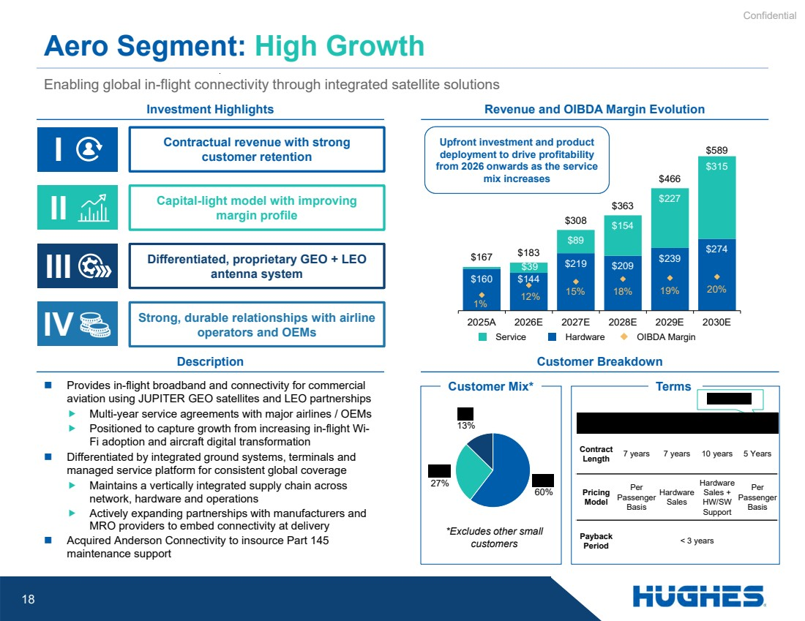 | Confidential 18 $160 $144 $219 $209 $239 $274 $39 $89 $154 $227 $315 $167 $183 $308 $363 $466 $589 1% 12% 15% 18% 19% 20% 2025A 2026E 2027E 2028E 2029E 2030E 60% 27% 13%  Provides in-flight broadband and connectivity for commercial Customer Mix* aviation using JUPITER GEO satellites and LEO partnerships  Multi-year service agreements with major airlines / OEMs  Positioned to capture growth from increasing in-flight Wi-Fi adoption and aircraft digital transformation  Differentiated by integrated ground systems, terminals and managed service platform for consistent global coverage  Maintains a vertically integrated supply chain across network, hardware and operations  Actively expanding partnerships with manufacturers and MRO providers to embed connectivity at delivery  Acquired Anderson Connectivity to insource Part 145 maintenance support Enabling global in-flight connectivity through integrated satellite solutions Aero Segment: High Growth Description Investment Highlights Contractual revenue with strong customer retention Capital-light model with improving margin profile I II III Revenue and OIBDA Margin Evolution Customer Breakdown Differentiated, proprietary GEO + LEO antenna system Terms IV Strong, durable relationships with airline operators and OEMs 7 years 7 years 10 years 5 Years Contract Length Per Passenger Basis Hardware Sales + HW/SW Support Hardware Sales Per Passenger Basis Pricing Model < 3 years Payback Period Service Hardware OIBDA Margin *Excludes other small customers Upfront investment and product deployment to drive profitability from 2026 onwards as the service mix increases
 | 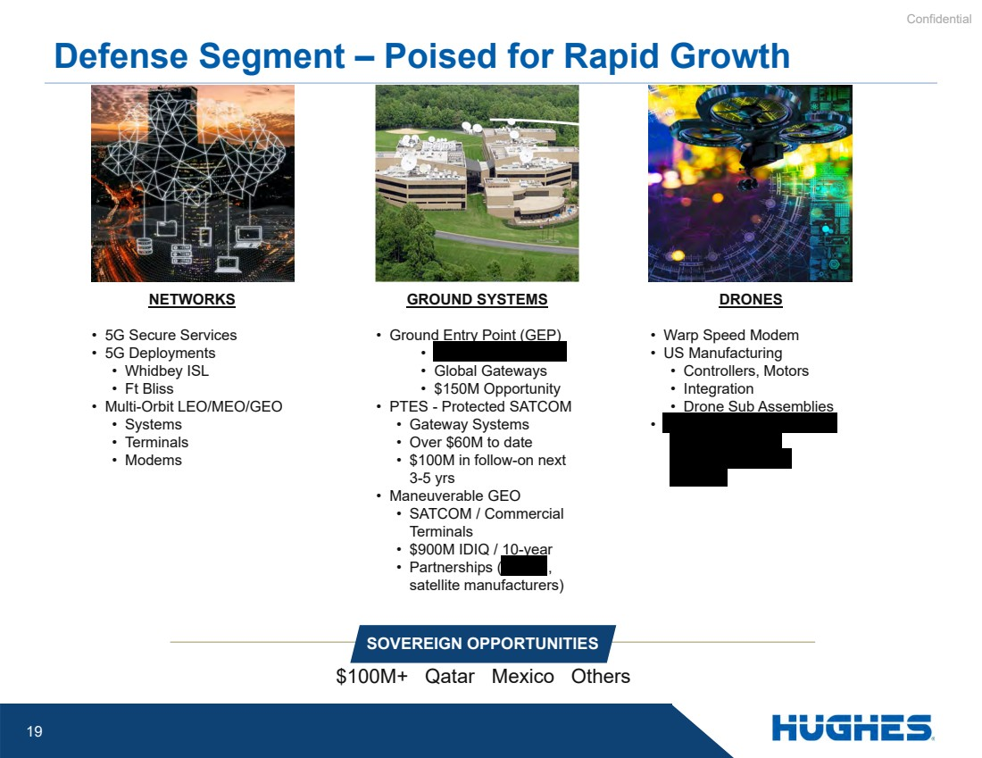 | Confidential 19 Defense Segment – Poised for Rapid Growth SOVEREIGN OPPORTUNITIES $100M+ Qatar Mexico Others NETWORKS • 5G Secure Services • 5G Deployments • Whidbey ISL • Ft Bliss • Multi-Orbit LEO/MEO/GEO • Systems • Terminals • Modems GROUND SYSTEMS • Ground Entry Point (GEP) • • Global Gateways • $150M Opportunity • PTES - Protected SATCOM • Gateway Systems • Over $60M to date • $100M in follow-on next 3-5 yrs • Maneuverable GEO • SATCOM / Commercial Terminals • $900M IDIQ / 10-year • Partnerships ( , satellite manufacturers) DRONES • Warp Speed Modem • US Manufacturing • Controllers, Motors • Integration • Drone Sub Assemblies •
 | 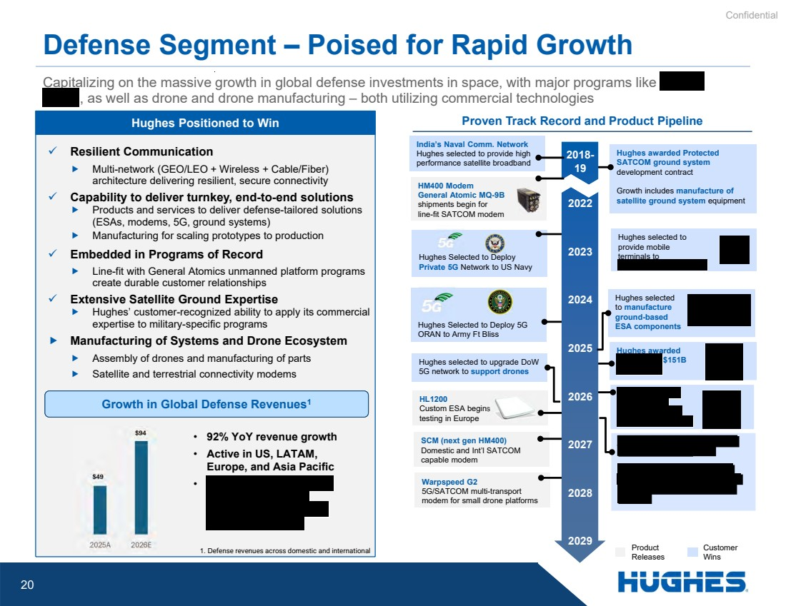 | Confidential 20 Hughes awarded $151B Hughes awarded Protected SATCOM ground system development contract Growth includes manufacture of satellite ground system equipment Hughes awarded Protected SATCOM ground system development contract Growth includes manufacture of satellite ground system equipment Warpspeed G2 5G/SATCOM multi-transport modem for small drone platforms SCM (next gen HM400) Domestic and Int’l SATCOM capable modem HL1200 Custom ESA begins testing in Europe Hughes selected to upgrade DoW 5G network to support drones Hughes Selected to Deploy Private 5G Network to US Navy Hughes selected to manufacture ground-based ESA components Defense Segment – Poised for Rapid Growth Capitalizing on the massive growth in global defense investments in space, with major programs like , as well as drone and drone manufacturing – both utilizing commercial technologies Proven Track Record and Product Pipeline HM400 Modem General Atomic MQ-9B shipments begin for line-fit SATCOM modem Hughes Selected to Deploy 5G ORAN to Army Ft Bliss 2029 2028 2027 2026 2025 2024 2023 2022 2018- 19 Product Releases Customer Wins ✓ Resilient Communication  Multi-network (GEO/LEO + Wireless + Cable/Fiber) architecture delivering resilient, secure connectivity ✓ Capability to deliver turnkey, end-to-end solutions  Products and services to deliver defense-tailored solutions (ESAs, modems, 5G, ground systems)  Manufacturing for scaling prototypes to production ✓ Embedded in Programs of Record  Line-fit with General Atomics unmanned platform programs create durable customer relationships ✓ Extensive Satellite Ground Expertise  Hughes’ customer-recognized ability to apply its commercial expertise to military-specific programs  Manufacturing of Systems and Drone Ecosystem  Assembly of drones and manufacturing of parts  Satellite and terrestrial connectivity modems Hughes Positioned to Win Growth in Global Defense Revenues1 1. Defense revenues across domestic and international • 92% YoY revenue growth • Active in US, LATAM, Europe, and Asia Pacific • India’s Naval Comm. Network Hughes selected to provide high performance satellite broadband Hughes selected to provide mobile terminals to
 | 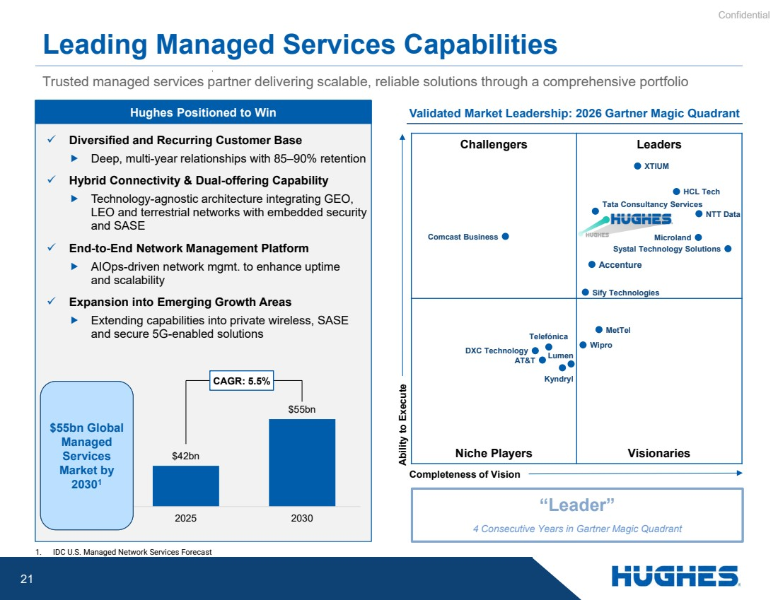 | Confidential 21 Challengers Leaders Niche Players Visionaries Leading Managed Services Capabilities Trusted managed services partner delivering scalable, reliable solutions through a comprehensive portfolio Validated Market Leadership: 2026 Gartner Magic Quadrant Ability to Execute Completeness of Vision Systal Technology Solutions Sify Technologies Telefónica Kyndryl DXC Technology Comcast Business Lumen Tata Consultancy Services AT&T NTT Data Wipro MetTel Accenture Microland HCL Tech “Leader” 4 Consecutive Years in Gartner Magic Quadrant 1. IDC U.S. Managed Network Services Forecast ✓ Diversified and Recurring Customer Base  Deep, multi-year relationships with 85–90% retention ✓ Hybrid Connectivity & Dual-offering Capability  Technology-agnostic architecture integrating GEO, LEO and terrestrial networks with embedded security and SASE ✓ End-to-End Network Management Platform  AIOps-driven network mgmt. to enhance uptime and scalability ✓ Expansion into Emerging Growth Areas  Extending capabilities into private wireless, SASE and secure 5G-enabled solutions Hughes Positioned to Win $42bn $55bn 2025 2030 $55bn Global Managed Services Market by 20301 CAGR: 5.5% XTIUM
 | 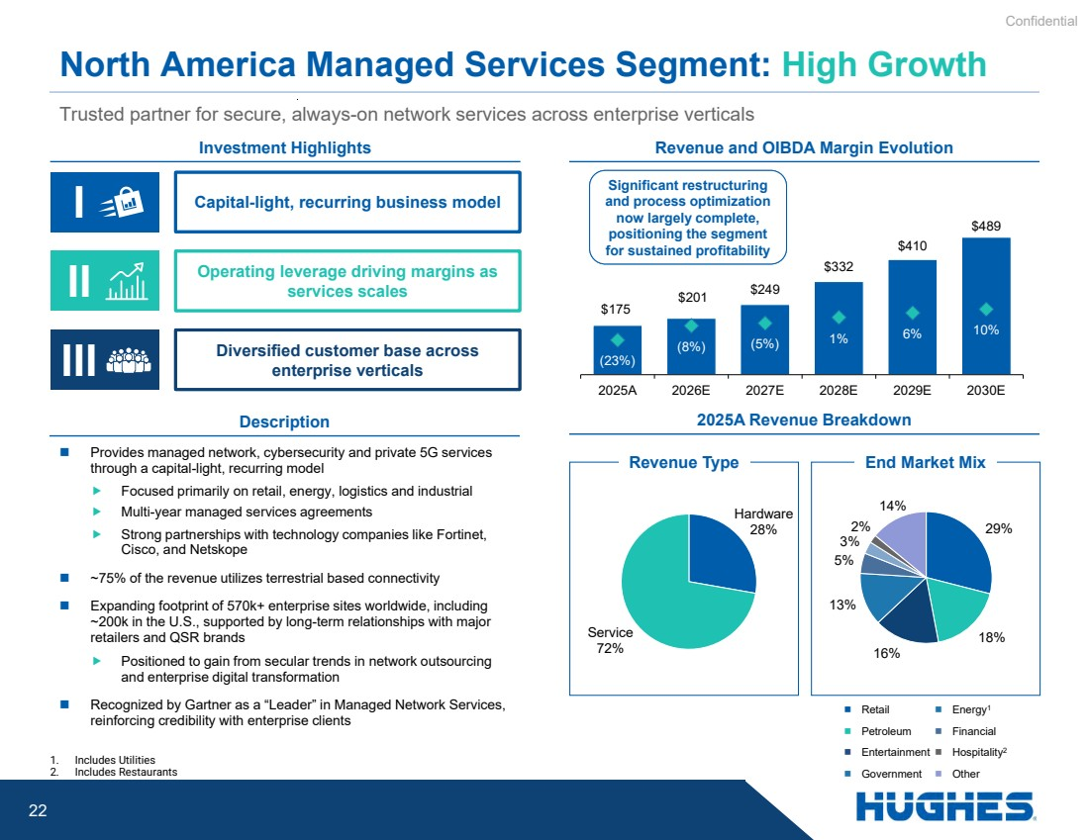 | Confidential 22 $175 $201 $249 $332 $410 $489 (23%) (8%) (5%) 1% 6% 10% 2025A 2026E 2027E 2028E 2029E 2030E  Provides managed network, cybersecurity and private 5G services through a capital-light, recurring model  Focused primarily on retail, energy, logistics and industrial  Multi-year managed services agreements  Strong partnerships with technology companies like Fortinet, Cisco, and Netskope  ~75% of the revenue utilizes terrestrial based connectivity  Expanding footprint of 570k+ enterprise sites worldwide, including ~200k in the U.S., supported by long-term relationships with major retailers and QSR brands  Positioned to gain from secular trends in network outsourcing and enterprise digital transformation  Recognized by Gartner as a “Leader” in Managed Network Services, reinforcing credibility with enterprise clients Trusted partner for secure, always-on network services across enterprise verticals North America Managed Services Segment: High Growth 1. Includes Utilities 2. Includes Restaurants Description Investment Highlights Capital-light, recurring business model Operating leverage driving margins as services scales Diversified customer base across III enterprise verticals II I Revenue and OIBDA Margin Evolution Hardware 28% Service 72% 2025A Revenue Breakdown  Retail  Petroleum  Entertainment  Government  Energy1  Financial  Hospitality2  Other Revenue Type End Market Mix 29% 18% 16% 13% 5% 3% 2% 14% Significant restructuring and process optimization now largely complete, positioning the segment for sustained profitability
 | 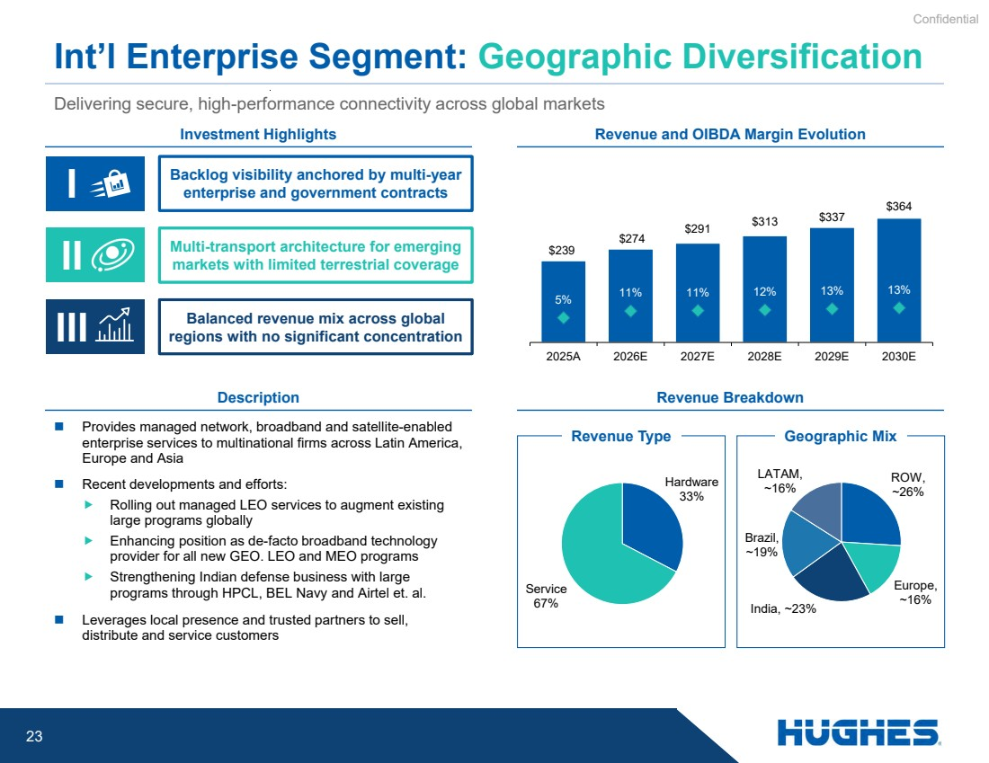 | Confidential 23 Hardware 33% Service 67% $239 $274 $291 $313 $337 $364 5% 11% 11% 12% 13% 13% 2025A 2026E 2027E 2028E 2029E 2030E Delivering secure, high-performance connectivity across global markets Int’l Enterprise Segment: Geographic Diversification Investment Highlights Description Revenue and OIBDA Margin Evolution  Provides managed network, broadband and satellite-enabled enterprise services to multinational firms across Latin America, Europe and Asia  Recent developments and efforts:  Rolling out managed LEO services to augment existing large programs globally  Enhancing position as de-facto broadband technology provider for all new GEO. LEO and MEO programs  Strengthening Indian defense business with large programs through HPCL, BEL Navy and Airtel et. al.  Leverages local presence and trusted partners to sell, distribute and service customers Revenue Breakdown Backlog visibility anchored by multi-year enterprise and government contracts Multi-transport architecture for emerging markets with limited terrestrial coverage Balanced revenue mix across global III regions with no significant concentration II I Revenue Type Geographic Mix ROW, ~26% Europe, ~16% India, ~23% Brazil, ~19% LATAM, ~16%
 |  | Confidential 24
 | 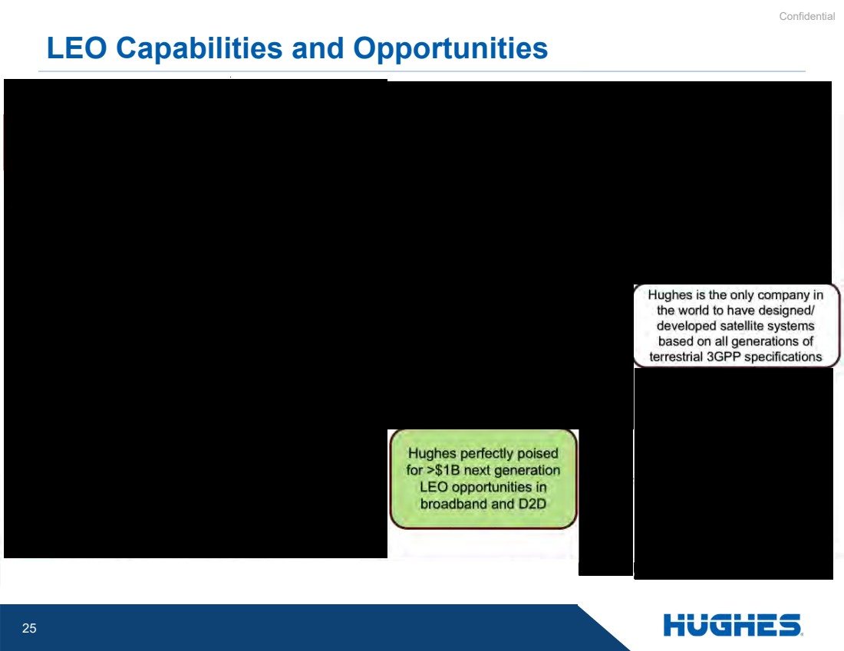 | Confidential 25 LEO Capabilities and Opportunities Mobility (Maritime, Landmobile) connectivity
 | 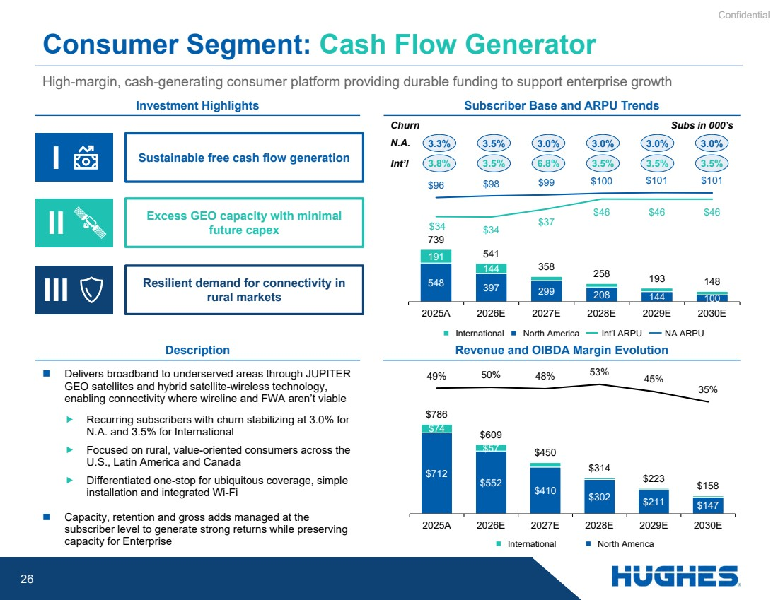 | Confidential 26 $712 $552 $410 $302 $211 $147 $74 $57 $786 $609 $450 $314 $223 $158 49% 50% 48% 53% 45% 35% 2025A 2026E 2027E 2028E 2029E 2030E 548 397 299 208 144 100 191 144 739 541 358 258 193 148 $96 $98 $99 $100 $101 $101 $34 $34 $37 $46 $46 $46 $ - $20 $40 $60 $80 $100 - 500 1,000 1,500 2025A 2026E 2027E 2028E 2029E 2030E  Delivers broadband to underserved areas through JUPITER GEO satellites and hybrid satellite-wireless technology, enabling connectivity where wireline and FWA aren’t viable  Recurring subscribers with churn stabilizing at 3.0% for N.A. and 3.5% for International  Focused on rural, value-oriented consumers across the U.S., Latin America and Canada  Differentiated one-stop for ubiquitous coverage, simple installation and integrated Wi-Fi  Capacity, retention and gross adds managed at the subscriber level to generate strong returns while preserving capacity for Enterprise Consumer Segment: Cash Flow Generator Description Investment Highlights Sustainable free cash flow generation Excess GEO capacity with minimal future capex Resilient demand for connectivity in rural markets II I III High-margin, cash-generating consumer platform providing durable funding to support enterprise growth Revenue and OIBDA Margin Evolution Subscriber Base and ARPU Trends 3.3% 3.5% 3.0% 3.0% 3.0% 3.0% Churn  International  North America  International  North America Int’l ARPU NA ARPU 3.8% 3.5% 6.8% 3.5% 3.5% 3.5% N.A. Int’l Subs in 000’s
 | 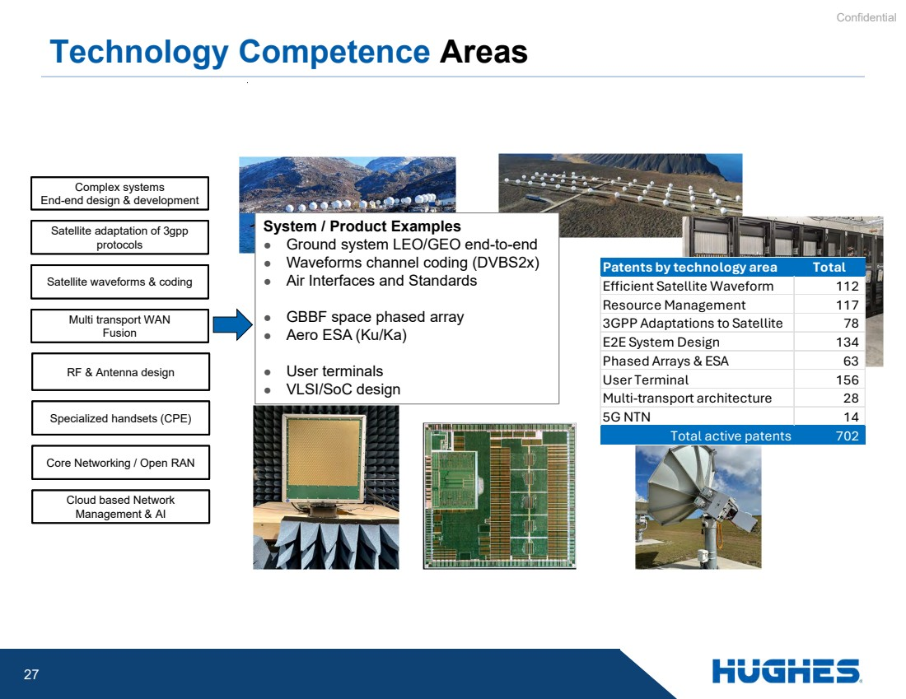 | Confidential 27 Technology Competence Areas RF & Antenna design Multi transport WAN Fusion Core Networking / Open RAN Satellite waveforms & coding Complex systems End-end design & development Specialized handsets (CPE) Satellite adaptation of 3gpp protocols Cloud based Network Management & AI System / Product Examples ● Ground system LEO/GEO end-to-end ● Waveforms channel coding (DVBS2x) ● Air Interfaces and Standards ● GBBF space phased array ● Aero ESA (Ku/Ka) ● User terminals ● VLSI/SoC design Patents by technology area Total Efficient Satellite Waveform 112 Resource Management 117 3GPP Adaptations to Satellite 78 E2E System Design 134 Phased Arrays & ESA 63 User Terminal 156 Multi-transport architecture 28 5G NTN 14 Total active patents 702
 | 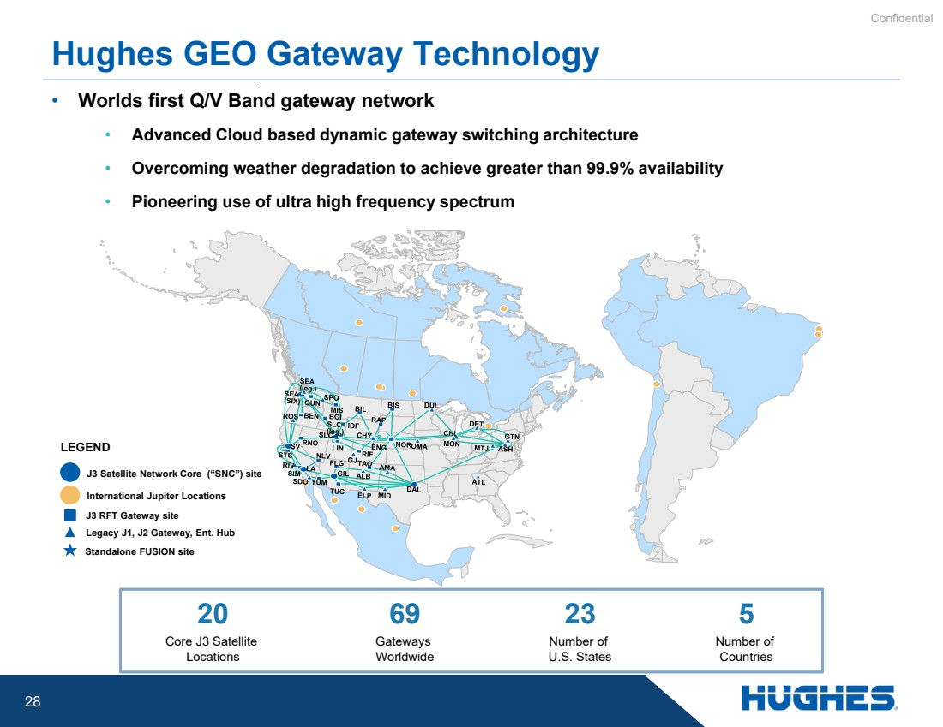 | Confidential 28 • Worlds first Q/V Band gateway network • Advanced Cloud based dynamic gateway switching architecture • Overcoming weather degradation to achieve greater than 99.9% availability • Pioneering use of ultra high frequency spectrum Hughes GEO Gateway Technology 20 Core J3 Satellite Locations 23 Number of U.S. States 5 Number of Countries 69 Gateways Worldwide J3 Satellite Network Core (“SNC”) site LEGEND J3 RFT Gateway site Legacy J1, J2 Gateway, Ent. Hub Standalone FUSION site International Jupiter Locations
 |  | Confidential 29
 |  | Confidential 30
 |  | Confidential 31
 | 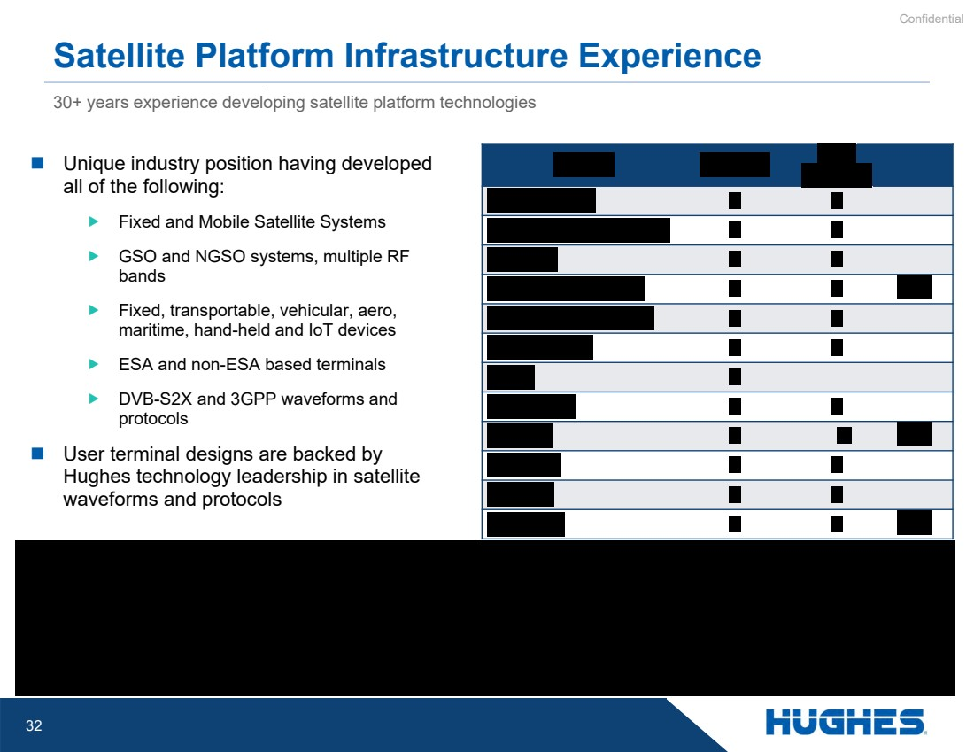 | Confidential 32 30+ years experience developing satellite platform technologies Satellite Platform Infrastructure Experience  Unique industry position having developed all of the following:  Fixed and Mobile Satellite Systems  GSO and NGSO systems, multiple RF bands  Fixed, transportable, vehicular, aero, maritime, hand-held and IoT devices  ESA and non-ESA based terminals  DVB-S2X and 3GPP waveforms and protocols  User terminal designs are backed by Hughes technology leadership in satellite waveforms and protocols
 | 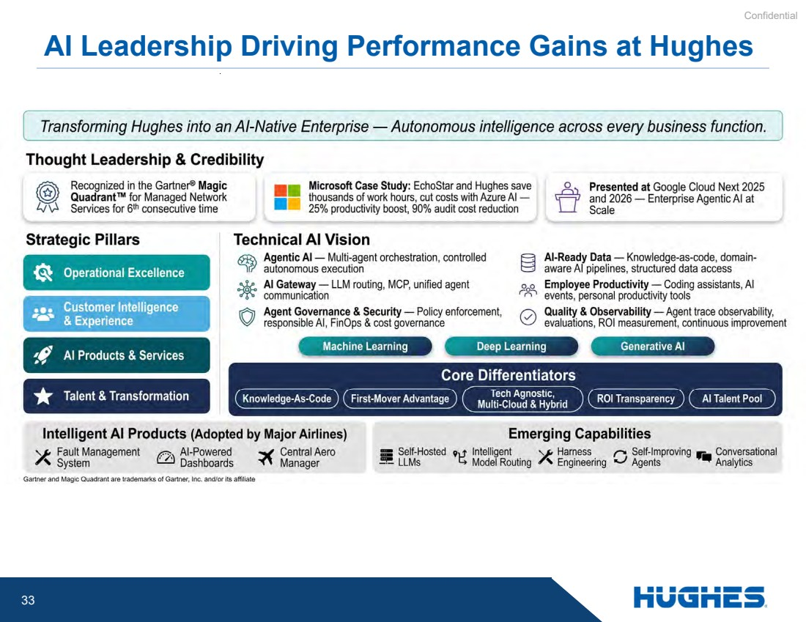 | Confidential 33 AI Leadership Driving Performance Gains at Hughes
 | 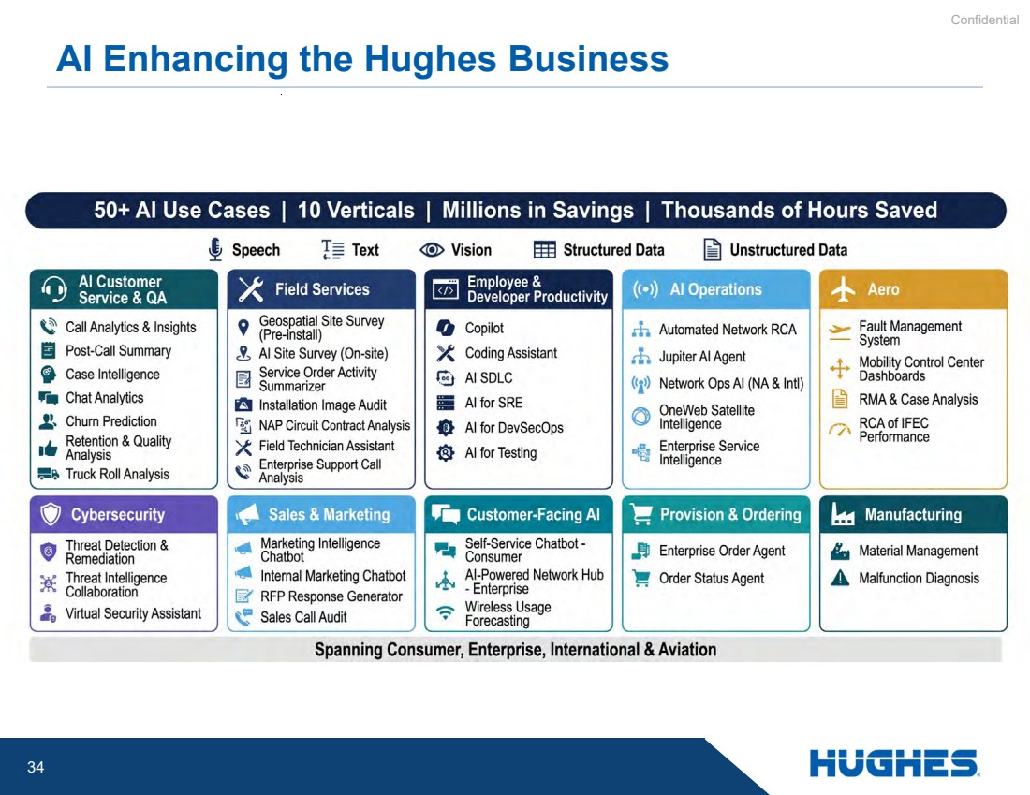 | Confidential 34 AI Enhancing the Hughes Business
 |  | Confidential 35
 |  | Confidential 36
 |  | Confidential 37
 | 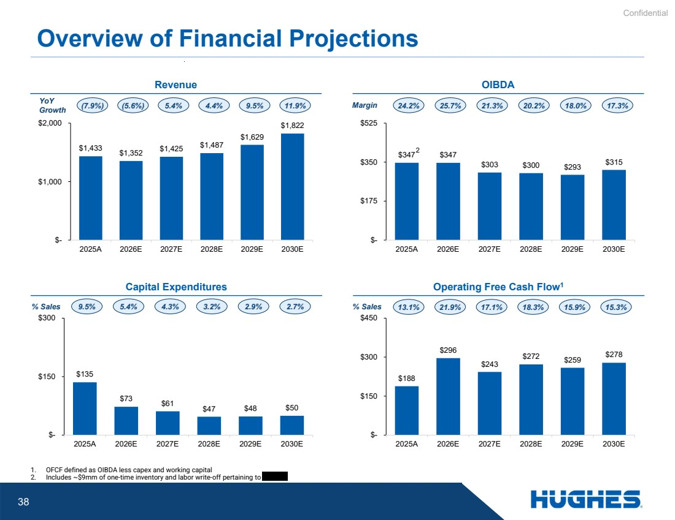 | Confidential 38 % Sales Overview of Financial Projections Revenue OIBDA Capital Expenditures Operating Free Cash Flow1 9.5% 5.4% 4.3% 3.2% 2.9% 2.7% % Sales 13.1% 21.9% 17.1% 18.3% 15.9% 15.3% YoY Growth (7.9%) (5.6%) 5.4% 4.4% 9.5% 11.9% Margin 24.2% 25.7% 21.3% 20.2% 18.0% 17.3% 1. OFCF defined as OIBDA less capex and working capital 2. Includes ~$9mm of one-time inventory and labor write-off pertaining to $1,433 $1,352 $1,425 $1,487 $1,629 $1,822 $- $1,000 $2,000 2025A 2026E 2027E 2028E 2029E 2030E $347 $347 $303 $300 $293 $315 $- $175 $350 $525 2025A 2026E 2027E 2028E 2029E 2030E $135 $73 $61 $47 $48 $50 $- $150 $300 2025A 2026E 2027E 2028E 2029E 2030E $188 $296 $243 $272 $259 $278 $- $150 $300 $450 2025A 2026E 2027E 2028E 2029E 2030E 2
 |  | Confidential 39 Appendix
 | 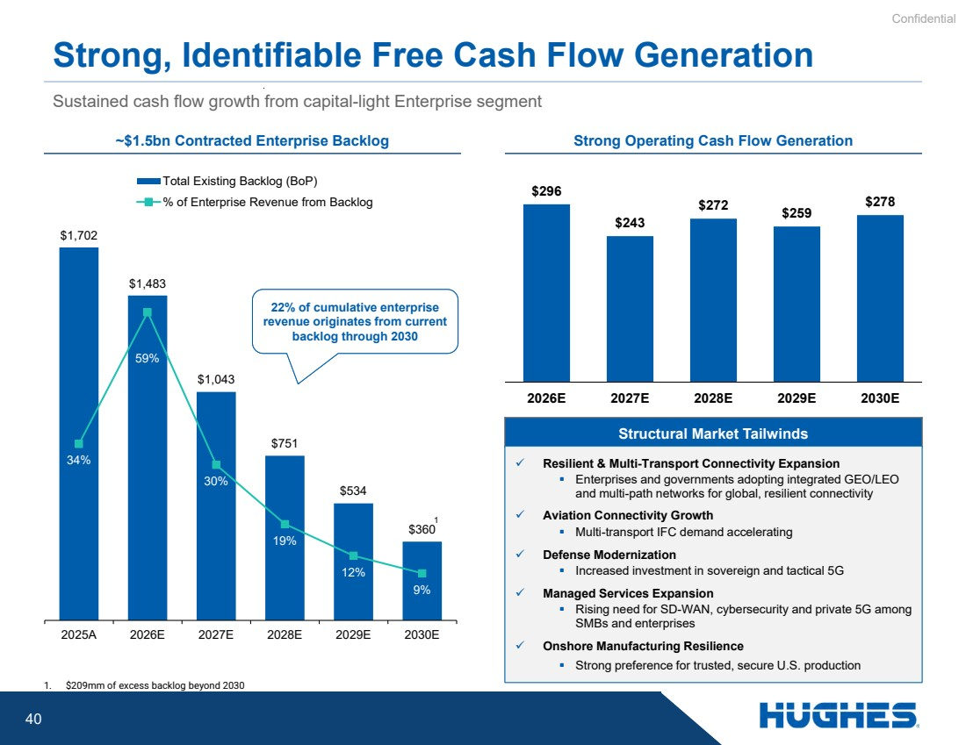 | Confidential 40 $1,702 $1,483 $1,043 $751 $534 $360 34% 59% 30% 19% 12% 9% 2025A 2026E 2027E 2028E 2029E 2030E Total Existing Backlog (BoP) % of Enterprise Revenue from Backlog Sustained cash flow growth from capital-light Enterprise segment Strong, Identifiable Free Cash Flow Generation ~$1.5bn Contracted Enterprise Backlog Strong Operating Cash Flow Generation Structural Market Tailwinds ✓ Resilient & Multi-Transport Connectivity Expansion ▪ Enterprises and governments adopting integrated GEO/LEO and multi-path networks for global, resilient connectivity ✓ Aviation Connectivity Growth ▪ Multi-transport IFC demand accelerating ✓ Defense Modernization ▪ Increased investment in sovereign and tactical 5G ✓ Managed Services Expansion ▪ Rising need for SD-WAN, cybersecurity and private 5G among SMBs and enterprises ✓ Onshore Manufacturing Resilience ▪ Strong preference for trusted, secure U.S. production 1 22% of cumulative enterprise revenue originates from current backlog through 2030 $296 $243 $272 $259 $278 2026E 2027E 2028E 2029E 2030E 1. $209mm of excess backlog beyond 2030 1
Exhibit 99.2
 | 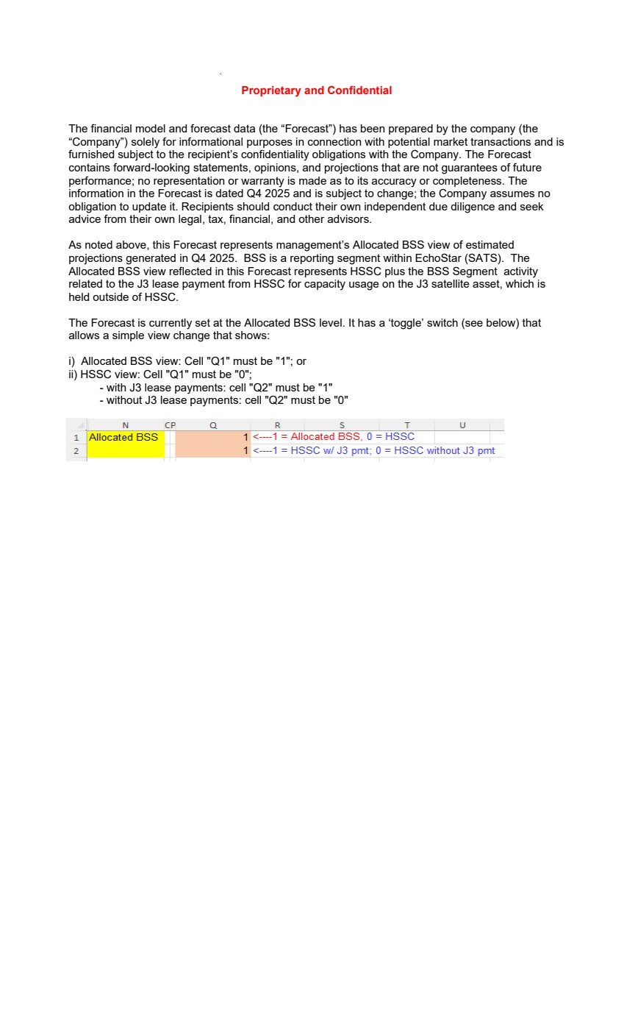 | Proprietary and Confidential The financial model and forecast data (the “Forecast”) has been prepared by the company (the “Company”) solely for informational purposes in connection with potential market transactions and is furnished subject to the recipient’s confidentiality obligations with the Company. The Forecast contains forward-looking statements, opinions, and projections that are not guarantees of future performance; no representation or warranty is made as to its accuracy or completeness. The information in the Forecast is dated Q4 2025 and is subject to change; the Company assumes no obligation to update it. Recipients should conduct their own independent due diligence and seek advice from their own legal, tax, financial, and other advisors. As noted above, this Forecast represents management’s Allocated BSS view of estimated projections generated in Q4 2025. BSS is a reporting segment within EchoStar (SATS). The Allocated BSS view reflected in this Forecast represents HSSC plus the BSS Segment activity related to the J3 lease payment from HSSC for capacity usage on the J3 satellite asset, which is held outside of HSSC. The Forecast is currently set at the Allocated BSS level. It has a ‘toggle’ switch (see below) that allows a simple view change that shows: i) Allocated BSS view: Cell "Q1" must be "1"; or ii) HSSC view: Cell "Q1" must be "0"; - with J3 lease payments: cell "Q2" must be "1" - without J3 lease payments: cell "Q2" must be "0"
 | 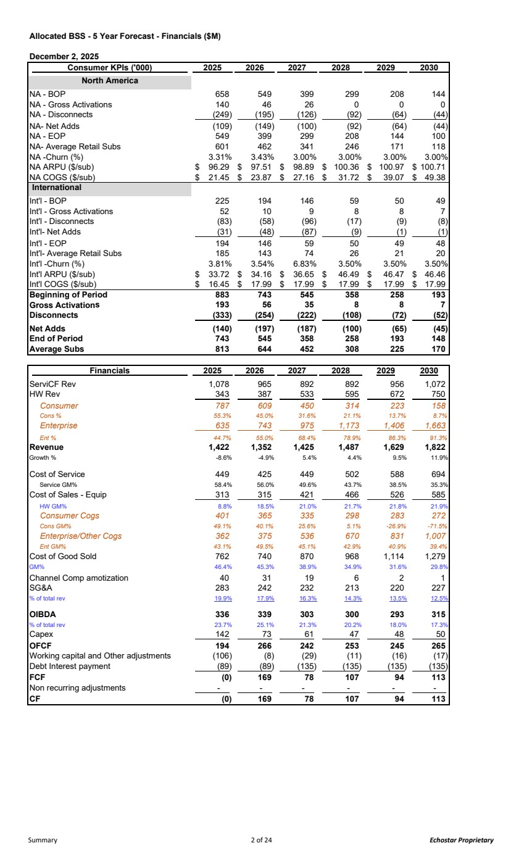 | Allocated BSS - 5 Year Forecast - Financials ($M) December 2, 2025 Consumer KPIs ('000) 2025 2026 2027 2028 2029 2030 North America NA - BOP 658 549 399 299 208 144 NA - Gross Activations 140 46 26 0 0 0 NA - Disconnects (249) (195) (126) (92) (64) (44) NA- Net Adds (109) (149) (100) (92) (64) (44) NA - EOP 549 399 299 208 144 100 NA- Average Retail Subs 601 462 341 246 171 118 NA -Churn (%) 3.31% 3.43% 3.00% 3.00% 3.00% 3.00% NA ARPU ($/sub) 96.29 $ 97.51 $ 98.89 $ 100.36 $ 100.97 $ 100.71 $ NA COGS ($/sub) 21.45 $ 23.87 $ 27.16 $ 31.72 $ 39.07 $ 49.38 $ International Int'l - BOP 225 194 146 59 50 49 Int'l - Gross Activations 52 10 9 8 8 7 Int'l - Disconnects (83) (58) (96) (17) (9) (8) Int'l- Net Adds (31) (48) (87) (9) (1) (1) Int'l - EOP 194 146 59 50 49 48 Int'l- Average Retail Subs 185 143 74 26 21 20 Int'l -Churn (%) 3.81% 3.54% 6.83% 3.50% 3.50% 3.50% Int'l ARPU ($/sub) 33.72 $ 34.16 $ 36.65 $ 46.49 $ 46.47 $ 46.46 $ Int'l COGS ($/sub) 16.45 $ 17.99 $ 17.99 $ 17.99 $ 17.99 $ 17.99 $ Beginning of Period 883 743 545 358 258 193 Gross Activations 56 193 35 8 8 7 Disconnects (333) (254) (222) (108) (72) (52) Net Adds (140) (197) (187) (100) (65) (45) End of Period 743 545 358 258 193 148 Average Subs 644 813 452 308 225 170 Financials 2025 2026 2027 2028 2029 2030 ServiCF Rev 1,078 965 892 892 956 1,072 HW Rev 343 387 533 595 672 750 Consumer 787 609 450 314 223 158 Cons % 55.3% 45.0% 31.6% 21.1% 13.7% 8.7% Enterprise 635 743 975 1,173 1,406 1,663 Ent % 44.7% 55.0% 68.4% 78.9% 86.3% 91.3% Revenue 1,422 1,352 1,425 1,487 1,629 1,822 Growth % -8.6% -4.9% 5.4% 4.4% 9.5% 11.9% Cost of Service 449 425 449 502 588 694 Service GM% 58.4% 56.0% 49.6% 43.7% 38.5% 35.3% Cost of Sales - Equip 313 315 421 466 526 585 HW GM% 8.8% 18.5% 21.0% 21.7% 21.8% 21.9% Consumer Cogs 401 365 335 298 283 272 Cons GM% 49.1% 40.1% 25.6% 5.1% -26.9% -71.5% Enterprise/Other Cogs 362 375 536 670 831 1,007 Ent GM% 43.1% 49.5% 45.1% 42.9% 40.9% 39.4% Cost of Good Sold 762 740 870 968 1,114 1,279 GM% 46.4% 45.3% 38.9% 34.9% 31.6% 29.8% Channel Comp amotization 40 31 19 6 2 1 SG&A 283 242 232 213 220 227 % of total rev 19.9% 17.9% 16.3% 14.3% 13.5% 12.5% OIBDA 336 339 303 300 293 315 % of total rev 23.7% 25.1% 21.3% 20.2% 18.0% 17.3% Capex 142 73 61 47 48 50 OFCF 194 266 242 253 245 265 Working capital and Other adjustments (106) (8) (29) (11) (16) (17) Debt Interest payment (89) (89) (135) (135) (135) (135) FCF (0) 169 78 107 94 113 Non recurring adjustments - - - - - - CF (0) 169 78 107 94 113 Summary 2 of 24 Echostar Proprietary
 | 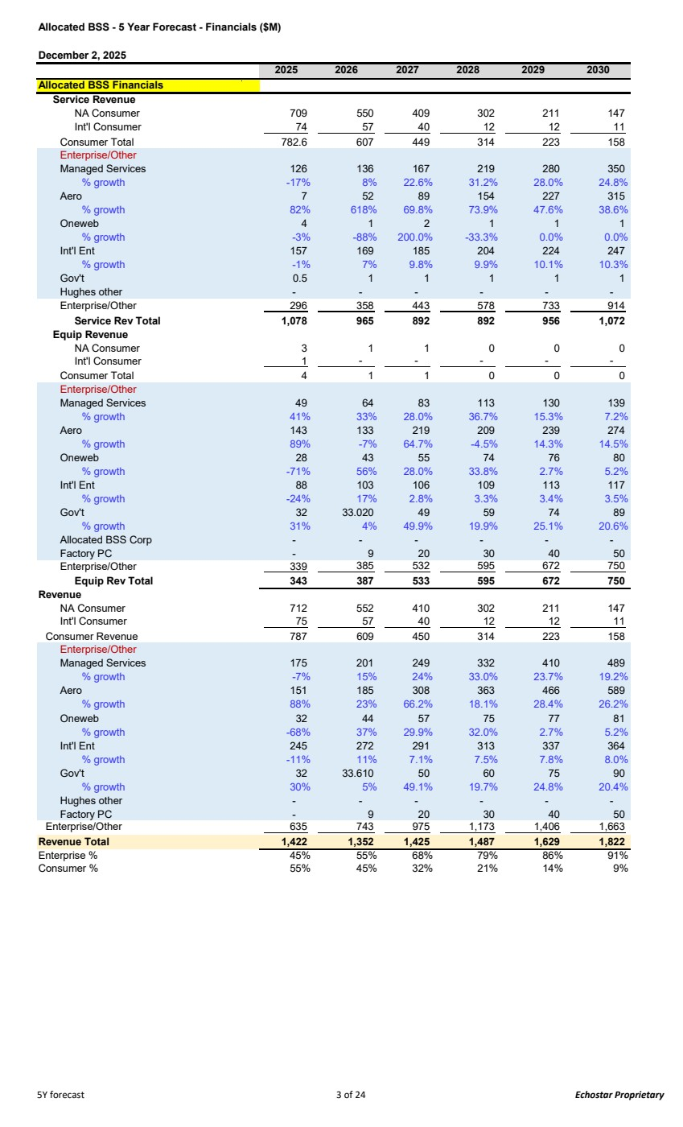 | Allocated BSS - 5 Year Forecast - Financials ($M) December 2, 2025 2025 2026 2027 2028 2029 2030 Allocated BSS Financials Service Revenue NA Consumer 709 550 409 302 211 147 Int'l Consumer 74 57 40 12 12 11 Consumer Total 782.6 607 449 314 223 158 Enterprise/Other Managed Services 126 136 167 219 280 350 % growth -17% 8% 22.6% 31.2% 28.0% 24.8% Aero 7 52 89 154 227 315 % growth 82% 618% 69.8% 73.9% 47.6% 38.6% Oneweb 4 1 2 1 1 1 % growth -3% -88% 200.0% -33.3% 0.0% 0.0% Int'l Ent 157 169 185 204 224 247 % growth -1% 7% 9.8% 9.9% 10.1% 10.3% Gov't 0.5 1 1 1 1 1 Hughes other - - - - - - Enterprise/Other 296 358 443 578 733 914 Service Rev Total 1,078 965 892 892 956 1,072 Equip Revenue NA Consumer 3 1 1 0 0 0 Int'l Consumer 1 - - - - - Consumer Total 4 1 1 0 0 0 Enterprise/Other Managed Services 49 64 83 113 130 139 % growth 41% 33% 28.0% 36.7% 15.3% 7.2% Aero 143 133 219 209 239 274 % growth 89% -7% 64.7% -4.5% 14.3% 14.5% Oneweb 28 43 55 74 76 80 % growth -71% 56% 28.0% 33.8% 2.7% 5.2% Int'l Ent 88 103 106 109 113 117 % growth -24% 17% 2.8% 3.3% 3.4% 3.5% Gov't 32 33.020 49 59 74 89 % growth 31% 4% 49.9% 19.9% 25.1% 20.6% Allocated BSS Corp - - - - - - Factory PC - 9 20 30 40 50 Enterprise/Other 339 385 532 595 672 750 Equip Rev Total 343 387 533 595 672 750 Revenue NA Consumer 712 552 410 302 211 147 Int'l Consumer 75 57 40 12 12 11 Consumer Revenue 787 609 450 314 223 158 Enterprise/Other Managed Services 175 201 249 332 410 489 % growth -7% 15% 24% 33.0% 23.7% 19.2% Aero 151 185 308 363 466 589 % growth 88% 23% 66.2% 18.1% 28.4% 26.2% Oneweb 32 44 57 75 77 81 % growth -68% 37% 29.9% 32.0% 2.7% 5.2% Int'l Ent 245 272 291 313 337 364 % growth -11% 11% 7.1% 7.5% 7.8% 8.0% Gov't 32 33.610 50 60 75 90 % growth 30% 5% 49.1% 19.7% 24.8% 20.4% Hughes other - - - - - - Factory PC - 9 20 30 40 50 Enterprise/Other 635 743 975 1,173 1,406 1,663 Revenue Total 1,422 1,352 1,425 1,487 1,629 1,822 Enterprise % 45% 55% 68% 79% 86% 91% Consumer % 55% 45% 32% 21% 14% 9% 5Y forecast 3 of 24 Echostar Proprietary
 | 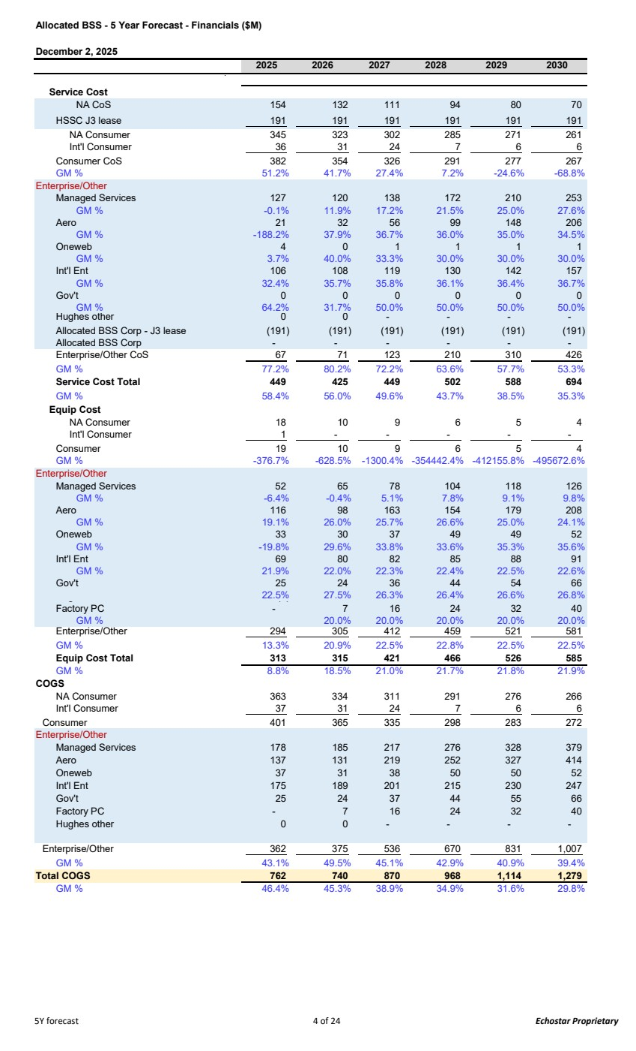 | Allocated BSS - 5 Year Forecast - Financials ($M) December 2, 2025 2025 2026 2027 2028 2029 2030 Service Cost NA CoS 154 132 111 94 80 70 HSSC J3 lease 191 191 191 191 191 191 NA Consumer 345 323 302 285 271 261 Int'l Consumer 36 31 24 7 6 6 Consumer CoS 382 354 326 291 277 267 GM % 51.2% 41.7% 27.4% 7.2% -24.6% -68.8% Enterprise/Other Managed Services 127 120 138 172 210 253 GM % -0.1% 11.9% 17.2% 21.5% 25.0% 27.6% Aero 21 32 56 99 148 206 GM % -188.2% 37.9% 36.7% 36.0% 35.0% 34.5% Oneweb 4 0 1 1 1 1 GM % 3.7% 40.0% 33.3% 30.0% 30.0% 30.0% Int'l Ent 106 108 119 130 142 157 GM % 32.4% 35.7% 35.8% 36.1% 36.4% 36.7% Gov't 0 0 0 0 0 0 GM % 64.2% 31.7% 50.0% 50.0% 50.0% 50.0% Hughes other 0 - 0 - - - Allocated BSS Corp - J3 lease (191) (191) (191) (191) (191) (191) Allocated BSS Corp - - - - - - Enterprise/Other CoS 67 71 123 210 310 426 GM % 77.2% 80.2% 72.2% 63.6% 57.7% 53.3% Service Cost Total 449 425 449 502 588 694 GM % 58.4% 56.0% 49.6% 43.7% 38.5% 35.3% Equip Cost NA Consumer 18 10 9 6 5 4 Int'l Consumer 1 - - - - - Consumer 19 10 9 6 5 4 GM % -376.7% -628.5% -1300.4% -354442.4% -412155.8% -495672.6% Enterprise/Other Managed Services 52 65 78 104 118 126 GM % -6.4% -0.4% 5.1% 7.8% 9.1% 9.8% Aero 116 98 163 154 179 208 GM % 19.1% 26.0% 25.7% 26.6% 25.0% 24.1% Oneweb 33 30 37 49 49 52 GM % -19.8% 29.6% 33.8% 33.6% 35.3% 35.6% Int'l Ent 69 80 82 85 88 91 GM % 21.9% 22.0% 22.3% 22.4% 22.5% 22.6% Gov't 25 24 36 44 54 66 g 22.5% 27.5% 26.3% 26.4% 26.6% 26.8% ( ) Factory PC - 7 16 24 32 40 GM % 20.0% 20.0% 20.0% 20.0% 20.0% Enterprise/Other 305 294 412 459 521 581 GM % 13.3% 20.9% 22.5% 22.8% 22.5% 22.5% Equip Cost Total 313 315 421 466 526 585 GM % 8.8% 18.5% 21.0% 21.7% 21.8% 21.9% COGS NA Consumer 363 334 311 291 276 266 Int'l Consumer 37 31 24 7 6 6 Consumer 401 365 335 298 283 272 Enterprise/Other Managed Services 178 185 217 276 328 379 Aero 137 131 219 252 327 414 Oneweb 37 31 38 50 50 52 Int'l Ent 175 189 201 215 230 247 Gov't 25 24 37 44 55 66 Factory PC - 7 16 24 32 40 Hughes other 0 0 - - - - Enterprise/Other 362 375 536 670 831 1,007 GM % 43.1% 49.5% 45.1% 42.9% 40.9% 39.4% Total COGS 762 740 870 968 1,114 1,279 GM % 46.4% 45.3% 38.9% 34.9% 31.6% 29.8% 5Y forecast 4 of 24 Echostar Proprietary
 | 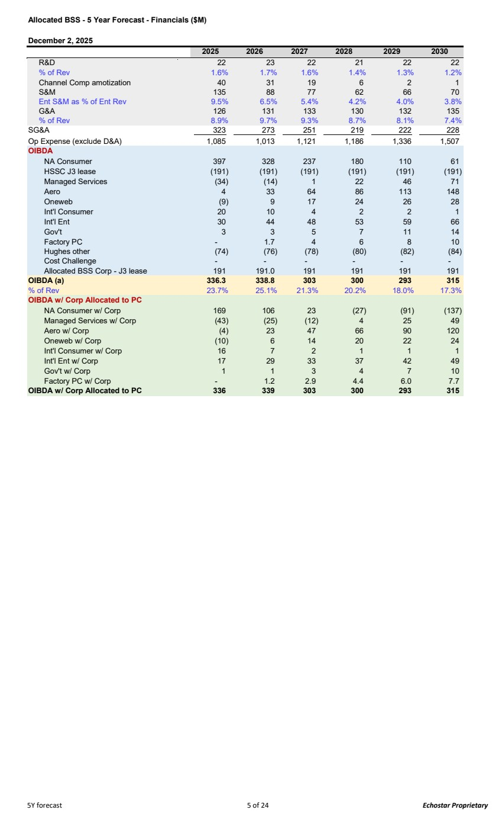 | Allocated BSS - 5 Year Forecast - Financials ($M) December 2, 2025 2025 2026 2027 2028 2029 2030 R&D 22 23 22 21 22 22 % of Rev 1.6% 1.7% 1.6% 1.4% 1.3% 1.2% Channel Comp amotization 40 31 19 6 2 1 S&M 135 88 77 62 66 70 Ent S&M as % of Ent Rev 9.5% 6.5% 5.4% 4.2% 4.0% 3.8% G&A 126 131 133 130 132 135 % of Rev 8.9% 9.7% 9.3% 8.7% 8.1% 7.4% SG&A 323 273 251 219 222 228 Op Expense (exclude D&A) 1,085 1,013 1,121 1,186 1,336 1,507 OIBDA NA Consumer 397 328 237 180 110 61 HSSC J3 lease (191) (191) (191) (191) (191) (191) Managed Services (34) (14) 1 22 46 71 Aero 4 33 64 86 113 148 Oneweb (9) 9 17 24 26 28 Int'l Consumer 20 10 4 2 2 1 Int'l Ent 30 44 48 53 59 66 Gov't 3 3 5 7 11 14 Factory PC - 1.7 4 6 8 10 Hughes other (74) (76) (78) (80) (82) (84) Cost Challenge - - - - - - Allocated BSS Corp - J3 lease 191 191.0 191 191 191 191 OIBDA (a) 336.3 338.8 303 300 293 315 % of Rev 23.7% 25.1% 21.3% 20.2% 18.0% 17.3% OIBDA w/ Corp Allocated to PC NA Consumer w/ Corp 169 106 23 (27) (91) (137) Managed Services w/ Corp (43) (25) (12) 4 25 49 Aero w/ Corp (4) 23 47 66 90 120 Oneweb w/ Corp (10) 6 14 20 22 24 Int'l Consumer w/ Corp 16 7 2 1 1 1 Int'l Ent w/ Corp 17 29 33 37 42 49 Gov't w/ Corp 1 1 3 4 7 10 Factory PC w/ Corp - 1.2 2.9 4.4 6.0 7.7 OIBDA w/ Corp Allocated to PC 336 339 303 300 293 315 5Y forecast 5 of 24 Echostar Proprietary
 | 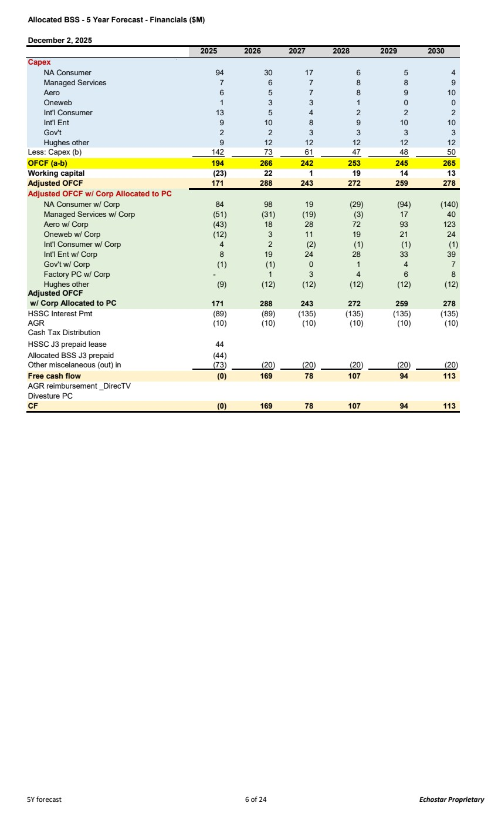 | Allocated BSS - 5 Year Forecast - Financials ($M) December 2, 2025 2025 2026 2027 2028 2029 2030 Capex NA Consumer 94 30 17 6 5 4 Managed Services 7 6 7 8 8 9 Aero 6 5 7 8 9 10 Oneweb 1 3 3 1 0 0 Int'l Consumer 13 5 4 2 2 2 Int'l Ent 9 10 8 9 10 10 Gov't 2 2 3 3 3 3 Hughes other 9 12 12 12 12 12 Less: Capex (b) 142 73 61 47 48 50 OFCF (a-b) 194 266 242 253 245 265 Working capital (23) 22 1 19 14 13 Adjusted OFCF 171 288 243 272 259 278 Adjusted OFCF w/ Corp Allocated to PC NA Consumer w/ Corp 84 98 19 (29) (94) (140) Managed Services w/ Corp (51) (31) (19) (3) 17 40 Aero w/ Corp (43) 18 28 72 93 123 Oneweb w/ Corp (12) 3 11 19 21 24 Int'l Consumer w/ Corp 4 2 (2) (1) (1) (1) Int'l Ent w/ Corp 8 19 24 28 33 39 Gov't w/ Corp (1) (1) 0 1 4 7 Factory PC w/ Corp - 1 3 4 6 8 Hughes other (9) (12) (12) (12) (12) (12) Adjusted OFCF w/ Corp Allocated to PC 288 171 243 272 259 278 HSSC Interest Pmt (89) (89) (135) (135) (135) (135) AGR (10) (10) (10) (10) (10) (10) Cash Tax Distribution HSSC J3 prepaid lease 44 Allocated BSS J3 prepaid (44) Other miscelaneous (out) in (73) (20) (20) (20) (20) (20) Free cash flow (0) 169 78 107 94 113 AGR reimbursement _DirecTV Divesture PC CF (0) 169 78 107 94 113 5Y forecast 6 of 24 Echostar Proprietary
 | 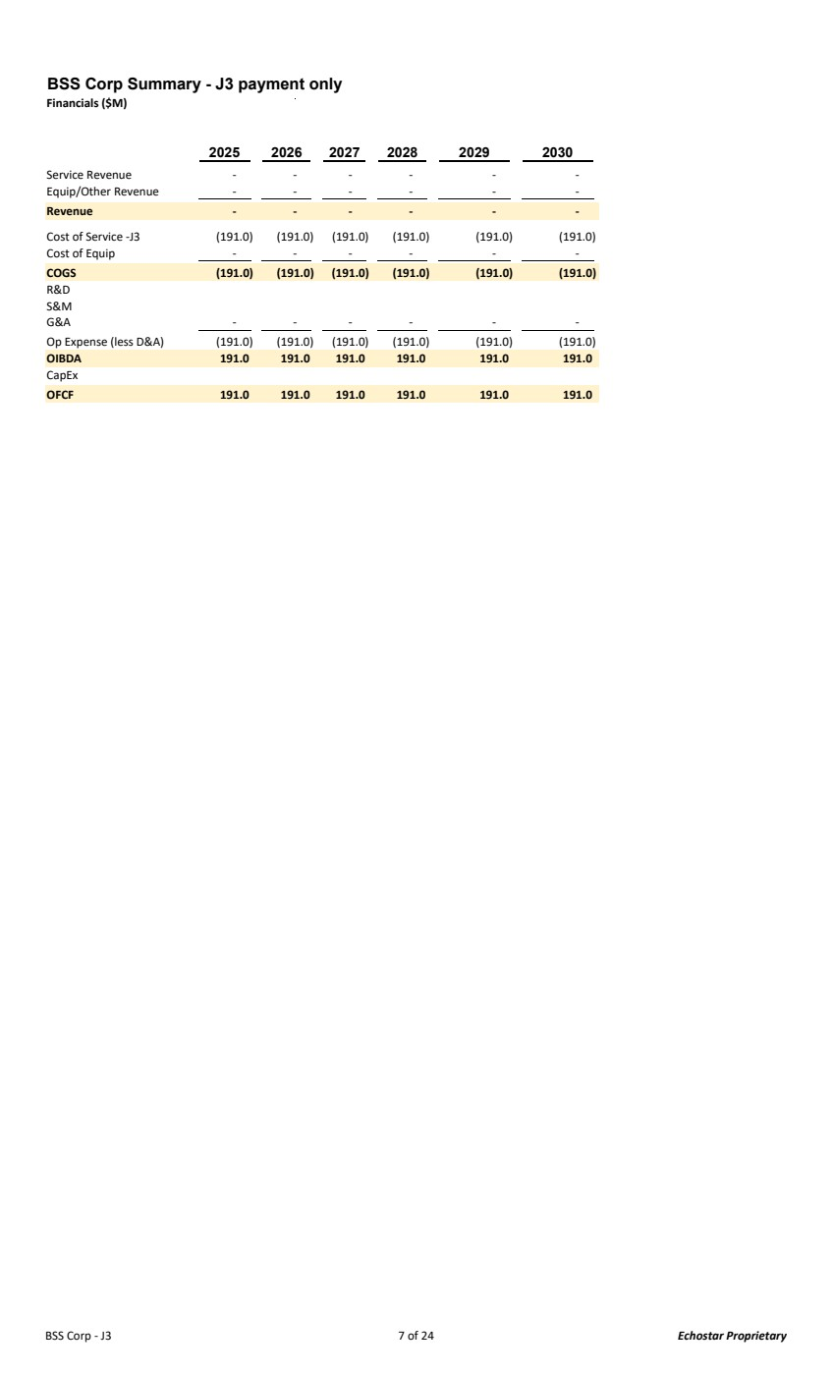 | BSS Corp Summary - J3 payment only Financials ($M) 2025 2026 2027 2028 2029 2030 Service Revenue - - - - - - Equip/Other Revenue - - - - - - Revenue - - - - - - Cost of Service -J3 (191.0) (191.0) (191.0) (191.0) (191.0) (191.0) Cost of Equip - - - - - - COGS (191.0) (191.0) (191.0) (191.0) (191.0) (191.0) R&D S&M G&A - - - - - - Op Expense (less D&A) (191.0) (191.0) (191.0) (191.0) (191.0) (191.0) OIBDA 191.0 191.0 191.0 191.0 191.0 191.0 CapEx OFCF 191.0 191.0 191.0 191.0 191.0 191.0 BSS Corp - J3 7 of 24 Echostar Proprietary
 | 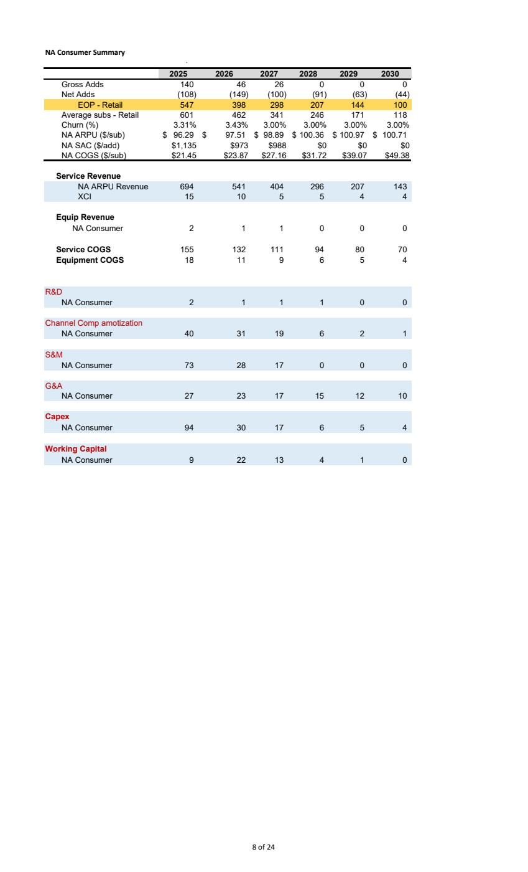 | NA Consumer Summary 2025 2026 2027 2028 2029 2030 Gross Adds 140 46 26 0 0 0 Net Adds (108) (149) (100) (91) (63) (44) EOP - Retail 547 398 298 207 144 100 Average subs - Retail 601 462 341 246 171 118 Churn (%) 3.31% 3.43% 3.00% 3.00% 3.00% 3.00% NA ARPU ($/sub) 96.29 $ 97.51 $ 98.89 $ 100.36 $ 100.97 $ 100.71 $ NA SAC ($/add) $1,135 $973 $988 $0 $0 $0 NA COGS ($/sub) $21.45 $23.87 $27.16 $31.72 $39.07 $49.38 Service Revenue NA ARPU Revenue 694 541 404 296 207 143 XCI 15 10 5 5 4 4 Equip Revenue NA Consumer 2 1 1 0 0 0 Service COGS 132 155 111 94 80 70 Equipment COGS 11 18 9 6 5 4 R&D NA Consumer 2 1 1 1 0 0 Channel Comp amotization NA Consumer 40 31 19 6 2 1 S&M NA Consumer 73 28 17 0 0 0 G&A NA Consumer 27 23 17 15 12 10 Capex NA Consumer 94 30 17 6 5 4 Working Capital NA Consumer 9 22 13 4 1 0 8 of 24
 | 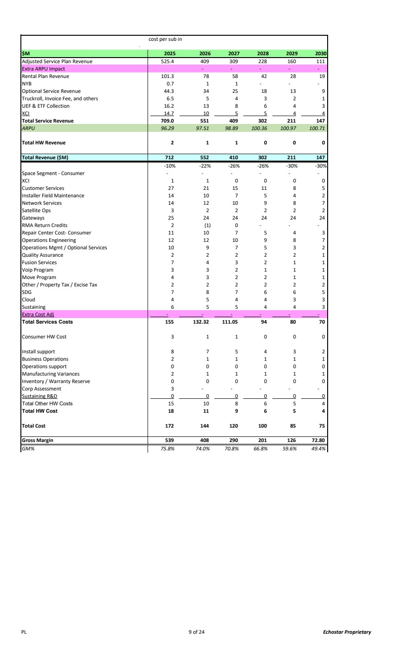 | cost per sub in $M 2025 2026 2027 2028 2029 2030 Adjusted Service Plan Revenue 525.4 409 309 228 160 111 Extra ARPU Impact - - - - - Rental Plan Revenue 101.3 78 58 42 28 19 NYB 0.7 1 1 - - - Optional Service Revenue 44.3 34 25 18 13 9 Truckroll, Invoice Fee, and others 6.5 5 4 3 2 1 UEF & ETF Collection 16.2 13 8 6 4 3 XCI 14.7 10 5 5 4 4 Total Service Revenue 709.0 551 409 302 211 147 ARPU 96.29 97.51 98.89 100.3 100.9 6 100.71 7 Total HW Revenue 2 1 1 0 0 0 Total Revenue ($M) 712 552 410 302 211 147 -10% -22% -26% -26% -30% -30% Space Segment - Consumer - - - - - - XCI 1 1 0 0 0 0 Customer Services 27 21 15 11 8 5 Installer Field Maintenance 14 10 7 5 4 2 Network Services 14 12 10 9 8 7 Satellite Ops 3 2 2 2 2 2 Gateways 25 24 24 24 24 24 RMA Return Credits 2 (1) 0 - - - Repair Center Cost- Consumer 10 11 7 5 4 3 Operations Engineering 12 12 10 9 8 7 Operations Mgmt / Optional Services 10 9 7 5 3 2 Quality Assurance 2 2 2 2 2 1 Fusion Services 7 4 3 2 1 1 Voip Program 3 3 2 1 1 1 Move Program 4 3 2 2 1 1 Other / Property Tax / Excise Tax 2 2 2 2 2 2 SDG 7 8 7 6 6 5 Cloud 4 5 4 4 3 3 Sustaining 6 5 5 4 4 3 Extra Cost Adj - - - - - - Total Services Costs 132.32 155 111.05 94 80 70 Consumer HW Cost 3 1 1 0 0 0 Install support 8 7 5 4 3 2 Business Operations 2 1 1 1 1 1 Operations support 0 0 0 0 0 0 Manufacturing Variances 1 2 1 1 1 1 Inventory / Warranty Reserve 0 0 0 0 0 0 Corp Assessment 3 - - - - - Sustaining R&D 0 0 0 0 0 0 Total Other HW Costs 10 15 8 6 5 4 Total HW Cost 11 18 9 6 5 4 Total Cost 172 144 120 100 85 75 Gross Margin 539 408 290 201 126 72.80 GM% 75.8% 74.0% 70.8% 66.8% 59.6% 49.4% PL 9 of 24 Echostar Proprietary
 | 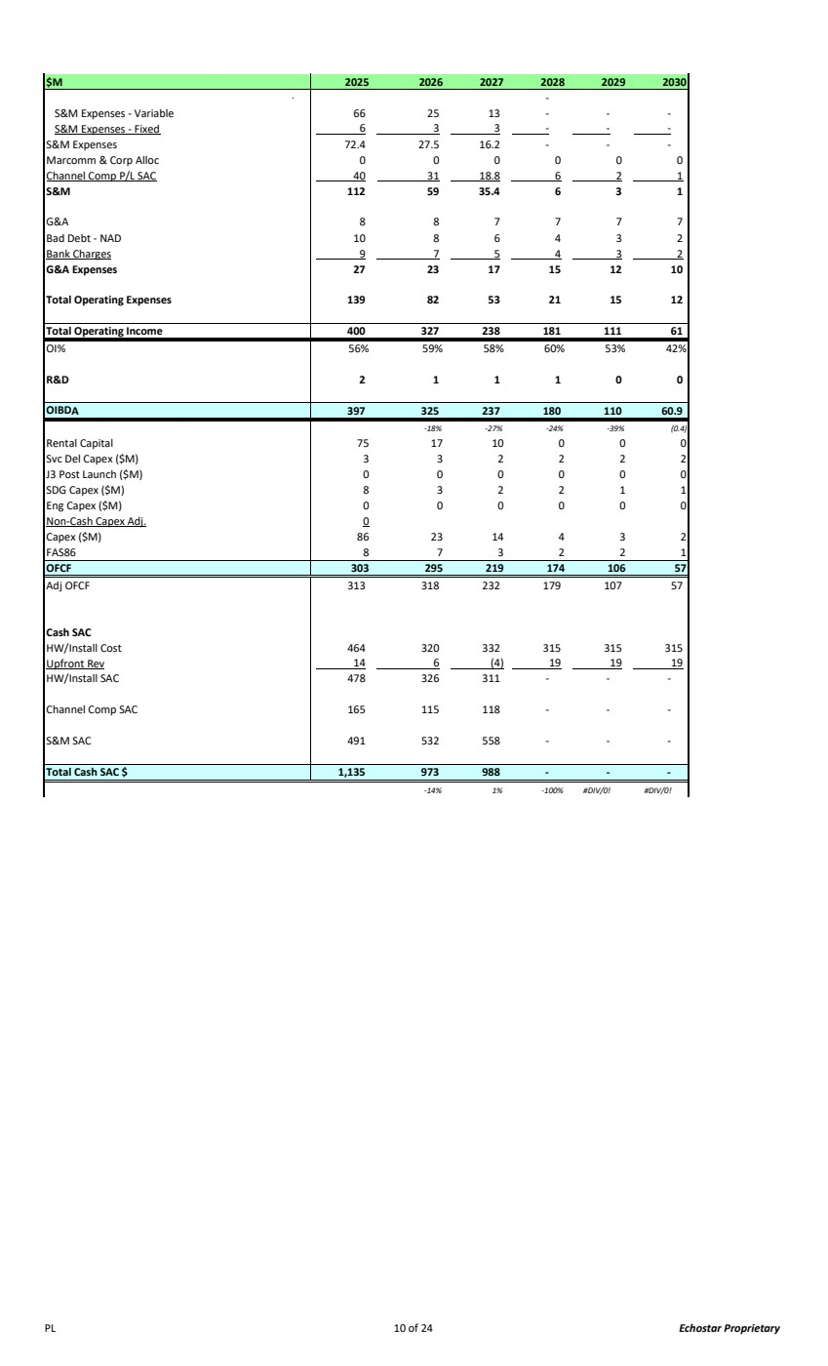 | $M 2025 2026 2027 2028 2029 2030 - S&M Expenses - Variable 66 25 13 - - - S&M Expenses - Fixed 6 3 3 - - - S&M Expenses 72.4 27.5 16.2 - - - Marcomm & Corp Alloc 0 0 0 0 0 0 Channel Comp P/L SAC 40 31 18.8 6 2 1 S&M 112 59 35.4 6 3 1 G&A 8 8 7 7 7 7 Bad Debt - NAD 10 8 6 4 3 2 Bank Charges 9 7 5 4 3 2 G&A Expenses 27 23 17 15 12 10 Total Operating Expenses 139 82 53 21 15 12 Total Operating Income 400 327 238 181 111 61 OI% 56% 59% 58% 60% 53% 42% R&D 2 1 1 1 0 0 OIBDA 325 397 237 180 110 60.9 -18% -27% -24% -39% (0.4) Rental Capital 75 17 10 0 0 0 Svc Del Capex ($M) 3 32222 J3 Post Launch ($M) 0 00000 SDG Capex ($M) 8 32211 Eng Capex ($M) 0 00000 Non-Cash Capex Adj. 0 Capex ($M) 86 23 14 4 3 2 FAS86 8 73221 OFCF 303 295 219 174 106 57 Adj OFCF 313 318 232 179 107 57 Cash SAC HW/Install Cost 464 320 332 315 315 315 Upfront Rev 14 6 (4) 19 19 19 HW/Install SAC 478 326 311 - - - Channel Comp SAC 165 115 118 - - - S&M SAC 491 532 558 - - - Total Cash SAC $ 1,135 973 988 - - - -14% 1% -100% #DIV/0! #DIV/0! PL 10 of 24 Echostar Proprietary
 | 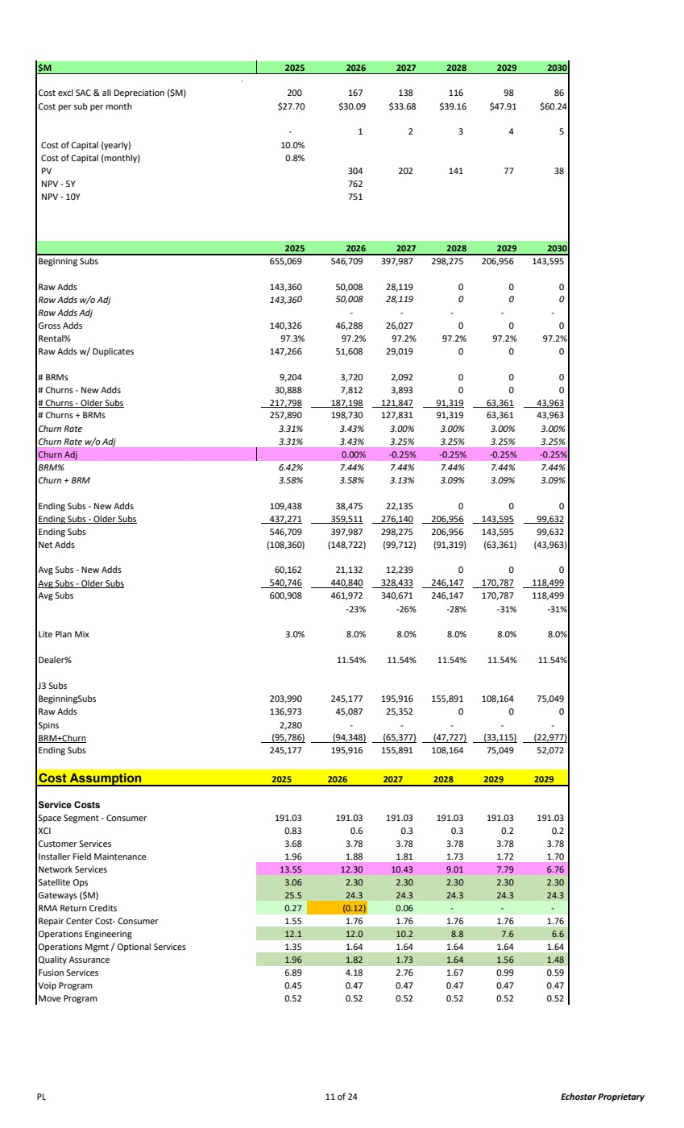 | $M 2025 2026 2027 2028 2029 2030 Cost excl SAC & all Depreciation ($M) 200 167 138 116 98 86 Cost per sub per month $27.70 $30.09 $33.68 $39.16 $47.91 $60.24 1 - 2 3 4 5 Cost of Capital (yearly) 10.0% Cost of Capital (monthly) 0.8% PV 304 202 141 77 38 NPV - 5Y 762 NPV - 10Y 751 2025 2026 2027 2028 2029 2030 Beginning Subs 655,069 546,709 397,987 298,275 206,956 143,595 Raw Adds 143,360 50,008 28,119 0 0 0 Raw Adds w/o Adj 143,36 50,008 0 28,119 0 0 0 Raw Adds Adj - - - - - Gross Adds 140,326 46,288 26,027 0 0 0 Rental% 97.3% 97.2% 97.2% 97.2% 97.2% 97.2% Raw Adds w/ Duplicates 147,266 51,608 29,019 0 0 0 # BRMs 9,204 3,720 2,092 0 0 0 # Churns - New Adds 30,888 7,812 3,893 0 0 0 # Churns - Older Subs 217,798 187,198 121,847 91,319 63,361 43,963 # Churns + BRMs 257,890 198,730 127,831 91,319 63,361 43,963 Churn Rate 3.31% 3.43% 3.00% 3.00% 3.00% 3.00% Churn Rate w/o Adj 3.31% 3.43% 3.25% 3.25% 3.25% 3.25% Churn Adj 0.00% -0.25% -0.25% -0.25% -0.25% BRM% 6.42% 7.44% 7.44% 7.44% 7.44% 7.44% Churn + BRM 3.58% 3.58% 3.13% 3.09% 3.09% 3.09% Ending Subs - New Adds 109,438 38,475 22,135 0 0 0 Ending Subs - Older Subs 437,271 359,511 276,140 206,956 143,595 99,632 Ending Subs 546,709 397,987 298,275 206,956 143,595 99,632 Net Adds (108,360) (148,722) (99,712) (91,319) (63,361) (43,963) Avg Subs - New Adds 60,162 21,132 12,239 0 0 0 Avg Subs - Older Subs 540,746 440,840 328,433 246,147 170,787 118,499 Avg Subs 600,908 461,972 340,671 246,147 170,787 118,499 -23% -26% -28% -31% -31% Lite Plan Mix 3.0% 8.0% 8.0% 8.0% 8.0% 8.0% Dealer% 11.54% 11.54% 11.54% 11.54% 11.54% J3 Subs BeginningSubs 203,990 245,177 195,916 155,891 108,164 75,049 Raw Adds 136,973 45,087 25,352 0 0 0 Spins 2,280 - - - - - BRM+Churn (95,786) (94,348) (65,377) (47,727) (33,115) (22,977) Ending Subs 245,177 195,916 155,891 108,164 75,049 52,072 Cost Assumption 2025 2026 2027 2028 2029 2029 Service Costs Space Segment - Consumer 191.03 191.03 191.03 191.03 191.03 191.03 XCI 0.83 0.6 0.3 0.3 0.2 0.2 Customer Services 3.68 3.78 3.78 3.78 3.78 3.78 Installer Field Maintenance 1.96 1.88 1.81 1.73 1.72 1.70 Network Services 13.55 12.30 10.43 9.01 7.79 6.76 Satellite Ops 3.06 2.30 2.30 2.30 2.30 2.30 Gateways ($M) 25.5 24.3 24.3 24.3 24.3 24.3 RMA Return Credits 0.27 (0.12) 0.06 - - - Repair Center Cost- Consumer 1.76 1.55 1.76 1.76 1.76 1.76 Operations Engineering 12.0 12.1 10.2 8.8 7.6 6.6 Operations Mgmt / Optional Services 1.35 1.64 1.64 1.64 1.64 1.64 Quality Assurance 1.96 1.82 1.73 1.64 1.56 1.48 Fusion Services 6.89 4.18 2.76 1.67 0.99 0.59 Voip Program 0.45 0.47 0.47 0.47 0.47 0.47 Move Program 0.52 0.52 0.52 0.52 0.52 0.52 PL 11 of 24 Echostar Proprietary
 | 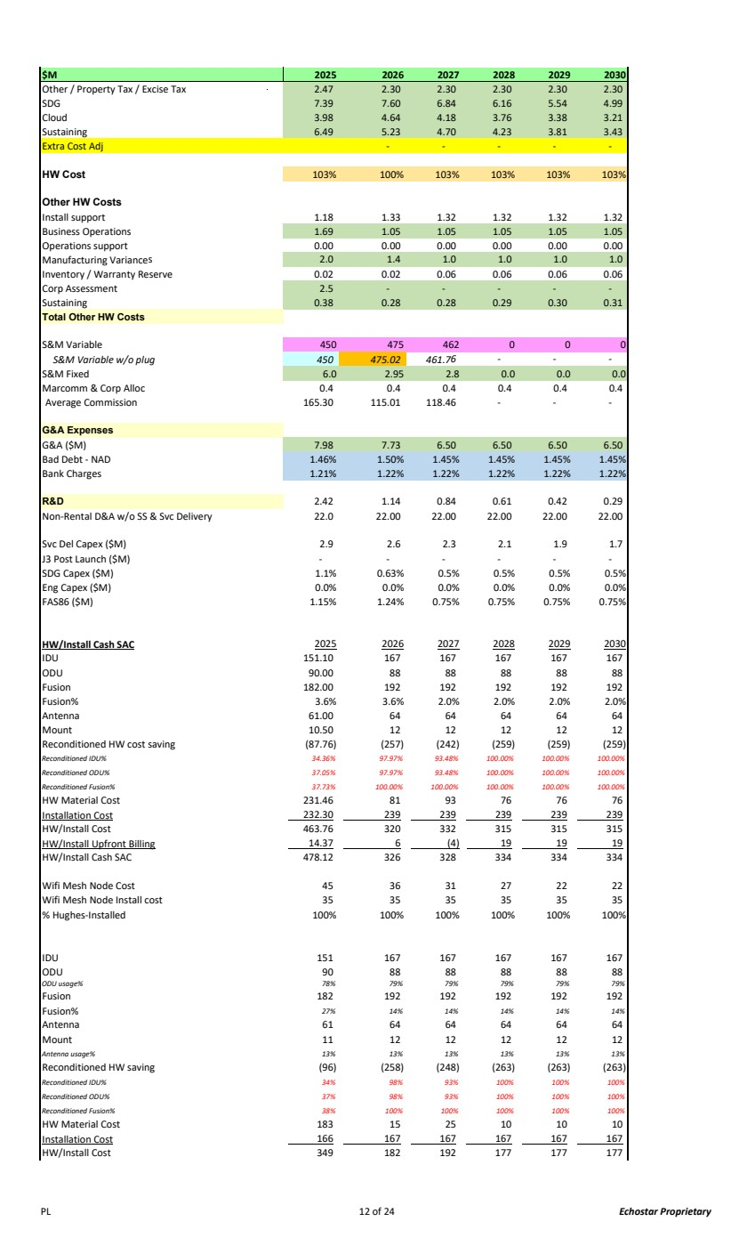 | $M 2025 2026 2027 2028 2029 2030 Other / Property Tax / Excise Tax 2.47 2.30 2.30 2.30 2.30 2.30 SDG 7.39 7.60 6.84 6.16 5.54 4.99 Cloud 3.98 4.64 4.18 3.76 3.38 3.21 Sustaining 6.49 5.23 4.70 4.23 3.81 3.43 Extra Cost Adj - - - - - HW Cost 103% 100% 103% 103% 103% 103% Other HW Costs Install support 1.18 1.33 1.32 1.32 1.32 1.32 Business Operations 1.69 1.05 1.05 1.05 1.05 1.05 Operations support 0.00 0.00 0.00 0.00 0.00 0.00 Manufacturing Variances 1.4 2.0 1.0 1.0 1.0 1.0 Inventory / Warranty Reserve 0.02 0.02 0.06 0.06 0.06 0.06 Corp Assessment 2.5 - - - - - Sustaining 0.38 0.28 0.28 0.29 0.30 0.31 Total Other HW Costs S&M Variable 450 475 462 0 0 0 S&M Variable w/o plug 450 475.02 461.7 - 6 - - S&M Fixed 6.0 2.95 2.8 0.0 0.0 0.0 Marcomm & Corp Alloc 0.4 0.4 0.4 0.4 0.4 0.4 Average Commission 165.30 115.01 118.46 - - - G&A Expenses G&A ($M) 7.98 7.73 6.50 6.50 6.50 6.50 Bad Debt - NAD 1.46% 1.50% 1.45% 1.45% 1.45% 1.45% Bank Charges 1.21% 1.22% 1.22% 1.22% 1.22% 1.22% R&D 1.14 2.42 0.84 0.61 0.42 0.29 Non-Rental D&A w/o SS & Svc Delivery 22.0 22.00 22.00 22.00 22.00 22.00 Svc Del Capex ($M) 2.9 2.6 2.3 2.1 1.9 1.7 J3 Post Launch ($M) - - - - - - SDG Capex ($M) 1.1% 0.63% 0.5% 0.5% 0.5% 0.5% Eng Capex ($M) 0.0% 0.0% 0.0% 0.0% 0.0% 0.0% FAS86 ($M) 1.15% 1.24% 0.75% 0.75% 0.75% 0.75% HW/Install Cash SAC 2025 2026 2027 2028 2029 2030 IDU 151.10 167 167 167 167 167 ODU 90.00 88 88 88 88 88 Fusion 182.00 192 192 192 192 192 Fusion% 3.6% 3.6% 2.0% 2.0% 2.0% 2.0% Antenna 61.00 64 64 64 64 64 Mount 10.50 12 12 12 12 12 Reconditioned HW cost saving (87.76) (257) (242) (259) (259) (259) Reconditioned IDU% 34.36% 97.97% 93.48% 100.00% 100.00% 100.00% Reconditioned ODU% 37.05% 97.97% 93.48% 100.00% 100.00% 100.00% Reconditioned Fusion% 37.73% 100.00% 100.00% 100.00% 100.00% 100.00% HW Material Cost 231.46 81 93 76 76 76 Installation Cost 232.30 239 239 239 239 239 HW/Install Cost 463.76 320 332 315 315 315 HW/Install Upfront Billing 14.37 6 (4) 19 19 19 HW/Install Cash SAC 478.12 326 328 334 334 334 Wifi Mesh Node Cost 45 36 31 27 22 22 Wifi Mesh Node Install cost 35 35 35 35 35 35 % Hughes-Installed 100% 100% 100% 100% 100% 100% IDU 151 167 167 167 167 167 ODU 90 88 88 88 88 88 ODU usage% 78% 79% 79% 79% 79% 79% Fusion 182 192 192 192 192 192 Fusion% 27% 14% 14% 14% 14% 14% Antenna 61 64 64 64 64 64 Mount 11 12 12 12 12 12 Antenna usage% 13% 13% 13% 13% 13% 13% Reconditioned HW saving (96) (258) (248) (263) (263) (263) Reconditioned IDU% 34% 98% 93% 100% 100% 100% Reconditioned ODU% 37% 98% 93% 100% 100% 100% Reconditioned Fusion% 38% 100% 100% 100% 100% 100% HW Material Cost 183 15 25 10 10 10 Installation Cost 166 167 167 167 167 167 HW/Install Cost 349 182 192 177 177 177 PL 12 of 24 Echostar Proprietary
 | 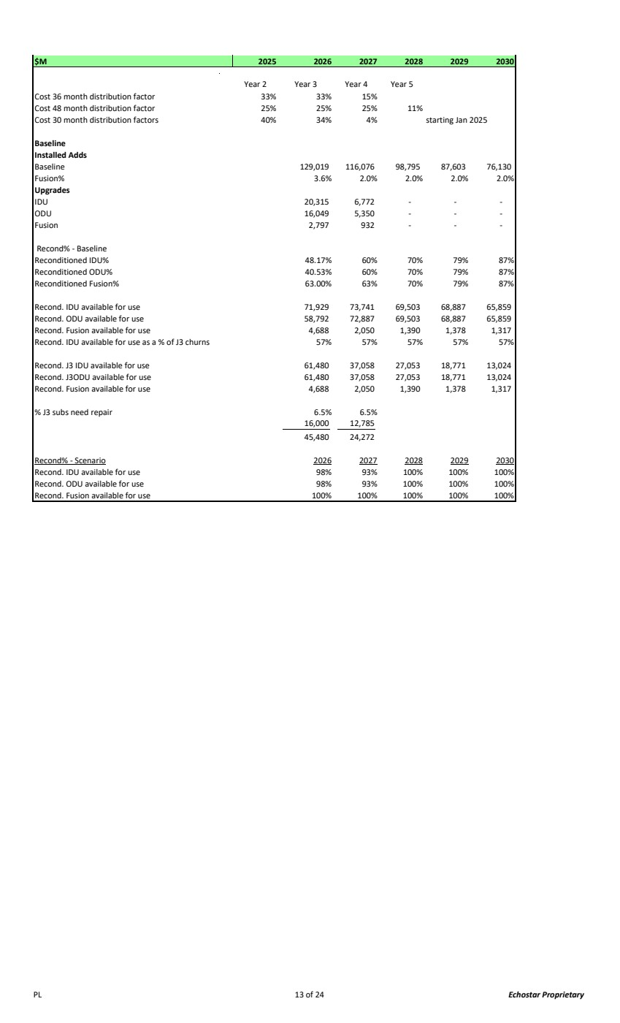 | $M 2025 2026 2027 2028 2029 2030 Year 2 Year 3 Year 4 Year 5 Cost 36 month distribution factor 33% 33% 15% Cost 48 month distribution factor 25% 25% 25% 11% Cost 30 month distribution factors 40% 34% 4% starting Jan 2025 Baseline Installed Adds Baseline 129,019 116,076 98,795 87,603 76,130 Fusion% 3.6% 2.0% 2.0% 2.0% 2.0% Upgrades IDU 20,315 6,772 - - - ODU 16,049 5,350 - - - Fusion 2,797 932 - - - Recond% - Baseline Reconditioned IDU% 48.17% 60% 70% 79% 87% Reconditioned ODU% 40.53% 60% 70% 79% 87% Reconditioned Fusion% 63.00% 63% 70% 79% 87% Recond. IDU available for use 71,929 73,741 69,503 68,887 65,859 Recond. ODU available for use 58,792 72,887 69,503 68,887 65,859 Recond. Fusion available for use 4,688 2,050 1,390 1,378 1,317 Recond. IDU available for use as a % of J3 churns 57% 57% 57% 57% 57% Recond. J3 IDU available for use 61,480 37,058 27,053 18,771 13,024 Recond. J3ODU available for use 61,480 37,058 27,053 18,771 13,024 Recond. Fusion available for use 4,688 2,050 1,390 1,378 1,317 % J3 subs need repair 6.5% 6.5% 12,785 16,000 24,272 45,480 Recond% - Scenario 2026 2027 2028 2029 2030 Recond. IDU available for use 98% 93% 100% 100% 100% Recond. ODU available for use 98% 93% 100% 100% 100% Recond. Fusion available for use 100% 100% 100% 100% 100% PL 13 of 24 Echostar Proprietary
 | 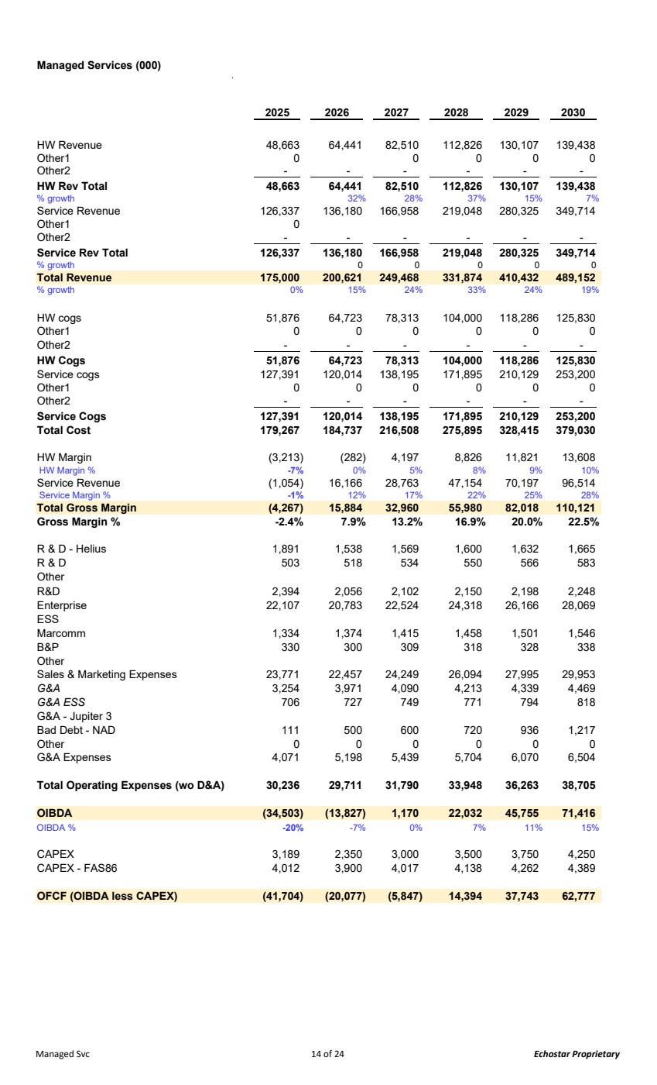 | Managed Services (000) 2025 2026 2027 2028 2029 2030 HW Revenue 48,663 64,441 82,510 112,826 130,107 139,438 Other1 0 0 0 0 0 Other2 - - - - - - HW Rev Total 48,663 64,441 82,510 112,826 130,107 139,438 % growth 32% 28% 37% 15% 7% Service Revenue 126,337 136,180 166,958 219,048 280,325 349,714 Other1 0 Other2 - - - - - - Service Rev Total 126,337 136,180 166,958 219,048 280,325 349,714 % growth 00 000 Total Revenue 175,000 200,621 249,468 331,874 410,432 489,152 % growth 0% 15% 24% 33% 24% 19% HW cogs 51,876 64,723 78,313 104,000 118,286 125,830 Other1 0 0 0 0 0 0 Other2 - - - - - - HW Cogs 51,876 64,723 78,313 104,000 118,286 125,830 Service cogs 127,391 120,014 138,195 171,895 210,129 253,200 Other1 0 0 0 0 0 0 Other2 - - - - - - Service Cogs 127,391 120,014 138,195 171,895 210,129 253,200 Total Cost 179,267 184,737 216,508 275,895 328,415 379,030 HW Margin (3,213) (282) 4,197 8,826 11,821 13,608 HW Margin % -7% 0% 5% 8% 9% 10% Service Revenue (1,054) 16,166 28,763 47,154 70,197 96,514 Service Margin % -1% 12% 17% 22% 25% 28% Total Gross Margin (4,267) 15,884 32,960 55,980 82,018 110,121 Gross Margin % -2.4% 7.9% 13.2% 16.9% 20.0% 22.5% R & D - Helius 1,891 1,538 1,569 1,600 1,632 1,665 R & D 503 518 534 550 566 583 Other R&D 2,394 2,056 2,102 2,150 2,198 2,248 Enterprise 22,107 20,783 22,524 24,318 26,166 28,069 ESS Marcomm 1,334 1,374 1,415 1,458 1,501 1,546 B&P 330 300 309 318 328 338 Other Sales & Marketing Expenses 23,771 22,457 24,249 26,094 27,995 29,953 G&A 3,254 3,971 4,090 4,213 4,339 4,469 G&A ESS 706 727 749 771 794 818 G&A - Jupiter 3 Bad Debt - NAD 111 500 600 720 936 1,217 Other 0 0 0 0 0 0 G&A Expenses 4,071 5,198 5,439 5,704 6,070 6,504 Total Operating Expenses (wo D&A) 30,236 29,711 31,790 33,948 36,263 38,705 OIBDA (34,503) (13,827) 1,170 22,032 45,755 71,416 OIBDA % -20% -7% 0% 7% 11% 15% CAPEX 3,189 2,350 3,000 3,500 3,750 4,250 CAPEX - FAS86 4,012 3,900 4,017 4,138 4,262 4,389 OFCF (OIBDA less CAPEX) (41,704) (20,077) (5,847) 14,394 37,743 62,777 Managed Svc 14 of 24 Echostar Proprietary
 | 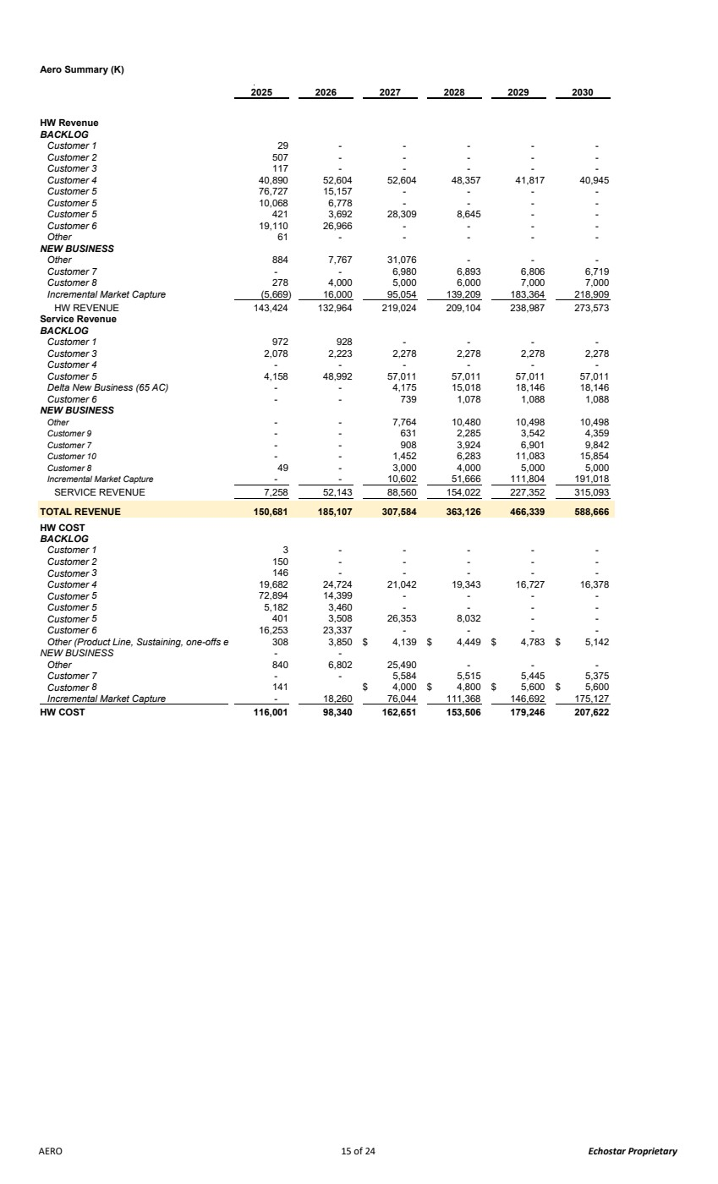 | Aero Summary (K) 2025 2026 2027 2028 2029 2030 HW Revenue BACKLOG Customer 1 - 29 - - - - Customer 2 - 507 - - - - Customer 3 - 117 - - - - Customer 4 52,604 40,890 52,604 48,357 41,817 40,945 Customer 5 15,157 76,727 - - - - Customer 5 6,778 10,068 - - - - Customer 5 3,692 421 28,309 8,645 - - Customer 6 26,966 19,110 - - - - Other - 61 - - - - NEW BUSINESS Other 7,767 884 31,076 - - - Customer 7 - - 6,980 6,893 6,806 6,719 Customer 8 4,000 278 5,000 6,000 7,000 7,000 Incremental Market Capture 16,000 (5,669) 95,054 139,209 183,364 218,909 HW REVENUE 143,424 132,964 219,024 209,104 238,987 273,573 Service Revenue BACKLOG Customer 1 928 972 - - - - Customer 3 2,223 2,078 2,278 2,278 2,278 2,278 Customer 4 - - - - - - Customer 5 48,992 4,158 57,011 57,011 57,011 57,011 Delta New Business (65 AC) - - 4,175 15,018 18,146 18,146 Customer 6 - - 739 1,078 1,088 1,088 NEW BUSINESS Other - - 7,764 10,480 10,498 10,498 Customer 9 - - 631 2,285 3,542 4,359 Customer 7 - - 908 3,924 6,901 9,842 Customer 10 - - 1,452 6,283 11,083 15,854 Customer 8 - 49 3,000 4,000 5,000 5,000 Incremental Market Capture - - 10,602 51,666 111,804 191,018 SERVICE REVENUE 7,258 52,143 88,560 154,022 227,352 315,093 TOTAL REVENUE 150,681 185,107 307,584 363,126 466,339 588,666 HW COST BACKLOG Customer 1 - 3 - - - - Customer 2 - 150 - - - - Customer 3 - 146 - - - - Customer 4 24,724 19,682 21,042 19,343 16,727 16,378 Customer 5 14,399 72,894 - - - - Customer 5 3,460 5,182 - - - - Customer 5 3,508 401 26,353 8,032 - - Customer 6 23,337 16,253 - - - - Other (Product Line, Sustaining, one-offs e 3,850 308 4,139 $ 4,449 $ 4,783 $ 5,142 $ NEW BUSINESS - - Other 6,802 840 25,490 - - - Customer 7 - - 5,584 5,515 5,445 5,375 Customer 8 4,000 141 $ 4,800 $ 5,600 $ 5,600 $ Incremental Market Capture - 18,260 76,044 111,368 146,692 175,127 HW COST 116,001 98,340 162,651 153,506 179,246 207,622 AERO 15 of 24 Echostar Proprietary
 | 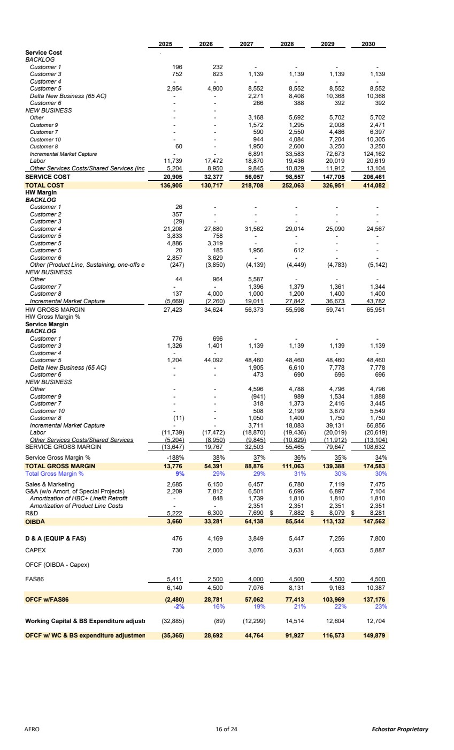 | 2025 2026 2027 2028 2029 2030 Service Cost BACKLOG Customer 1 232 196 - - - - Customer 3 823 752 1,139 1,139 1,139 1,139 Customer 4 - - - - - - Customer 5 4,900 2,954 8,552 8,552 8,552 8,552 Delta New Business (65 AC) - - 2,271 8,408 10,368 10,368 Customer 6 - - 266 388 392 392 NEW BUSINESS - - Other - - 3,168 5,692 5,702 5,702 Customer 9 - - 1,572 1,295 2,008 2,471 Customer 7 - - 590 2,550 4,486 6,397 Customer 10 - - 944 4,084 7,204 10,305 Customer 8 - 60 1,950 2,600 3,250 3,250 Incremental Market Capture - - 6,891 33,583 72,673 124,162 Labor 17,472 11,739 18,870 19,436 20,019 20,619 Other Services Costs/Shared Services (inc 8,950 5,204 9,845 10,829 11,912 13,104 SERVICE COST 32,377 20,905 56,057 98,557 147,705 206,461 TOTAL COST 130,717 136,905 218,708 252,063 326,951 414,082 HW Margin BACKLOG Customer 1 - 26 - - - - Customer 2 - 357 - - - - Customer 3 - (29) - - - - Customer 4 27,880 21,208 31,562 29,014 25,090 24,567 Customer 5 758 3,833 - - - - Customer 5 3,319 4,886 - - - - Customer 5 185 20 1,956 612 - - Customer 6 3,629 2,857 - - - - Other (Product Line, Sustaining, one-offs e (3,850) (247) (4,139) (4,449) (4,783) (5,142) NEW BUSINESS Other 964 44 5,587 - - - Customer 7 - - 1,396 1,379 1,361 1,344 Customer 8 4,000 137 1,000 1,200 1,400 1,400 Incremental Market Capture (5,669) (2,260) 19,011 27,842 36,673 43,782 HW GROSS MARGIN 27,423 34,624 56,373 55,598 59,741 65,951 HW Gross Margin % Service Margin BACKLOG Customer 1 696 776 - - - - Customer 3 1,401 1,326 1,139 1,139 1,139 1,139 Customer 4 - - - - - - Customer 5 44,092 1,204 48,460 48,460 48,460 48,460 Delta New Business (65 AC) - - 1,905 6,610 7,778 7,778 Customer 6 - - 473 690 696 696 NEW BUSINESS Other - - 4,596 4,788 4,796 4,796 Customer 9 - - (941) 989 1,534 1,888 Customer 7 - - 318 1,373 2,416 3,445 Customer 10 - - 508 2,199 3,879 5,549 Customer 8 - (11) 1,050 1,400 1,750 1,750 Incremental Market Capture - - 3,711 18,083 39,131 66,856 Labor (17,472) (11,739) (18,870) (19,436) (20,019) (20,619) Other Services Costs/Shared Services (5,204) (8,950) (9,845) (10,829) (11,912) (13,104) SERVICE GROSS MARGIN (13,647) 19,767 32,503 55,465 79,647 108,632 Service Gross Margin % -188% 38% 37% 36% 35% 34% TOTAL GROSS MARGIN 54,391 13,776 88,876 111,063 139,388 174,583 Total Gross Margin % 9% 29% 29% 31% 30% 30% Sales & Marketing 2,685 6,150 6,457 6,780 7,119 7,475 G&A (w/o Amort. of Special Projects) 2,209 7,812 6,501 6,696 6,897 7,104 Amortization of HBC+ Linefit Retrofit 848 - 1,739 1,810 1,810 1,810 Amortization of Product Line Costs - - 2,351 2,351 2,351 2,351 R&D 5,222 6,300 7,690 7,882 $ 8,079 $ 8,281 $ OIBDA 33,281 3,660 64,138 85,544 113,132 147,562 D & A (EQUIP & FAS) 4,169 476 3,849 5,447 7,256 7,800 CAPEX 2,000 730 3,076 3,631 4,663 5,887 OFCF (OIBDA - Capex) FAS86 5,411 2,500 4,000 4,500 4,500 4,500 4,500 6,140 7,076 8,131 9,163 10,387 OFCF w/FAS86 (2,480) 28,781 57,062 77,413 103,969 137,176 -2% 16% 19% 21% 22% 23% Working Capital & BS Expenditure adjustm (89) (32,885) (12,299) 14,514 12,604 12,704 OFCF w/ WC & BS expenditure adjustmen 28,692 (35,365) 44,764 91,927 116,573 149,879 AERO 16 of 24 Echostar Proprietary
 | 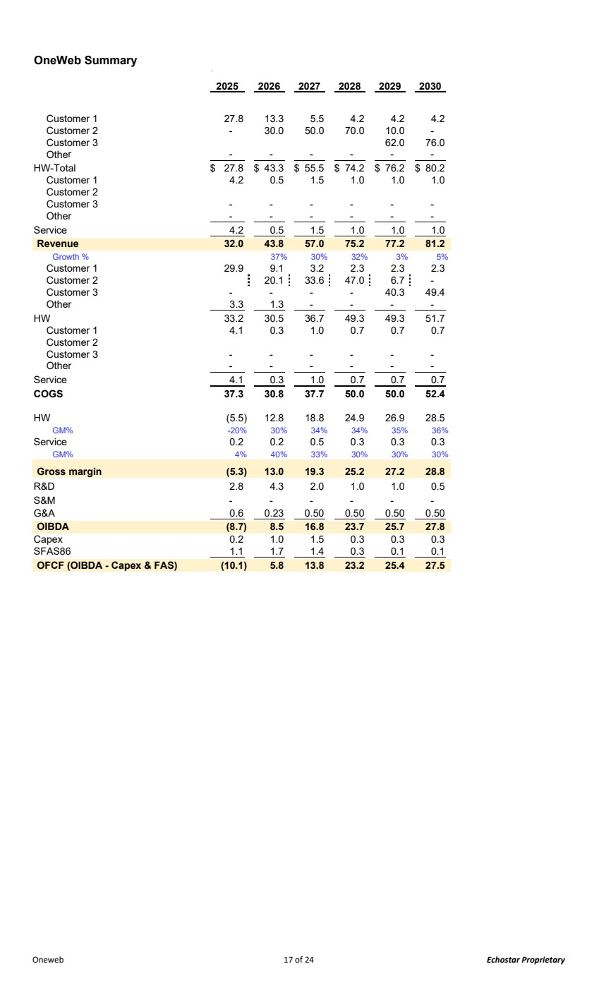 | OneWeb Summary 2025 2026 2027 2028 2029 2030 Customer 1 27.8 13.3 5.5 4.2 4.2 4.2 Customer 2 - 30.0 50.0 70.0 10.0 - Customer 3 62.0 76.0 Other - - - - - - HW-Total 27.8 $ 43.3 $ 55.5 $ 74.2 $ 76.2 $ 80.2 $ Customer 1 4.2 0.5 1.5 1.0 1.0 1.0 Customer 2 Customer 3 - - - - - - Other - - - - - - Service 4.2 0.5 1.5 1.0 1.0 1.0 Revenue 32.0 43.8 57.0 75.2 77.2 81.2 Growth % 37% 30% 32% 3% 5% Customer 1 29.9 9.1 3.2 2.3 2.3 2.3 Customer 2 20.1 33.6 47.0 6.7 - Customer 3 - - - - 40.3 49.4 Other 3.3 1.3 - - - - HW 33.2 30.5 36.7 49.3 49.3 51.7 Customer 1 4.1 0.3 1.0 0.7 0.7 0.7 Customer 2 Customer 3 - - - - - - Other - - - - - - Service 4.1 0.3 1.0 0.7 0.7 0.7 COGS 37.3 30.8 37.7 50.0 50.0 52.4 HW (5.5) 12.8 18.8 24.9 26.9 28.5 GM% -20% 30% 34% 34% 35% 36% Service 0.2 0.2 0.5 0.3 0.3 0.3 GM% 4% 40% 33% 30% 30% 30% Gross margin (5.3) 13.0 19.3 25.2 27.2 28.8 R&D 2.8 4.3 2.0 1.0 1.0 0.5 S&M - - - - - - G&A 0.6 0.23 0.50 0.50 0.50 0.50 OIBDA (8.7) 8.5 16.8 23.7 25.7 27.8 Capex 0.2 1.0 1.5 0.3 0.3 0.3 SFAS86 1.1 1.7 1.4 0.3 0.1 0.1 OFCF (OIBDA - Capex & FAS) (10.1) 5.8 13.8 23.2 25.4 27.5 Oneweb 17 of 24 Echostar Proprietary
 | 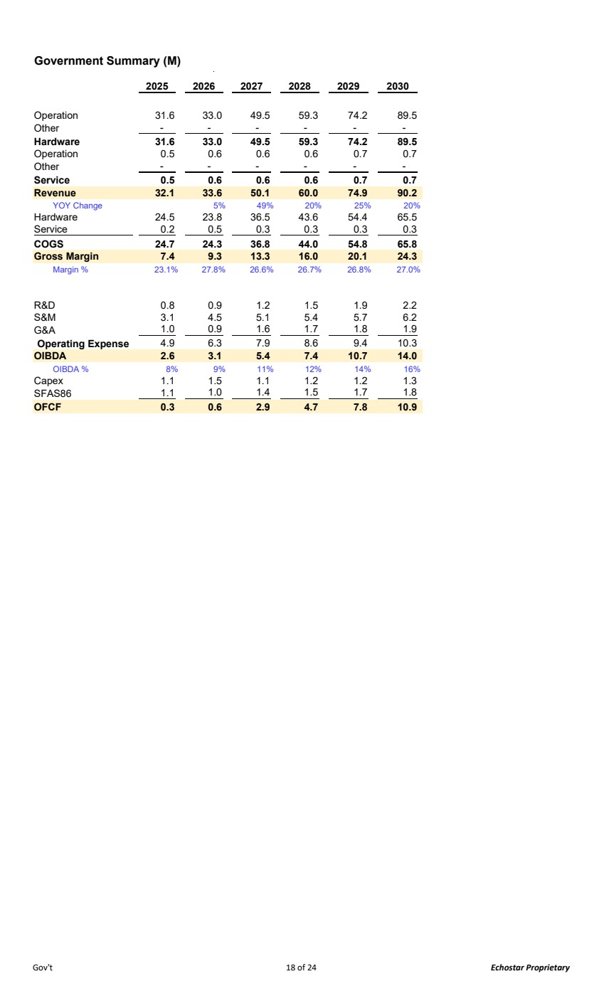 | Government Summary (M) 2025 2026 2027 2028 2029 2030 Operation 31.6 33.0 49.5 59.3 74.2 89.5 Other - - - - - - Hardware 31.6 33.0 49.5 59.3 74.2 89.5 Operation 0.5 0.6 0.6 0.6 0.7 0.7 Other - - - - - - Service 0.5 0.6 0.6 0.6 0.7 0.7 Revenue 32.1 33.6 50.1 60.0 74.9 90.2 YOY Change 5% 49% 20% 25% 20% Hardware 24.5 23.8 36.5 43.6 54.4 65.5 Service 0.5 0.2 0.3 0.3 0.3 0.3 COGS 24.7 24.3 36.8 44.0 54.8 65.8 Gross Margin 7.4 9.3 13.3 16.0 20.1 24.3 Margin % 23.1% 27.8% 26.6% 26.7% 26.8% 27.0% R&D 0.8 0.9 1.2 1.5 1.9 2.2 S&M 3.1 4.5 5.1 5.4 5.7 6.2 G&A 0.9 1.0 1.6 1.7 1.8 1.9 Operating Expense 6.3 4.9 7.9 8.6 9.4 10.3 OIBDA 2.6 3.1 5.4 7.4 10.7 14.0 OIBDA % 8% 9% 11% 12% 14% 16% Capex 1.1 1.5 1.1 1.2 1.2 1.3 SFAS86 1.0 1.1 1.4 1.5 1.7 1.8 OFCF 0.3 0.6 2.9 4.7 7.8 10.9 Gov't 18 of 24 Echostar Proprietary
 | 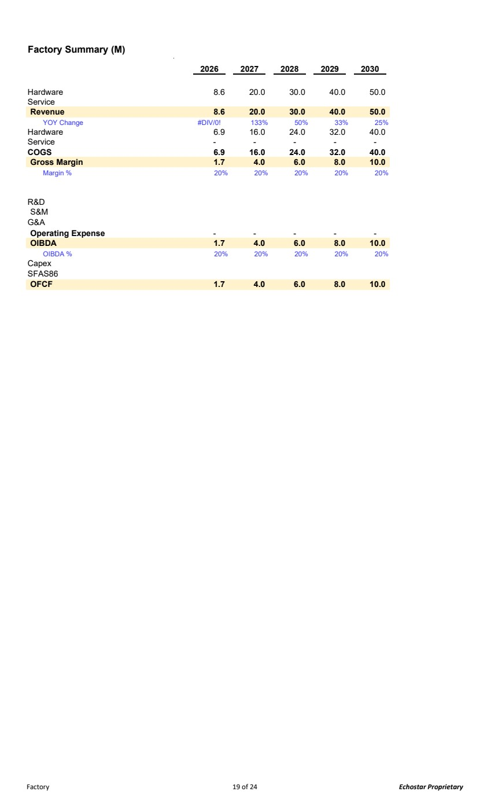 | Factory Summary (M) 2026 2027 2028 2029 2030 Hardware 8.6 20.0 30.0 40.0 50.0 Service Revenue 8.6 20.0 30.0 40.0 50.0 YOY Change #DIV/0! 133% 50% 33% 25% Hardware 6.9 16.0 24.0 32.0 40.0 Service - - - - - COGS 6.9 16.0 24.0 32.0 40.0 Gross Margin 1.7 4.0 6.0 8.0 10.0 Margin % 20% 20% 20% 20% 20% R&D S&M G&A Operating Expense - - - - - OIBDA 1.7 4.0 6.0 8.0 10.0 OIBDA % 20% 20% 20% 20% 20% Capex SFAS86 OFCF 1.7 4.0 6.0 8.0 10.0 Factory 19 of 24 Echostar Proprietary
 | 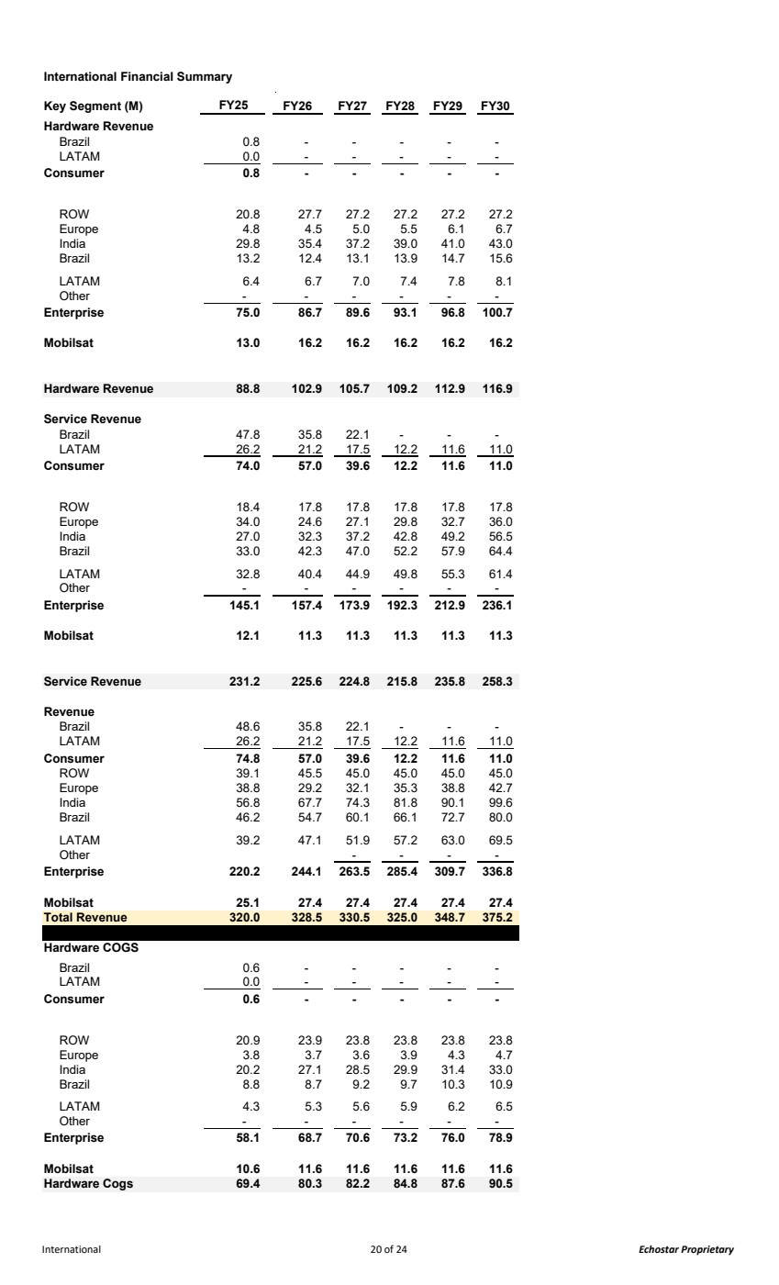 | International Financial Summary Key Segment (M) FY25 FY26 FY27 FY28 FY29 FY30 Hardware Revenue Brazil 0.8 - - - - - LATAM 0.0 - - - - - Consumer - 0.8 - - - - ROW 20.8 27.7 27.2 27.2 27.2 27.2 Europe 4.8 4.5 5.0 5.5 6.1 6.7 India 29.8 35.4 37.2 39.0 41.0 43.0 Brazil 13.2 12.4 13.1 13.9 14.7 15.6 LATAM 6.4 6.7 7.0 7.4 7.8 8.1 Other - - - - - - Enterprise 75.0 86.7 89.6 93.1 96.8 100.7 Mobilsat 13.0 16.2 16.2 16.2 16.2 16.2 Hardware Revenue 88.8 102.9 105.7 109.2 112.9 116.9 Service Revenue Brazil 47.8 35.8 22.1 - - - LATAM 26.2 21.2 17.5 12.2 11.6 11.0 Consumer 57.0 74.0 39.6 12.2 11.6 11.0 ROW 18.4 17.8 17.8 17.8 17.8 17.8 Europe 34.0 24.6 27.1 29.8 32.7 36.0 India 27.0 32.3 37.2 42.8 49.2 56.5 Brazil 33.0 42.3 47.0 52.2 57.9 64.4 LATAM 32.8 40.4 44.9 49.8 55.3 61.4 Other - - - - - - Enterprise 145.1 157. 173.9 4 192.3 212.9 236.1 Mobilsat 12.1 11.3 11.3 11.3 11.3 11.3 Service Revenue 225.6 231.2 224.8 215.8 235.8 258.3 Revenue Brazil 48.6 35.8 22.1 - - - LATAM 26.2 21.2 17.5 12.2 11.6 11.0 Consumer 57.0 74.8 39.6 12.2 11.6 11.0 ROW 39.1 45.5 45.0 45.0 45.0 45.0 Europe 38.8 29.2 32.1 35.3 38.8 42.7 India 56.8 67.7 74.3 81.8 90.1 99.6 Brazil 46.2 54.7 60.1 66.1 72.7 80.0 LATAM 39.2 47.1 51.9 57.2 63.0 69.5 Other - - - - Enterprise 220.2 244.1 263.5 285. 309.7 4 336.8 Mobilsat 25.1 27.4 27.4 27.4 27.4 27.4 Total Revenue 320.0 328.5 330.5 325.0 348.7 375.2 Hardware COGS Brazil 0.6 - - - - - LATAM 0.0 - - - - - Consumer - 0.6 - - - - ROW 20.9 23.9 23.8 23.8 23.8 23.8 Europe 3.8 3.7 3.6 3.9 4.3 4.7 India 20.2 27.1 28.5 29.9 31.4 33.0 Brazil 8.8 8.7 9.2 9.7 10.3 10.9 LATAM 4.3 5.3 5.6 5.9 6.2 6.5 Other - - - - - - Enterprise 58.1 68.7 70.6 73.2 76.0 78.9 Mobilsat 10.6 11.6 11.6 11.6 11.6 11.6 Hardware Cogs 69.4 80.3 82.2 84.8 87.6 90.5 International 20 of 24 Echostar Proprietary
 | 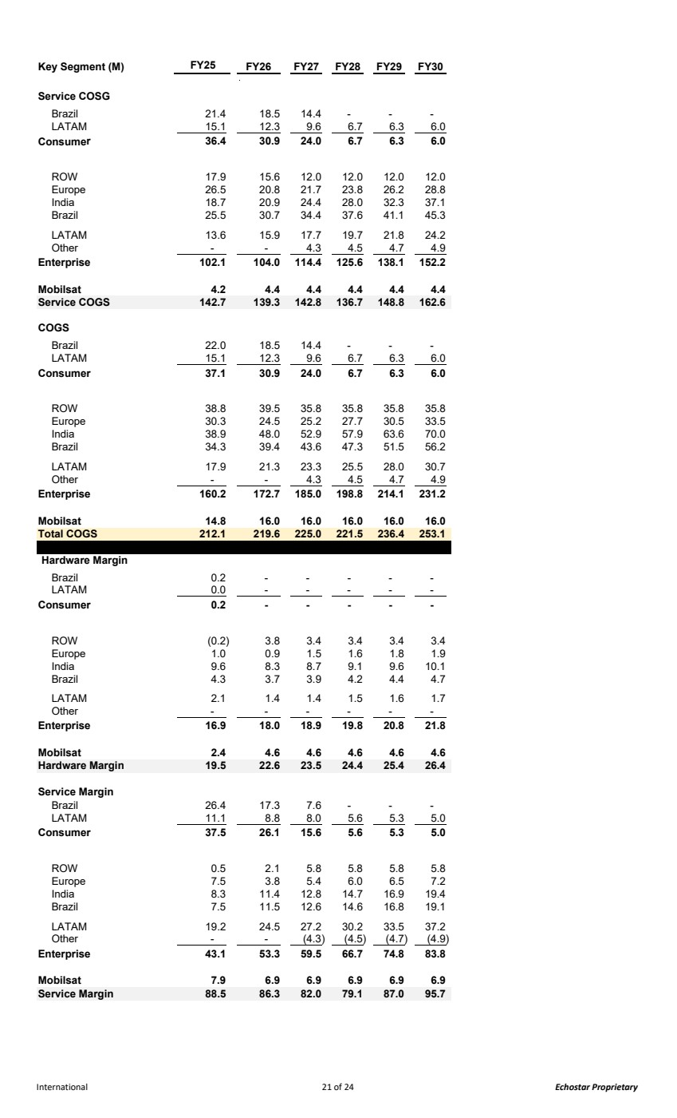 | Key Segment (M) FY25 FY26 FY27 FY28 FY29 FY30 Service COSG Brazil 21.4 18.5 14.4 - - - LATAM 15.1 12.3 9.6 6.7 6.3 6.0 Consumer 30.9 36.4 24.0 6.7 6.3 6.0 ROW 17.9 15.6 12.0 12.0 12.0 12.0 Europe 26.5 20.8 21.7 23.8 26.2 28.8 India 18.7 20.9 24.4 28.0 32.3 37.1 Brazil 25.5 30.7 34.4 37.6 41.1 45.3 LATAM 13.6 15.9 17.7 19.7 21.8 24.2 Other - - 4.3 4.5 4.7 4.9 Enterprise 102.1 104.0 114. 125.6 4 138.1 152.2 Mobilsat 4.2 4.4 4.4 4.4 4.4 4.4 Service COGS 139.3 142.7 142.8 136.7 148.8 162.6 COGS Brazil 22.0 18.5 14.4 - - - LATAM 15.1 12.3 9.6 6.7 6.3 6.0 Consumer 30.9 37.1 24.0 6.7 6.3 6.0 ROW 38.8 39.5 35.8 35.8 35.8 35.8 Europe 30.3 24.5 25.2 27.7 30.5 33.5 India 38.9 48.0 52.9 57.9 63.6 70.0 Brazil 34.3 39.4 43.6 47.3 51.5 56.2 LATAM 17.9 21.3 23.3 25.5 28.0 30.7 Other - - 4.3 4.5 4.7 4.9 Enterprise 160.2 172.7 185.0 198.8 214.1 231.2 Mobilsat 14.8 16.0 16.0 16.0 16.0 16.0 Total COGS 212.1 219.6 225.0 221.5 236. 253.1 4 Hardware Margin Brazil 0.2 - - - - - LATAM 0.0 - - - - - Consumer - 0.2 - - - - ROW (0.2) 3.8 3.4 3.4 3.4 3.4 Europe 1.0 0.9 1.5 1.6 1.8 1.9 India 9.6 8.3 8.7 9.1 9.6 10.1 Brazil 4.3 3.7 3.9 4.2 4.4 4.7 LATAM 2.1 1.4 1.4 1.5 1.6 1.7 Other - - - - - - Enterprise 16.9 18.0 18.9 19.8 20.8 21.8 Mobilsat 2.4 4.6 4.6 4.6 4.6 4.6 Hardware Margin 19.5 22.6 23.5 24.4 25.4 26.4 Service Margin Brazil 26.4 17.3 7.6 - - - LATAM 11.1 8.8 8.0 5.6 5.3 5.0 Consumer 26.1 37.5 15.6 5.6 5.3 5.0 ROW 0.5 2.1 5.8 5.8 5.8 5.8 Europe 7.5 3.8 5.4 6.0 6.5 7.2 India 8.3 11.4 12.8 14.7 16.9 19.4 Brazil 7.5 11.5 12.6 14.6 16.8 19.1 LATAM 19.2 24.5 27.2 30.2 33.5 37.2 Other - - (4.3) (4.5) (4.7) (4.9) Enterprise 43.1 53.3 59.5 66.7 74.8 83.8 Mobilsat 7.9 6.9 6.9 6.9 6.9 6.9 Service Margin 88.5 86.3 82.0 79.1 87.0 95.7 International 21 of 24 Echostar Proprietary
 | 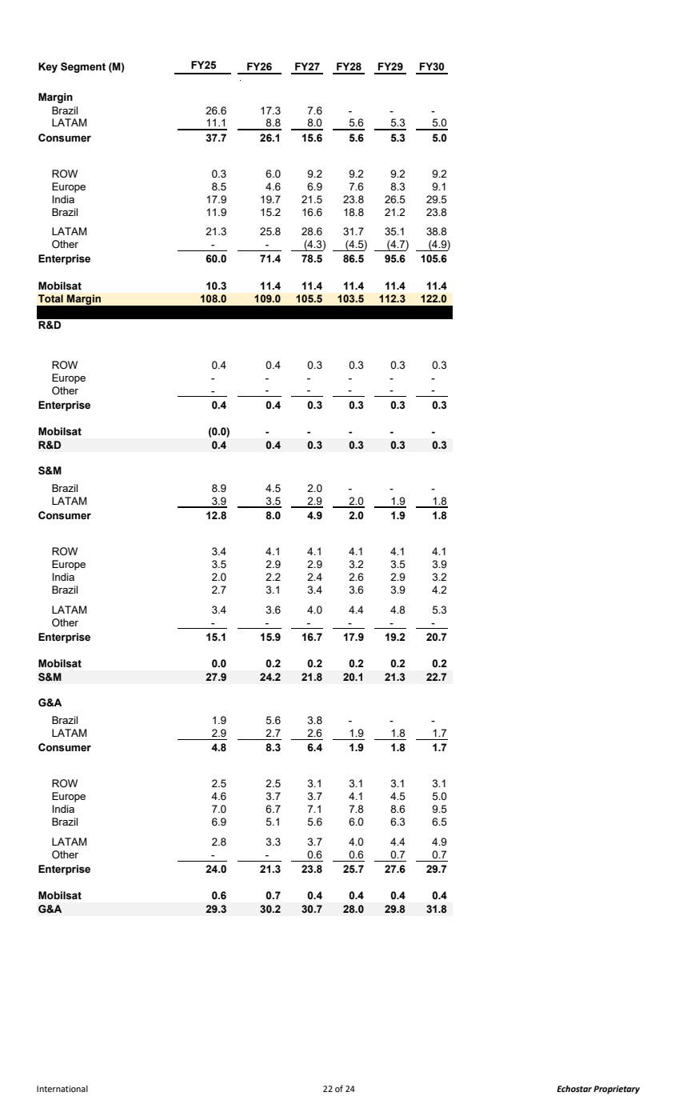 | Key Segment (M) FY25 FY26 FY27 FY28 FY29 FY30 Margin Brazil 26.6 17.3 7.6 - - - LATAM 11.1 8.8 8.0 5.6 5.3 5.0 Consumer 26.1 37.7 15.6 5.6 5.3 5.0 ROW 0.3 6.0 9.2 9.2 9.2 9.2 Europe 8.5 4.6 6.9 7.6 8.3 9.1 India 17.9 19.7 21.5 23.8 26.5 29.5 Brazil 11.9 15.2 16.6 18.8 21.2 23.8 LATAM 21.3 25.8 28.6 31.7 35.1 38.8 Other - - (4.3) (4.5) (4.7) (4.9) Enterprise 60.0 71.4 78.5 86.5 95.6 105.6 Mobilsat 10.3 11.4 11.4 11.4 11.4 11.4 Total Margin 108.0 109.0 105.5 103.5 112.3 122.0 R&D ROW 0.4 0.4 0.3 0.3 0.3 0.3 Europe - - - - - - Other - - - - - - Enterprise 0.4 0.4 0.3 0.3 0.3 0.3 Mobilsat (0.0) - - - - - R&D 0.4 0.4 0.3 0.3 0.3 0.3 S&M Brazil 8.9 4.5 2.0 - - - LATAM 3.9 3.5 2.9 2.0 1.9 1.8 Consumer 8.0 12.8 4.9 2.0 1.9 1.8 ROW 3.4 4.1 4.1 4.1 4.1 4.1 Europe 3.5 2.9 2.9 3.2 3.5 3.9 India 2.0 2.2 2.4 2.6 2.9 3.2 Brazil 2.7 3.1 3.4 3.6 3.9 4.2 LATAM 3.4 3.6 4.0 4.4 4.8 5.3 Other - - - - - - Enterprise 15.1 15.9 16.7 17.9 19.2 20.7 Mobilsat 0.0 0.2 0.2 0.2 0.2 0.2 S&M 27.9 24.2 21.8 20.1 21.3 22.7 G&A Brazil 1.9 5.6 3.8 - - - LATAM 2.9 2.7 2.6 1.9 1.8 1.7 Consumer 8.3 4.8 6.4 1.9 1.8 1.7 ROW 2.5 2.5 3.1 3.1 3.1 3.1 Europe 4.6 3.7 3.7 4.1 4.5 5.0 India 7.0 6.7 7.1 7.8 8.6 9.5 Brazil 6.9 5.1 5.6 6.0 6.3 6.5 LATAM 2.8 3.3 3.7 4.0 4.4 4.9 Other - - 0.6 0.6 0.7 0.7 Enterprise 24.0 21.3 23.8 25.7 27.6 29.7 Mobilsat 0.6 0.7 0.4 0.4 0.4 0.4 G&A 30.2 29.3 30.7 28.0 29.8 31.8 International 22 of 24 Echostar Proprietary
 | 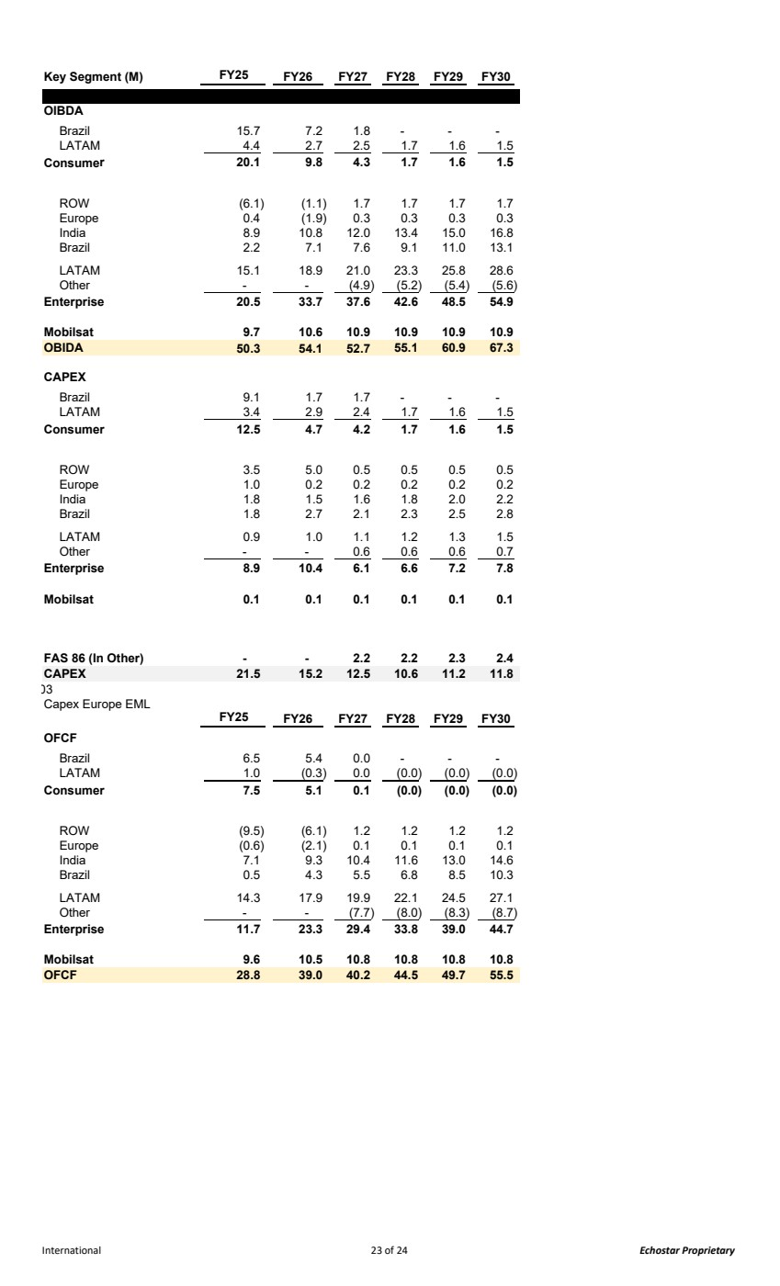 | Key Segment (M) FY25 FY26 FY27 FY28 FY29 FY30 OIBDA Brazil 15.7 7.2 1.8 - - - LATAM 4.4 2.7 2.5 1.7 1.6 1.5 Consumer 9.8 20.1 4.3 1.7 1.6 1.5 ROW (6.1) (1.1) 1.7 1.7 1.7 1.7 Europe 0.4 (1.9) 0.3 0.3 0.3 0.3 India 8.9 10.8 12.0 13.4 15.0 16.8 Brazil 2.2 7.1 7.6 9.1 11.0 13.1 LATAM 15.1 18.9 21.0 23.3 25.8 28.6 Other - - (4.9) (5.2) (5.4) (5.6) Enterprise 20.5 33.7 37.6 42.6 48.5 54.9 Mobilsat 9.7 10.6 10.9 10.9 10.9 10.9 OBIDA 54.1 50.3 52.7 60.9 55.1 67.3 CAPEX Brazil 9.1 1.7 1.7 - - - LATAM 3.4 2.9 2.4 1.7 1.6 1.5 Consumer 4.7 12.5 4.2 1.7 1.6 1.5 ROW 3.5 5.0 0.5 0.5 0.5 0.5 Europe 1.0 0.2 0.2 0.2 0.2 0.2 India 1.8 1.5 1.6 1.8 2.0 2.2 Brazil 1.8 2.7 2.1 2.3 2.5 2.8 LATAM 0.9 1.0 1.1 1.2 1.3 1.5 Other - - 0.6 0.6 0.6 0.7 Enterprise 8.9 10.4 6.1 6.6 7.2 7.8 Mobilsat 0.1 0.1 0.1 0.1 0.1 0.1 FAS 86 (In Other) - - 2.2 2.2 2.3 2.4 CAPEX 15.2 21.5 12.5 10.6 11.2 11.8 03 Capex Europe EML FY25 FY26 FY27 FY28 FY29 FY30 OFCF Brazil 6.5 5.4 0.0 - - - LATAM 1.0 (0.3) 0.0 (0.0) (0.0) (0.0) Consumer 5.1 7.5 0.1 (0.0) (0.0) (0.0) ROW (9.5) (6.1) 1.2 1.2 1.2 1.2 Europe (0.6) (2.1) 0.1 0.1 0.1 0.1 India 7.1 9.3 10.4 11.6 13.0 14.6 Brazil 0.5 4.3 5.5 6.8 8.5 10.3 LATAM 14.3 17.9 19.9 22.1 24.5 27.1 Other - - (7.7) (8.0) (8.3) (8.7) Enterprise 11.7 23.3 29.4 33.8 39.0 44.7 Mobilsat 9.6 10.5 10.8 10.8 10.8 10.8 OFCF 39.0 28.8 40.2 49.7 44.5 55.5 International 23 of 24 Echostar Proprietary
 | 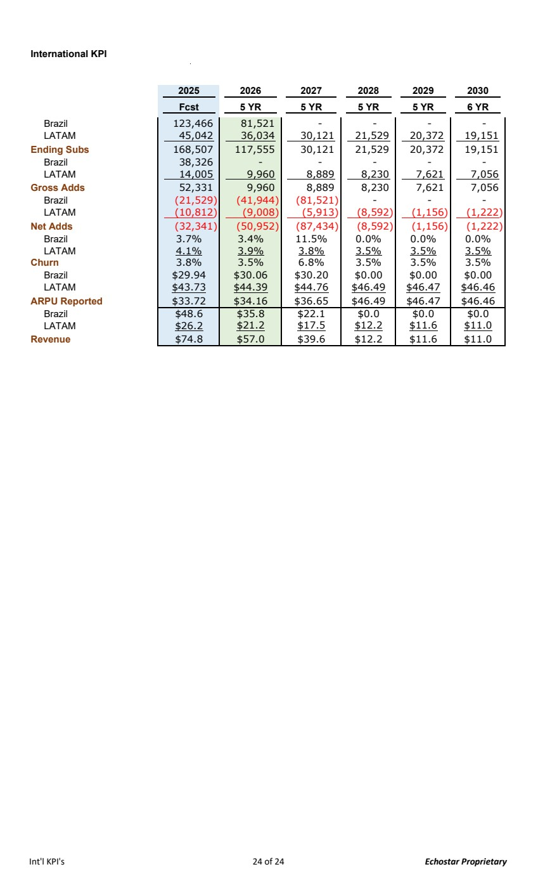 | International KPI 2025 2026 2027 2028 2029 2030 Fcst 5 YR 5 YR 5 YR 5 YR 6 YR Brazil 81,521 123,466 - - - - LATAM 36,034 45,042 30,121 21,529 20,372 19,151 Ending Subs 117,555 168,507 30,121 21,529 20,372 19,151 Brazil - 38,326 - - - - LATAM 9,960 14,005 8,889 8,230 7,621 7,056 Gross Adds 9,960 52,331 8,889 8,230 7,621 7,056 Brazil (21,529) (41,944) (81,521) - - - LATAM (10,812) (9,008) (5,913) (8,592) (1,156) (1,222) Net Adds (32,341) (50,952) (87,434) (8,592) (1,156) (1,222) Brazil 3.7% 3.4% 11.5% 0.0% 0.0% 0.0% LATAM 4.1% 3.9% 3.8% 3.5% 3.5% 3.5% Churn 3.8% 3.5% 6.8% 3.5% 3.5% 3.5% Brazil $29.94 $30.06 $30.20 $0.00 $0.00 $0.00 LATAM $43.73 $44.39 $44.76 $46.49 $46.47 $46.46 ARPU Reported $33.72 $34.16 $36.65 $46.49 $46.47 $46.46 Brazil $48.6 $35.8 $22.1 $0.0 $0.0 $0.0 LATAM $26.2 $21.2 $17.5 $12.2 $11.6 $11.0 Revenue $74.8 $57.0 $39.6 $12.2 $11.6 $11.0 Int'l KPI's 24 of 24 Echostar Proprietary
Exhibit 99.3
Proprietary and Confidential The financial model and forecast data (the “Forecast”) has been prepared by the company (the “Company”) solely for informational purposes in connection with potential market transactions and is furnished subject to the recipient’s confidentiality obligations with the Company. The Forecast contains forward-looking statements, opinions, and projections that are not guarantees of future performance; no representation or warranty is made as to its accuracy or completeness. The information in the Forecast is dated Q4 2025 and is subject to change; the Company assumes no obligation to update it. Recipients should conduct their own independent due diligence and seek advice from their own legal, tax, financial, and other advisors. As noted above, this Forecast represents management’s Allocated BSS view of estimated projections generated in Q4 2025. BSS is a reporting segment within EchoStar (SATS). The Allocated BSS view reflected in this Forecast represents HSSC plus the BSS Segment activity related to the J3 lease payment from HSSC for capacity usage on the J3 satellite asset, which is held outside of HSSC. The Forecast is currently set at the Allocated BSS level. It has a ‘toggle’ switch (see below) that allows a simple view change that shows: i) Allocated BSS view: Cell "Q1" must be "1"; or ii) HSSC view: Cell "Q1" must be "0"; - with J3 lease payments: cell "Q2" must be "1" - without J3 lease payments: cell "Q2" must be "0"
 | 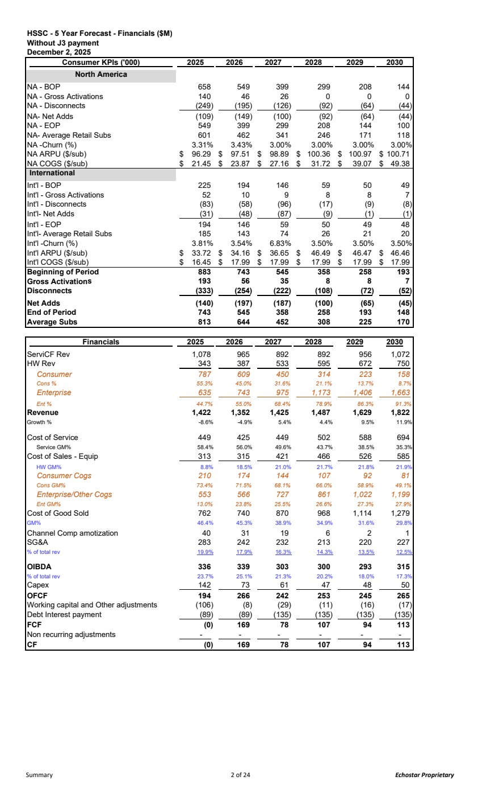 | HSSC - 5 Year Forecast - Financials ($M) Without J3 payment December 2, 2025 Consumer KPIs ('000) 2025 2026 2027 2028 2029 2030 North America NA - BOP 658 549 399 299 208 144 NA - Gross Activations 140 46 26 0 0 0 NA - Disconnects (249) (195) (126) (92) (64) (44) NA- Net Adds (109) (149) (100) (92) (64) (44) NA - EOP 549 399 299 208 144 100 NA- Average Retail Subs 601 462 341 246 171 118 NA -Churn (%) 3.31% 3.43% 3.00% 3.00% 3.00% 3.00% NA ARPU ($/sub) 96.29 $ 97.51 $ 98.89 $ 100.36 $ 100.97 $ 100.71 $ NA COGS ($/sub) 21.45 $ 23.87 $ 27.16 $ 31.72 $ 39.07 $ 49.38 $ International Int'l - BOP 225 194 146 59 50 49 Int'l - Gross Activations 52 10 9 8 8 7 Int'l - Disconnects (83) (58) (96) (17) (9) (8) Int'l- Net Adds (31) (48) (87) (9) (1) (1) Int'l - EOP 194 146 59 50 49 48 Int'l- Average Retail Subs 185 143 74 26 21 20 Int'l -Churn (%) 3.81% 3.54% 6.83% 3.50% 3.50% 3.50% Int'l ARPU ($/sub) 33.72 $ 34.16 $ 36.65 $ 46.49 $ 46.47 $ 46.46 $ Int'l COGS ($/sub) 16.45 $ 17.99 $ 17.99 $ 17.99 $ 17.99 $ 17.99 $ Beginning of Period 883 743 545 358 258 193 Gross Activations 56 193 35 8 8 7 Disconnects (333) (254) (222) (108) (72) (52) Net Adds (140) (197) (187) (100) (65) (45) End of Period 743 545 358 258 193 148 Average Subs 644 813 452 308 225 170 Financials 2025 2026 2027 2028 2029 2030 ServiCF Rev 1,078 965 892 892 956 1,072 HW Rev 343 387 533 595 672 750 Consumer 787 609 450 314 223 158 Cons % 55.3% 45.0% 31.6% 21.1% 13.7% 8.7% Enterprise 635 743 975 1,173 1,406 1,663 Ent % 44.7% 55.0% 68.4% 78.9% 86.3% 91.3% Revenue 1,422 1,352 1,425 1,487 1,629 1,822 Growth % -8.6% -4.9% 5.4% 4.4% 9.5% 11.9% Cost of Service 449 425 449 502 588 694 Service GM% 58.4% 56.0% 49.6% 43.7% 38.5% 35.3% Cost of Sales - Equip 313 315 421 466 526 585 HW GM% 8.8% 18.5% 21.0% 21.7% 21.8% 21.9% Consumer Cogs 210 174 144 107 92 81 Cons GM% 73.4% 71.5% 68.1% 66.0% 58.9% 49.1% Enterprise/Other Cogs 553 566 727 861 1,022 1,199 Ent GM% 13.0% 23.8% 25.5% 26.6% 27.3% 27.9% Cost of Good Sold 762 740 870 968 1,114 1,279 GM% 46.4% 45.3% 38.9% 34.9% 31.6% 29.8% Channel Comp amotization 40 31 19 6 2 1 SG&A 283 242 232 213 220 227 % of total rev 19.9% 17.9% 16.3% 14.3% 13.5% 12.5% OIBDA 336 339 303 300 293 315 % of total rev 23.7% 25.1% 21.3% 20.2% 18.0% 17.3% Capex 142 73 61 47 48 50 OFCF 194 266 242 253 245 265 Working capital and Other adjustments (106) (8) (29) (11) (16) (17) Debt Interest payment (89) (89) (135) (135) (135) (135) FCF (0) 169 78 107 94 113 Non recurring adjustments - - - - - - CF (0) 169 78 107 94 113 Summary 2 of 24 Echostar Proprietary
 | 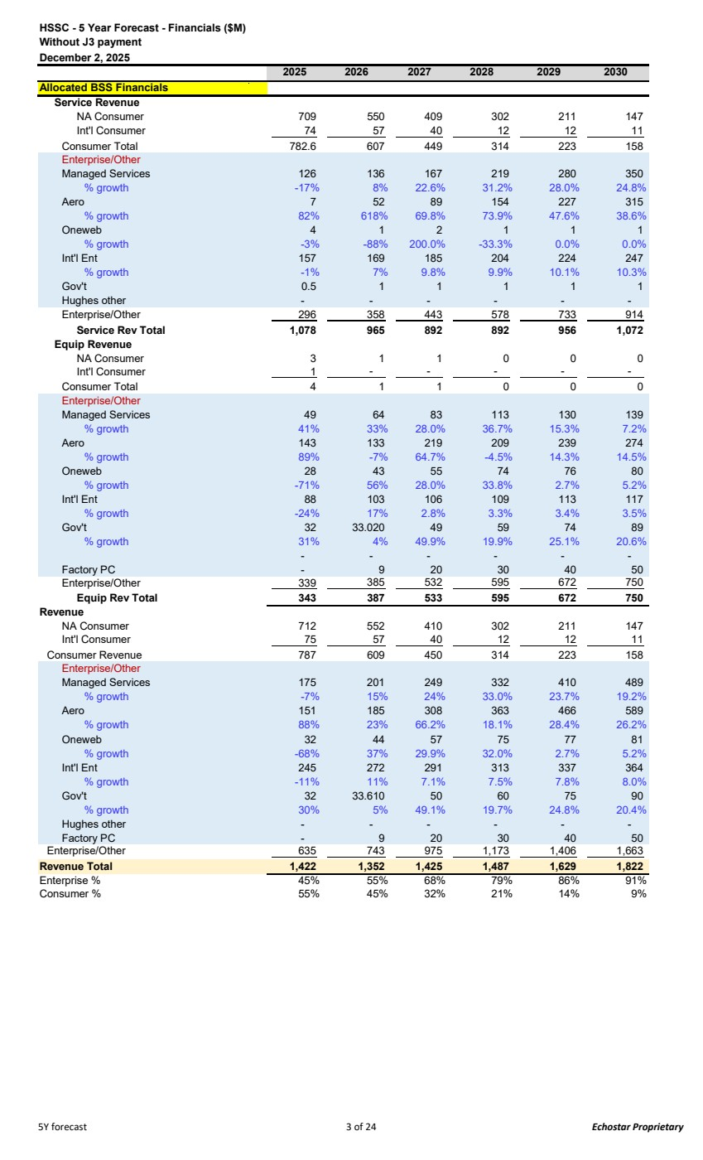 | HSSC - 5 Year Forecast - Financials ($M) Without J3 payment December 2, 2025 2025 2026 2027 2028 2029 2030 Allocated BSS Financials Service Revenue NA Consumer 709 550 409 302 211 147 Int'l Consumer 74 57 40 12 12 11 Consumer Total 782.6 607 449 314 223 158 Enterprise/Other Managed Services 126 136 167 219 280 350 % growth -17% 8% 22.6% 31.2% 28.0% 24.8% Aero 7 52 89 154 227 315 % growth 82% 618% 69.8% 73.9% 47.6% 38.6% Oneweb 4 1 2 1 1 1 % growth -3% -88% 200.0% -33.3% 0.0% 0.0% Int'l Ent 157 169 185 204 224 247 % growth -1% 7% 9.8% 9.9% 10.1% 10.3% Gov't 0.5 1 1 1 1 1 Hughes other - - - - - - Enterprise/Other 296 358 443 578 733 914 Service Rev Total 1,078 965 892 892 956 1,072 Equip Revenue NA Consumer 3 1 1 0 0 0 Int'l Consumer 1 - - - - - Consumer Total 4 1 1 0 0 0 Enterprise/Other Managed Services 49 64 83 113 130 139 % growth 41% 33% 28.0% 36.7% 15.3% 7.2% Aero 143 133 219 209 239 274 % growth 89% -7% 64.7% -4.5% 14.3% 14.5% Oneweb 28 43 55 74 76 80 % growth -71% 56% 28.0% 33.8% 2.7% 5.2% Int'l Ent 88 103 106 109 113 117 % growth -24% 17% 2.8% 3.3% 3.4% 3.5% Gov't 32 33.020 49 59 74 89 % growth 31% 4% 49.9% 19.9% 25.1% 20.6% - - - - - - Factory PC - 9 20 30 40 50 Enterprise/Other 339 385 532 595 672 750 Equip Rev Total 343 387 533 595 672 750 Revenue NA Consumer 712 552 410 302 211 147 Int'l Consumer 75 57 40 12 12 11 Consumer Revenue 787 609 450 314 223 158 Enterprise/Other Managed Services 175 201 249 332 410 489 % growth -7% 15% 24% 33.0% 23.7% 19.2% Aero 151 185 308 363 466 589 % growth 88% 23% 66.2% 18.1% 28.4% 26.2% Oneweb 32 44 57 75 77 81 % growth -68% 37% 29.9% 32.0% 2.7% 5.2% Int'l Ent 245 272 291 313 337 364 % growth -11% 11% 7.1% 7.5% 7.8% 8.0% Gov't 32 33.610 50 60 75 90 % growth 30% 5% 49.1% 19.7% 24.8% 20.4% Hughes other - - - - - - Factory PC - 9 20 30 40 50 Enterprise/Other 635 743 975 1,173 1,406 1,663 Revenue Total 1,422 1,352 1,425 1,487 1,629 1,822 Enterprise % 45% 55% 68% 79% 86% 91% Consumer % 55% 45% 32% 21% 14% 9% 5Y forecast 3 of 24 Echostar Proprietary
 | 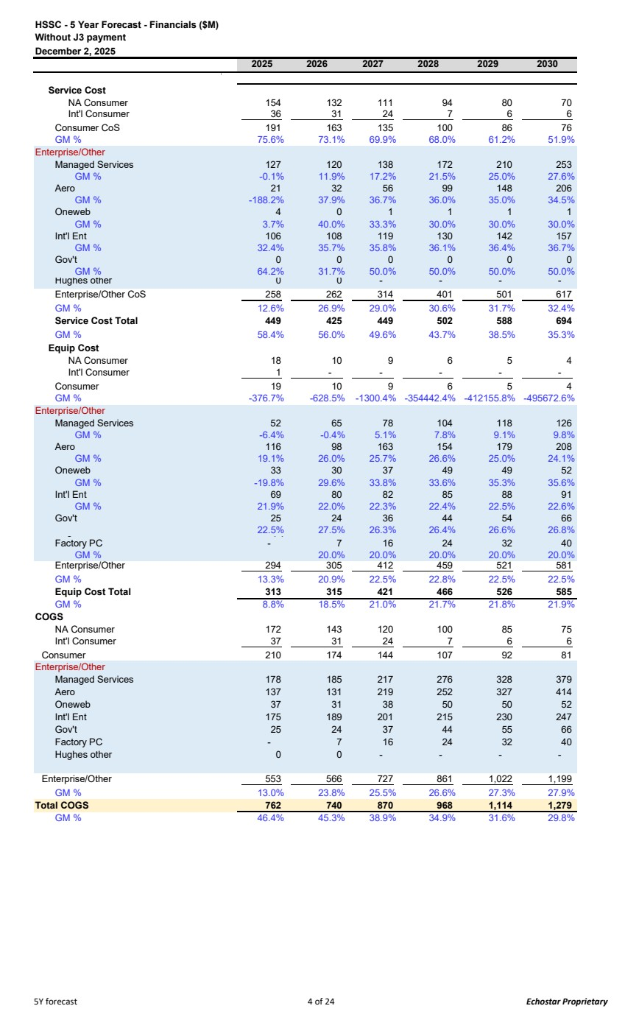 | HSSC - 5 Year Forecast - Financials ($M) Without J3 payment December 2, 2025 2025 2026 2027 2028 2029 2030 Service Cost NA Consumer 154 132 111 94 80 70 Int'l Consumer 36 31 24 7 6 6 Consumer CoS 191 163 135 100 86 76 GM % 75.6% 73.1% 69.9% 68.0% 61.2% 51.9% Enterprise/Other Managed Services 127 120 138 172 210 253 GM % -0.1% 11.9% 17.2% 21.5% 25.0% 27.6% Aero 21 32 56 99 148 206 GM % -188.2% 37.9% 36.7% 36.0% 35.0% 34.5% Oneweb 4 0 1 1 1 1 GM % 3.7% 40.0% 33.3% 30.0% 30.0% 30.0% Int'l Ent 106 108 119 130 142 157 GM % 32.4% 35.7% 35.8% 36.1% 36.4% 36.7% Gov't 0 0 0 0 0 0 GM % 64.2% 31.7% 50.0% 50.0% 50.0% 50.0% Hughes other 0 - 0 - - - Enterprise/Other CoS 258 262 314 401 501 617 GM % 12.6% 26.9% 29.0% 30.6% 31.7% 32.4% Service Cost Total 449 425 449 502 588 694 GM % 58.4% 56.0% 49.6% 43.7% 38.5% 35.3% Equip Cost NA Consumer 18 10 9 6 5 4 Int'l Consumer 1 - - - - - Consumer 19 10 9 6 5 4 GM % -376.7% -628.5% -1300.4% -354442.4% -412155.8% -495672.6% Enterprise/Other Managed Services 52 65 78 104 118 126 GM % -6.4% -0.4% 5.1% 7.8% 9.1% 9.8% Aero 116 98 163 154 179 208 GM % 19.1% 26.0% 25.7% 26.6% 25.0% 24.1% Oneweb 33 30 37 49 49 52 GM % -19.8% 29.6% 33.8% 33.6% 35.3% 35.6% Int'l Ent 69 80 82 85 88 91 GM % 21.9% 22.0% 22.3% 22.4% 22.5% 22.6% Gov't 25 24 36 44 54 66 g 22.5% 27.5% 26.3% 26.4% 26.6% 26.8% ( ) Factory PC - 7 16 24 32 40 GM % 20.0% 20.0% 20.0% 20.0% 20.0% Enterprise/Other 305 294 412 459 521 581 GM % 13.3% 20.9% 22.5% 22.8% 22.5% 22.5% Equip Cost Total 313 315 421 466 526 585 GM % 8.8% 18.5% 21.0% 21.7% 21.8% 21.9% COGS NA Consumer 172 143 120 100 85 75 Int'l Consumer 37 31 24 7 6 6 Consumer 210 174 144 107 92 81 Enterprise/Other Managed Services 178 185 217 276 328 379 Aero 137 131 219 252 327 414 Oneweb 37 31 38 50 50 52 Int'l Ent 175 189 201 215 230 247 Gov't 25 24 37 44 55 66 Factory PC - 7 16 24 32 40 Hughes other 0 0 - - - - Enterprise/Other 553 566 727 861 1,022 1,199 GM % 13.0% 23.8% 25.5% 26.6% 27.3% 27.9% Total COGS 762 740 870 968 1,114 1,279 GM % 46.4% 45.3% 38.9% 34.9% 31.6% 29.8% 5Y forecast 4 of 24 Echostar Proprietary
 | 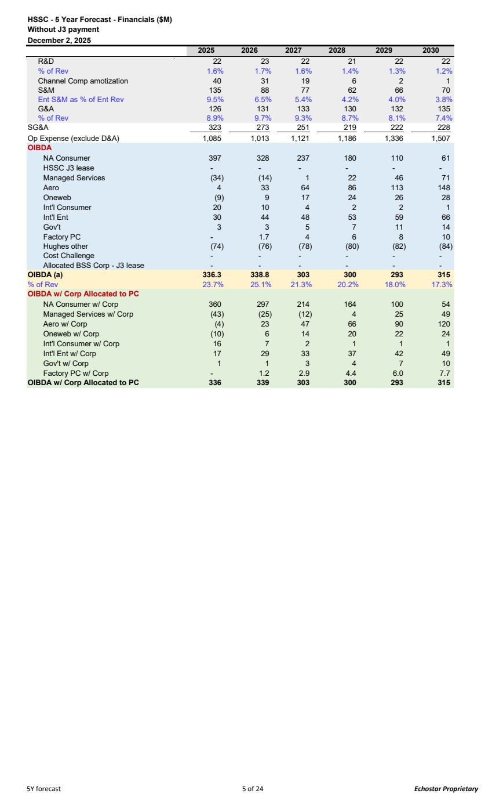 | HSSC - 5 Year Forecast - Financials ($M) Without J3 payment December 2, 2025 2025 2026 2027 2028 2029 2030 R&D 22 23 22 21 22 22 % of Rev 1.6% 1.7% 1.6% 1.4% 1.3% 1.2% Channel Comp amotization 40 31 19 6 2 1 S&M 135 88 77 62 66 70 Ent S&M as % of Ent Rev 9.5% 6.5% 5.4% 4.2% 4.0% 3.8% G&A 126 131 133 130 132 135 % of Rev 8.9% 9.7% 9.3% 8.7% 8.1% 7.4% SG&A 323 273 251 219 222 228 Op Expense (exclude D&A) 1,085 1,013 1,121 1,186 1,336 1,507 OIBDA NA Consumer 397 328 237 180 110 61 HSSC J3 lease - - - - - - Managed Services (34) (14) 1 22 46 71 Aero 4 33 64 86 113 148 Oneweb (9) 9 17 24 26 28 Int'l Consumer 20 10 4 2 2 1 Int'l Ent 30 44 48 53 59 66 Gov't 3 3 5 7 11 14 Factory PC - 1.7 4 6 8 10 Hughes other (74) (76) (78) (80) (82) (84) Cost Challenge - - - - - - Allocated BSS Corp - J3 lease - - - - - - OIBDA (a) 336.3 338.8 303 300 293 315 % of Rev 23.7% 25.1% 21.3% 20.2% 18.0% 17.3% OIBDA w/ Corp Allocated to PC NA Consumer w/ Corp 360 297 214 164 100 54 Managed Services w/ Corp (43) (25) (12) 4 25 49 Aero w/ Corp (4) 23 47 66 90 120 Oneweb w/ Corp (10) 6 14 20 22 24 Int'l Consumer w/ Corp 16 7 2 1 1 1 Int'l Ent w/ Corp 17 29 33 37 42 49 Gov't w/ Corp 1 1 3 4 7 10 Factory PC w/ Corp - 1.2 2.9 4.4 6.0 7.7 OIBDA w/ Corp Allocated to PC 336 339 303 300 293 315 5Y forecast 5 of 24 Echostar Proprietary
 | 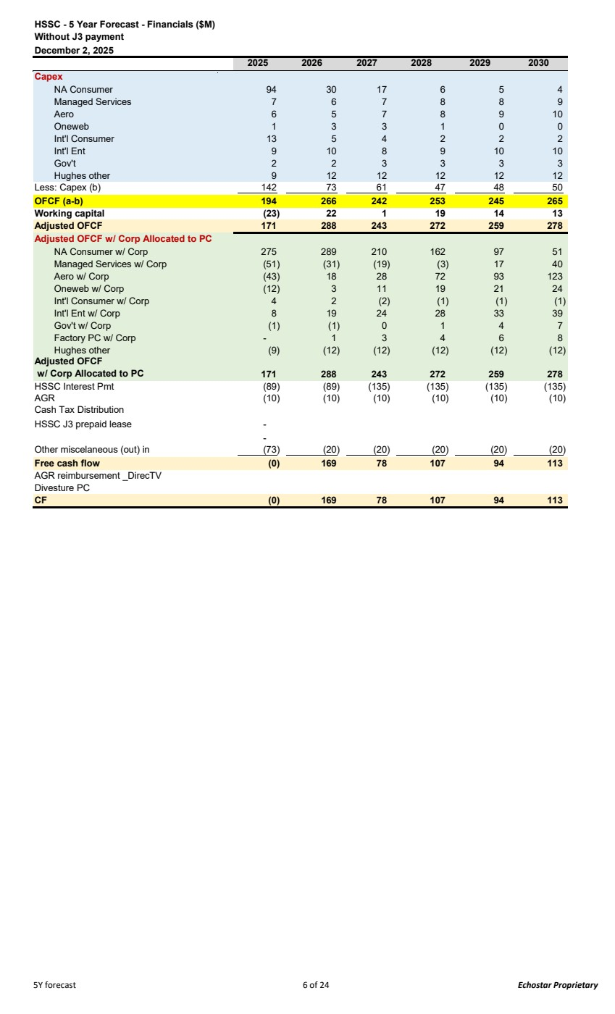 | HSSC - 5 Year Forecast - Financials ($M) Without J3 payment December 2, 2025 2025 2026 2027 2028 2029 2030 Capex NA Consumer 94 30 17 6 5 4 Managed Services 7 6 7 8 8 9 Aero 6 5 7 8 9 10 Oneweb 1 3 3 1 0 0 Int'l Consumer 13 5 4 2 2 2 Int'l Ent 9 10 8 9 10 10 Gov't 2 2 3 3 3 3 Hughes other 9 12 12 12 12 12 Less: Capex (b) 73 142 61 47 48 50 OFCF (a-b) 194 266 242 253 245 265 Working capital (23) 22 1 19 14 13 Adjusted OFCF 171 288 243 272 259 278 Adjusted OFCF w/ Corp Allocated to PC NA Consumer w/ Corp 275 289 210 162 97 51 Managed Services w/ Corp (51) (31) (19) (3) 17 40 Aero w/ Corp (43) 18 28 72 93 123 Oneweb w/ Corp (12) 3 11 19 21 24 Int'l Consumer w/ Corp 4 2 (2) (1) (1) (1) Int'l Ent w/ Corp 8 19 24 28 33 39 Gov't w/ Corp (1) (1) 0 1 4 7 Factory PC w/ Corp - 1 3 4 6 8 Hughes other (9) (12) (12) (12) (12) (12) Adjusted OFCF w/ Corp Allocated to PC 171 288 243 272 259 278 HSSC Interest Pmt (89) (89) (135) (135) (135) (135) AGR (10) (10) (10) (10) (10) (10) Cash Tax Distribution HSSC J3 prepaid lease - - Other miscelaneous (out) in (73) (20) (20) (20) (20) (20) Free cash flow (0) 169 78 107 94 113 AGR reimbursement _DirecTV Divesture PC CF (0) 169 78 107 94 113 5Y forecast 6 of 24 Echostar Proprietary
NA Consumer Summary 2025 2026 2027 2028 2029 2030 Gross Adds 140 46 26 0 0 0 Net Adds (108) (149) (100) (91) (63) (44) EOP - Retail 547 398 298 207 144 100 Average subs - Retail 601 462 341 246 171 118 Churn (%) 3.31% 3.43% 3.00% 3.00% 3.00% 3.00% NA ARPU ($/sub) 96.29 $ 97.51 $ 98.89 $ 100.36 $ 100.97 $ 100.71 $ NA SAC ($/add) $1,135 $973 $988 $0 $0 $0 NA COGS ($/sub) $21.45 $23.87 $27.16 $31.72 $39.07 $49.38 Service Revenue NA ARPU Revenue 694 541 404 296 207 143 XCI 15 10 5 5 4 4 Equip Revenue NA Consumer 2 1 1 0 0 0 Service COGS 132 155 111 94 80 70 Equipment COGS 11 18 9 6 5 4 R&D NA Consumer 2 1 1 1 0 0 Channel Comp amotization NA Consumer 40 31 19 6 2 1 S&M NA Consumer 73 28 17 0 0 0 G&A NA Consumer 27 23 17 15 12 10 Capex NA Consumer 94 30 17 6 5 4 Working Capital NA Consumer 9 22 13 4 1 0 8 of 24
cost per sub in $M 2025 2026 2027 2028 2029 2030 Adjusted Service Plan Revenue 525.4 409 309 228 160 111 Extra ARPU Impact - - - - - Rental Plan Revenue 101.3 78 58 42 28 19 NYB 0.7 1 1 - - - Optional Service Revenue 44.3 34 25 18 13 9 Truckroll, Invoice Fee, and others 6.5 5 4 3 2 1 UEF & ETF Collection 16.2 13 8 6 4 3 XCI 14.7 10 5 5 4 4 Total Service Revenue 709.0 551 409 302 211 147 ARPU 96.29 97.51 98.89 100.3 100.9 6 100.71 7 Total HW Revenue 2 1 1 0 0 0 Total Revenue ($M) 712 552 410 302 211 147 -10% -22% -26% -26% -30% -30% Space Segment - Consumer - - - - - - XCI 1 1 0 0 0 0 Customer Services 27 21 15 11 8 5 Installer Field Maintenance 14 10 7 5 4 2 Network Services 14 12 10 9 8 7 Satellite Ops 3 2 2 2 2 2 Gateways 25 24 24 24 24 24 RMA Return Credits 2 (1) 0 - - - Repair Center Cost- Consumer 10 11 7 5 4 3 Operations Engineering 12 12 10 9 8 7 Operations Mgmt / Optional Services 10 9 7 5 3 2 Quality Assurance 2 2 2 2 2 1 Fusion Services 7 4 3 2 1 1 Voip Program 3 3 2 1 1 1 Move Program 4 3 2 2 1 1 Other / Property Tax / Excise Tax 2 2 2 2 2 2 SDG 7 8 7 6 6 5 Cloud 4 5 4 4 3 3 Sustaining 6 5 5 4 4 3 Extra Cost Adj - - - - - - Total Services Costs 132.32 155 111.05 94 80 70 Consumer HW Cost 3 1 1 0 0 0 Install support 8 7 5 4 3 2 Business Operations 2 1 1 1 1 1 Operations support 0 0 0 0 0 0 Manufacturing Variances 1 2 1 1 1 1 Inventory / Warranty Reserve 0 0 0 0 0 0 Corp Assessment 3 - - - - - Sustaining R&D 0 0 0 0 0 0 Total Other HW Costs 10 15 8 6 5 4 Total HW Cost 11 18 9 6 5 4 Total Cost 172 144 120 100 85 75 Gross Margin 539 408 290 201 126 72.80 GM% 75.8% 74.0% 70.8% 66.8% 59.6% 49.4% PL 9 of 24 Echostar Proprietary
$M 2025 2026 2027 2028 2029 2030 - S&M Expenses - Variable 66 25 13 - - - S&M Expenses - Fixed 6 3 3 - - - S&M Expenses 72.4 27.5 16.2 - - - Marcomm & Corp Alloc 0 0 0 0 0 0 Channel Comp P/L SAC 40 31 18.8 6 2 1 S&M 112 59 35.4 6 3 1 G&A 8 8 7 7 7 7 Bad Debt - NAD 10 8 6 4 3 2 Bank Charges 9 7 5 4 3 2 G&A Expenses 27 23 17 15 12 10 Total Operating Expenses 139 82 53 21 15 12 Total Operating Income 400 327 238 181 111 61 OI% 56% 59% 58% 60% 53% 42% R&D 2 1 1 1 0 0 OIBDA 325 397 237 180 110 60.9 -18% -27% -24% -39% (0.4) Rental Capital 75 17 10 0 0 0 Svc Del Capex ($M) 3 32222 J3 Post Launch ($M) 0 00000 SDG Capex ($M) 8 32211 Eng Capex ($M) 0 00000 Non-Cash Capex Adj. 0 Capex ($M) 86 23 14 4 3 2 FAS86 8 73221 OFCF 303 295 219 174 106 57 Adj OFCF 313 318 232 179 107 57 Cash SAC HW/Install Cost 464 320 332 315 315 315 Upfront Rev 14 6 (4) 19 19 19 HW/Install SAC 478 326 311 - - - Channel Comp SAC 165 115 118 - - - S&M SAC 491 532 558 - - - Total Cash SAC $ 1,135 973 988 - - - -14% 1% -100% #DIV/0! #DIV/0! PL 10 of 24 Echostar Proprietary
$M 2025 2026 2027 2028 2029 2030 Cost excl SAC & all Depreciation ($M) 200 167 138 116 98 86 Cost per sub per month $27.70 $30.09 $33.68 $39.16 $47.91 $60.24 1 - 2 3 4 5 Cost of Capital (yearly) 10.0% Cost of Capital (monthly) 0.8% PV 304 202 141 77 38 NPV - 5Y 762 NPV - 10Y 751 2025 2026 2027 2028 2029 2030 Beginning Subs 655,069 546,709 397,987 298,275 206,956 143,595 Raw Adds 143,360 50,008 28,119 0 0 0 Raw Adds w/o Adj 143,36 50,008 0 28,119 0 0 0 Raw Adds Adj - - - - - Gross Adds 140,326 46,288 26,027 0 0 0 Rental% 97.3% 97.2% 97.2% 97.2% 97.2% 97.2% Raw Adds w/ Duplicates 147,266 51,608 29,019 0 0 0 # BRMs 9,204 3,720 2,092 0 0 0 # Churns - New Adds 30,888 7,812 3,893 0 0 0 # Churns - Older Subs 217,798 187,198 121,847 91,319 63,361 43,963 # Churns + BRMs 257,890 198,730 127,831 91,319 63,361 43,963 Churn Rate 3.31% 3.43% 3.00% 3.00% 3.00% 3.00% Churn Rate w/o Adj 3.31% 3.43% 3.25% 3.25% 3.25% 3.25% Churn Adj 0.00% -0.25% -0.25% -0.25% -0.25% BRM% 6.42% 7.44% 7.44% 7.44% 7.44% 7.44% Churn + BRM 3.58% 3.58% 3.13% 3.09% 3.09% 3.09% Ending Subs - New Adds 109,438 38,475 22,135 0 0 0 Ending Subs - Older Subs 437,271 359,511 276,140 206,956 143,595 99,632 Ending Subs 546,709 397,987 298,275 206,956 143,595 99,632 Net Adds (108,360) (148,722) (99,712) (91,319) (63,361) (43,963) Avg Subs - New Adds 60,162 21,132 12,239 0 0 0 Avg Subs - Older Subs 540,746 440,840 328,433 246,147 170,787 118,499 Avg Subs 600,908 461,972 340,671 246,147 170,787 118,499 -23% -26% -28% -31% -31% Lite Plan Mix 3.0% 8.0% 8.0% 8.0% 8.0% 8.0% Dealer% 11.54% 11.54% 11.54% 11.54% 11.54% J3 Subs BeginningSubs 203,990 245,177 195,916 155,891 108,164 75,049 Raw Adds 136,973 45,087 25,352 0 0 0 Spins 2,280 - - - - - BRM+Churn (95,786) (94,348) (65,377) (47,727) (33,115) (22,977) Ending Subs 245,177 195,916 155,891 108,164 75,049 52,072 Cost Assumption 2025 2026 2027 2028 2029 2029 Service Costs Space Segment - Consumer 191.03 191.03 191.03 191.03 191.03 191.03 XCI 0.83 0.6 0.3 0.3 0.2 0.2 Customer Services 3.68 3.78 3.78 3.78 3.78 3.78 Installer Field Maintenance 1.96 1.88 1.81 1.73 1.72 1.70 Network Services 13.55 12.30 10.43 9.01 7.79 6.76 Satellite Ops 3.06 2.30 2.30 2.30 2.30 2.30 Gateways ($M) 25.5 24.3 24.3 24.3 24.3 24.3 RMA Return Credits 0.27 (0.12) 0.06 - - - Repair Center Cost- Consumer 1.76 1.55 1.76 1.76 1.76 1.76 Operations Engineering 12.0 12.1 10.2 8.8 7.6 6.6 Operations Mgmt / Optional Services 1.35 1.64 1.64 1.64 1.64 1.64 Quality Assurance 1.96 1.82 1.73 1.64 1.56 1.48 Fusion Services 6.89 4.18 2.76 1.67 0.99 0.59 Voip Program 0.45 0.47 0.47 0.47 0.47 0.47 Move Program 0.52 0.52 0.52 0.52 0.52 0.52 PL 11 of 24 Echostar Proprietary
$M 2025 2026 2027 2028 2029 2030 Other / Property Tax / Excise Tax 2.47 2.30 2.30 2.30 2.30 2.30 SDG 7.39 7.60 6.84 6.16 5.54 4.99 Cloud 3.98 4.64 4.18 3.76 3.38 3.21 Sustaining 6.49 5.23 4.70 4.23 3.81 3.43 Extra Cost Adj - - - - - HW Cost 103% 100% 103% 103% 103% 103% Other HW Costs Install support 1.18 1.33 1.32 1.32 1.32 1.32 Business Operations 1.69 1.05 1.05 1.05 1.05 1.05 Operations support 0.00 0.00 0.00 0.00 0.00 0.00 Manufacturing Variances 1.4 2.0 1.0 1.0 1.0 1.0 Inventory / Warranty Reserve 0.02 0.02 0.06 0.06 0.06 0.06 Corp Assessment 2.5 - - - - - Sustaining 0.38 0.28 0.28 0.29 0.30 0.31 Total Other HW Costs S&M Variable 450 475 462 0 0 0 S&M Variable w/o plug 450 475.02 461.7 - 6 - - S&M Fixed 6.0 2.95 2.8 0.0 0.0 0.0 Marcomm & Corp Alloc 0.4 0.4 0.4 0.4 0.4 0.4 Average Commission 165.30 115.01 118.46 - - - G&A Expenses G&A ($M) 7.98 7.73 6.50 6.50 6.50 6.50 Bad Debt - NAD 1.46% 1.50% 1.45% 1.45% 1.45% 1.45% Bank Charges 1.21% 1.22% 1.22% 1.22% 1.22% 1.22% R&D 1.14 2.42 0.84 0.61 0.42 0.29 Non-Rental D&A w/o SS & Svc Delivery 22.0 22.00 22.00 22.00 22.00 22.00 Svc Del Capex ($M) 2.9 2.6 2.3 2.1 1.9 1.7 J3 Post Launch ($M) - - - - - - SDG Capex ($M) 1.1% 0.63% 0.5% 0.5% 0.5% 0.5% Eng Capex ($M) 0.0% 0.0% 0.0% 0.0% 0.0% 0.0% FAS86 ($M) 1.15% 1.24% 0.75% 0.75% 0.75% 0.75% HW/Install Cash SAC 2025 2026 2027 2028 2029 2030 IDU 151.10 167 167 167 167 167 ODU 90.00 88 88 88 88 88 Fusion 182.00 192 192 192 192 192 Fusion% 3.6% 3.6% 2.0% 2.0% 2.0% 2.0% Antenna 61.00 64 64 64 64 64 Mount 10.50 12 12 12 12 12 Reconditioned HW cost saving (87.76) (257) (242) (259) (259) (259) Reconditioned IDU% 34.36% 97.97% 93.48% 100.00% 100.00% 100.00% Reconditioned ODU% 37.05% 97.97% 93.48% 100.00% 100.00% 100.00% Reconditioned Fusion% 37.73% 100.00% 100.00% 100.00% 100.00% 100.00% HW Material Cost 231.46 81 93 76 76 76 Installation Cost 232.30 239 239 239 239 239 HW/Install Cost 463.76 320 332 315 315 315 HW/Install Upfront Billing 14.37 6 (4) 19 19 19 HW/Install Cash SAC 478.12 326 328 334 334 334 Wifi Mesh Node Cost 45 36 31 27 22 22 Wifi Mesh Node Install cost 35 35 35 35 35 35 % Hughes-Installed 100% 100% 100% 100% 100% 100% IDU 151 167 167 167 167 167 ODU 90 88 88 88 88 88 ODU usage% 78% 79% 79% 79% 79% 79% Fusion 182 192 192 192 192 192 Fusion% 27% 14% 14% 14% 14% 14% Antenna 61 64 64 64 64 64 Mount 11 12 12 12 12 12 Antenna usage% 13% 13% 13% 13% 13% 13% Reconditioned HW saving (96) (258) (248) (263) (263) (263) Reconditioned IDU% 34% 98% 93% 100% 100% 100% Reconditioned ODU% 37% 98% 93% 100% 100% 100% Reconditioned Fusion% 38% 100% 100% 100% 100% 100% HW Material Cost 183 15 25 10 10 10 Installation Cost 166 167 167 167 167 167 HW/Install Cost 349 182 192 177 177 177 PL 12 of 24 Echostar Proprietary
$M 2025 2026 2027 2028 2029 2030 Year 2 Year 3 Year 4 Year 5 Cost 36 month distribution factor 33% 33% 15% Cost 48 month distribution factor 25% 25% 25% 11% Cost 30 month distribution factors 40% 34% 4% starting Jan 2025 Baseline Installed Adds Baseline 129,019 116,076 98,795 87,603 76,130 Fusion% 3.6% 2.0% 2.0% 2.0% 2.0% Upgrades IDU 20,315 6,772 - - - ODU 16,049 5,350 - - - Fusion 2,797 932 - - - Recond% - Baseline Reconditioned IDU% 48.17% 60% 70% 79% 87% Reconditioned ODU% 40.53% 60% 70% 79% 87% Reconditioned Fusion% 63.00% 63% 70% 79% 87% Recond. IDU available for use 71,929 73,741 69,503 68,887 65,859 Recond. ODU available for use 58,792 72,887 69,503 68,887 65,859 Recond. Fusion available for use 4,688 2,050 1,390 1,378 1,317 Recond. IDU available for use as a % of J3 churns 57% 57% 57% 57% 57% Recond. J3 IDU available for use 61,480 37,058 27,053 18,771 13,024 Recond. J3ODU available for use 61,480 37,058 27,053 18,771 13,024 Recond. Fusion available for use 4,688 2,050 1,390 1,378 1,317 % J3 subs need repair 6.5% 6.5% 12,785 16,000 24,272 45,480 Recond% - Scenario 2026 2027 2028 2029 2030 Recond. IDU available for use 98% 93% 100% 100% 100% Recond. ODU available for use 98% 93% 100% 100% 100% Recond. Fusion available for use 100% 100% 100% 100% 100% PL 13 of 24 Echostar Proprietary
Managed Services (000) 2025 2026 2027 2028 2029 2030 HW Revenue 48,663 64,441 82,510 112,826 130,107 139,438 Other1 0 0 0 0 0 Other2 - - - - - - HW Rev Total 48,663 64,441 82,510 112,826 130,107 139,438 % growth 32% 28% 37% 15% 7% Service Revenue 126,337 136,180 166,958 219,048 280,325 349,714 Other1 0 Other2 - - - - - - Service Rev Total 126,337 136,180 166,958 219,048 280,325 349,714 % growth 00 000 Total Revenue 175,000 200,621 249,468 331,874 410,432 489,152 % growth 0% 15% 24% 33% 24% 19% HW cogs 51,876 64,723 78,313 104,000 118,286 125,830 Other1 0 0 0 0 0 0 Other2 - - - - - - HW Cogs 51,876 64,723 78,313 104,000 118,286 125,830 Service cogs 127,391 120,014 138,195 171,895 210,129 253,200 Other1 0 0 0 0 0 0 Other2 - - - - - - Service Cogs 127,391 120,014 138,195 171,895 210,129 253,200 Total Cost 179,267 184,737 216,508 275,895 328,415 379,030 HW Margin (3,213) (282) 4,197 8,826 11,821 13,608 HW Margin % -7% 0% 5% 8% 9% 10% Service Revenue (1,054) 16,166 28,763 47,154 70,197 96,514 Service Margin % -1% 12% 17% 22% 25% 28% Total Gross Margin (4,267) 15,884 32,960 55,980 82,018 110,121 Gross Margin % -2.4% 7.9% 13.2% 16.9% 20.0% 22.5% R & D - Helius 1,891 1,538 1,569 1,600 1,632 1,665 R & D 503 518 534 550 566 583 Other R&D 2,394 2,056 2,102 2,150 2,198 2,248 Enterprise 22,107 20,783 22,524 24,318 26,166 28,069 ESS Marcomm 1,334 1,374 1,415 1,458 1,501 1,546 B&P 330 300 309 318 328 338 Other Sales & Marketing Expenses 23,771 22,457 24,249 26,094 27,995 29,953 G&A 3,254 3,971 4,090 4,213 4,339 4,469 G&A ESS 706 727 749 771 794 818 G&A - Jupiter 3 Bad Debt - NAD 111 500 600 720 936 1,217 Other 0 0 0 0 0 0 G&A Expenses 4,071 5,198 5,439 5,704 6,070 6,504 Total Operating Expenses (wo D&A) 30,236 29,711 31,790 33,948 36,263 38,705 OIBDA (34,503) (13,827) 1,170 22,032 45,755 71,416 OIBDA % -20% -7% 0% 7% 11% 15% CAPEX 3,189 2,350 3,000 3,500 3,750 4,250 CAPEX - FAS86 4,012 3,900 4,017 4,138 4,262 4,389 OFCF (OIBDA less CAPEX) (41,704) (20,077) (5,847) 14,394 37,743 62,777 Managed Svc 14 of 24 Echostar Proprietary
 | 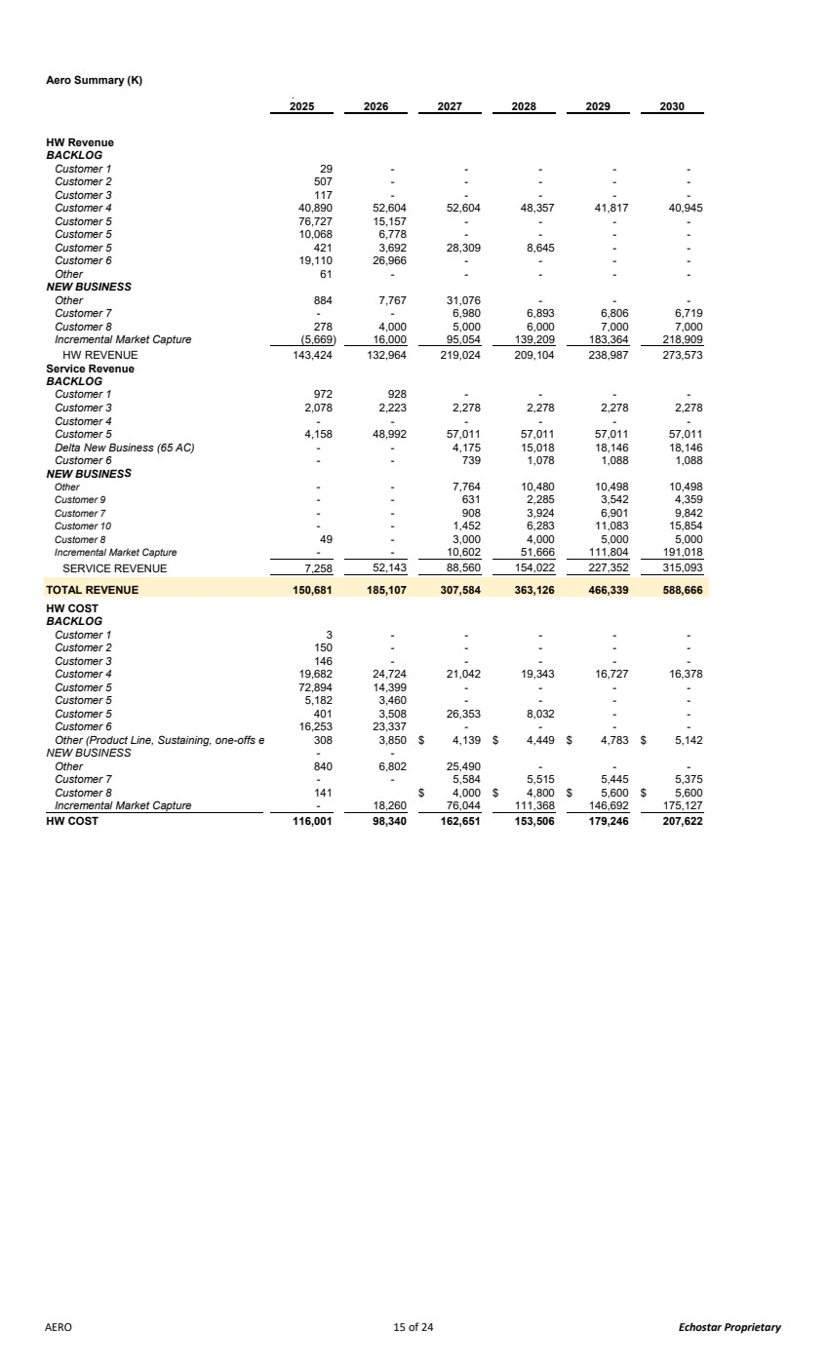 | Aero Summary (K) 2025 2026 2027 2028 2029 2030 HW Revenue BACKLOG Customer 1 - 29 - - - - Customer 2 - 507 - - - - Customer 3 - 117 - - - - Customer 4 52,604 40,890 52,604 48,357 41,817 40,945 Customer 5 15,157 76,727 - - - - Customer 5 6,778 10,068 - - - - Customer 5 3,692 421 28,309 8,645 - - Customer 6 26,966 19,110 - - - - Other - 61 - - - - NEW BUSINESS Other 7,767 884 31,076 - - - Customer 7 - - 6,980 6,893 6,806 6,719 Customer 8 4,000 278 5,000 6,000 7,000 7,000 Incremental Market Capture (5,669) 16,000 95,054 139,209 183,364 218,909 HW REVENUE 143,424 132,964 219,024 209,104 238,987 273,573 Service Revenue BACKLOG Customer 1 928 972 - - - - Customer 3 2,223 2,078 2,278 2,278 2,278 2,278 Customer 4 - - - - - - Customer 5 48,992 4,158 57,011 57,011 57,011 57,011 Delta New Business (65 AC) - - 4,175 15,018 18,146 18,146 Customer 6 - - 739 1,078 1,088 1,088 NEW BUSINESS Other - - 7,764 10,480 10,498 10,498 Customer 9 - - 631 2,285 3,542 4,359 Customer 7 - - 908 3,924 6,901 9,842 Customer 10 - - 1,452 6,283 11,083 15,854 Customer 8 - 49 3,000 4,000 5,000 5,000 Incremental Market Capture - - 10,602 51,666 111,804 191,018 SERVICE REVENUE 7,258 52,143 88,560 154,022 227,352 315,093 TOTAL REVENUE 150,681 185,107 307,584 363,126 466,339 588,666 HW COST BACKLOG Customer 1 - 3 - - - - Customer 2 - 150 - - - - Customer 3 - 146 - - - - Customer 4 24,724 19,682 21,042 19,343 16,727 16,378 Customer 5 14,399 72,894 - - - - Customer 5 3,460 5,182 - - - - Customer 5 3,508 401 26,353 8,032 - - Customer 6 23,337 16,253 - - - - Other (Product Line, Sustaining, one-offs e 3,850 308 4,139 $ 4,449 $ 4,783 $ 5,142 $ NEW BUSINESS - - Other 6,802 840 25,490 - - - Customer 7 - - 5,584 5,515 5,445 5,375 Customer 8 4,000 141 $ 4,800 $ 5,600 $ 5,600 $ Incremental Market Capture - 18,260 76,044 111,368 146,692 175,127 HW COST 98,340 116,001 162,651 153,506 179,246 207,622 AERO 15 of 24 Echostar Proprietary
 | 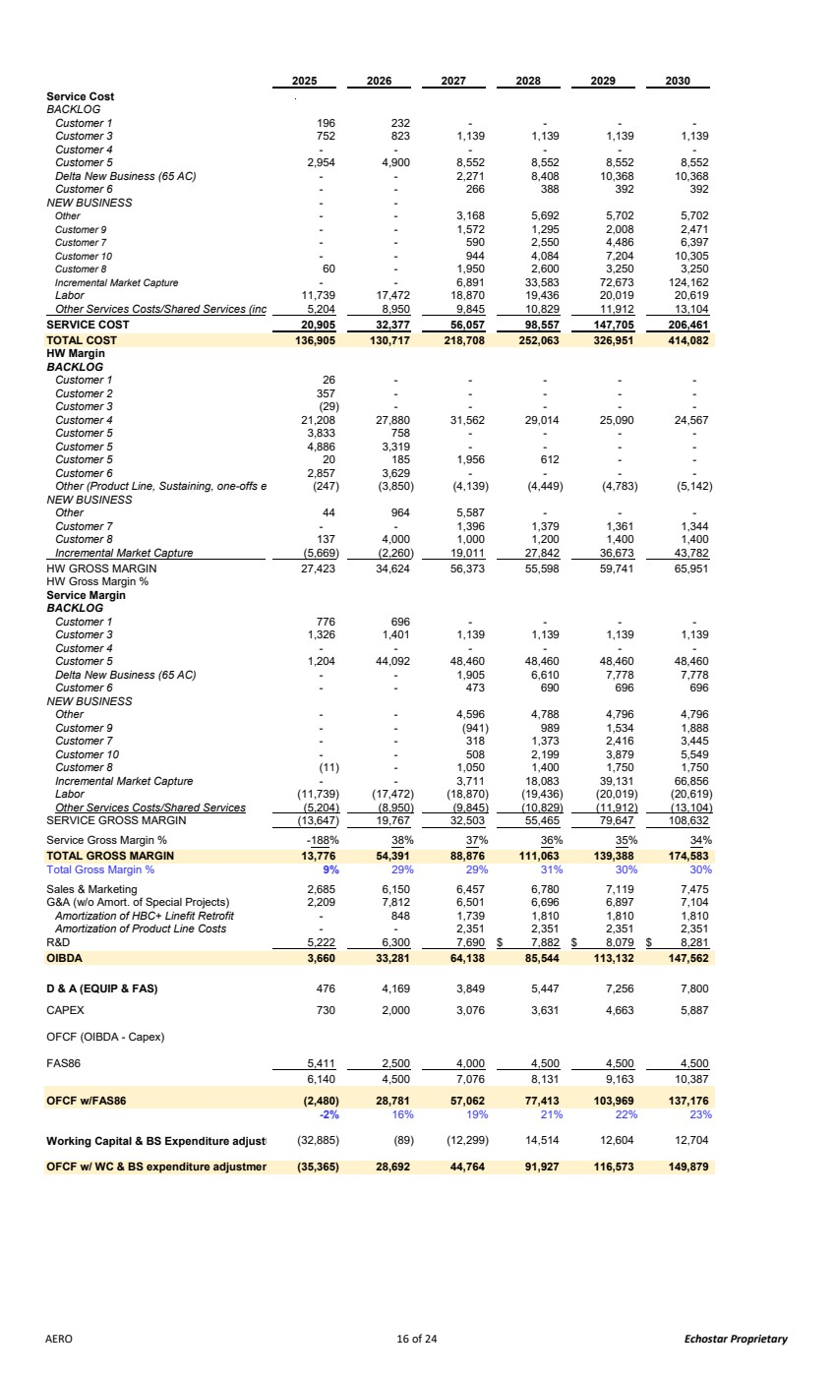 | 2025 2026 2027 2028 2029 2030 Service Cost BACKLOG Customer 1 232 196 - - - - Customer 3 823 752 1,139 1,139 1,139 1,139 Customer 4 - - - - - - Customer 5 4,900 2,954 8,552 8,552 8,552 8,552 Delta New Business (65 AC) - - 2,271 8,408 10,368 10,368 Customer 6 - - 266 388 392 392 NEW BUSINESS - - Other - - 3,168 5,692 5,702 5,702 Customer 9 - - 1,572 1,295 2,008 2,471 Customer 7 - - 590 2,550 4,486 6,397 Customer 10 - - 944 4,084 7,204 10,305 Customer 8 - 60 1,950 2,600 3,250 3,250 Incremental Market Capture - - 6,891 33,583 72,673 124,162 Labor 17,472 11,739 18,870 19,436 20,019 20,619 Other Services Costs/Shared Services (inc 8,950 5,204 9,845 10,829 11,912 13,104 SERVICE COST 32,377 20,905 56,057 98,557 147,705 206,461 TOTAL COST 130,717 136,905 218,708 252,063 326,951 414,082 HW Margin BACKLOG Customer 1 - 26 - - - - Customer 2 - 357 - - - - Customer 3 - (29) - - - - Customer 4 27,880 21,208 31,562 29,014 25,090 24,567 Customer 5 758 3,833 - - - - Customer 5 3,319 4,886 - - - - Customer 5 185 20 1,956 612 - - Customer 6 3,629 2,857 - - - - Other (Product Line, Sustaining, one-offs e (3,850) (247) (4,139) (4,449) (4,783) (5,142) NEW BUSINESS Other 964 44 5,587 - - - Customer 7 - - 1,396 1,379 1,361 1,344 Customer 8 4,000 137 1,000 1,200 1,400 1,400 Incremental Market Capture (5,669) (2,260) 19,011 27,842 36,673 43,782 HW GROSS MARGIN 27,423 34,624 56,373 55,598 59,741 65,951 HW Gross Margin % Service Margin BACKLOG Customer 1 696 776 - - - - Customer 3 1,401 1,326 1,139 1,139 1,139 1,139 Customer 4 - - - - - - Customer 5 44,092 1,204 48,460 48,460 48,460 48,460 Delta New Business (65 AC) - - 1,905 6,610 7,778 7,778 Customer 6 - - 473 690 696 696 NEW BUSINESS Other - - 4,596 4,788 4,796 4,796 Customer 9 - - (941) 989 1,534 1,888 Customer 7 - - 318 1,373 2,416 3,445 Customer 10 - - 508 2,199 3,879 5,549 Customer 8 - (11) 1,050 1,400 1,750 1,750 Incremental Market Capture - - 3,711 18,083 39,131 66,856 Labor (17,472) (11,739) (18,870) (19,436) (20,019) (20,619) Other Services Costs/Shared Services (5,204) (8,950) (9,845) (10,829) (11,912) (13,104) SERVICE GROSS MARGIN (13,647) 19,767 32,503 55,465 79,647 108,632 Service Gross Margin % -188% 38% 37% 36% 35% 34% TOTAL GROSS MARGIN 13,776 54,391 88,876 111,063 139,388 174,583 Total Gross Margin % 9% 29% 29% 31% 30% 30% Sales & Marketing 2,685 6,150 6,457 6,780 7,119 7,475 G&A (w/o Amort. of Special Projects) 2,209 7,812 6,501 6,696 6,897 7,104 Amortization of HBC+ Linefit Retrofit 848 - 1,739 1,810 1,810 1,810 Amortization of Product Line Costs - - 2,351 2,351 2,351 2,351 R&D 5,222 6,300 7,690 7,882 $ 8,079 $ 8,281 $ OIBDA 33,281 3,660 64,138 85,544 113,132 147,562 D & A (EQUIP & FAS) 4,169 476 3,849 5,447 7,256 7,800 CAPEX 730 2,000 3,076 3,631 4,663 5,887 OFCF (OIBDA - Capex) FAS86 5,411 2,500 4,000 4,500 4,500 4,500 4,500 6,140 7,076 8,131 9,163 10,387 OFCF w/FAS86 (2,480) 28,781 57,062 77,413 103,969 137,176 -2% 16% 19% 21% 22% 23% Working Capital & BS Expenditure adjustm (89) (32,885) (12,299) 14,514 12,604 12,704 OFCF w/ WC & BS expenditure adjustmen 28,692 (35,365) 44,764 91,927 116,573 149,879 AERO 16 of 24 Echostar Proprietary
OneWeb Summary 2025 2026 2027 2028 2029 2030 Customer 1 27.8 13.3 5.5 4.2 4.2 4.2 Customer 2 - 30.0 50.0 70.0 10.0 - Customer 3 62.0 76.0 Other - - - - - - HW-Total 27.8 $ 43.3 $ 55.5 $ 74.2 $ 76.2 $ 80.2 $ Customer 1 4.2 0.5 1.5 1.0 1.0 1.0 Customer 2 Customer 3 - - - - - - Other - - - - - - Service 4.2 0.5 1.5 1.0 1.0 1.0 Revenue 32.0 43.8 57.0 75.2 77.2 81.2 Growth % 37% 30% 32% 3% 5% Customer 1 29.9 9.1 3.2 2.3 2.3 2.3 Customer 2 20.1 33.6 47.0 6.7 - Customer 3 - - - - 40.3 49.4 Other 3.3 1.3 - - - - HW 33.2 30.5 36.7 49.3 49.3 51.7 Customer 1 4.1 0.3 1.0 0.7 0.7 0.7 Customer 2 Customer 3 - - - - - - Other - - - - - - Service 4.1 0.3 1.0 0.7 0.7 0.7 COGS 37.3 30.8 37.7 50.0 50.0 52.4 HW (5.5) 12.8 18.8 24.9 26.9 28.5 GM% -20% 30% 34% 34% 35% 36% Service 0.2 0.2 0.5 0.3 0.3 0.3 GM% 4% 40% 33% 30% 30% 30% Gross margin (5.3) 13.0 19.3 25.2 27.2 28.8 R&D 2.8 4.3 2.0 1.0 1.0 0.5 S&M - - - - - - G&A 0.6 0.23 0.50 0.50 0.50 0.50 OIBDA (8.7) 8.5 16.8 23.7 25.7 27.8 Capex 0.2 1.0 1.5 0.3 0.3 0.3 SFAS86 1.1 1.7 1.4 0.3 0.1 0.1 OFCF (OIBDA - Capex & FAS) (10.1) 5.8 13.8 23.2 25.4 27.5 Oneweb 17 of 24 Echostar Proprietary
Government Summary (M) 2025 2026 2027 2028 2029 2030 Operation 31.6 33.0 49.5 59.3 74.2 89.5 Other - - - - - - Hardware 31.6 33.0 49.5 59.3 74.2 89.5 Operation 0.5 0.6 0.6 0.6 0.7 0.7 Other - - - - - - Service 0.5 0.6 0.6 0.6 0.7 0.7 Revenue 32.1 33.6 50.1 60.0 74.9 90.2 YOY Change 5% 49% 20% 25% 20% Hardware 24.5 23.8 36.5 43.6 54.4 65.5 Service 0.5 0.2 0.3 0.3 0.3 0.3 COGS 24.7 24.3 36.8 44.0 54.8 65.8 Gross Margin 7.4 9.3 13.3 16.0 20.1 24.3 Margin % 23.1% 27.8% 26.6% 26.7% 26.8% 27.0% R&D 0.8 0.9 1.2 1.5 1.9 2.2 S&M 3.1 4.5 5.1 5.4 5.7 6.2 G&A 0.9 1.0 1.6 1.7 1.8 1.9 Operating Expense 6.3 4.9 7.9 8.6 9.4 10.3 OIBDA 2.6 3.1 5.4 7.4 10.7 14.0 OIBDA % 8% 9% 11% 12% 14% 16% Capex 1.1 1.5 1.1 1.2 1.2 1.3 SFAS86 1.0 1.1 1.4 1.5 1.7 1.8 OFCF 0.3 0.6 2.9 4.7 7.8 10.9 Gov't 18 of 24 Echostar Proprietary
Factory Summary (M) 2026 2027 2028 2029 2030 Hardware 8.6 20.0 30.0 40.0 50.0 Service Revenue 8.6 20.0 30.0 40.0 50.0 YOY Change #DIV/0! 133% 50% 33% 25% Hardware 6.9 16.0 24.0 32.0 40.0 Service - - - - - COGS 6.9 16.0 24.0 32.0 40.0 Gross Margin 1.7 4.0 6.0 8.0 10.0 Margin % 20% 20% 20% 20% 20% R&D S&M G&A Operating Expense - - - - - OIBDA 1.7 4.0 6.0 8.0 10.0 OIBDA % 20% 20% 20% 20% 20% Capex SFAS86 OFCF 1.7 4.0 6.0 8.0 10.0 Factory 19 of 24 Echostar Proprietary
 | 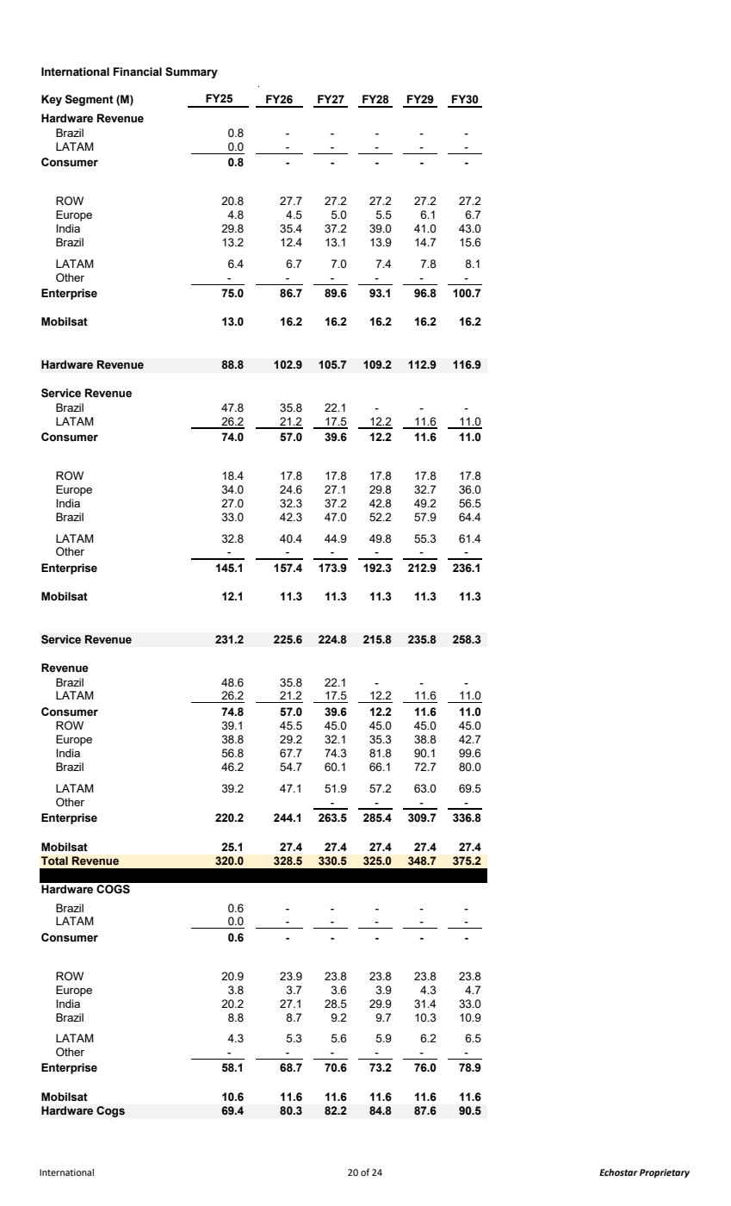 | International Financial Summary Key Segment (M) FY25 FY26 FY27 FY28 FY29 FY30 Hardware Revenue Brazil 0.8 - - - - - LATAM 0.0 - - - - - Consumer - 0.8 - - - - ROW 20.8 27.7 27.2 27.2 27.2 27.2 Europe 4.8 4.5 5.0 5.5 6.1 6.7 India 29.8 35.4 37.2 39.0 41.0 43.0 Brazil 13.2 12.4 13.1 13.9 14.7 15.6 LATAM 6.4 6.7 7.0 7.4 7.8 8.1 Other - - - - - - Enterprise 75.0 86.7 89.6 93.1 96.8 100.7 Mobilsat 13.0 16.2 16.2 16.2 16.2 16.2 Hardware Revenue 88.8 102.9 105.7 109.2 112.9 116.9 Service Revenue Brazil 47.8 35.8 22.1 - - - LATAM 26.2 21.2 17.5 12.2 11.6 11.0 Consumer 57.0 74.0 39.6 12.2 11.6 11.0 ROW 18.4 17.8 17.8 17.8 17.8 17.8 Europe 34.0 24.6 27.1 29.8 32.7 36.0 India 27.0 32.3 37.2 42.8 49.2 56.5 Brazil 33.0 42.3 47.0 52.2 57.9 64.4 LATAM 32.8 40.4 44.9 49.8 55.3 61.4 Other - - - - - - Enterprise 145.1 157.4 173.9 192.3 212.9 236.1 Mobilsat 12.1 11.3 11.3 11.3 11.3 11.3 Service Revenue 231.2 225.6 224.8 215.8 235.8 258.3 Revenue Brazil 48.6 35.8 22.1 - - - LATAM 26.2 21.2 17.5 12.2 11.6 11.0 Consumer 57.0 74.8 39.6 12.2 11.6 11.0 ROW 39.1 45.5 45.0 45.0 45.0 45.0 Europe 38.8 29.2 32.1 35.3 38.8 42.7 India 56.8 67.7 74.3 81.8 90.1 99.6 Brazil 46.2 54.7 60.1 66.1 72.7 80.0 LATAM 39.2 47.1 51.9 57.2 63.0 69.5 Other - - - - Enterprise 220.2 244.1 263.5 285.4 309.7 336.8 Mobilsat 25.1 27.4 27.4 27.4 27.4 27.4 Total Revenue 320.0 328.5 330.5 325.0 348.7 375.2 Hardware COGS Brazil 0.6 - - - - - LATAM 0.0 - - - - - Consumer - 0.6 - - - - ROW 20.9 23.9 23.8 23.8 23.8 23.8 Europe 3.8 3.7 3.6 3.9 4.3 4.7 India 20.2 27.1 28.5 29.9 31.4 33.0 Brazil 8.8 8.7 9.2 9.7 10.3 10.9 LATAM 4.3 5.3 5.6 5.9 6.2 6.5 Other - - - - - - Enterprise 58.1 68.7 70.6 73.2 76.0 78.9 Mobilsat 10.6 11.6 11.6 11.6 11.6 11.6 Hardware Cogs 69.4 80.3 82.2 84.8 87.6 90.5 International 20 of 24 Echostar Proprietary
 | 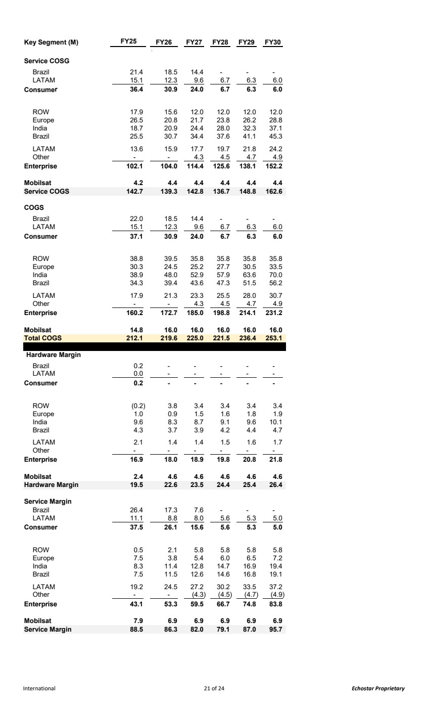 | Key Segment (M) FY25 FY26 FY27 FY28 FY29 FY30 Service COSG Brazil 21.4 18.5 14.4 - - - LATAM 15.1 12.3 9.6 6.7 6.3 6.0 Consumer 30.9 36.4 24.0 6.7 6.3 6.0 ROW 17.9 15.6 12.0 12.0 12.0 12.0 Europe 26.5 20.8 21.7 23.8 26.2 28.8 India 18.7 20.9 24.4 28.0 32.3 37.1 Brazil 25.5 30.7 34.4 37.6 41.1 45.3 LATAM 13.6 15.9 17.7 19.7 21.8 24.2 Other - - 4.3 4.5 4.7 4.9 Enterprise 102.1 104.0 114.4 125.6 138.1 152.2 Mobilsat 4.2 4.4 4.4 4.4 4.4 4.4 Service COGS 142.7 139.3 142.8 136.7 148.8 162.6 COGS Brazil 22.0 18.5 14.4 - - - LATAM 15.1 12.3 9.6 6.7 6.3 6.0 Consumer 30.9 37.1 24.0 6.7 6.3 6.0 ROW 38.8 39.5 35.8 35.8 35.8 35.8 Europe 30.3 24.5 25.2 27.7 30.5 33.5 India 38.9 48.0 52.9 57.9 63.6 70.0 Brazil 34.3 39.4 43.6 47.3 51.5 56.2 LATAM 17.9 21.3 23.3 25.5 28.0 30.7 Other - - 4.3 4.5 4.7 4.9 Enterprise 160.2 172.7 185.0 198.8 214.1 231.2 Mobilsat 14.8 16.0 16.0 16.0 16.0 16.0 Total COGS 212.1 219.6 225.0 221.5 236.4 253.1 Hardware Margin Brazil 0.2 - - - - - LATAM 0.0 - - - - - Consumer - 0.2 - - - - ROW (0.2) 3.8 3.4 3.4 3.4 3.4 Europe 1.0 0.9 1.5 1.6 1.8 1.9 India 9.6 8.3 8.7 9.1 9.6 10.1 Brazil 4.3 3.7 3.9 4.2 4.4 4.7 LATAM 2.1 1.4 1.4 1.5 1.6 1.7 Other - - - - - - Enterprise 16.9 18.0 18.9 19.8 20.8 21.8 Mobilsat 2.4 4.6 4.6 4.6 4.6 4.6 Hardware Margin 19.5 22.6 23.5 24.4 25.4 26.4 Service Margin Brazil 26.4 17.3 7.6 - - - LATAM 11.1 8.8 8.0 5.6 5.3 5.0 Consumer 26.1 37.5 15.6 5.6 5.3 5.0 ROW 0.5 2.1 5.8 5.8 5.8 5.8 Europe 7.5 3.8 5.4 6.0 6.5 7.2 India 8.3 11.4 12.8 14.7 16.9 19.4 Brazil 7.5 11.5 12.6 14.6 16.8 19.1 LATAM 19.2 24.5 27.2 30.2 33.5 37.2 Other - - (4.3) (4.5) (4.7) (4.9) Enterprise 43.1 53.3 59.5 66.7 74.8 83.8 Mobilsat 7.9 6.9 6.9 6.9 6.9 6.9 Service Margin 88.5 86.3 82.0 79.1 87.0 95.7 International 21 of 24 Echostar Proprietary
 | 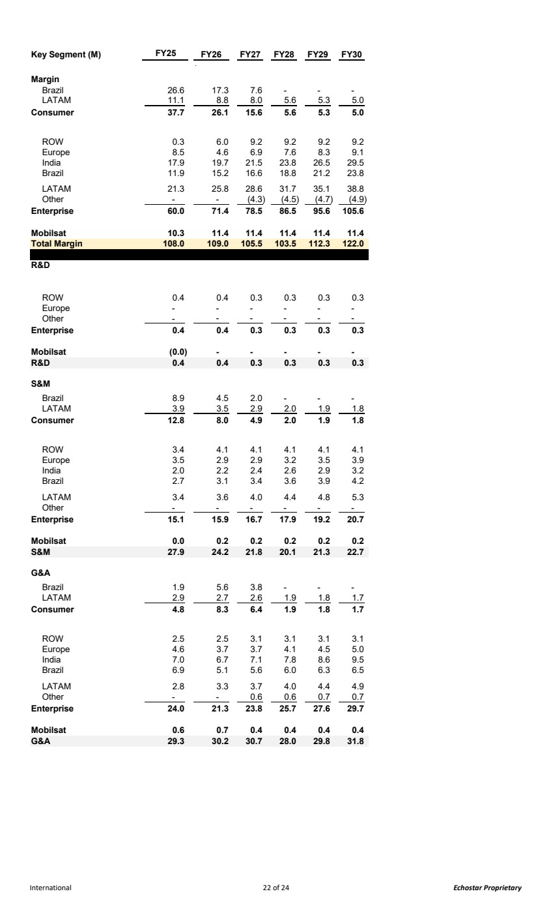 | Key Segment (M) FY25 FY26 FY27 FY28 FY29 FY30 Margin Brazil 26.6 17.3 7.6 - - - LATAM 11.1 8.8 8.0 5.6 5.3 5.0 Consumer 26.1 37.7 15.6 5.6 5.3 5.0 ROW 0.3 6.0 9.2 9.2 9.2 9.2 Europe 8.5 4.6 6.9 7.6 8.3 9.1 India 17.9 19.7 21.5 23.8 26.5 29.5 Brazil 11.9 15.2 16.6 18.8 21.2 23.8 LATAM 21.3 25.8 28.6 31.7 35.1 38.8 Other - - (4.3) (4.5) (4.7) (4.9) Enterprise 60.0 71.4 78.5 86.5 95.6 105.6 Mobilsat 10.3 11.4 11.4 11.4 11.4 11.4 Total Margin 108.0 109.0 105.5 103.5 112.3 122.0 R&D ROW 0.4 0.4 0.3 0.3 0.3 0.3 Europe - - - - - - Other - - - - - - Enterprise 0.4 0.4 0.3 0.3 0.3 0.3 Mobilsat (0.0) - - - - - R&D 0.4 0.4 0.3 0.3 0.3 0.3 S&M Brazil 8.9 4.5 2.0 - - - LATAM 3.9 3.5 2.9 2.0 1.9 1.8 Consumer 8.0 12.8 4.9 2.0 1.9 1.8 ROW 3.4 4.1 4.1 4.1 4.1 4.1 Europe 3.5 2.9 2.9 3.2 3.5 3.9 India 2.0 2.2 2.4 2.6 2.9 3.2 Brazil 2.7 3.1 3.4 3.6 3.9 4.2 LATAM 3.4 3.6 4.0 4.4 4.8 5.3 Other - - - - - - Enterprise 15.1 15.9 16.7 17.9 19.2 20.7 Mobilsat 0.0 0.2 0.2 0.2 0.2 0.2 S&M 27.9 24.2 21.8 20.1 21.3 22.7 G&A Brazil 1.9 5.6 3.8 - - - LATAM 2.9 2.7 2.6 1.9 1.8 1.7 Consumer 8.3 4.8 6.4 1.9 1.8 1.7 ROW 2.5 2.5 3.1 3.1 3.1 3.1 Europe 4.6 3.7 3.7 4.1 4.5 5.0 India 7.0 6.7 7.1 7.8 8.6 9.5 Brazil 6.9 5.1 5.6 6.0 6.3 6.5 LATAM 2.8 3.3 3.7 4.0 4.4 4.9 Other - - 0.6 0.6 0.7 0.7 Enterprise 24.0 21.3 23.8 25.7 27.6 29.7 Mobilsat 0.6 0.7 0.4 0.4 0.4 0.4 G&A 30.2 29.3 30.7 28.0 29.8 31.8 International 22 of 24 Echostar Proprietary
 | 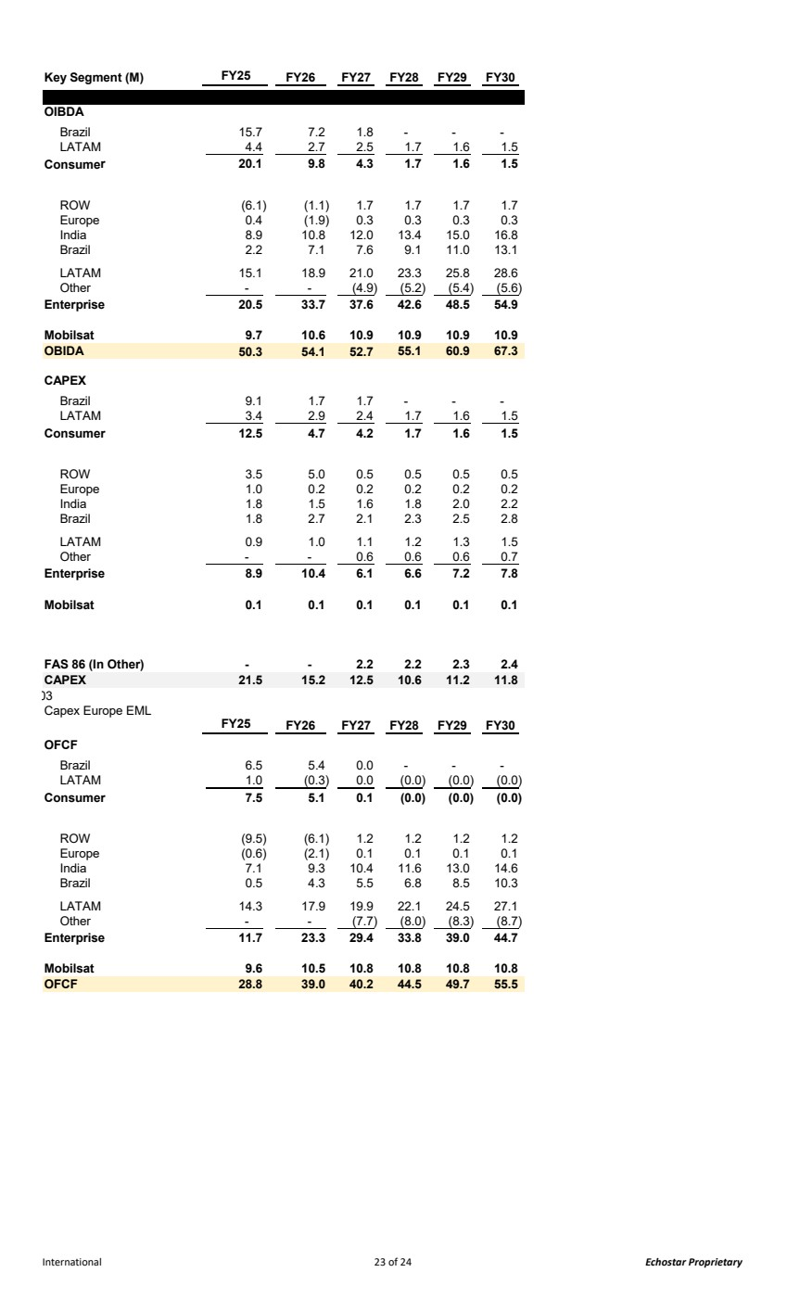 | Key Segment (M) FY25 FY26 FY27 FY28 FY29 FY30 OIBDA Brazil 15.7 7.2 1.8 - - - LATAM 4.4 2.7 2.5 1.7 1.6 1.5 Consumer 9.8 20.1 4.3 1.7 1.6 1.5 ROW (6.1) (1.1) 1.7 1.7 1.7 1.7 Europe 0.4 (1.9) 0.3 0.3 0.3 0.3 India 8.9 10.8 12.0 13.4 15.0 16.8 Brazil 2.2 7.1 7.6 9.1 11.0 13.1 LATAM 15.1 18.9 21.0 23.3 25.8 28.6 Other - - (4.9) (5.2) (5.4) (5.6) Enterprise 20.5 33.7 37.6 42.6 48.5 54.9 Mobilsat 9.7 10.6 10.9 10.9 10.9 10.9 OBIDA 54.1 50.3 52.7 60.9 55.1 67.3 CAPEX Brazil 9.1 1.7 1.7 - - - LATAM 3.4 2.9 2.4 1.7 1.6 1.5 Consumer 4.7 12.5 4.2 1.7 1.6 1.5 ROW 3.5 5.0 0.5 0.5 0.5 0.5 Europe 1.0 0.2 0.2 0.2 0.2 0.2 India 1.8 1.5 1.6 1.8 2.0 2.2 Brazil 1.8 2.7 2.1 2.3 2.5 2.8 LATAM 0.9 1.0 1.1 1.2 1.3 1.5 Other - - 0.6 0.6 0.6 0.7 Enterprise 8.9 10.4 6.1 6.6 7.2 7.8 Mobilsat 0.1 0.1 0.1 0.1 0.1 0.1 FAS 86 (In Other) - - 2.2 2.2 2.3 2.4 CAPEX 15.2 21.5 12.5 10.6 11.2 11.8 03 Capex Europe EML FY25 FY26 FY27 FY28 FY29 FY30 OFCF Brazil 6.5 5.4 0.0 - - - LATAM 1.0 (0.3) 0.0 (0.0) (0.0) (0.0) Consumer 5.1 7.5 0.1 (0.0) (0.0) (0.0) ROW (9.5) (6.1) 1.2 1.2 1.2 1.2 Europe (0.6) (2.1) 0.1 0.1 0.1 0.1 India 7.1 9.3 10.4 11.6 13.0 14.6 Brazil 0.5 4.3 5.5 6.8 8.5 10.3 LATAM 14.3 17.9 19.9 22.1 24.5 27.1 Other - - (7.7) (8.0) (8.3) (8.7) Enterprise 11.7 23.3 29.4 33.8 39.0 44.7 Mobilsat 9.6 10.5 10.8 10.8 10.8 10.8 OFCF 39.0 28.8 40.2 49.7 44.5 55.5 International 23 of 24 Echostar Proprietary
International KPI 2025 2026 2027 2028 2029 2030 Fcst 5 YR 5 YR 5 YR 5 YR 6 YR Brazil 81,521 123,466 - - - - LATAM 36,034 45,042 30,121 21,529 20,372 19,151 Ending Subs 117,555 168,507 30,121 21,529 20,372 19,151 Brazil - 38,326 - - - - LATAM 9,960 14,005 8,889 8,230 7,621 7,056 Gross Adds 9,960 52,331 8,889 8,230 7,621 7,056 Brazil (21,529) (41,944) (81,521) - - - LATAM (10,812) (9,008) (5,913) (8,592) (1,156) (1,222) Net Adds (32,341) (50,952) (87,434) (8,592) (1,156) (1,222) Brazil 3.7% 3.4% 11.5% 0.0% 0.0% 0.0% LATAM 4.1% 3.9% 3.8% 3.5% 3.5% 3.5% Churn 3.8% 3.5% 6.8% 3.5% 3.5% 3.5% Brazil $29.94 $30.06 $30.20 $0.00 $0.00 $0.00 LATAM $43.73 $44.39 $44.76 $46.49 $46.47 $46.46 ARPU Reported $33.72 $34.16 $36.65 $46.49 $46.47 $46.46 Brazil $48.6 $35.8 $22.1 $0.0 $0.0 $0.0 LATAM $26.2 $21.2 $17.5 $12.2 $11.6 $11.0 Revenue $74.8 $57.0 $39.6 $12.2 $11.6 $11.0 Int'l KPI's 24 of 24 Echostar Proprietary
Exhibit 99.4
Proprietary and Confidential The financial model and forecast data (the “Forecast”) has been prepared by the company (the “Company”) solely for informational purposes in connection with potential market transactions and is furnished subject to the recipient’s confidentiality obligations with the Company. The Forecast contains forward-looking statements, opinions, and projections that are not guarantees of future performance; no representation or warranty is made as to its accuracy or completeness. The information in the Forecast is dated Q4 2025 and is subject to change; the Company assumes no obligation to update it. Recipients should conduct their own independent due diligence and seek advice from their own legal, tax, financial, and other advisors. As noted above, this Forecast represents management’s Allocated BSS view of estimated projections generated in Q4 2025. BSS is a reporting segment within EchoStar (SATS). The Allocated BSS view reflected in this Forecast represents HSSC plus the BSS Segment activity related to the J3 lease payment from HSSC for capacity usage on the J3 satellite asset, which is held outside of HSSC. The Forecast is currently set at the Allocated BSS level. It has a ‘toggle’ switch (see below) that allows a simple view change that shows: i) Allocated BSS view: Cell "Q1" must be "1"; or ii) HSSC view: Cell "Q1" must be "0"; - with J3 lease payments: cell "Q2" must be "1" - without J3 lease payments: cell "Q2" must be "0"
 | 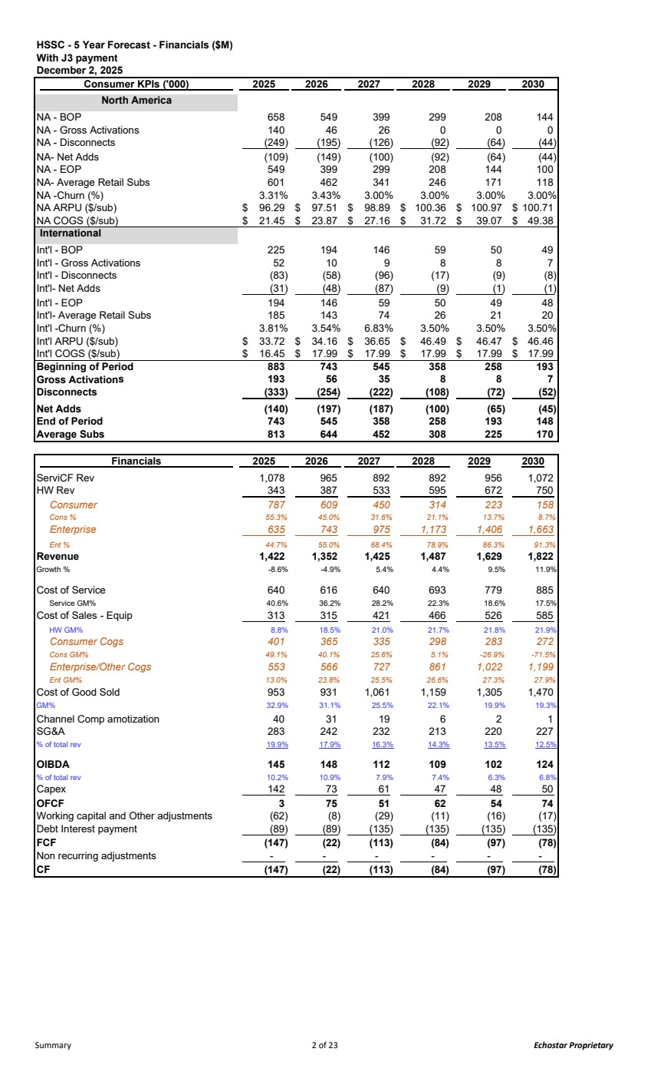 | HSSC - 5 Year Forecast - Financials ($M) With J3 payment December 2, 2025 Consumer KPIs ('000) 2025 2026 2027 2028 2029 2030 North America NA - BOP 658 549 399 299 208 144 NA - Gross Activations 140 46 26 0 0 0 NA - Disconnects (249) (195) (126) (92) (64) (44) NA- Net Adds (109) (149) (100) (92) (64) (44) NA - EOP 549 399 299 208 144 100 NA- Average Retail Subs 601 462 341 246 171 118 NA -Churn (%) 3.31% 3.43% 3.00% 3.00% 3.00% 3.00% NA ARPU ($/sub) 96.29 $ 97.51 $ 98.89 $ 100.36 $ 100.97 $ 100.71 $ NA COGS ($/sub) 21.45 $ 23.87 $ 27.16 $ 31.72 $ 39.07 $ 49.38 $ International Int'l - BOP 225 194 146 59 50 49 Int'l - Gross Activations 52 10 9 8 8 7 Int'l - Disconnects (83) (58) (96) (17) (9) (8) Int'l- Net Adds (31) (48) (87) (9) (1) (1) Int'l - EOP 194 146 59 50 49 48 Int'l- Average Retail Subs 185 143 74 26 21 20 Int'l -Churn (%) 3.81% 3.54% 6.83% 3.50% 3.50% 3.50% Int'l ARPU ($/sub) 33.72 $ 34.16 $ 36.65 $ 46.49 $ 46.47 $ 46.46 $ Int'l COGS ($/sub) 16.45 $ 17.99 $ 17.99 $ 17.99 $ 17.99 $ 17.99 $ Beginning of Period 883 743 545 358 258 193 Gross Activations 56 193 35 8 8 7 Disconnects (333) (254) (222) (108) (72) (52) Net Adds (140) (197) (187) (100) (65) (45) End of Period 743 545 358 258 193 148 Average Subs 644 813 452 308 225 170 Financials 2025 2026 2027 2028 2029 2030 ServiCF Rev 1,078 965 892 892 956 1,072 HW Rev 343 387 533 595 672 750 Consumer 787 609 450 314 223 158 Cons % 55.3% 45.0% 31.6% 21.1% 13.7% 8.7% Enterprise 635 743 975 1,173 1,406 1,663 Ent % 44.7% 55.0% 68.4% 78.9% 86.3% 91.3% Revenue 1,422 1,352 1,425 1,487 1,629 1,822 Growth % -8.6% -4.9% 5.4% 4.4% 9.5% 11.9% Cost of Service 640 616 640 693 779 885 Service GM% 40.6% 36.2% 28.2% 22.3% 18.6% 17.5% Cost of Sales - Equip 313 315 421 466 526 585 HW GM% 8.8% 18.5% 21.0% 21.7% 21.8% 21.9% Consumer Cogs 401 365 335 298 283 272 Cons GM% 49.1% 40.1% 25.6% 5.1% -26.9% -71.5% Enterprise/Other Cogs 553 566 727 861 1,022 1,199 Ent GM% 13.0% 23.8% 25.5% 26.6% 27.3% 27.9% Cost of Good Sold 953 931 1,061 1,159 1,305 1,470 GM% 32.9% 31.1% 25.5% 22.1% 19.9% 19.3% Channel Comp amotization 40 31 19 6 2 1 SG&A 283 242 232 213 220 227 % of total rev 19.9% 17.9% 16.3% 14.3% 13.5% 12.5% OIBDA 145 148 112 109 102 124 % of total rev 10.2% 10.9% 7.9% 7.4% 6.3% 6.8% Capex 142 73 61 47 48 50 OFCF 3 75 51 62 54 74 Working capital and Other adjustments (62) (8) (29) (11) (16) (17) Debt Interest payment (89) (89) (135) (135) (135) (135) FCF (147) (22) (113) (84) (97) (78) Non recurring adjustments - - - - - - CF (147) (22) (113) (84) (97) (78) Summary 2 of 23 Echostar Proprietary
 | 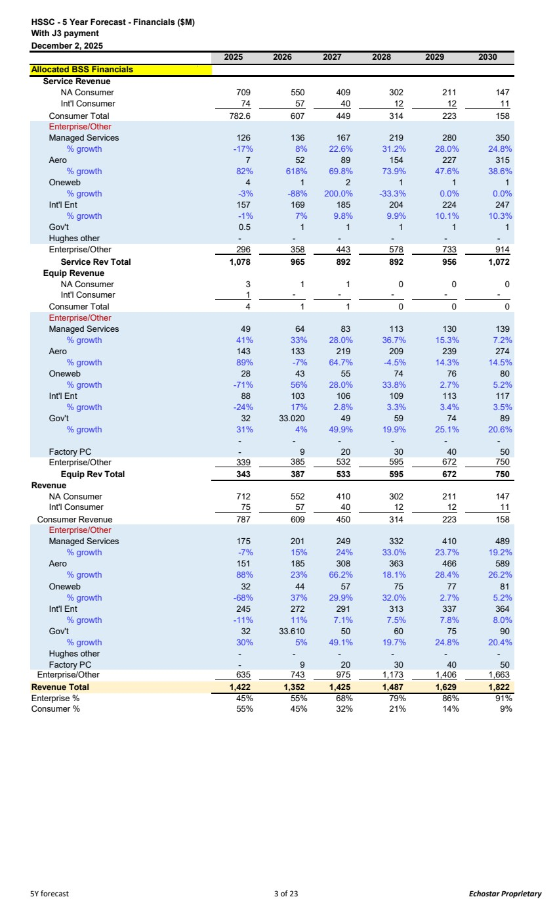 | HSSC - 5 Year Forecast - Financials ($M) With J3 payment December 2, 2025 2025 2026 2027 2028 2029 2030 Allocated BSS Financials Service Revenue NA Consumer 709 550 409 302 211 147 Int'l Consumer 74 57 40 12 12 11 Consumer Total 782.6 607 449 314 223 158 Enterprise/Other Managed Services 126 136 167 219 280 350 % growth -17% 8% 22.6% 31.2% 28.0% 24.8% Aero 7 52 89 154 227 315 % growth 82% 618% 69.8% 73.9% 47.6% 38.6% Oneweb 4 1 2 1 1 1 % growth -3% -88% 200.0% -33.3% 0.0% 0.0% Int'l Ent 157 169 185 204 224 247 % growth -1% 7% 9.8% 9.9% 10.1% 10.3% Gov't 0.5 1 1 1 1 1 Hughes other - - - - - - Enterprise/Other 296 358 443 578 733 914 Service Rev Total 1,078 965 892 892 956 1,072 Equip Revenue NA Consumer 3 1 1 0 0 0 Int'l Consumer 1 - - - - - Consumer Total 4 1 1 0 0 0 Enterprise/Other Managed Services 49 64 83 113 130 139 % growth 41% 33% 28.0% 36.7% 15.3% 7.2% Aero 143 133 219 209 239 274 % growth 89% -7% 64.7% -4.5% 14.3% 14.5% Oneweb 28 43 55 74 76 80 % growth -71% 56% 28.0% 33.8% 2.7% 5.2% Int'l Ent 88 103 106 109 113 117 % growth -24% 17% 2.8% 3.3% 3.4% 3.5% Gov't 32 33.020 49 59 74 89 % growth 31% 4% 49.9% 19.9% 25.1% 20.6% - - - - - - Factory PC - 9 20 30 40 50 Enterprise/Other 339 385 532 595 672 750 Equip Rev Total 343 387 533 595 672 750 Revenue NA Consumer 712 552 410 302 211 147 Int'l Consumer 75 57 40 12 12 11 Consumer Revenue 787 609 450 314 223 158 Enterprise/Other Managed Services 175 201 249 332 410 489 % growth -7% 15% 24% 33.0% 23.7% 19.2% Aero 151 185 308 363 466 589 % growth 88% 23% 66.2% 18.1% 28.4% 26.2% Oneweb 32 44 57 75 77 81 % growth -68% 37% 29.9% 32.0% 2.7% 5.2% Int'l Ent 245 272 291 313 337 364 % growth -11% 11% 7.1% 7.5% 7.8% 8.0% Gov't 32 33.610 50 60 75 90 % growth 30% 5% 49.1% 19.7% 24.8% 20.4% Hughes other - - - - - - Factory PC - 9 20 30 40 50 Enterprise/Other 635 743 975 1,173 1,406 1,663 Revenue Total 1,422 1,352 1,425 1,487 1,629 1,822 Enterprise % 45% 55% 68% 79% 86% 91% Consumer % 55% 45% 32% 21% 14% 9% 5Y forecast 3 of 23 Echostar Proprietary
 | 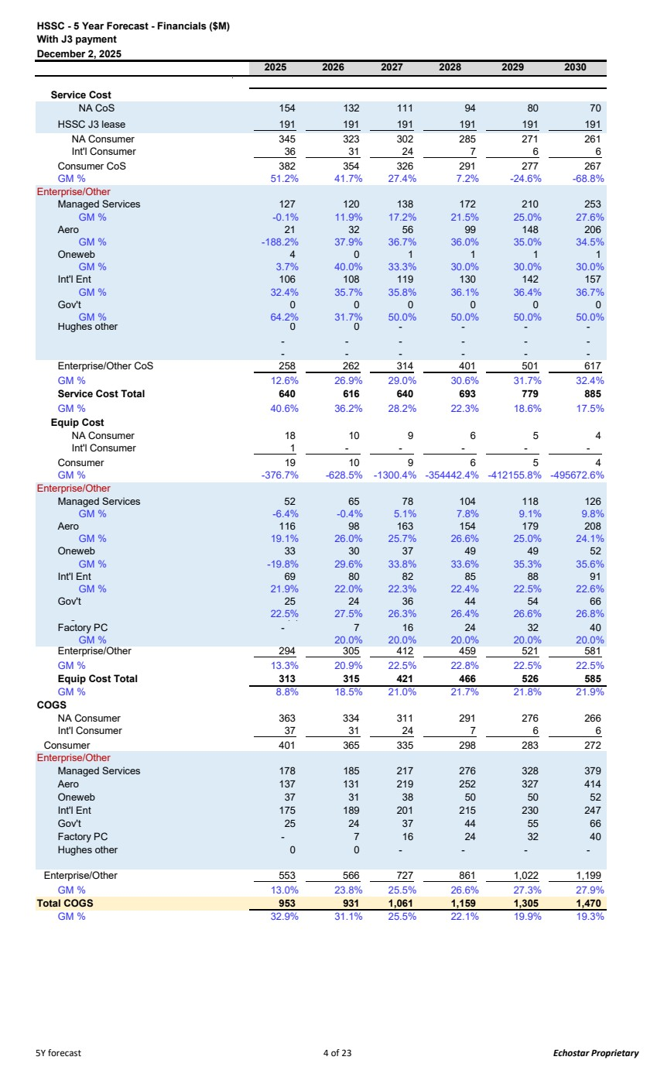 | HSSC - 5 Year Forecast - Financials ($M) With J3 payment December 2, 2025 2025 2026 2027 2028 2029 2030 Service Cost NA CoS 154 132 111 94 80 70 HSSC J3 lease 191 191 191 191 191 191 NA Consumer 345 323 302 285 271 261 Int'l Consumer 36 31 24 7 6 6 Consumer CoS 382 354 326 291 277 267 GM % 51.2% 41.7% 27.4% 7.2% -24.6% -68.8% Enterprise/Other Managed Services 127 120 138 172 210 253 GM % -0.1% 11.9% 17.2% 21.5% 25.0% 27.6% Aero 21 32 56 99 148 206 GM % -188.2% 37.9% 36.7% 36.0% 35.0% 34.5% Oneweb 4 0 1 1 1 1 GM % 3.7% 40.0% 33.3% 30.0% 30.0% 30.0% Int'l Ent 106 108 119 130 142 157 GM % 32.4% 35.7% 35.8% 36.1% 36.4% 36.7% Gov't 0 0 0 0 0 0 GM % 64.2% 31.7% 50.0% 50.0% 50.0% 50.0% Hughes other 0 - 0 - - - - - - - - - - - - - - - Enterprise/Other CoS 258 262 314 401 501 617 GM % 12.6% 26.9% 29.0% 30.6% 31.7% 32.4% Service Cost Total 640 616 640 693 779 885 GM % 40.6% 36.2% 28.2% 22.3% 18.6% 17.5% Equip Cost NA Consumer 18 10 9 6 5 4 Int'l Consumer 1 - - - - - Consumer 19 10 9 6 5 4 GM % -376.7% -628.5% -1300.4% -354442.4% -412155.8% -495672.6% Enterprise/Other Managed Services 52 65 78 104 118 126 GM % -6.4% -0.4% 5.1% 7.8% 9.1% 9.8% Aero 116 98 163 154 179 208 GM % 19.1% 26.0% 25.7% 26.6% 25.0% 24.1% Oneweb 33 30 37 49 49 52 GM % -19.8% 29.6% 33.8% 33.6% 35.3% 35.6% Int'l Ent 69 80 82 85 88 91 GM % 21.9% 22.0% 22.3% 22.4% 22.5% 22.6% Gov't 25 24 36 44 54 66 g 22.5% 27.5% 26.3% 26.4% 26.6% 26.8% ( ) Factory PC - 7 16 24 32 40 GM % 20.0% 20.0% 20.0% 20.0% 20.0% Enterprise/Other 305 294 412 459 521 581 GM % 13.3% 20.9% 22.5% 22.8% 22.5% 22.5% Equip Cost Total 313 315 421 466 526 585 GM % 8.8% 18.5% 21.0% 21.7% 21.8% 21.9% COGS NA Consumer 363 334 311 291 276 266 Int'l Consumer 37 31 24 7 6 6 Consumer 401 365 335 298 283 272 Enterprise/Other Managed Services 178 185 217 276 328 379 Aero 137 131 219 252 327 414 Oneweb 37 31 38 50 50 52 Int'l Ent 175 189 201 215 230 247 Gov't 25 24 37 44 55 66 Factory PC - 7 16 24 32 40 Hughes other 0 0 - - - - Enterprise/Other 553 566 727 861 1,022 1,199 GM % 13.0% 23.8% 25.5% 26.6% 27.3% 27.9% Total COGS 953 931 1,061 1,159 1,305 1,470 GM % 32.9% 31.1% 25.5% 22.1% 19.9% 19.3% 5Y forecast 4 of 23 Echostar Proprietary
 | 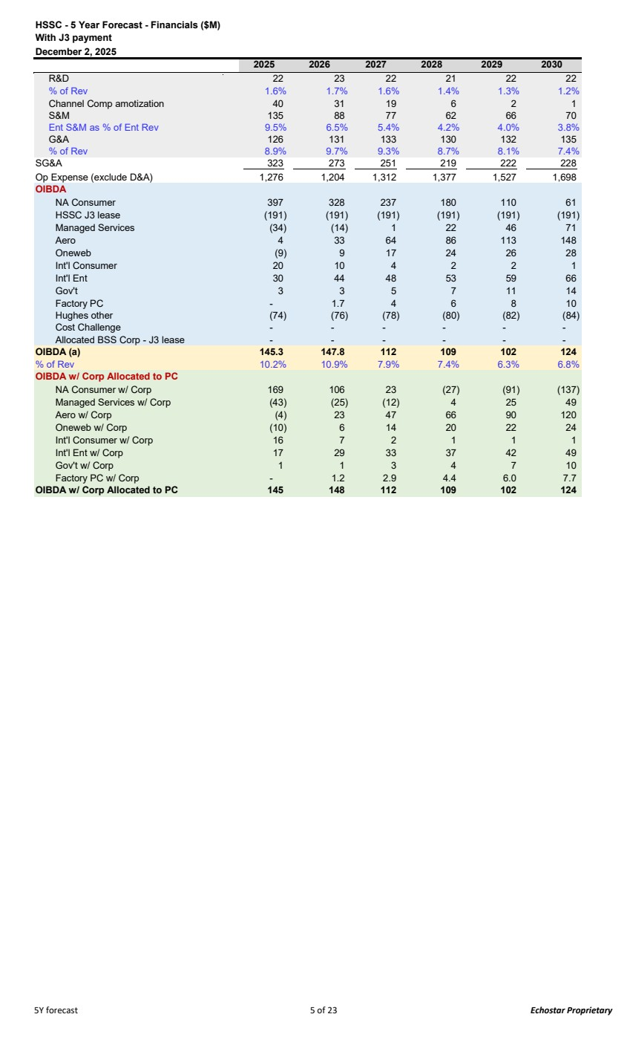 | HSSC - 5 Year Forecast - Financials ($M) With J3 payment December 2, 2025 2025 2026 2027 2028 2029 2030 R&D 22 23 22 21 22 22 % of Rev 1.6% 1.7% 1.6% 1.4% 1.3% 1.2% Channel Comp amotization 40 31 19 6 2 1 S&M 135 88 77 62 66 70 Ent S&M as % of Ent Rev 9.5% 6.5% 5.4% 4.2% 4.0% 3.8% G&A 126 131 133 130 132 135 % of Rev 8.9% 9.7% 9.3% 8.7% 8.1% 7.4% SG&A 323 273 251 219 222 228 Op Expense (exclude D&A) 1,276 1,204 1,312 1,377 1,527 1,698 OIBDA NA Consumer 397 328 237 180 110 61 HSSC J3 lease (191) (191) (191) (191) (191) (191) Managed Services (34) (14) 1 22 46 71 Aero 4 33 64 86 113 148 Oneweb (9) 9 17 24 26 28 Int'l Consumer 20 10 4 2 2 1 Int'l Ent 30 44 48 53 59 66 Gov't 3 3 5 7 11 14 Factory PC - 1.7 4 6 8 10 Hughes other (74) (76) (78) (80) (82) (84) Cost Challenge - - - - - - Allocated BSS Corp - J3 lease - - - - - - OIBDA (a) 145.3 147.8 112 109 102 124 % of Rev 10.2% 10.9% 7.9% 7.4% 6.3% 6.8% OIBDA w/ Corp Allocated to PC NA Consumer w/ Corp 169 106 23 (27) (91) (137) Managed Services w/ Corp (43) (25) (12) 4 25 49 Aero w/ Corp (4) 23 47 66 90 120 Oneweb w/ Corp (10) 6 14 20 22 24 Int'l Consumer w/ Corp 16 7 2 1 1 1 Int'l Ent w/ Corp 17 29 33 37 42 49 Gov't w/ Corp 1 1 3 4 7 10 Factory PC w/ Corp - 1.2 2.9 4.4 6.0 7.7 OIBDA w/ Corp Allocated to PC 145 148 112 109 102 124 5Y forecast 5 of 23 Echostar Proprietary
 | 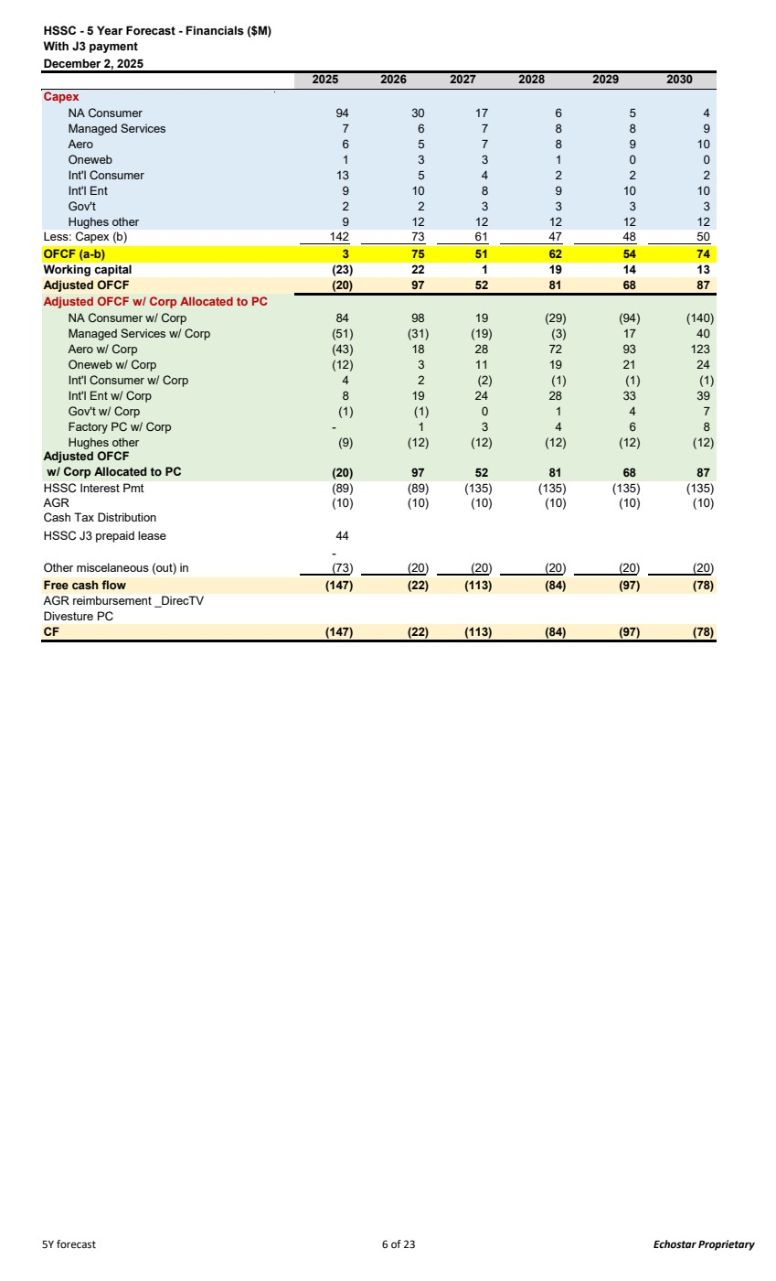 | HSSC - 5 Year Forecast - Financials ($M) With J3 payment December 2, 2025 2025 2026 2027 2028 2029 2030 Capex NA Consumer 94 30 17 6 5 4 Managed Services 7 6 7 8 8 9 Aero 6 5 7 8 9 10 Oneweb 1 3 3 1 0 0 Int'l Consumer 13 5 4 2 2 2 Int'l Ent 9 10 8 9 10 10 Gov't 2 2 3 3 3 3 Hughes other 9 12 12 12 12 12 Less: Capex (b) 142 73 61 47 48 50 OFCF (a-b) 3 75 51 62 54 74 Working capital (23) 22 1 19 14 13 Adjusted OFCF (20) 97 52 81 68 87 Adjusted OFCF w/ Corp Allocated to PC NA Consumer w/ Corp 84 98 19 (29) (94) (140) Managed Services w/ Corp (51) (31) (19) (3) 17 40 Aero w/ Corp (43) 18 28 72 93 123 Oneweb w/ Corp (12) 3 11 19 21 24 Int'l Consumer w/ Corp 4 2 (2) (1) (1) (1) Int'l Ent w/ Corp 8 19 24 28 33 39 Gov't w/ Corp (1) (1) 0 1 4 7 Factory PC w/ Corp - 1 3 4 6 8 Hughes other (9) (12) (12) (12) (12) (12) Adjusted OFCF w/ Corp Allocated to PC 97 (20) 52 81 68 87 HSSC Interest Pmt (89) (89) (135) (135) (135) (135) AGR (10) (10) (10) (10) (10) (10) Cash Tax Distribution HSSC J3 prepaid lease 44 - Other miscelaneous (out) in (73) (20) (20) (20) (20) (20) Free cash flow (147) (22) (113) (84) (97) (78) AGR reimbursement _DirecTV Divesture PC CF (147) (22) (113) (84) (97) (78) 5Y forecast 6 of 23 Echostar Proprietary
 | 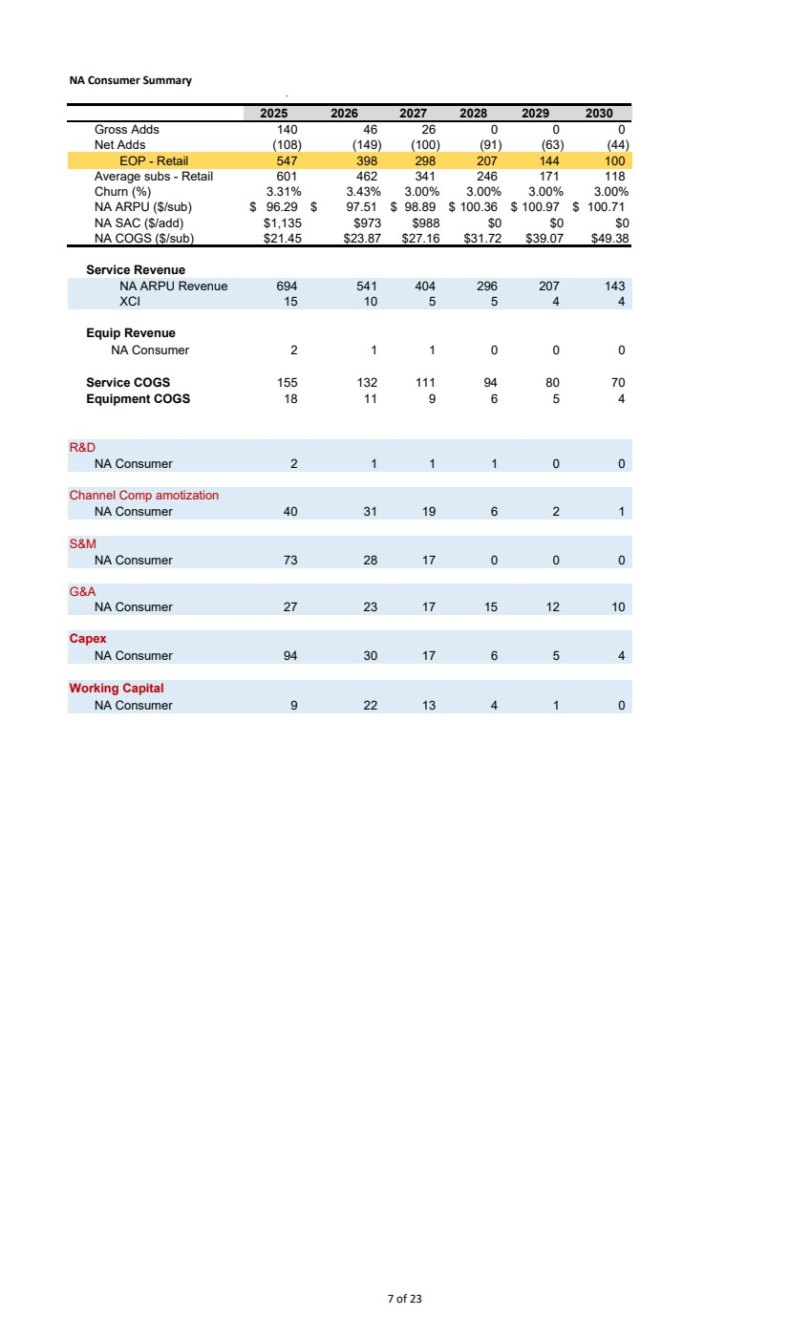 | NA Consumer Summary 2025 2026 2027 2028 2029 2030 Gross Adds 140 46 26 0 0 0 Net Adds (108) (149) (100) (91) (63) (44) EOP - Retail 547 398 298 207 144 100 Average subs - Retail 601 462 341 246 171 118 Churn (%) 3.31% 3.43% 3.00% 3.00% 3.00% 3.00% NA ARPU ($/sub) 96.29 $ 97.51 $ 98.89 $ 100.36 $ 100.97 $ 100.71 $ NA SAC ($/add) $1,135 $973 $988 $0 $0 $0 NA COGS ($/sub) $21.45 $23.87 $27.16 $31.72 $39.07 $49.38 Service Revenue NA ARPU Revenue 694 541 404 296 207 143 XCI 15 10 5 5 4 4 Equip Revenue NA Consumer 2 1 1 0 0 0 Service COGS 132 155 111 94 80 70 Equipment COGS 11 18 9 6 5 4 R&D NA Consumer 2 1 1 1 0 0 Channel Comp amotization NA Consumer 40 31 19 6 2 1 S&M NA Consumer 73 28 17 0 0 0 G&A NA Consumer 27 23 17 15 12 10 Capex NA Consumer 94 30 17 6 5 4 Working Capital NA Consumer 9 22 13 4 1 0 7 of 23
 | 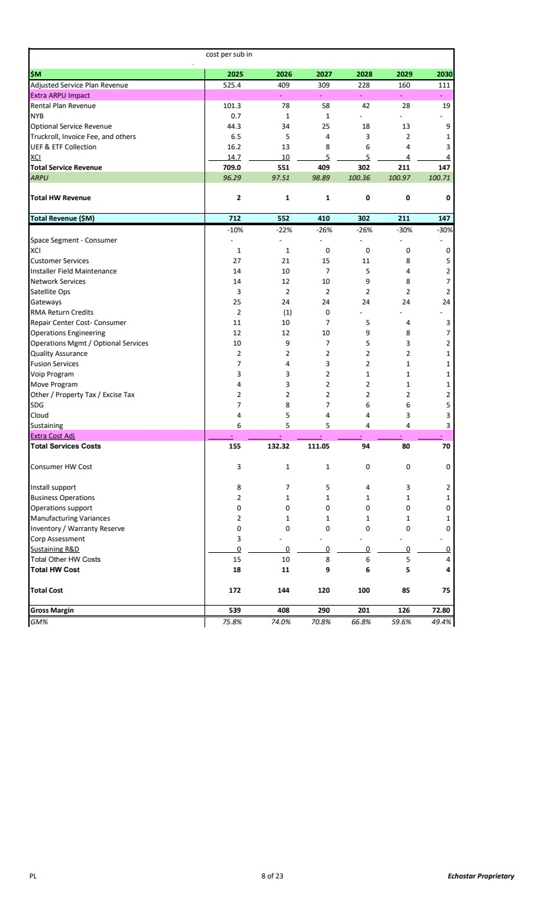 | cost per sub in $M 2025 2026 2027 2028 2029 2030 Adjusted Service Plan Revenue 525.4 409 309 228 160 111 Extra ARPU Impact - - - - - Rental Plan Revenue 101.3 78 58 42 28 19 NYB 0.7 1 1 - - - Optional Service Revenue 44.3 34 25 18 13 9 Truckroll, Invoice Fee, and others 6.5 5 4 3 2 1 UEF & ETF Collection 16.2 13 8 6 4 3 XCI 14.7 10 5 5 4 4 Total Service Revenue 709.0 551 409 302 211 147 ARPU 96.29 97.51 98.89 100.3 100.9 6 100.71 7 Total HW Revenue 2 1 1 0 0 0 Total Revenue ($M) 712 552 410 302 211 147 -10% -22% -26% -26% -30% -30% Space Segment - Consumer - - - - - - XCI 1 1 0 0 0 0 Customer Services 27 21 15 11 8 5 Installer Field Maintenance 14 10 7 5 4 2 Network Services 14 12 10 9 8 7 Satellite Ops 3 2 2 2 2 2 Gateways 25 24 24 24 24 24 RMA Return Credits 2 (1) 0 - - - Repair Center Cost- Consumer 10 11 7 5 4 3 Operations Engineering 12 12 10 9 8 7 Operations Mgmt / Optional Services 10 9 7 5 3 2 Quality Assurance 2 2 2 2 2 1 Fusion Services 7 4 3 2 1 1 Voip Program 3 3 2 1 1 1 Move Program 4 3 2 2 1 1 Other / Property Tax / Excise Tax 2 2 2 2 2 2 SDG 7 8 7 6 6 5 Cloud 4 5 4 4 3 3 Sustaining 6 5 5 4 4 3 Extra Cost Adj - - - - - - Total Services Costs 132.32 155 111.05 94 80 70 Consumer HW Cost 3 1 1 0 0 0 Install support 8 7 5 4 3 2 Business Operations 2 1 1 1 1 1 Operations support 0 0 0 0 0 0 Manufacturing Variances 1 2 1 1 1 1 Inventory / Warranty Reserve 0 0 0 0 0 0 Corp Assessment 3 - - - - - Sustaining R&D 0 0 0 0 0 0 Total Other HW Costs 10 15 8 6 5 4 Total HW Cost 11 18 9 6 5 4 Total Cost 172 144 120 100 85 75 Gross Margin 539 408 290 201 126 72.80 GM% 75.8% 74.0% 70.8% 66.8% 59.6% 49.4% PL 8 of 23 Echostar Proprietary
 | 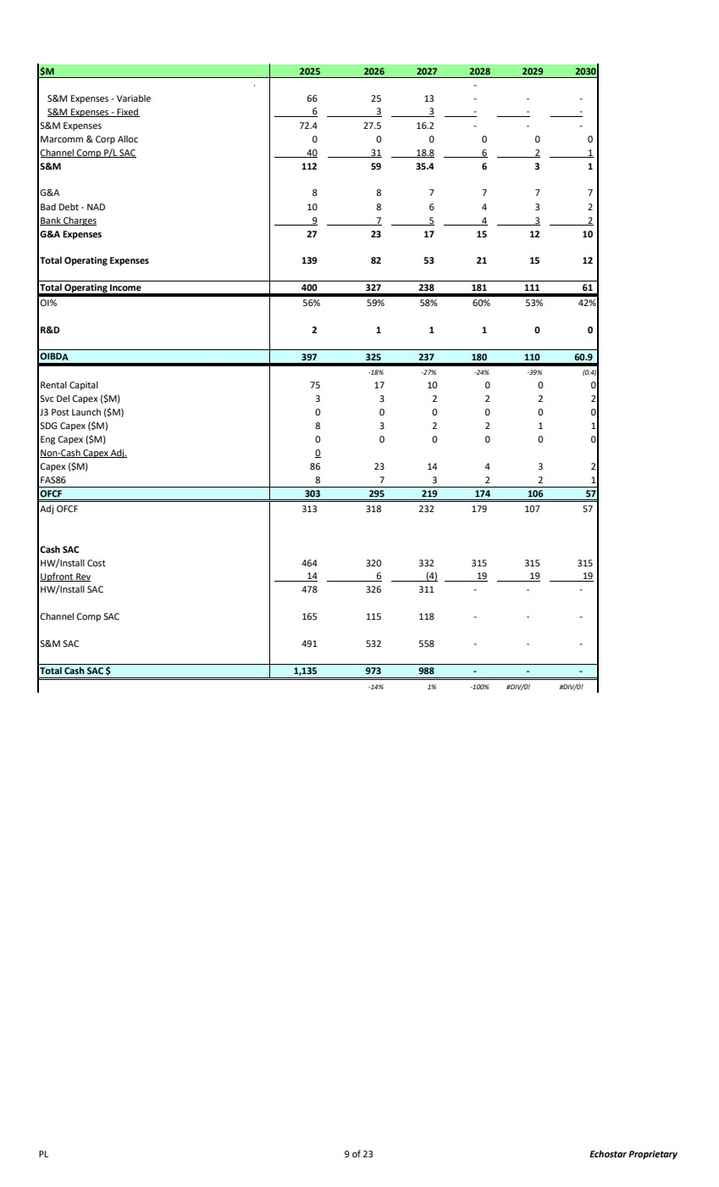 | $M 2025 2026 2027 2028 2029 2030 - S&M Expenses - Variable 66 25 13 - - - S&M Expenses - Fixed 6 3 3 - - - S&M Expenses 72.4 27.5 16.2 - - - Marcomm & Corp Alloc 0 0 0 0 0 0 Channel Comp P/L SAC 40 31 18.8 6 2 1 S&M 112 59 35.4 6 3 1 G&A 8 8 7 7 7 7 Bad Debt - NAD 10 8 6 4 3 2 Bank Charges 9 7 5 4 3 2 G&A Expenses 27 23 17 15 12 10 Total Operating Expenses 139 82 53 21 15 12 Total Operating Income 400 327 238 181 111 61 OI% 56% 59% 58% 60% 53% 42% R&D 2 1 1 1 0 0 OIBDA 325 397 237 180 110 60.9 -18% -27% -24% -39% (0.4) Rental Capital 75 17 10 0 0 0 Svc Del Capex ($M) 3 32222 J3 Post Launch ($M) 0 00000 SDG Capex ($M) 8 32211 Eng Capex ($M) 0 00000 Non-Cash Capex Adj. 0 Capex ($M) 86 23 14 4 3 2 FAS86 8 73221 OFCF 303 295 219 174 106 57 Adj OFCF 313 318 232 179 107 57 Cash SAC HW/Install Cost 464 320 332 315 315 315 Upfront Rev 14 6 (4) 19 19 19 HW/Install SAC 478 326 311 - - - Channel Comp SAC 165 115 118 - - - S&M SAC 491 532 558 - - - Total Cash SAC $ 1,135 973 988 - - - -14% 1% -100% #DIV/0! #DIV/0! PL 9 of 23 Echostar Proprietary
 | 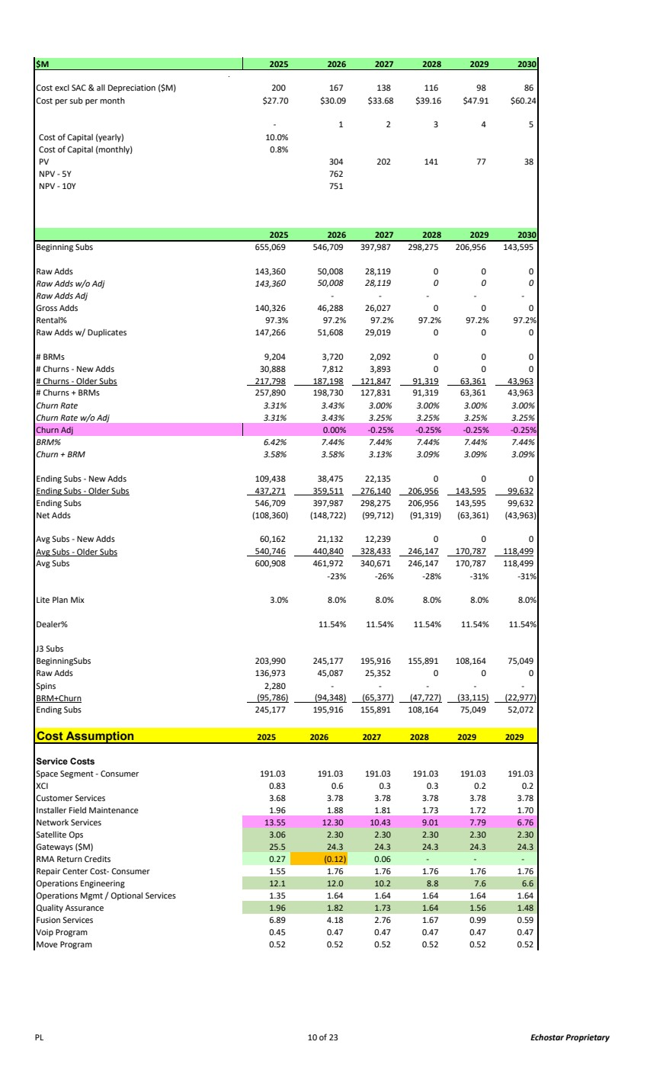 | $M 2025 2026 2027 2028 2029 2030 Cost excl SAC & all Depreciation ($M) 200 167 138 116 98 86 Cost per sub per month $27.70 $30.09 $33.68 $39.16 $47.91 $60.24 1 - 2 3 4 5 Cost of Capital (yearly) 10.0% Cost of Capital (monthly) 0.8% PV 304 202 141 77 38 NPV - 5Y 762 NPV - 10Y 751 2025 2026 2027 2028 2029 2030 Beginning Subs 655,069 546,709 397,987 298,275 206,956 143,595 Raw Adds 143,360 50,008 28,119 0 0 0 Raw Adds w/o Adj 143,36 50,008 0 28,119 0 0 0 Raw Adds Adj - - - - - Gross Adds 140,326 46,288 26,027 0 0 0 Rental% 97.3% 97.2% 97.2% 97.2% 97.2% 97.2% Raw Adds w/ Duplicates 147,266 51,608 29,019 0 0 0 # BRMs 9,204 3,720 2,092 0 0 0 # Churns - New Adds 30,888 7,812 3,893 0 0 0 # Churns - Older Subs 217,798 187,198 121,847 91,319 63,361 43,963 # Churns + BRMs 257,890 198,730 127,831 91,319 63,361 43,963 Churn Rate 3.31% 3.43% 3.00% 3.00% 3.00% 3.00% Churn Rate w/o Adj 3.31% 3.43% 3.25% 3.25% 3.25% 3.25% Churn Adj 0.00% -0.25% -0.25% -0.25% -0.25% BRM% 6.42% 7.44% 7.44% 7.44% 7.44% 7.44% Churn + BRM 3.58% 3.58% 3.13% 3.09% 3.09% 3.09% Ending Subs - New Adds 109,438 38,475 22,135 0 0 0 Ending Subs - Older Subs 437,271 359,511 276,140 206,956 143,595 99,632 Ending Subs 546,709 397,987 298,275 206,956 143,595 99,632 Net Adds (108,360) (148,722) (99,712) (91,319) (63,361) (43,963) Avg Subs - New Adds 60,162 21,132 12,239 0 0 0 Avg Subs - Older Subs 540,746 440,840 328,433 246,147 170,787 118,499 Avg Subs 600,908 461,972 340,671 246,147 170,787 118,499 -23% -26% -28% -31% -31% Lite Plan Mix 3.0% 8.0% 8.0% 8.0% 8.0% 8.0% Dealer% 11.54% 11.54% 11.54% 11.54% 11.54% J3 Subs BeginningSubs 203,990 245,177 195,916 155,891 108,164 75,049 Raw Adds 136,973 45,087 25,352 0 0 0 Spins 2,280 - - - - - BRM+Churn (95,786) (94,348) (65,377) (47,727) (33,115) (22,977) Ending Subs 245,177 195,916 155,891 108,164 75,049 52,072 Cost Assumption 2025 2026 2027 2028 2029 2029 Service Costs Space Segment - Consumer 191.03 191.03 191.03 191.03 191.03 191.03 XCI 0.83 0.6 0.3 0.3 0.2 0.2 Customer Services 3.68 3.78 3.78 3.78 3.78 3.78 Installer Field Maintenance 1.96 1.88 1.81 1.73 1.72 1.70 Network Services 13.55 12.30 10.43 9.01 7.79 6.76 Satellite Ops 3.06 2.30 2.30 2.30 2.30 2.30 Gateways ($M) 25.5 24.3 24.3 24.3 24.3 24.3 RMA Return Credits 0.27 (0.12) 0.06 - - - Repair Center Cost- Consumer 1.76 1.55 1.76 1.76 1.76 1.76 Operations Engineering 12.0 12.1 10.2 8.8 7.6 6.6 Operations Mgmt / Optional Services 1.35 1.64 1.64 1.64 1.64 1.64 Quality Assurance 1.96 1.82 1.73 1.64 1.56 1.48 Fusion Services 6.89 4.18 2.76 1.67 0.99 0.59 Voip Program 0.45 0.47 0.47 0.47 0.47 0.47 Move Program 0.52 0.52 0.52 0.52 0.52 0.52 PL 10 of 23 Echostar Proprietary
 | 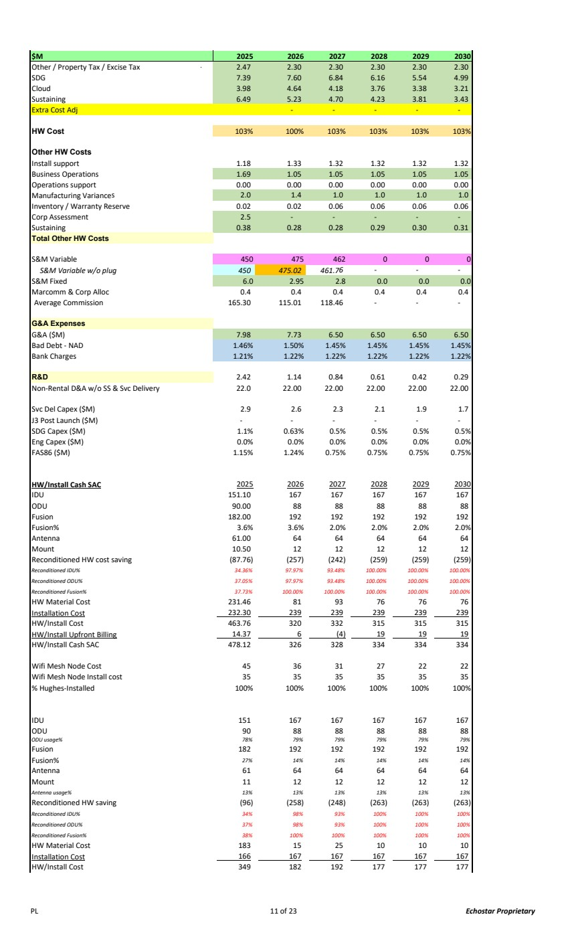 | $M 2025 2026 2027 2028 2029 2030 Other / Property Tax / Excise Tax 2.47 2.30 2.30 2.30 2.30 2.30 SDG 7.39 7.60 6.84 6.16 5.54 4.99 Cloud 3.98 4.64 4.18 3.76 3.38 3.21 Sustaining 6.49 5.23 4.70 4.23 3.81 3.43 Extra Cost Adj - - - - - HW Cost 103% 100% 103% 103% 103% 103% Other HW Costs Install support 1.18 1.33 1.32 1.32 1.32 1.32 Business Operations 1.69 1.05 1.05 1.05 1.05 1.05 Operations support 0.00 0.00 0.00 0.00 0.00 0.00 Manufacturing Variances 1.4 2.0 1.0 1.0 1.0 1.0 Inventory / Warranty Reserve 0.02 0.02 0.06 0.06 0.06 0.06 Corp Assessment 2.5 - - - - - Sustaining 0.38 0.28 0.28 0.29 0.30 0.31 Total Other HW Costs S&M Variable 450 475 462 0 0 0 S&M Variable w/o plug 450 475.02 461.7 - 6 - - S&M Fixed 6.0 2.95 2.8 0.0 0.0 0.0 Marcomm & Corp Alloc 0.4 0.4 0.4 0.4 0.4 0.4 Average Commission 165.30 115.01 118.46 - - - G&A Expenses G&A ($M) 7.98 7.73 6.50 6.50 6.50 6.50 Bad Debt - NAD 1.46% 1.50% 1.45% 1.45% 1.45% 1.45% Bank Charges 1.21% 1.22% 1.22% 1.22% 1.22% 1.22% R&D 1.14 2.42 0.84 0.61 0.42 0.29 Non-Rental D&A w/o SS & Svc Delivery 22.0 22.00 22.00 22.00 22.00 22.00 Svc Del Capex ($M) 2.9 2.6 2.3 2.1 1.9 1.7 J3 Post Launch ($M) - - - - - - SDG Capex ($M) 1.1% 0.63% 0.5% 0.5% 0.5% 0.5% Eng Capex ($M) 0.0% 0.0% 0.0% 0.0% 0.0% 0.0% FAS86 ($M) 1.15% 1.24% 0.75% 0.75% 0.75% 0.75% HW/Install Cash SAC 2025 2026 2027 2028 2029 2030 IDU 151.10 167 167 167 167 167 ODU 90.00 88 88 88 88 88 Fusion 182.00 192 192 192 192 192 Fusion% 3.6% 3.6% 2.0% 2.0% 2.0% 2.0% Antenna 61.00 64 64 64 64 64 Mount 10.50 12 12 12 12 12 Reconditioned HW cost saving (87.76) (257) (242) (259) (259) (259) Reconditioned IDU% 34.36% 97.97% 93.48% 100.00% 100.00% 100.00% Reconditioned ODU% 37.05% 97.97% 93.48% 100.00% 100.00% 100.00% Reconditioned Fusion% 37.73% 100.00% 100.00% 100.00% 100.00% 100.00% HW Material Cost 231.46 81 93 76 76 76 Installation Cost 232.30 239 239 239 239 239 HW/Install Cost 463.76 320 332 315 315 315 HW/Install Upfront Billing 14.37 6 (4) 19 19 19 HW/Install Cash SAC 478.12 326 328 334 334 334 Wifi Mesh Node Cost 45 36 31 27 22 22 Wifi Mesh Node Install cost 35 35 35 35 35 35 % Hughes-Installed 100% 100% 100% 100% 100% 100% IDU 151 167 167 167 167 167 ODU 90 88 88 88 88 88 ODU usage% 78% 79% 79% 79% 79% 79% Fusion 182 192 192 192 192 192 Fusion% 27% 14% 14% 14% 14% 14% Antenna 61 64 64 64 64 64 Mount 11 12 12 12 12 12 Antenna usage% 13% 13% 13% 13% 13% 13% Reconditioned HW saving (96) (258) (248) (263) (263) (263) Reconditioned IDU% 34% 98% 93% 100% 100% 100% Reconditioned ODU% 37% 98% 93% 100% 100% 100% Reconditioned Fusion% 38% 100% 100% 100% 100% 100% HW Material Cost 183 15 25 10 10 10 Installation Cost 166 167 167 167 167 167 HW/Install Cost 349 182 192 177 177 177 PL 11 of 23 Echostar Proprietary
 | 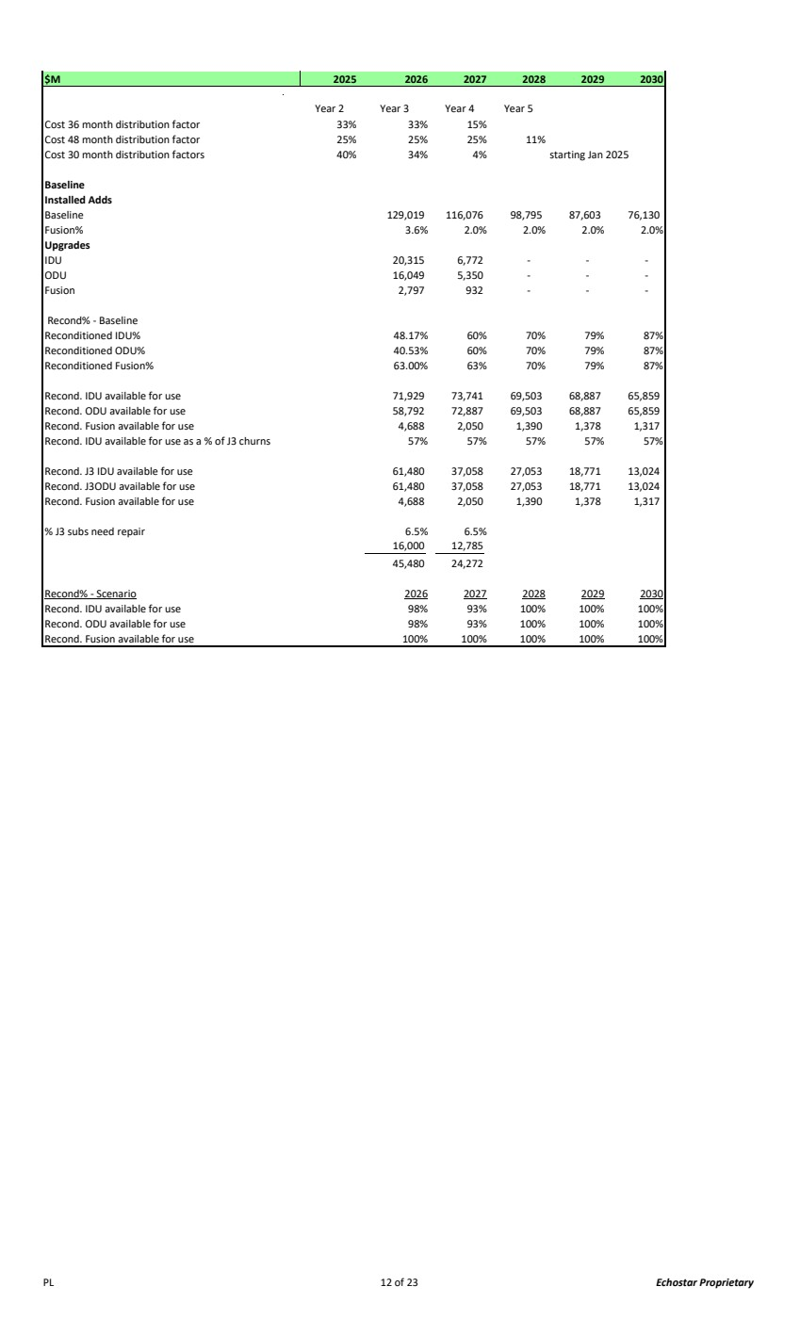 | $M 2025 2026 2027 2028 2029 2030 Year 2 Year 3 Year 4 Year 5 Cost 36 month distribution factor 33% 33% 15% Cost 48 month distribution factor 25% 25% 25% 11% Cost 30 month distribution factors 40% 34% 4% starting Jan 2025 Baseline Installed Adds Baseline 129,019 116,076 98,795 87,603 76,130 Fusion% 3.6% 2.0% 2.0% 2.0% 2.0% Upgrades IDU 20,315 6,772 - - - ODU 16,049 5,350 - - - Fusion 2,797 932 - - - Recond% - Baseline Reconditioned IDU% 48.17% 60% 70% 79% 87% Reconditioned ODU% 40.53% 60% 70% 79% 87% Reconditioned Fusion% 63.00% 63% 70% 79% 87% Recond. IDU available for use 71,929 73,741 69,503 68,887 65,859 Recond. ODU available for use 58,792 72,887 69,503 68,887 65,859 Recond. Fusion available for use 4,688 2,050 1,390 1,378 1,317 Recond. IDU available for use as a % of J3 churns 57% 57% 57% 57% 57% Recond. J3 IDU available for use 61,480 37,058 27,053 18,771 13,024 Recond. J3ODU available for use 61,480 37,058 27,053 18,771 13,024 Recond. Fusion available for use 4,688 2,050 1,390 1,378 1,317 % J3 subs need repair 6.5% 6.5% 12,785 16,000 24,272 45,480 Recond% - Scenario 2026 2027 2028 2029 2030 Recond. IDU available for use 98% 93% 100% 100% 100% Recond. ODU available for use 98% 93% 100% 100% 100% Recond. Fusion available for use 100% 100% 100% 100% 100% PL 12 of 23 Echostar Proprietary
 | 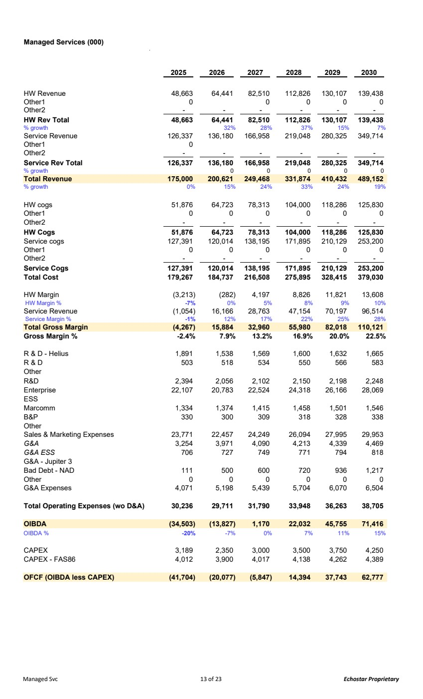 | Managed Services (000) 2025 2026 2027 2028 2029 2030 HW Revenue 48,663 64,441 82,510 112,826 130,107 139,438 Other1 0 0 0 0 0 Other2 - - - - - - HW Rev Total 48,663 64,441 82,510 112,826 130,107 139,438 % growth 32% 28% 37% 15% 7% Service Revenue 126,337 136,180 166,958 219,048 280,325 349,714 Other1 0 Other2 - - - - - - Service Rev Total 126,337 136,180 166,958 219,048 280,325 349,714 % growth 00 000 Total Revenue 175,000 200,621 249,468 331,874 410,432 489,152 % growth 0% 15% 24% 33% 24% 19% HW cogs 51,876 64,723 78,313 104,000 118,286 125,830 Other1 0 0 0 0 0 0 Other2 - - - - - - HW Cogs 51,876 64,723 78,313 104,000 118,286 125,830 Service cogs 127,391 120,014 138,195 171,895 210,129 253,200 Other1 0 0 0 0 0 0 Other2 - - - - - - Service Cogs 127,391 120,014 138,195 171,895 210,129 253,200 Total Cost 179,267 184,737 216,508 275,895 328,415 379,030 HW Margin (3,213) (282) 4,197 8,826 11,821 13,608 HW Margin % -7% 0% 5% 8% 9% 10% Service Revenue (1,054) 16,166 28,763 47,154 70,197 96,514 Service Margin % -1% 12% 17% 22% 25% 28% Total Gross Margin (4,267) 15,884 32,960 55,980 82,018 110,121 Gross Margin % -2.4% 7.9% 13.2% 16.9% 20.0% 22.5% R & D - Helius 1,891 1,538 1,569 1,600 1,632 1,665 R & D 503 518 534 550 566 583 Other R&D 2,394 2,056 2,102 2,150 2,198 2,248 Enterprise 22,107 20,783 22,524 24,318 26,166 28,069 ESS Marcomm 1,334 1,374 1,415 1,458 1,501 1,546 B&P 330 300 309 318 328 338 Other Sales & Marketing Expenses 23,771 22,457 24,249 26,094 27,995 29,953 G&A 3,254 3,971 4,090 4,213 4,339 4,469 G&A ESS 706 727 749 771 794 818 G&A - Jupiter 3 Bad Debt - NAD 111 500 600 720 936 1,217 Other 0 0 0 0 0 0 G&A Expenses 4,071 5,198 5,439 5,704 6,070 6,504 Total Operating Expenses (wo D&A) 30,236 29,711 31,790 33,948 36,263 38,705 OIBDA (34,503) (13,827) 1,170 22,032 45,755 71,416 OIBDA % -20% -7% 0% 7% 11% 15% CAPEX 3,189 2,350 3,000 3,500 3,750 4,250 CAPEX - FAS86 4,012 3,900 4,017 4,138 4,262 4,389 OFCF (OIBDA less CAPEX) (41,704) (20,077) (5,847) 14,394 37,743 62,777 Managed Svc 13 of 23 Echostar Proprietary
 | 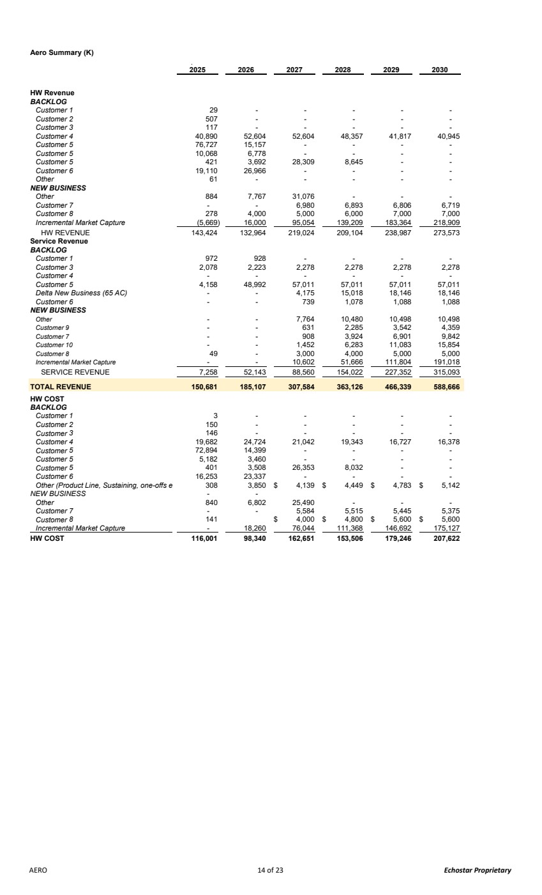 | Aero Summary (K) 2025 2026 2027 2028 2029 2030 HW Revenue BACKLOG Customer 1 - 29 - - - - Customer 2 - 507 - - - - Customer 3 - 117 - - - - Customer 4 52,604 40,890 52,604 48,357 41,817 40,945 Customer 5 15,157 76,727 - - - - Customer 5 6,778 10,068 - - - - Customer 5 3,692 421 28,309 8,645 - - Customer 6 26,966 19,110 - - - - Other - 61 - - - - NEW BUSINESS Other 7,767 884 31,076 - - - Customer 7 - - 6,980 6,893 6,806 6,719 Customer 8 4,000 278 5,000 6,000 7,000 7,000 Incremental Market Capture 16,000 (5,669) 95,054 139,209 183,364 218,909 HW REVENUE 143,424 132,964 219,024 209,104 238,987 273,573 Service Revenue BACKLOG Customer 1 928 972 - - - - Customer 3 2,223 2,078 2,278 2,278 2,278 2,278 Customer 4 - - - - - - Customer 5 48,992 4,158 57,011 57,011 57,011 57,011 Delta New Business (65 AC) - - 4,175 15,018 18,146 18,146 Customer 6 - - 739 1,078 1,088 1,088 NEW BUSINESS Other - - 7,764 10,480 10,498 10,498 Customer 9 - - 631 2,285 3,542 4,359 Customer 7 - - 908 3,924 6,901 9,842 Customer 10 - - 1,452 6,283 11,083 15,854 Customer 8 - 49 3,000 4,000 5,000 5,000 Incremental Market Capture - - 10,602 51,666 111,804 191,018 SERVICE REVENUE 7,258 52,143 88,560 154,022 227,352 315,093 TOTAL REVENUE 150,681 185,107 307,584 363,126 466,339 588,666 HW COST BACKLOG Customer 1 - 3 - - - - Customer 2 - 150 - - - - Customer 3 - 146 - - - - Customer 4 24,724 19,682 21,042 19,343 16,727 16,378 Customer 5 14,399 72,894 - - - - Customer 5 3,460 5,182 - - - - Customer 5 3,508 401 26,353 8,032 - - Customer 6 23,337 16,253 - - - - Other (Product Line, Sustaining, one-offs e 3,850 308 4,139 $ 4,449 $ 4,783 $ 5,142 $ NEW BUSINESS - - Other 6,802 840 25,490 - - - Customer 7 - - 5,584 5,515 5,445 5,375 Customer 8 4,000 141 $ 4,800 $ 5,600 $ 5,600 $ Incremental Market Capture - 18,260 76,044 111,368 146,692 175,127 HW COST 116,001 98,340 162,651 153,506 179,246 207,622 AERO 14 of 23 Echostar Proprietary
 | 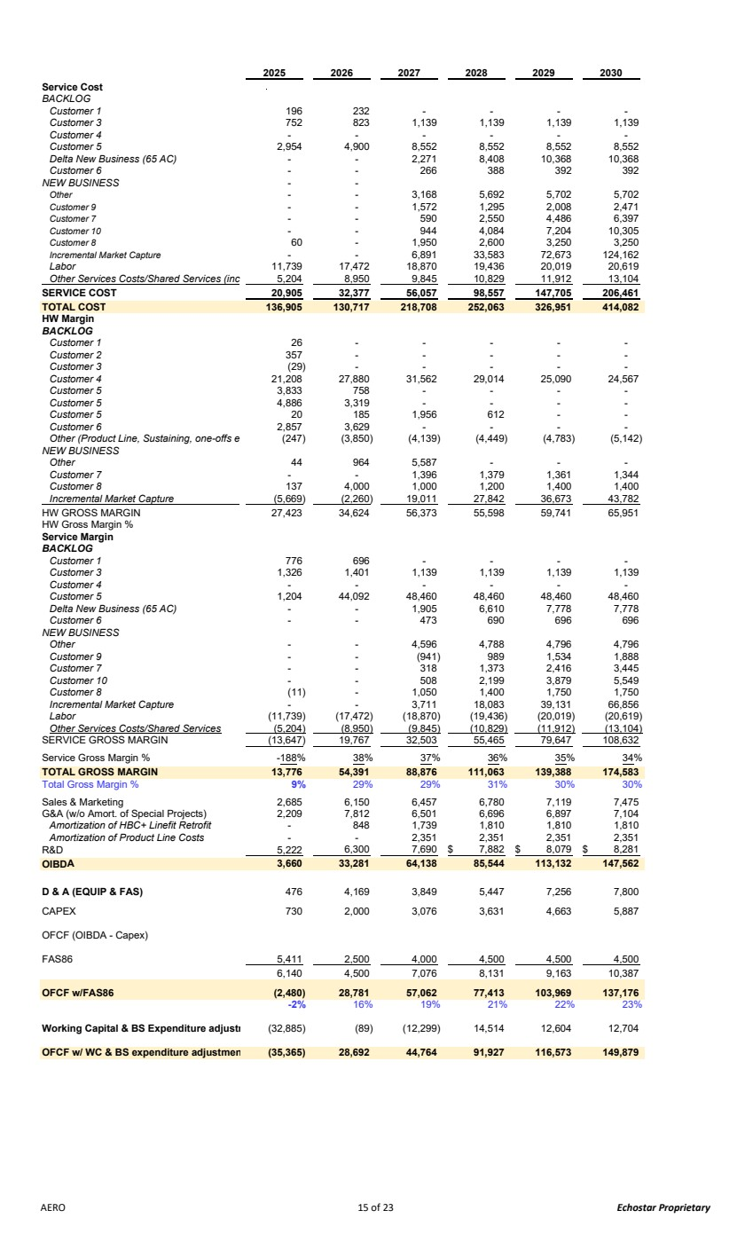 | 2025 2026 2027 2028 2029 2030 Service Cost BACKLOG Customer 1 232 196 - - - - Customer 3 823 752 1,139 1,139 1,139 1,139 Customer 4 - - - - - - Customer 5 4,900 2,954 8,552 8,552 8,552 8,552 Delta New Business (65 AC) - - 2,271 8,408 10,368 10,368 Customer 6 - - 266 388 392 392 NEW BUSINESS - - Other - - 3,168 5,692 5,702 5,702 Customer 9 - - 1,572 1,295 2,008 2,471 Customer 7 - - 590 2,550 4,486 6,397 Customer 10 - - 944 4,084 7,204 10,305 Customer 8 - 60 1,950 2,600 3,250 3,250 Incremental Market Capture - - 6,891 33,583 72,673 124,162 Labor 17,472 11,739 18,870 19,436 20,019 20,619 Other Services Costs/Shared Services (inc 8,950 5,204 9,845 10,829 11,912 13,104 SERVICE COST 32,377 20,905 56,057 98,557 147,705 206,461 TOTAL COST 130,717 136,905 218,708 252,063 326,951 414,082 HW Margin BACKLOG Customer 1 - 26 - - - - Customer 2 - 357 - - - - Customer 3 - (29) - - - - Customer 4 27,880 21,208 31,562 29,014 25,090 24,567 Customer 5 758 3,833 - - - - Customer 5 3,319 4,886 - - - - Customer 5 185 20 1,956 612 - - Customer 6 3,629 2,857 - - - - Other (Product Line, Sustaining, one-offs e (3,850) (247) (4,139) (4,449) (4,783) (5,142) NEW BUSINESS Other 964 44 5,587 - - - Customer 7 - - 1,396 1,379 1,361 1,344 Customer 8 4,000 137 1,000 1,200 1,400 1,400 Incremental Market Capture (5,669) (2,260) 19,011 27,842 36,673 43,782 HW GROSS MARGIN 27,423 34,624 56,373 55,598 59,741 65,951 HW Gross Margin % Service Margin BACKLOG Customer 1 696 776 - - - - Customer 3 1,401 1,326 1,139 1,139 1,139 1,139 Customer 4 - - - - - - Customer 5 44,092 1,204 48,460 48,460 48,460 48,460 Delta New Business (65 AC) - - 1,905 6,610 7,778 7,778 Customer 6 - - 473 690 696 696 NEW BUSINESS Other - - 4,596 4,788 4,796 4,796 Customer 9 - - (941) 989 1,534 1,888 Customer 7 - - 318 1,373 2,416 3,445 Customer 10 - - 508 2,199 3,879 5,549 Customer 8 - (11) 1,050 1,400 1,750 1,750 Incremental Market Capture - - 3,711 18,083 39,131 66,856 Labor (17,472) (11,739) (18,870) (19,436) (20,019) (20,619) Other Services Costs/Shared Services (5,204) (8,950) (9,845) (10,829) (11,912) (13,104) SERVICE GROSS MARGIN (13,647) 19,767 32,503 55,465 79,647 108,632 Service Gross Margin % -188% 38% 37% 36% 35% 34% TOTAL GROSS MARGIN 54,391 13,776 88,876 111,063 139,388 174,583 Total Gross Margin % 9% 29% 29% 31% 30% 30% Sales & Marketing 2,685 6,150 6,457 6,780 7,119 7,475 G&A (w/o Amort. of Special Projects) 2,209 7,812 6,501 6,696 6,897 7,104 Amortization of HBC+ Linefit Retrofit 848 - 1,739 1,810 1,810 1,810 Amortization of Product Line Costs - - 2,351 2,351 2,351 2,351 R&D 5,222 6,300 7,690 7,882 $ 8,079 $ 8,281 $ OIBDA 33,281 3,660 64,138 85,544 113,132 147,562 D & A (EQUIP & FAS) 4,169 476 3,849 5,447 7,256 7,800 CAPEX 2,000 730 3,076 3,631 4,663 5,887 OFCF (OIBDA - Capex) FAS86 5,411 2,500 4,000 4,500 4,500 4,500 4,500 6,140 7,076 8,131 9,163 10,387 OFCF w/FAS86 (2,480) 28,781 57,062 77,413 103,969 137,176 -2% 16% 19% 21% 22% 23% Working Capital & BS Expenditure adjustm (89) (32,885) (12,299) 14,514 12,604 12,704 OFCF w/ WC & BS expenditure adjustmen 28,692 (35,365) 44,764 91,927 116,573 149,879 AERO 15 of 23 Echostar Proprietary
 | 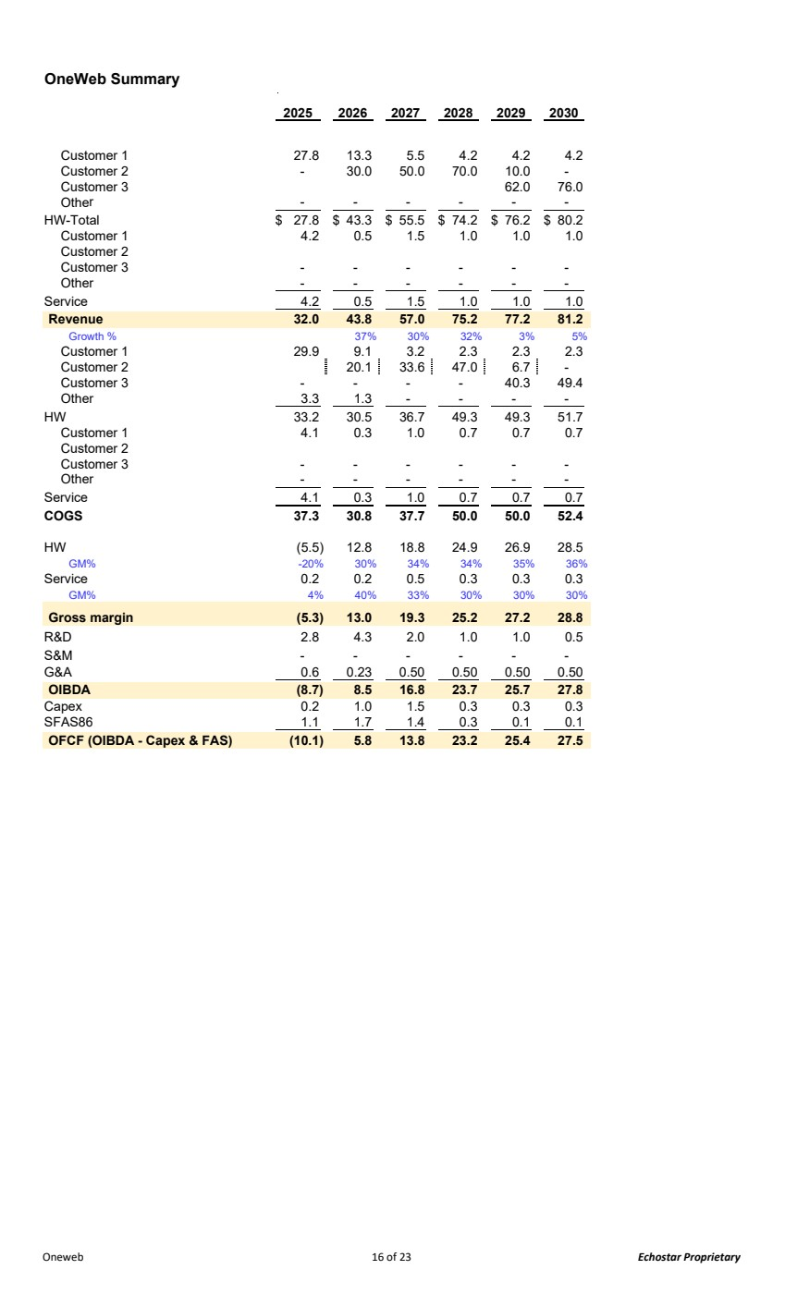 | OneWeb Summary 2025 2026 2027 2028 2029 2030 Customer 1 27.8 13.3 5.5 4.2 4.2 4.2 Customer 2 - 30.0 50.0 70.0 10.0 - Customer 3 62.0 76.0 Other - - - - - - HW-Total 27.8 $ 43.3 $ 55.5 $ 74.2 $ 76.2 $ 80.2 $ Customer 1 4.2 0.5 1.5 1.0 1.0 1.0 Customer 2 Customer 3 - - - - - - Other - - - - - - Service 4.2 0.5 1.5 1.0 1.0 1.0 Revenue 32.0 43.8 57.0 75.2 77.2 81.2 Growth % 37% 30% 32% 3% 5% Customer 1 29.9 9.1 3.2 2.3 2.3 2.3 Customer 2 20.1 33.6 47.0 6.7 - Customer 3 - - - - 40.3 49.4 Other 3.3 1.3 - - - - HW 33.2 30.5 36.7 49.3 49.3 51.7 Customer 1 4.1 0.3 1.0 0.7 0.7 0.7 Customer 2 Customer 3 - - - - - - Other - - - - - - Service 4.1 0.3 1.0 0.7 0.7 0.7 COGS 37.3 30.8 37.7 50.0 50.0 52.4 HW (5.5) 12.8 18.8 24.9 26.9 28.5 GM% -20% 30% 34% 34% 35% 36% Service 0.2 0.2 0.5 0.3 0.3 0.3 GM% 4% 40% 33% 30% 30% 30% Gross margin (5.3) 13.0 19.3 25.2 27.2 28.8 R&D 2.8 4.3 2.0 1.0 1.0 0.5 S&M - - - - - - G&A 0.6 0.23 0.50 0.50 0.50 0.50 OIBDA (8.7) 8.5 16.8 23.7 25.7 27.8 Capex 0.2 1.0 1.5 0.3 0.3 0.3 SFAS86 1.1 1.7 1.4 0.3 0.1 0.1 OFCF (OIBDA - Capex & FAS) (10.1) 5.8 13.8 23.2 25.4 27.5 Oneweb 16 of 23 Echostar Proprietary
 | 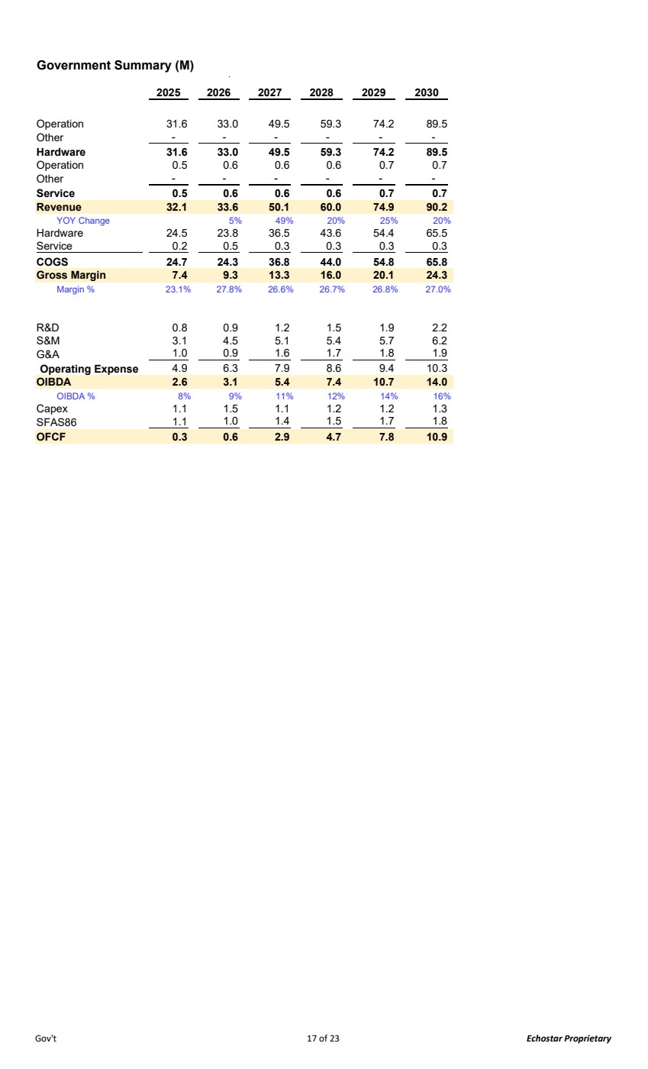 | Government Summary (M) 2025 2026 2027 2028 2029 2030 Operation 31.6 33.0 49.5 59.3 74.2 89.5 Other - - - - - - Hardware 31.6 33.0 49.5 59.3 74.2 89.5 Operation 0.5 0.6 0.6 0.6 0.7 0.7 Other - - - - - - Service 0.5 0.6 0.6 0.6 0.7 0.7 Revenue 32.1 33.6 50.1 60.0 74.9 90.2 YOY Change 5% 49% 20% 25% 20% Hardware 24.5 23.8 36.5 43.6 54.4 65.5 Service 0.5 0.2 0.3 0.3 0.3 0.3 COGS 24.7 24.3 36.8 44.0 54.8 65.8 Gross Margin 7.4 9.3 13.3 16.0 20.1 24.3 Margin % 23.1% 27.8% 26.6% 26.7% 26.8% 27.0% R&D 0.8 0.9 1.2 1.5 1.9 2.2 S&M 3.1 4.5 5.1 5.4 5.7 6.2 G&A 0.9 1.0 1.6 1.7 1.8 1.9 Operating Expense 6.3 4.9 7.9 8.6 9.4 10.3 OIBDA 2.6 3.1 5.4 7.4 10.7 14.0 OIBDA % 8% 9% 11% 12% 14% 16% Capex 1.1 1.5 1.1 1.2 1.2 1.3 SFAS86 1.0 1.1 1.4 1.5 1.7 1.8 OFCF 0.3 0.6 2.9 4.7 7.8 10.9 Gov't 17 of 23 Echostar Proprietary
 | 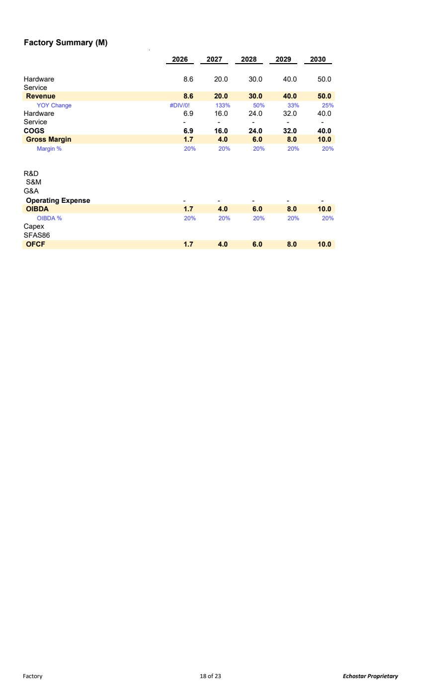 | Factory Summary (M) 2026 2027 2028 2029 2030 Hardware 8.6 20.0 30.0 40.0 50.0 Service Revenue 8.6 20.0 30.0 40.0 50.0 YOY Change #DIV/0! 133% 50% 33% 25% Hardware 6.9 16.0 24.0 32.0 40.0 Service - - - - - COGS 6.9 16.0 24.0 32.0 40.0 Gross Margin 1.7 4.0 6.0 8.0 10.0 Margin % 20% 20% 20% 20% 20% R&D S&M G&A Operating Expense - - - - - OIBDA 1.7 4.0 6.0 8.0 10.0 OIBDA % 20% 20% 20% 20% 20% Capex SFAS86 OFCF 1.7 4.0 6.0 8.0 10.0 Factory 18 of 23 Echostar Proprietary
 | 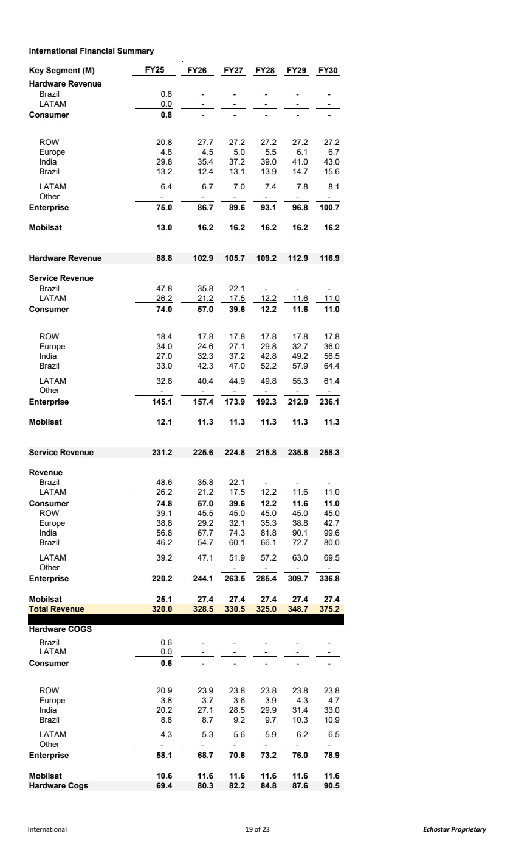 | International Financial Summary Key Segment (M) FY25 FY26 FY27 FY28 FY29 FY30 Hardware Revenue Brazil 0.8 - - - - - LATAM 0.0 - - - - - Consumer - 0.8 - - - - ROW 20.8 27.7 27.2 27.2 27.2 27.2 Europe 4.8 4.5 5.0 5.5 6.1 6.7 India 29.8 35.4 37.2 39.0 41.0 43.0 Brazil 13.2 12.4 13.1 13.9 14.7 15.6 LATAM 6.4 6.7 7.0 7.4 7.8 8.1 Other - - - - - - Enterprise 75.0 86.7 89.6 93.1 96.8 100.7 Mobilsat 13.0 16.2 16.2 16.2 16.2 16.2 Hardware Revenue 88.8 102.9 105.7 109.2 112.9 116.9 Service Revenue Brazil 47.8 35.8 22.1 - - - LATAM 26.2 21.2 17.5 12.2 11.6 11.0 Consumer 57.0 74.0 39.6 12.2 11.6 11.0 ROW 18.4 17.8 17.8 17.8 17.8 17.8 Europe 34.0 24.6 27.1 29.8 32.7 36.0 India 27.0 32.3 37.2 42.8 49.2 56.5 Brazil 33.0 42.3 47.0 52.2 57.9 64.4 LATAM 32.8 40.4 44.9 49.8 55.3 61.4 Other - - - - - - Enterprise 145.1 157. 173.9 4 192.3 212.9 236.1 Mobilsat 12.1 11.3 11.3 11.3 11.3 11.3 Service Revenue 225.6 231.2 224.8 215.8 235.8 258.3 Revenue Brazil 48.6 35.8 22.1 - - - LATAM 26.2 21.2 17.5 12.2 11.6 11.0 Consumer 57.0 74.8 39.6 12.2 11.6 11.0 ROW 39.1 45.5 45.0 45.0 45.0 45.0 Europe 38.8 29.2 32.1 35.3 38.8 42.7 India 56.8 67.7 74.3 81.8 90.1 99.6 Brazil 46.2 54.7 60.1 66.1 72.7 80.0 LATAM 39.2 47.1 51.9 57.2 63.0 69.5 Other - - - - Enterprise 220.2 244.1 263.5 285. 309.7 4 336.8 Mobilsat 25.1 27.4 27.4 27.4 27.4 27.4 Total Revenue 320.0 328.5 330.5 325.0 348.7 375.2 Hardware COGS Brazil 0.6 - - - - - LATAM 0.0 - - - - - Consumer - 0.6 - - - - ROW 20.9 23.9 23.8 23.8 23.8 23.8 Europe 3.8 3.7 3.6 3.9 4.3 4.7 India 20.2 27.1 28.5 29.9 31.4 33.0 Brazil 8.8 8.7 9.2 9.7 10.3 10.9 LATAM 4.3 5.3 5.6 5.9 6.2 6.5 Other - - - - - - Enterprise 58.1 68.7 70.6 73.2 76.0 78.9 Mobilsat 10.6 11.6 11.6 11.6 11.6 11.6 Hardware Cogs 69.4 80.3 82.2 84.8 87.6 90.5 International 19 of 23 Echostar Proprietary
 | 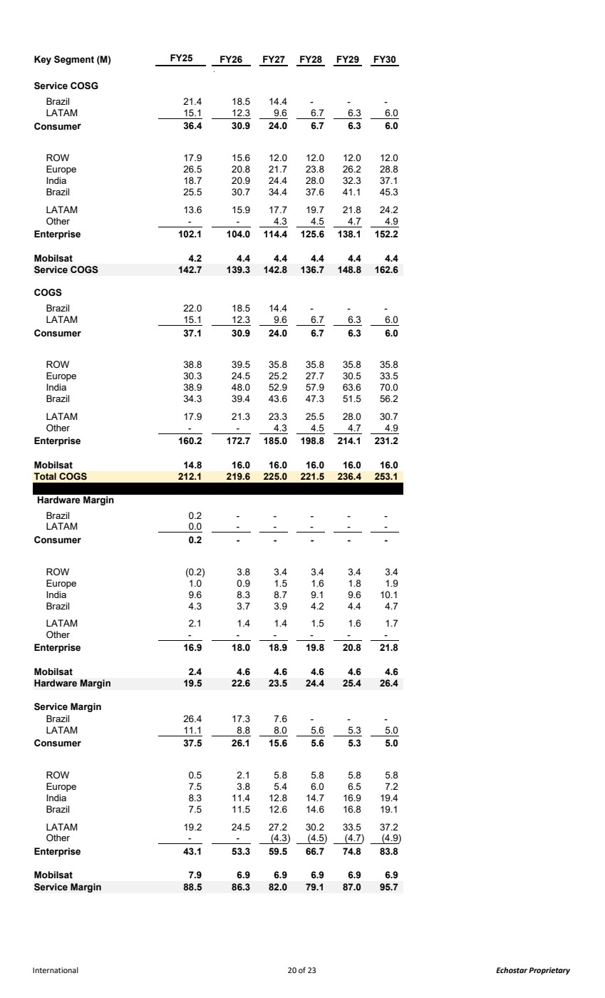 | Key Segment (M) FY25 FY26 FY27 FY28 FY29 FY30 Service COSG Brazil 21.4 18.5 14.4 - - - LATAM 15.1 12.3 9.6 6.7 6.3 6.0 Consumer 30.9 36.4 24.0 6.7 6.3 6.0 ROW 17.9 15.6 12.0 12.0 12.0 12.0 Europe 26.5 20.8 21.7 23.8 26.2 28.8 India 18.7 20.9 24.4 28.0 32.3 37.1 Brazil 25.5 30.7 34.4 37.6 41.1 45.3 LATAM 13.6 15.9 17.7 19.7 21.8 24.2 Other - - 4.3 4.5 4.7 4.9 Enterprise 102.1 104.0 114. 125.6 4 138.1 152.2 Mobilsat 4.2 4.4 4.4 4.4 4.4 4.4 Service COGS 139.3 142.7 142.8 136.7 148.8 162.6 COGS Brazil 22.0 18.5 14.4 - - - LATAM 15.1 12.3 9.6 6.7 6.3 6.0 Consumer 30.9 37.1 24.0 6.7 6.3 6.0 ROW 38.8 39.5 35.8 35.8 35.8 35.8 Europe 30.3 24.5 25.2 27.7 30.5 33.5 India 38.9 48.0 52.9 57.9 63.6 70.0 Brazil 34.3 39.4 43.6 47.3 51.5 56.2 LATAM 17.9 21.3 23.3 25.5 28.0 30.7 Other - - 4.3 4.5 4.7 4.9 Enterprise 160.2 172.7 185.0 198.8 214.1 231.2 Mobilsat 14.8 16.0 16.0 16.0 16.0 16.0 Total COGS 212.1 219.6 225.0 221.5 236. 253.1 4 Hardware Margin Brazil 0.2 - - - - - LATAM 0.0 - - - - - Consumer - 0.2 - - - - ROW (0.2) 3.8 3.4 3.4 3.4 3.4 Europe 1.0 0.9 1.5 1.6 1.8 1.9 India 9.6 8.3 8.7 9.1 9.6 10.1 Brazil 4.3 3.7 3.9 4.2 4.4 4.7 LATAM 2.1 1.4 1.4 1.5 1.6 1.7 Other - - - - - - Enterprise 16.9 18.0 18.9 19.8 20.8 21.8 Mobilsat 2.4 4.6 4.6 4.6 4.6 4.6 Hardware Margin 19.5 22.6 23.5 24.4 25.4 26.4 Service Margin Brazil 26.4 17.3 7.6 - - - LATAM 11.1 8.8 8.0 5.6 5.3 5.0 Consumer 26.1 37.5 15.6 5.6 5.3 5.0 ROW 0.5 2.1 5.8 5.8 5.8 5.8 Europe 7.5 3.8 5.4 6.0 6.5 7.2 India 8.3 11.4 12.8 14.7 16.9 19.4 Brazil 7.5 11.5 12.6 14.6 16.8 19.1 LATAM 19.2 24.5 27.2 30.2 33.5 37.2 Other - - (4.3) (4.5) (4.7) (4.9) Enterprise 43.1 53.3 59.5 66.7 74.8 83.8 Mobilsat 7.9 6.9 6.9 6.9 6.9 6.9 Service Margin 88.5 86.3 82.0 79.1 87.0 95.7 International 20 of 23 Echostar Proprietary
 | 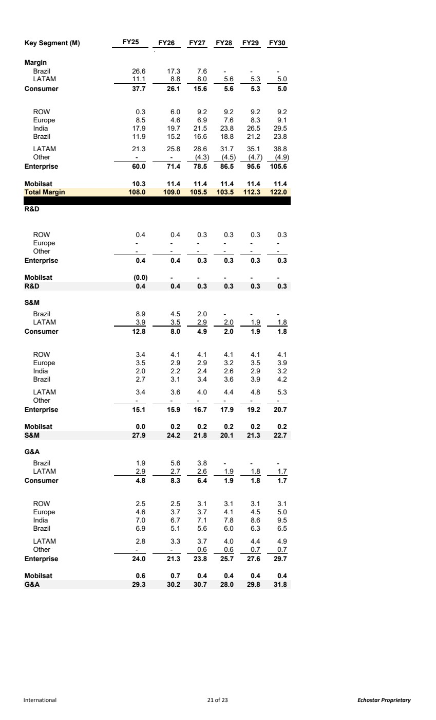 | Key Segment (M) FY25 FY26 FY27 FY28 FY29 FY30 Margin Brazil 26.6 17.3 7.6 - - - LATAM 11.1 8.8 8.0 5.6 5.3 5.0 Consumer 26.1 37.7 15.6 5.6 5.3 5.0 ROW 0.3 6.0 9.2 9.2 9.2 9.2 Europe 8.5 4.6 6.9 7.6 8.3 9.1 India 17.9 19.7 21.5 23.8 26.5 29.5 Brazil 11.9 15.2 16.6 18.8 21.2 23.8 LATAM 21.3 25.8 28.6 31.7 35.1 38.8 Other - - (4.3) (4.5) (4.7) (4.9) Enterprise 60.0 71.4 78.5 86.5 95.6 105.6 Mobilsat 10.3 11.4 11.4 11.4 11.4 11.4 Total Margin 108.0 109.0 105.5 103.5 112.3 122.0 R&D ROW 0.4 0.4 0.3 0.3 0.3 0.3 Europe - - - - - - Other - - - - - - Enterprise 0.4 0.4 0.3 0.3 0.3 0.3 Mobilsat (0.0) - - - - - R&D 0.4 0.4 0.3 0.3 0.3 0.3 S&M Brazil 8.9 4.5 2.0 - - - LATAM 3.9 3.5 2.9 2.0 1.9 1.8 Consumer 8.0 12.8 4.9 2.0 1.9 1.8 ROW 3.4 4.1 4.1 4.1 4.1 4.1 Europe 3.5 2.9 2.9 3.2 3.5 3.9 India 2.0 2.2 2.4 2.6 2.9 3.2 Brazil 2.7 3.1 3.4 3.6 3.9 4.2 LATAM 3.4 3.6 4.0 4.4 4.8 5.3 Other - - - - - - Enterprise 15.1 15.9 16.7 17.9 19.2 20.7 Mobilsat 0.0 0.2 0.2 0.2 0.2 0.2 S&M 27.9 24.2 21.8 20.1 21.3 22.7 G&A Brazil 1.9 5.6 3.8 - - - LATAM 2.9 2.7 2.6 1.9 1.8 1.7 Consumer 8.3 4.8 6.4 1.9 1.8 1.7 ROW 2.5 2.5 3.1 3.1 3.1 3.1 Europe 4.6 3.7 3.7 4.1 4.5 5.0 India 7.0 6.7 7.1 7.8 8.6 9.5 Brazil 6.9 5.1 5.6 6.0 6.3 6.5 LATAM 2.8 3.3 3.7 4.0 4.4 4.9 Other - - 0.6 0.6 0.7 0.7 Enterprise 24.0 21.3 23.8 25.7 27.6 29.7 Mobilsat 0.6 0.7 0.4 0.4 0.4 0.4 G&A 30.2 29.3 30.7 28.0 29.8 31.8 International 21 of 23 Echostar Proprietary
 | 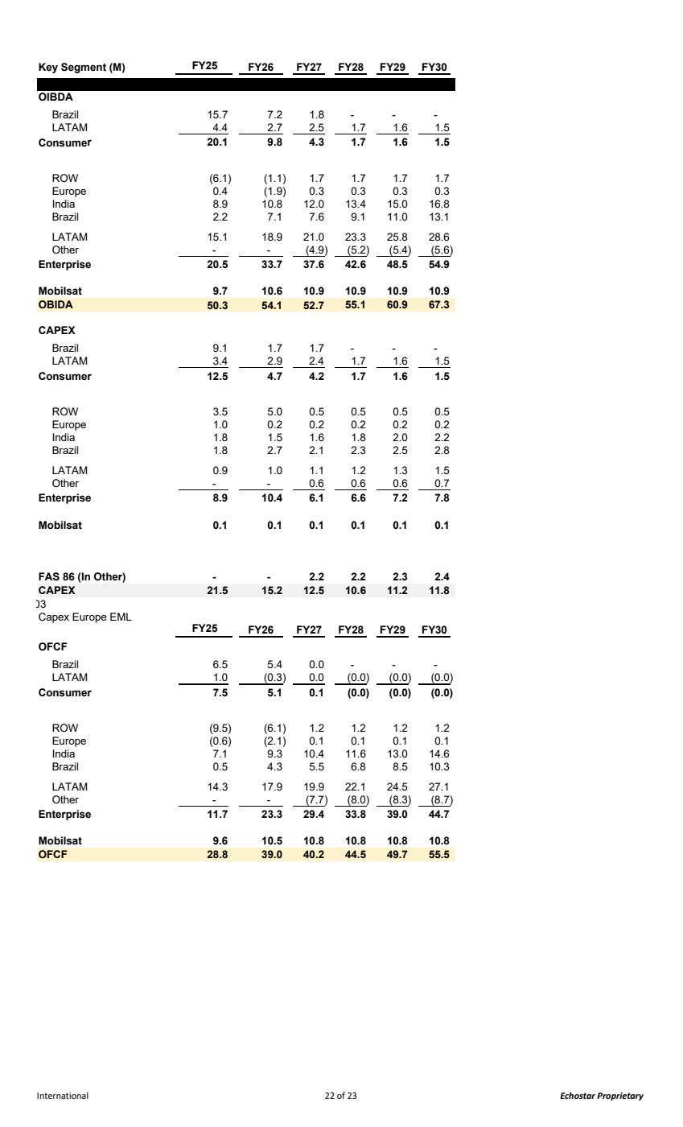 | Key Segment (M) FY25 FY26 FY27 FY28 FY29 FY30 OIBDA Brazil 15.7 7.2 1.8 - - - LATAM 4.4 2.7 2.5 1.7 1.6 1.5 Consumer 9.8 20.1 4.3 1.7 1.6 1.5 ROW (6.1) (1.1) 1.7 1.7 1.7 1.7 Europe 0.4 (1.9) 0.3 0.3 0.3 0.3 India 8.9 10.8 12.0 13.4 15.0 16.8 Brazil 2.2 7.1 7.6 9.1 11.0 13.1 LATAM 15.1 18.9 21.0 23.3 25.8 28.6 Other - - (4.9) (5.2) (5.4) (5.6) Enterprise 20.5 33.7 37.6 42.6 48.5 54.9 Mobilsat 9.7 10.6 10.9 10.9 10.9 10.9 OBIDA 54.1 50.3 52.7 60.9 55.1 67.3 CAPEX Brazil 9.1 1.7 1.7 - - - LATAM 3.4 2.9 2.4 1.7 1.6 1.5 Consumer 4.7 12.5 4.2 1.7 1.6 1.5 ROW 3.5 5.0 0.5 0.5 0.5 0.5 Europe 1.0 0.2 0.2 0.2 0.2 0.2 India 1.8 1.5 1.6 1.8 2.0 2.2 Brazil 1.8 2.7 2.1 2.3 2.5 2.8 LATAM 0.9 1.0 1.1 1.2 1.3 1.5 Other - - 0.6 0.6 0.6 0.7 Enterprise 8.9 10.4 6.1 6.6 7.2 7.8 Mobilsat 0.1 0.1 0.1 0.1 0.1 0.1 FAS 86 (In Other) - - 2.2 2.2 2.3 2.4 CAPEX 15.2 21.5 12.5 10.6 11.2 11.8 03 Capex Europe EML FY25 FY26 FY27 FY28 FY29 FY30 OFCF Brazil 6.5 5.4 0.0 - - - LATAM 1.0 (0.3) 0.0 (0.0) (0.0) (0.0) Consumer 5.1 7.5 0.1 (0.0) (0.0) (0.0) ROW (9.5) (6.1) 1.2 1.2 1.2 1.2 Europe (0.6) (2.1) 0.1 0.1 0.1 0.1 India 7.1 9.3 10.4 11.6 13.0 14.6 Brazil 0.5 4.3 5.5 6.8 8.5 10.3 LATAM 14.3 17.9 19.9 22.1 24.5 27.1 Other - - (7.7) (8.0) (8.3) (8.7) Enterprise 11.7 23.3 29.4 33.8 39.0 44.7 Mobilsat 9.6 10.5 10.8 10.8 10.8 10.8 OFCF 39.0 28.8 40.2 49.7 44.5 55.5 International 22 of 23 Echostar Proprietary
 | 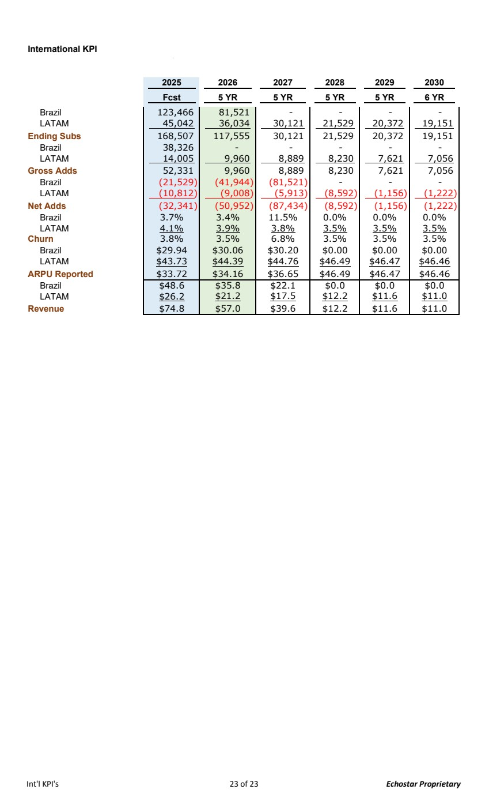 | International KPI 2025 2026 2027 2028 2029 2030 Fcst 5 YR 5 YR 5 YR 5 YR 6 YR Brazil 81,521 123,466 - - - - LATAM 36,034 45,042 30,121 21,529 20,372 19,151 Ending Subs 117,555 168,507 30,121 21,529 20,372 19,151 Brazil - 38,326 - - - - LATAM 9,960 14,005 8,889 8,230 7,621 7,056 Gross Adds 9,960 52,331 8,889 8,230 7,621 7,056 Brazil (21,529) (41,944) (81,521) - - - LATAM (10,812) (9,008) (5,913) (8,592) (1,156) (1,222) Net Adds (32,341) (50,952) (87,434) (8,592) (1,156) (1,222) Brazil 3.7% 3.4% 11.5% 0.0% 0.0% 0.0% LATAM 4.1% 3.9% 3.8% 3.5% 3.5% 3.5% Churn 3.8% 3.5% 6.8% 3.5% 3.5% 3.5% Brazil $29.94 $30.06 $30.20 $0.00 $0.00 $0.00 LATAM $43.73 $44.39 $44.76 $46.49 $46.47 $46.46 ARPU Reported $33.72 $34.16 $36.65 $46.49 $46.47 $46.46 Brazil $48.6 $35.8 $22.1 $0.0 $0.0 $0.0 LATAM $26.2 $21.2 $17.5 $12.2 $11.6 $11.0 Revenue $74.8 $57.0 $39.6 $12.2 $11.6 $11.0 Int'l KPI's 23 of 23 Echostar Proprietary

