​
​
​
​
UNITED STATES
SECURITIES AND EXCHANGE COMMISSION
Washington, D.C. 20549
​
SCHEDULE 14A
​
Proxy Statement Pursuant to Section 14(a) of
the Securities Exchange Act of 1934
​
Filed by the Registrant ☒
​
Filed by a Party other than the Registrant ☐
​
Check the appropriate box:
☐ | Preliminary Proxy Statement
☐ | Confidential, for Use of the Commission Only (as permitted by Rule 14a-6(e)(2))
☐ | Definitive Proxy Statement
☒ | Definitive Additional Materials
☐ | Soliciting Material under §240.14a-12
​
EchoStar Corporation
(Name of Registrant as Specified In Its Charter)
​
​
(Name of Person(s) Filing Proxy Statement, if other than the Registrant)
​
Payment of Filing Fee (Check all boxes that apply):
☒ | No fee required.
☐ | Fee paid previously with preliminary materials.
☐ | Fee computed on table in exhibit required by Item 25(b) per Exchange Act Rules 14a-6(i)(1) and 0-11.
​
​

 | 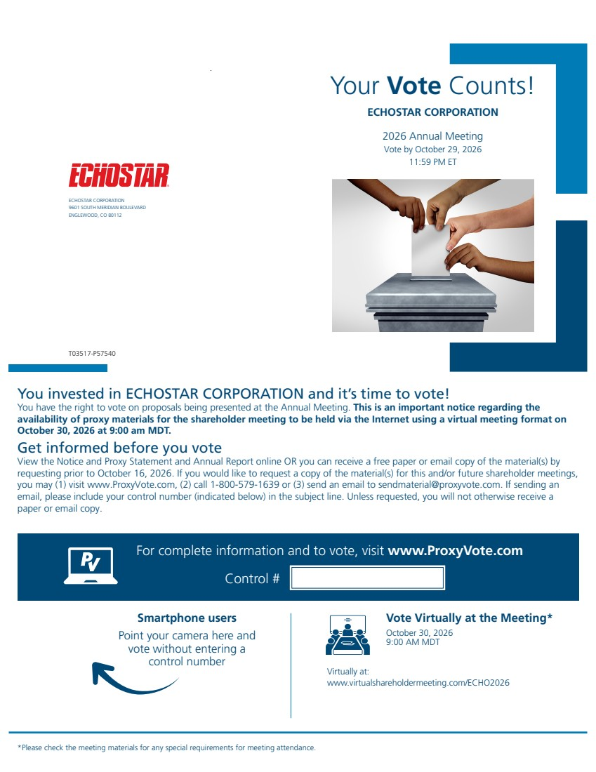 | Your Vote Counts! Smartphone users Point your camera here and vote without entering a control number For complete information and to vote, visit www.ProxyVote.com Control # T03517-P57540 ECHOSTAR CORPORATION 9601 SOUTH MERIDIAN BOULEVARD ENGLEWOOD, CO 80112 ECHOSTAR CORPORATION 2026 Annual Meeting Vote by October 29, 2026 11:59 PM ET You invested in ECHOSTAR CORPORATION and it’s time to vote! You have the right to vote on proposals being presented at the Annual Meeting. This is an important notice regarding the availability of proxy materials for the shareholder meeting to be held via the Internet using a virtual meeting format on October 30, 2026 at 9:00 am MDT. Vote Virtually at the Meeting* October 30, 2026 9:00 AM MDT Virtually at: www.virtualshareholdermeeting.com/ECHO2026 *Please check the meeting materials for any special requirements for meeting attendance. Get informed before you vote View the Notice and Proxy Statement and Annual Report online OR you can receive a free paper or email copy of the material(s) by requesting prior to October 16, 2026. If you would like to request a copy of the material(s) for this and/or future shareholder meetings, you may (1) visit www.ProxyVote.com, (2) call 1-800-579-1639 or (3) send an email to sendmaterial@proxyvote.com. If sending an email, please include your control number (indicated below) in the subject line. Unless requested, you will not otherwise receive a paper or email copy.
 | 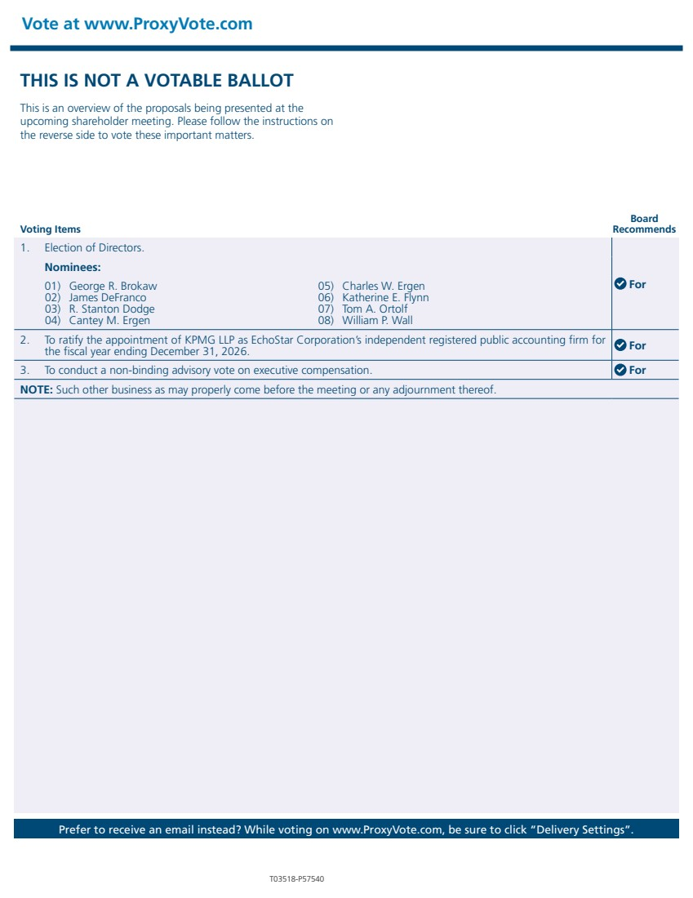 | THIS IS NOT A VOTABLE BALLOT This is an overview of the proposals being presented at the upcoming shareholder meeting. Please follow the instructions on the reverse side to vote these important matters. Vote at www.ProxyVote.com Prefer to receive an email instead? While voting on www.ProxyVote.com, be sure to click “Delivery Settings”. Voting Items Board Recommends T03518-P57540 1. Election of Directors. For Nominees: 01) George R. Brokaw 02) James DeFranco 03) R. Stanton Dodge 04) Cantey M. Ergen 05) Charles W. Ergen 06) Katherine E. Flynn 07) Tom A. Ortolf 08) William P. Wall 2. To ratify the appointment of KPMG LLP as EchoStar Corporation’s independent registered public accounting firm for the fiscal year ending December 31, 2026. For 3. To conduct a non-binding advisory vote on executive compensation. For NOTE: Such other business as may properly come before the meeting or any adjournment thereof.

