UNITED STATES
SECURITIES AND EXCHANGE COMMISSION
Washington, D.C. 20549
Form 8-K
CURRENT REPORT
Pursuant to Section 13 OR 15(d) of the Securities Exchange Act of 1934
Date of Report (Date of earliest event reported): July 28, 2026
ECHOSTAR CORPORATION
(Exact name of registrant as specified in its charter)
​
001-33807
(Commission File Number)
​

​ | ​ | ​
Nevada | ​ | 26-1232727
(State or other jurisdiction of incorporation or organization) | ​ | (I.R.S. Employer Identification No.)
​ | ​ | ​
9601 South Meridian Boulevard | ​ | ​
Englewood, Colorado | ​ | 80112
(Address of principal executive offices) | ​ | (Zip code)
​
(303) 723-1000
(Registrant’s telephone number, including area code)
​
Securities registered pursuant to Section 12(b) of the Act:

 | ​ |  | ​
Title of each class | ​ | Trading Symbol(s) | ​ | Name of each exchange on which registered
Class A common stock, $0.001 par value | ​ | ECHO | ​ | The Nasdaq Stock Market L.L.C.
​
Check the appropriate box below if the Form 8-K filing is intended to simultaneously satisfy the filing obligation of the registrant under any of the following provisions:
​ | ​ | ​
​ | ​ | ​
☐ |  | Written communications pursuant to Rule 425 under the Securities Act (17 CFR 230.425)
​ | ​ | ​
☐ |  | Soliciting material pursuant to Rule 14a-12 under the Exchange Act (17 CFR 240.14a-12)
​ | ​ | ​
☐ |  | Pre-commencement communications pursuant to Rule 14d-2(b) under the Exchange Act (17 CFR 240.14d-2(b))
​ | ​ | ​
☐ |  | Pre-commencement communications pursuant to Rule 13e-4(c) under the Exchange Act (17 CFR 240.13e-4(c))

Indicate by check mark whether the registrant is an emerging growth company as defined in Rule 405 of the Securities Act of 1933 (§230.405 of this chapter) or Rule 12b-2 of the Securities Exchange Act of 1934 (§240.12b-2 of this chapter).
Emerging growth company ☐
​
If an emerging growth company, indicate by check mark if the registrant has elected not to use the extended transition period for complying with any new or revised financial accounting standards provided pursuant to Section 13(a) of the Exchange Act. ☐
​

​
​
​

Item 1.02. | Termination of a Material Definitive Agreement.
​
On July 28, 2026, DISH DBS Corporation (“DISH DBS”) further advanced its announced deleveraging objectives by consummating the full repayment and satisfaction of all outstanding obligations under its 7.75% Senior Notes due July 1, 2026 (the “Notes”). The total payment made on July 28, 2026 was comprised of $2,000,000,000 in aggregate principal amount along with accrued and unpaid interest through the date of repayment.
​
The repayment in full of the Notes and the discharge of the related Indenture obligations were authorized by the United States Bankruptcy Court for the Southern District of Texas, which is presiding over DISH DBS’ pending restructuring proceedings.
​
Item 2.01. | Completion of Acquisition or Disposition of Assets.
​
The information set forth in Item 8.01 is incorporated in this Item 2.01 by reference.
​
Item 8.01. | Other Events.
​
Completion of Sale of Spectrum Licenses Pursuant to AT&T License Purchase Agreement
​
On July 28, 2026, EchoStar Corporation, a Nevada corporation (“EchoStar” or the “Seller”), and the other Seller Parties named therein (together with the Seller, the “Seller Parties” and each, a “Seller Party”), completed (the “Closing”) the previously announced transactions contemplated by the License Purchase Agreement, dated as of August 25, 2025 (the “License Purchase Agreement,” and the transactions contemplated thereby, the “Transactions”), by and between the Seller Parties and AT&T Mobility II LLC, a Delaware limited liability company (the “Buyer”), a subsidiary of AT&T Inc.
​
Pursuant to the License Purchase Agreement, at the Closing, the Seller Parties sold all 3.45 GHz and 600 MHz spectrum licenses that were held by the Seller Parties (collectively, the “Licenses”) and entered into a 99-year extension of existing leases for the Buyer’s exclusive use of certain wireless spectrum licenses in Hawaii. In connection with the Closing, Seller received proceeds of $20,250,000,000 and an additional $2,400,000,000 was deposited by the Buyer into the mandated FCC Trust (as defined below).
​
In connection with the Closing, all amounts outstanding under that certain Loan and Security Agreement, dated as of November 26, 2021, between DISH DBS Corporation, as lender, and DISH Network Corporation, as borrower, were satisfied in full. Additionally, the approximately $3.686 billion outstanding (inclusive of early redemption premium and accrued but unpaid interest) of the 11 3/4% Senior Secured Notes due November 15, 2027 issued pursuant to the Secured Indenture, dated November 15, 2022, by and among DISH Network Corporation, the guarantors identified therein, and U.S. Bank Trust Company, National Association, as trustee and collateral agent, was redeemed in full at the Closing in accordance with the terms thereof.
​
Establishment of FCC Trust
​
As a condition to the Federal Communications Commission’s (the “FCC”) approval of the assignment of the Licenses to the Buyer pursuant to the License Purchase Agreement, the FCC’s Wireless Telecommunications Bureau (the “Bureau”) required the establishment of a trust fund in the amount of $2,400,000,000 (the “FCC Trust”) to pay obligations to persons or entities that may obtain a final judgment, arbitration award or settlement against an EchoStar Party for amounts due in connection with the construction, operation, maintenance, decommissioning and provisioning of goods or services related to communications sites and the communications network associated with the Licenses being sold in the Transactions. The FCC Trust was funded at the Closing by the Buyer directly using cash that constituted a portion of the purchase price.
​
The FCC Trust, formally known as the “Wireless Creditor Trust,” was established pursuant to a Trust Agreement dated as of June 26, 2026 (the “FCC Trust Agreement”), in accordance with the Wireless Telecommunications Bureau’s Memorandum Opinion and Orders, DA 26-470 and DA 26-471, dated May 12, 2026. The FCC Trust is required to pay eligible covered claims in three priority tiers: (i) “Type A Claims” of $100,000 or less, funded from an initial $200,000,000 segregated reserve; (ii) “Type B-1 Claims” for outstanding amounts due under agreements related to the covered activities; and (iii) “Type B-2 Claims” for lost future rents, profits and other future amounts. The FCC Trust will terminate upon satisfaction of all eligible claims or, if not earlier terminated, no later than five years from the trust effective date, subject to the Bureau’s authority to extend the term.
​
The foregoing description of the License Purchase Agreement, the Transactions and the FCC Trust Agreement does not purport to be complete and is qualified in its entirety by reference to the full text of the License Purchase Agreement and the FCC Trust Agreement, which are filed as Exhibit 10.1 and Exhibit 10.2, respectively, to this Current Report on Form 8-K and are incorporated herein by reference. A summary of the material terms of the License Purchase Agreement was previously included in Item 1.01 of EchoStar’s Current Report on Form 8-K filed with the Securities and Exchange Commission on August 26, 2025, and is also incorporated herein by reference.
​
​
Item 9.01. Financial Statements and Exhibits.
Exhibit No. | Description
Exhibit 10.1 | License Purchase Agreement, dated as of August 25, 2025, by and among EchoStar Corporation and AT&T Mobility II LLC (incorporated by reference to Exhibit 10.1 to EchoStar Corporation’s Quarterly Report on Form 10 Q for the quarter ended September 30, 2025, filed November 6, 2025).
Exhibit 10.2 | Trust Agreement (Wireless Creditor Trust), dated as of June 26, 2026, by and between EchoStar Corporation (on behalf of itself and its subsidiaries and affiliates) and The Bank of New York Mellon, as trustee.
Exhibit 104 | Cover Page Interactive Data File (embedded within the Inline XBRL document).
​
​
​
​
SIGNATURES
Pursuant to the requirements of the Securities Exchange Act of 1934, the registrant has duly caused this report to be signed on its behalf by the undersigned hereunto duly authorized.
​
​ | ​ | ​ | ​
 | ECHOSTAR CORPORATION
Date: July 28, 2026 | By: | /s/ Jeffrey H. Blum
Jeffrey H. Blum
Acting Chief Legal Officer and Secretary
 |  | ​
 |  | ​
 |  | ​
 |  | ​
​
​
​
​
Exhibit 10
 | 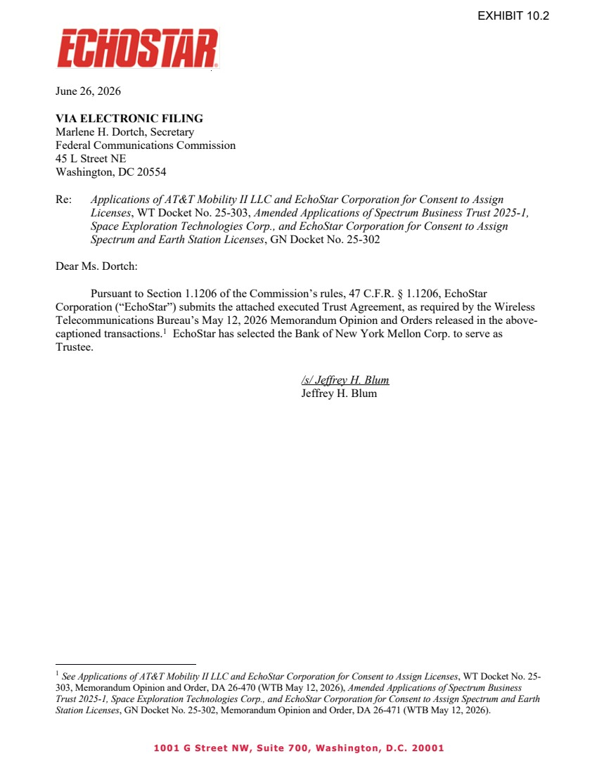 | 1001 G Street NW, Suite 700, Washington, D.C. 20001 June 26, 2026 VIA ELECTRONIC FILING Marlene H. Dortch, Secretary Federal Communications Commission 45 L Street NE Washington, DC 20554 Re: Applications of AT&T Mobility II LLC and EchoStar Corporation for Consent to Assign Licenses, WT Docket No. 25-303, Amended Applications of Spectrum Business Trust 2025-1, Space Exploration Technologies Corp., and EchoStar Corporation for Consent to Assign Spectrum and Earth Station Licenses, GN Docket No. 25-302 Dear Ms. Dortch: Pursuant to Section 1.1206 of the Commission’s rules, 47 C.F.R. § 1.1206, EchoStar Corporation (“EchoStar”) submits the attached executed Trust Agreement, as required by the Wireless Telecommunications Bureau’s May 12, 2026 Memorandum Opinion and Orders released in the above-captioned transactions.1 EchoStar has selected the Bank of New York Mellon Corp. to serve as Trustee. /s/ Jeffrey H. Blum Jeffrey H. Blum 1 See Applications of AT&T Mobility II LLC and EchoStar Corporation for Consent to Assign Licenses, WT Docket No. 25- 303, Memorandum Opinion and Order, DA 26-470 (WTB May 12, 2026), Amended Applications of Spectrum Business Trust 2025-1, Space Exploration Technologies Corp., and EchoStar Corporation for Consent to Assign Spectrum and Earth Station Licenses, GN Docket No. 25-302, Memorandum Opinion and Order, DA 26-471 (WTB May 12, 2026). EXHIBIT 10.2
 | 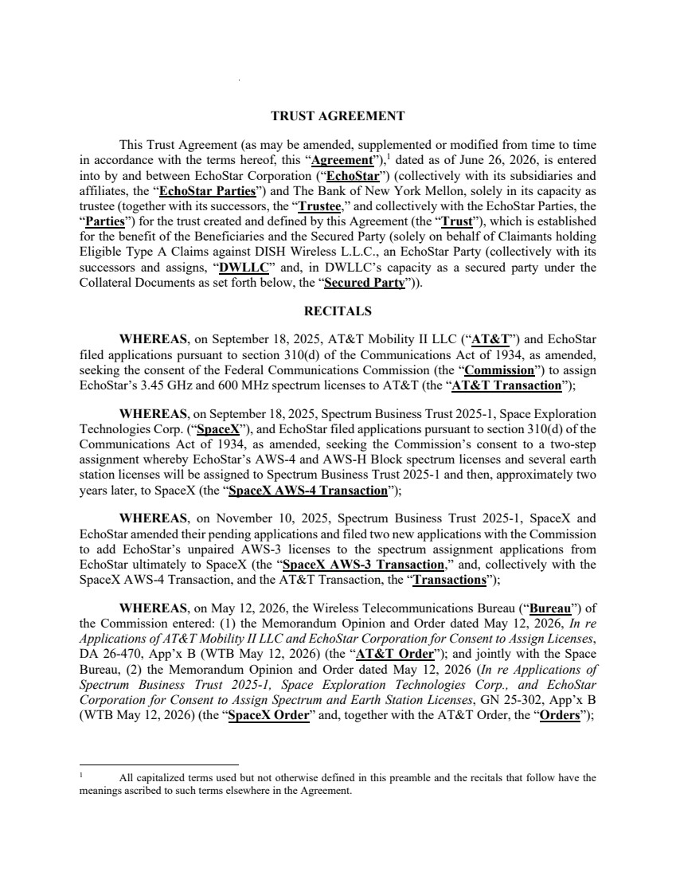 | TRUST AGREEMENT This Trust Agreement (as may be amended, supplemented or modified from time to time in accordance with the terms hereof, this “Agreement”),1 dated as of June 26, 2026, is entered into by and between EchoStar Corporation (“EchoStar”) (collectively with its subsidiaries and affiliates, the “EchoStar Parties”) and The Bank of New York Mellon, solely in its capacity as trustee (together with its successors, the “Trustee,” and collectively with the EchoStar Parties, the “Parties”) for the trust created and defined by this Agreement (the “Trust”), which is established for the benefit of the Beneficiaries and the Secured Party (solely on behalf of Claimants holding Eligible Type A Claims against DISH Wireless L.L.C., an EchoStar Party (collectively with its successors and assigns, “DWLLC” and, in DWLLC’s capacity as a secured party under the Collateral Documents as set forth below, the “Secured Party”)). RECITALS WHEREAS, on September 18, 2025, AT&T Mobility II LLC (“AT&T”) and EchoStar filed applications pursuant to section 310(d) of the Communications Act of 1934, as amended, seeking the consent of the Federal Communications Commission (the “Commission”) to assign EchoStar’s 3.45 GHz and 600 MHz spectrum licenses to AT&T (the “AT&T Transaction”); WHEREAS, on September 18, 2025, Spectrum Business Trust 2025-1, Space Exploration Technologies Corp. (“SpaceX”), and EchoStar filed applications pursuant to section 310(d) of the Communications Act of 1934, as amended, seeking the Commission’s consent to a two-step assignment whereby EchoStar’s AWS-4 and AWS-H Block spectrum licenses and several earth station licenses will be assigned to Spectrum Business Trust 2025-1 and then, approximately two years later, to SpaceX (the “SpaceX AWS-4 Transaction”); WHEREAS, on November 10, 2025, Spectrum Business Trust 2025-1, SpaceX and EchoStar amended their pending applications and filed two new applications with the Commission to add EchoStar’s unpaired AWS-3 licenses to the spectrum assignment applications from EchoStar ultimately to SpaceX (the “SpaceX AWS-3 Transaction,” and, collectively with the SpaceX AWS-4 Transaction, and the AT&T Transaction, the “Transactions”); WHEREAS, on May 12, 2026, the Wireless Telecommunications Bureau (“Bureau”) of the Commission entered: (1) the Memorandum Opinion and Order dated May 12, 2026, In re Applications of AT&T Mobility II LLC and EchoStar Corporation for Consent to Assign Licenses, DA 26-470, App’x B (WTB May 12, 2026) (the “AT&T Order”); and jointly with the Space Bureau, (2) the Memorandum Opinion and Order dated May 12, 2026 (In re Applications of Spectrum Business Trust 2025-1, Space Exploration Technologies Corp., and EchoStar Corporation for Consent to Assign Spectrum and Earth Station Licenses, GN 25-302, App’x B (WTB May 12, 2026) (the “SpaceX Order” and, together with the AT&T Order, the “Orders”); 1 All capitalized terms used but not otherwise defined in this preamble and the recitals that follow have the meanings ascribed to such terms elsewhere in the Agreement.
 | 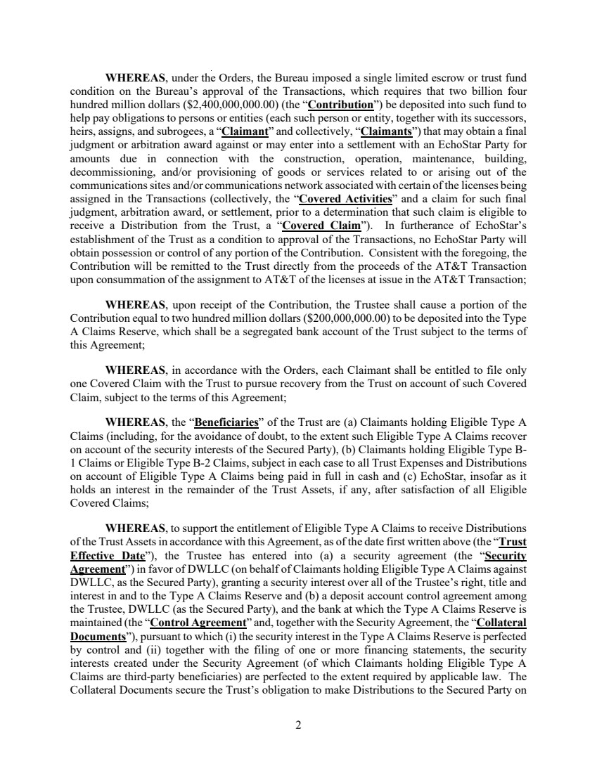 | 2 WHEREAS, under the Orders, the Bureau imposed a single limited escrow or trust fund condition on the Bureau’s approval of the Transactions, which requires that two billion four hundred million dollars ($2,400,000,000.00) (the “Contribution”) be deposited into such fund to help pay obligations to persons or entities (each such person or entity, together with its successors, heirs, assigns, and subrogees, a “Claimant” and collectively, “Claimants”) that may obtain a final judgment or arbitration award against or may enter into a settlement with an EchoStar Party for amounts due in connection with the construction, operation, maintenance, building, decommissioning, and/or provisioning of goods or services related to or arising out of the communications sites and/or communications network associated with certain of the licenses being assigned in the Transactions (collectively, the “Covered Activities” and a claim for such final judgment, arbitration award, or settlement, prior to a determination that such claim is eligible to receive a Distribution from the Trust, a “Covered Claim”). In furtherance of EchoStar’s establishment of the Trust as a condition to approval of the Transactions, no EchoStar Party will obtain possession or control of any portion of the Contribution. Consistent with the foregoing, the Contribution will be remitted to the Trust directly from the proceeds of the AT&T Transaction upon consummation of the assignment to AT&T of the licenses at issue in the AT&T Transaction; WHEREAS, upon receipt of the Contribution, the Trustee shall cause a portion of the Contribution equal to two hundred million dollars ($200,000,000.00) to be deposited into the Type A Claims Reserve, which shall be a segregated bank account of the Trust subject to the terms of this Agreement; WHEREAS, in accordance with the Orders, each Claimant shall be entitled to file only one Covered Claim with the Trust to pursue recovery from the Trust on account of such Covered Claim, subject to the terms of this Agreement; WHEREAS, the “Beneficiaries” of the Trust are (a) Claimants holding Eligible Type A Claims (including, for the avoidance of doubt, to the extent such Eligible Type A Claims recover on account of the security interests of the Secured Party), (b) Claimants holding Eligible Type B-1 Claims or Eligible Type B-2 Claims, subject in each case to all Trust Expenses and Distributions on account of Eligible Type A Claims being paid in full in cash and (c) EchoStar, insofar as it holds an interest in the remainder of the Trust Assets, if any, after satisfaction of all Eligible Covered Claims; WHEREAS, to support the entitlement of Eligible Type A Claims to receive Distributions of the Trust Assets in accordance with this Agreement, as of the date first written above (the “Trust Effective Date”), the Trustee has entered into (a) a security agreement (the “Security Agreement”) in favor of DWLLC (on behalf of Claimants holding Eligible Type A Claims against DWLLC, as the Secured Party), granting a security interest over all of the Trustee’s right, title and interest in and to the Type A Claims Reserve and (b) a deposit account control agreement among the Trustee, DWLLC (as the Secured Party), and the bank at which the Type A Claims Reserve is maintained (the “Control Agreement” and, together with the Security Agreement, the “Collateral Documents”), pursuant to which (i) the security interest in the Type A Claims Reserve is perfected by control and (ii) together with the filing of one or more financing statements, the security interests created under the Security Agreement (of which Claimants holding Eligible Type A Claims are third-party beneficiaries) are perfected to the extent required by applicable law. The Collateral Documents secure the Trust’s obligation to make Distributions to the Secured Party on
 | 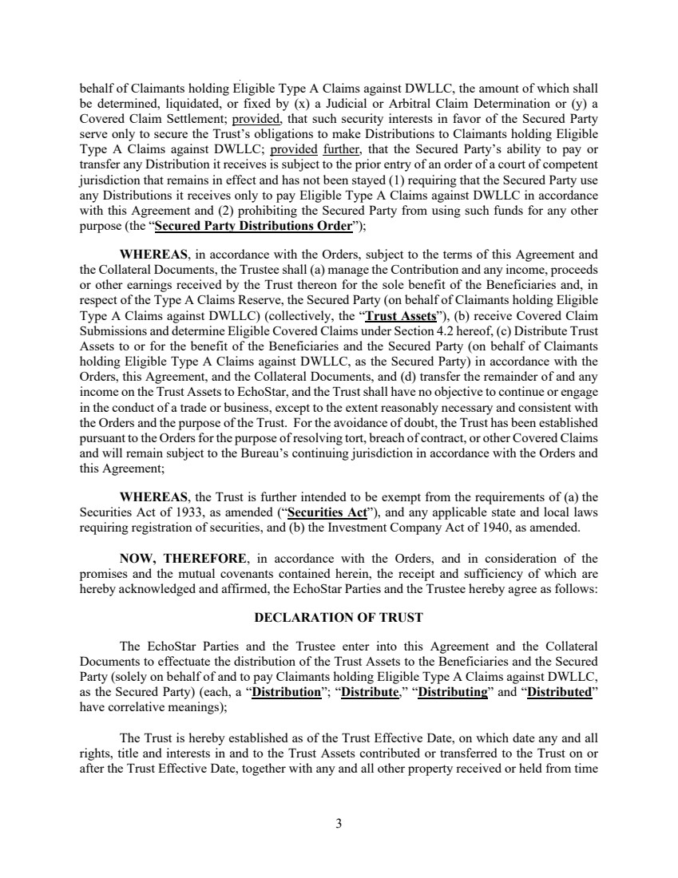 | 3 behalf of Claimants holding Eligible Type A Claims against DWLLC, the amount of which shall be determined, liquidated, or fixed by (x) a Judicial or Arbitral Claim Determination or (y) a Covered Claim Settlement; provided, that such security interests in favor of the Secured Party serve only to secure the Trust’s obligations to make Distributions to Claimants holding Eligible Type A Claims against DWLLC; provided further, that the Secured Party’s ability to pay or transfer any Distribution it receives is subject to the prior entry of an order of a court of competent jurisdiction that remains in effect and has not been stayed (1) requiring that the Secured Party use any Distributions it receives only to pay Eligible Type A Claims against DWLLC in accordance with this Agreement and (2) prohibiting the Secured Party from using such funds for any other purpose (the “Secured Party Distributions Order”); WHEREAS, in accordance with the Orders, subject to the terms of this Agreement and the Collateral Documents, the Trustee shall (a) manage the Contribution and any income, proceeds or other earnings received by the Trust thereon for the sole benefit of the Beneficiaries and, in respect of the Type A Claims Reserve, the Secured Party (on behalf of Claimants holding Eligible Type A Claims against DWLLC) (collectively, the “Trust Assets”), (b) receive Covered Claim Submissions and determine Eligible Covered Claims under Section 4.2 hereof, (c) Distribute Trust Assets to or for the benefit of the Beneficiaries and the Secured Party (on behalf of Claimants holding Eligible Type A Claims against DWLLC, as the Secured Party) in accordance with the Orders, this Agreement, and the Collateral Documents, and (d) transfer the remainder of and any income on the Trust Assets to EchoStar, and the Trust shall have no objective to continue or engage in the conduct of a trade or business, except to the extent reasonably necessary and consistent with the Orders and the purpose of the Trust. For the avoidance of doubt, the Trust has been established pursuant to the Orders for the purpose of resolving tort, breach of contract, or other Covered Claims and will remain subject to the Bureau’s continuing jurisdiction in accordance with the Orders and this Agreement; WHEREAS, the Trust is further intended to be exempt from the requirements of (a) the Securities Act of 1933, as amended (“Securities Act”), and any applicable state and local laws requiring registration of securities, and (b) the Investment Company Act of 1940, as amended. NOW, THEREFORE, in accordance with the Orders, and in consideration of the promises and the mutual covenants contained herein, the receipt and sufficiency of which are hereby acknowledged and affirmed, the EchoStar Parties and the Trustee hereby agree as follows: DECLARATION OF TRUST The EchoStar Parties and the Trustee enter into this Agreement and the Collateral Documents to effectuate the distribution of the Trust Assets to the Beneficiaries and the Secured Party (solely on behalf of and to pay Claimants holding Eligible Type A Claims against DWLLC, as the Secured Party) (each, a “Distribution”; “Distribute,” “Distributing” and “Distributed” have correlative meanings); The Trust is hereby established as of the Trust Effective Date, on which date any and all rights, title and interests in and to the Trust Assets contributed or transferred to the Trust on or after the Trust Effective Date, together with any and all other property received or held from time
 | 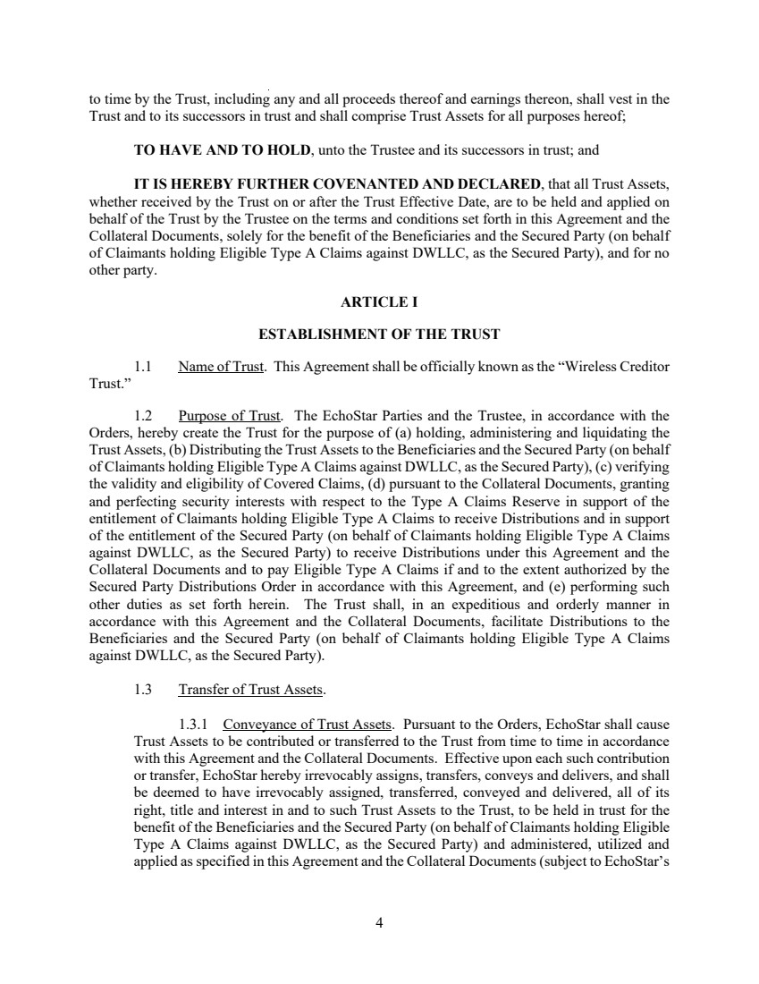 | 4 to time by the Trust, including any and all proceeds thereof and earnings thereon, shall vest in the Trust and to its successors in trust and shall comprise Trust Assets for all purposes hereof; TO HAVE AND TO HOLD, unto the Trustee and its successors in trust; and IT IS HEREBY FURTHER COVENANTED AND DECLARED, that all Trust Assets, whether received by the Trust on or after the Trust Effective Date, are to be held and applied on behalf of the Trust by the Trustee on the terms and conditions set forth in this Agreement and the Collateral Documents, solely for the benefit of the Beneficiaries and the Secured Party (on behalf of Claimants holding Eligible Type A Claims against DWLLC, as the Secured Party), and for no other party. ARTICLE I ESTABLISHMENT OF THE TRUST 1.1 Name of Trust. This Agreement shall be officially known as the “Wireless Creditor Trust.” 1.2 Purpose of Trust. The EchoStar Parties and the Trustee, in accordance with the Orders, hereby create the Trust for the purpose of (a) holding, administering and liquidating the Trust Assets, (b) Distributing the Trust Assets to the Beneficiaries and the Secured Party (on behalf of Claimants holding Eligible Type A Claims against DWLLC, as the Secured Party), (c) verifying the validity and eligibility of Covered Claims, (d) pursuant to the Collateral Documents, granting and perfecting security interests with respect to the Type A Claims Reserve in support of the entitlement of Claimants holding Eligible Type A Claims to receive Distributions and in support of the entitlement of the Secured Party (on behalf of Claimants holding Eligible Type A Claims against DWLLC, as the Secured Party) to receive Distributions under this Agreement and the Collateral Documents and to pay Eligible Type A Claims if and to the extent authorized by the Secured Party Distributions Order in accordance with this Agreement, and (e) performing such other duties as set forth herein. The Trust shall, in an expeditious and orderly manner in accordance with this Agreement and the Collateral Documents, facilitate Distributions to the Beneficiaries and the Secured Party (on behalf of Claimants holding Eligible Type A Claims against DWLLC, as the Secured Party). 1.3 Transfer of Trust Assets. 1.3.1 Conveyance of Trust Assets. Pursuant to the Orders, EchoStar shall cause Trust Assets to be contributed or transferred to the Trust from time to time in accordance with this Agreement and the Collateral Documents. Effective upon each such contribution or transfer, EchoStar hereby irrevocably assigns, transfers, conveys and delivers, and shall be deemed to have irrevocably assigned, transferred, conveyed and delivered, all of its right, title and interest in and to such Trust Assets to the Trust, to be held in trust for the benefit of the Beneficiaries and the Secured Party (on behalf of Claimants holding Eligible Type A Claims against DWLLC, as the Secured Party) and administered, utilized and applied as specified in this Agreement and the Collateral Documents (subject to EchoStar’s
 | 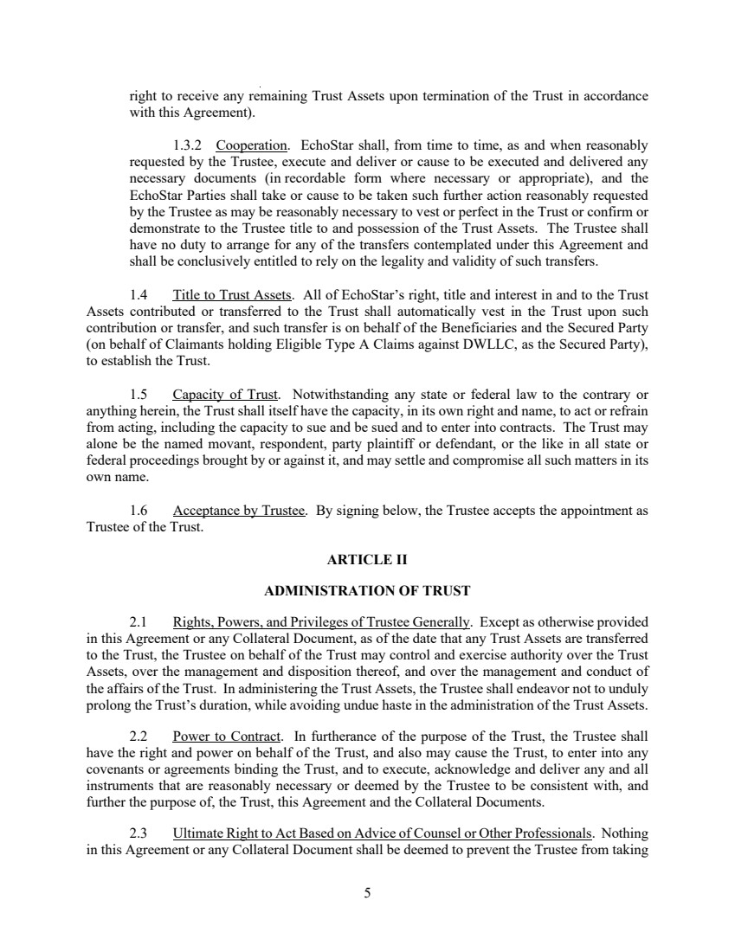 | 5 right to receive any remaining Trust Assets upon termination of the Trust in accordance with this Agreement). 1.3.2 Cooperation. EchoStar shall, from time to time, as and when reasonably requested by the Trustee, execute and deliver or cause to be executed and delivered any necessary documents (in recordable form where necessary or appropriate), and the EchoStar Parties shall take or cause to be taken such further action reasonably requested by the Trustee as may be reasonably necessary to vest or perfect in the Trust or confirm or demonstrate to the Trustee title to and possession of the Trust Assets. The Trustee shall have no duty to arrange for any of the transfers contemplated under this Agreement and shall be conclusively entitled to rely on the legality and validity of such transfers. 1.4 Title to Trust Assets. All of EchoStar’s right, title and interest in and to the Trust Assets contributed or transferred to the Trust shall automatically vest in the Trust upon such contribution or transfer, and such transfer is on behalf of the Beneficiaries and the Secured Party (on behalf of Claimants holding Eligible Type A Claims against DWLLC, as the Secured Party), to establish the Trust. 1.5 Capacity of Trust. Notwithstanding any state or federal law to the contrary or anything herein, the Trust shall itself have the capacity, in its own right and name, to act or refrain from acting, including the capacity to sue and be sued and to enter into contracts. The Trust may alone be the named movant, respondent, party plaintiff or defendant, or the like in all state or federal proceedings brought by or against it, and may settle and compromise all such matters in its own name. 1.6 Acceptance by Trustee. By signing below, the Trustee accepts the appointment as Trustee of the Trust. ARTICLE II ADMINISTRATION OF TRUST 2.1 Rights, Powers, and Privileges of Trustee Generally. Except as otherwise provided in this Agreement or any Collateral Document, as of the date that any Trust Assets are transferred to the Trust, the Trustee on behalf of the Trust may control and exercise authority over the Trust Assets, over the management and disposition thereof, and over the management and conduct of the affairs of the Trust. In administering the Trust Assets, the Trustee shall endeavor not to unduly prolong the Trust’s duration, while avoiding undue haste in the administration of the Trust Assets. 2.2 Power to Contract. In furtherance of the purpose of the Trust, the Trustee shall have the right and power on behalf of the Trust, and also may cause the Trust, to enter into any covenants or agreements binding the Trust, and to execute, acknowledge and deliver any and all instruments that are reasonably necessary or deemed by the Trustee to be consistent with, and further the purpose of, the Trust, this Agreement and the Collateral Documents. 2.3 Ultimate Right to Act Based on Advice of Counsel or Other Professionals. Nothing in this Agreement or any Collateral Document shall be deemed to prevent the Trustee from taking
 | 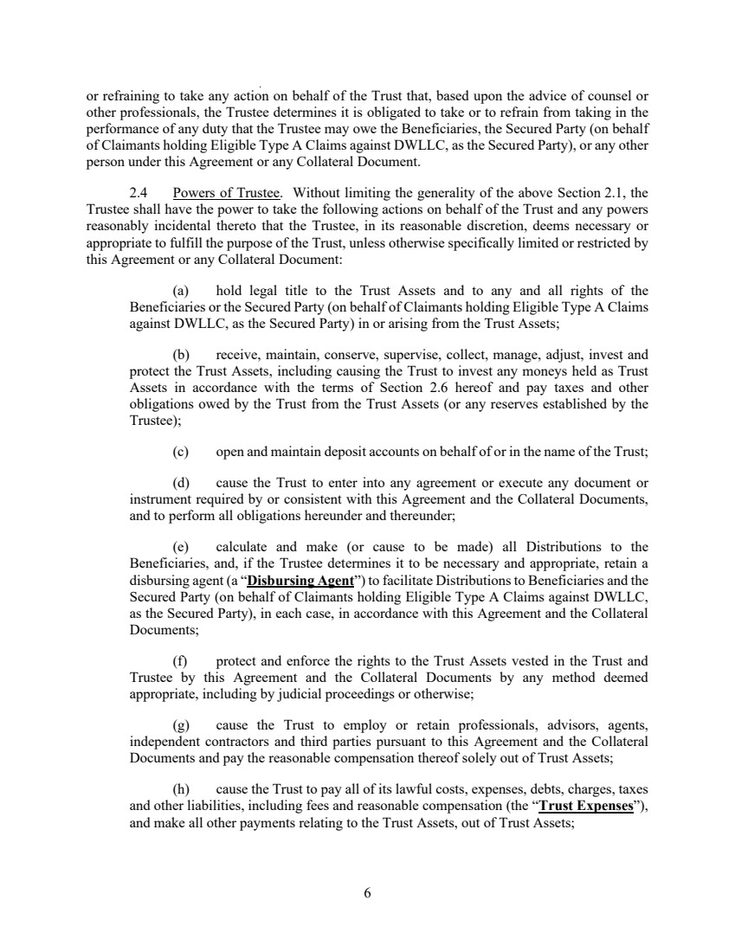 | 6 or refraining to take any action on behalf of the Trust that, based upon the advice of counsel or other professionals, the Trustee determines it is obligated to take or to refrain from taking in the performance of any duty that the Trustee may owe the Beneficiaries, the Secured Party (on behalf of Claimants holding Eligible Type A Claims against DWLLC, as the Secured Party), or any other person under this Agreement or any Collateral Document. 2.4 Powers of Trustee. Without limiting the generality of the above Section 2.1, the Trustee shall have the power to take the following actions on behalf of the Trust and any powers reasonably incidental thereto that the Trustee, in its reasonable discretion, deems necessary or appropriate to fulfill the purpose of the Trust, unless otherwise specifically limited or restricted by this Agreement or any Collateral Document: (a) hold legal title to the Trust Assets and to any and all rights of the Beneficiaries or the Secured Party (on behalf of Claimants holding Eligible Type A Claims against DWLLC, as the Secured Party) in or arising from the Trust Assets; (b) receive, maintain, conserve, supervise, collect, manage, adjust, invest and protect the Trust Assets, including causing the Trust to invest any moneys held as Trust Assets in accordance with the terms of Section 2.6 hereof and pay taxes and other obligations owed by the Trust from the Trust Assets (or any reserves established by the Trustee); (c) open and maintain deposit accounts on behalf of or in the name of the Trust; (d) cause the Trust to enter into any agreement or execute any document or instrument required by or consistent with this Agreement and the Collateral Documents, and to perform all obligations hereunder and thereunder; (e) calculate and make (or cause to be made) all Distributions to the Beneficiaries, and, if the Trustee determines it to be necessary and appropriate, retain a disbursing agent (a “Disbursing Agent”) to facilitate Distributions to Beneficiaries and the Secured Party (on behalf of Claimants holding Eligible Type A Claims against DWLLC, as the Secured Party), in each case, in accordance with this Agreement and the Collateral Documents; (f) protect and enforce the rights to the Trust Assets vested in the Trust and Trustee by this Agreement and the Collateral Documents by any method deemed appropriate, including by judicial proceedings or otherwise; (g) cause the Trust to employ or retain professionals, advisors, agents, independent contractors and third parties pursuant to this Agreement and the Collateral Documents and pay the reasonable compensation thereof solely out of Trust Assets; (h) cause the Trust to pay all of its lawful costs, expenses, debts, charges, taxes and other liabilities, including fees and reasonable compensation (the “Trust Expenses”), and make all other payments relating to the Trust Assets, out of Trust Assets;
 | 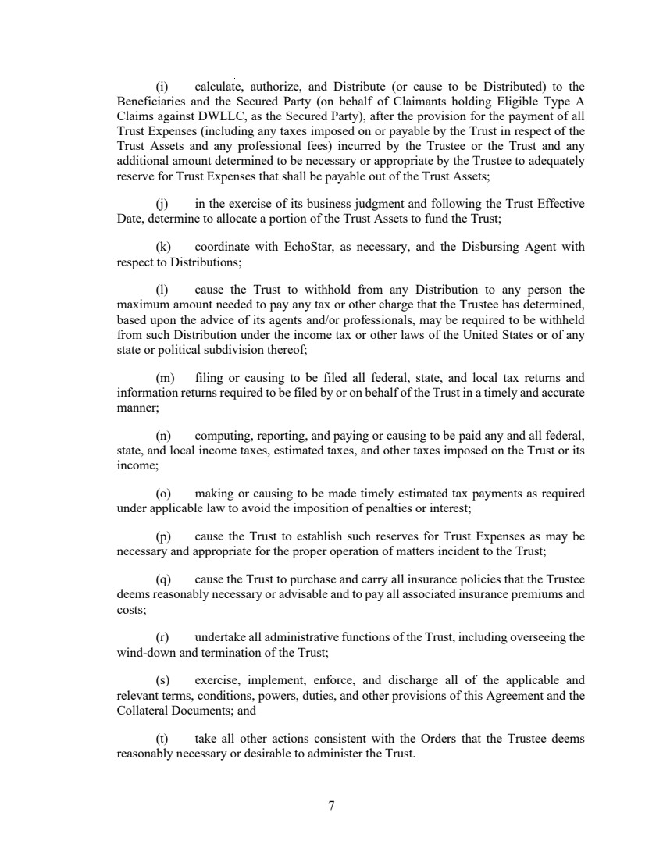 | 7 (i) calculate, authorize, and Distribute (or cause to be Distributed) to the Beneficiaries and the Secured Party (on behalf of Claimants holding Eligible Type A Claims against DWLLC, as the Secured Party), after the provision for the payment of all Trust Expenses (including any taxes imposed on or payable by the Trust in respect of the Trust Assets and any professional fees) incurred by the Trustee or the Trust and any additional amount determined to be necessary or appropriate by the Trustee to adequately reserve for Trust Expenses that shall be payable out of the Trust Assets; (j) in the exercise of its business judgment and following the Trust Effective Date, determine to allocate a portion of the Trust Assets to fund the Trust; (k) coordinate with EchoStar, as necessary, and the Disbursing Agent with respect to Distributions; (l) cause the Trust to withhold from any Distribution to any person the maximum amount needed to pay any tax or other charge that the Trustee has determined, based upon the advice of its agents and/or professionals, may be required to be withheld from such Distribution under the income tax or other laws of the United States or of any state or political subdivision thereof; (m) filing or causing to be filed all federal, state, and local tax returns and information returns required to be filed by or on behalf of the Trust in a timely and accurate manner; (n) computing, reporting, and paying or causing to be paid any and all federal, state, and local income taxes, estimated taxes, and other taxes imposed on the Trust or its income; (o) making or causing to be made timely estimated tax payments as required under applicable law to avoid the imposition of penalties or interest; (p) cause the Trust to establish such reserves for Trust Expenses as may be necessary and appropriate for the proper operation of matters incident to the Trust; (q) cause the Trust to purchase and carry all insurance policies that the Trustee deems reasonably necessary or advisable and to pay all associated insurance premiums and costs; (r) undertake all administrative functions of the Trust, including overseeing the wind-down and termination of the Trust; (s) exercise, implement, enforce, and discharge all of the applicable and relevant terms, conditions, powers, duties, and other provisions of this Agreement and the Collateral Documents; and (t) take all other actions consistent with the Orders that the Trustee deems reasonably necessary or desirable to administer the Trust.
 | 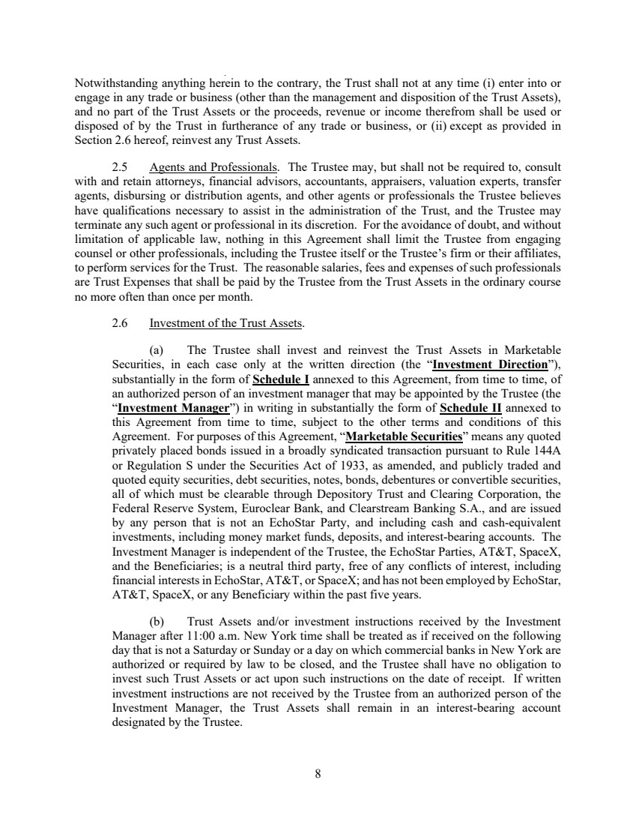 | 8 Notwithstanding anything herein to the contrary, the Trust shall not at any time (i) enter into or engage in any trade or business (other than the management and disposition of the Trust Assets), and no part of the Trust Assets or the proceeds, revenue or income therefrom shall be used or disposed of by the Trust in furtherance of any trade or business, or (ii) except as provided in Section 2.6 hereof, reinvest any Trust Assets. 2.5 Agents and Professionals. The Trustee may, but shall not be required to, consult with and retain attorneys, financial advisors, accountants, appraisers, valuation experts, transfer agents, disbursing or distribution agents, and other agents or professionals the Trustee believes have qualifications necessary to assist in the administration of the Trust, and the Trustee may terminate any such agent or professional in its discretion. For the avoidance of doubt, and without limitation of applicable law, nothing in this Agreement shall limit the Trustee from engaging counsel or other professionals, including the Trustee itself or the Trustee’s firm or their affiliates, to perform services for the Trust. The reasonable salaries, fees and expenses of such professionals are Trust Expenses that shall be paid by the Trustee from the Trust Assets in the ordinary course no more often than once per month. 2.6 Investment of the Trust Assets. (a) The Trustee shall invest and reinvest the Trust Assets in Marketable Securities, in each case only at the written direction (the “Investment Direction”), substantially in the form of Schedule I annexed to this Agreement, from time to time, of an authorized person of an investment manager that may be appointed by the Trustee (the “Investment Manager”) in writing in substantially the form of Schedule II annexed to this Agreement from time to time, subject to the other terms and conditions of this Agreement. For purposes of this Agreement, “Marketable Securities” means any quoted privately placed bonds issued in a broadly syndicated transaction pursuant to Rule 144A or Regulation S under the Securities Act of 1933, as amended, and publicly traded and quoted equity securities, debt securities, notes, bonds, debentures or convertible securities, all of which must be clearable through Depository Trust and Clearing Corporation, the Federal Reserve System, Euroclear Bank, and Clearstream Banking S.A., and are issued by any person that is not an EchoStar Party, and including cash and cash-equivalent investments, including money market funds, deposits, and interest-bearing accounts. The Investment Manager is independent of the Trustee, the EchoStar Parties, AT&T, SpaceX, and the Beneficiaries; is a neutral third party, free of any conflicts of interest, including financial interests in EchoStar, AT&T, or SpaceX; and has not been employed by EchoStar, AT&T, SpaceX, or any Beneficiary within the past five years. (b) Trust Assets and/or investment instructions received by the Investment Manager after 11:00 a.m. New York time shall be treated as if received on the following day that is not a Saturday or Sunday or a day on which commercial banks in New York are authorized or required by law to be closed, and the Trustee shall have no obligation to invest such Trust Assets or act upon such instructions on the date of receipt. If written investment instructions are not received by the Trustee from an authorized person of the Investment Manager, the Trust Assets shall remain in an interest-bearing account designated by the Trustee.
 | 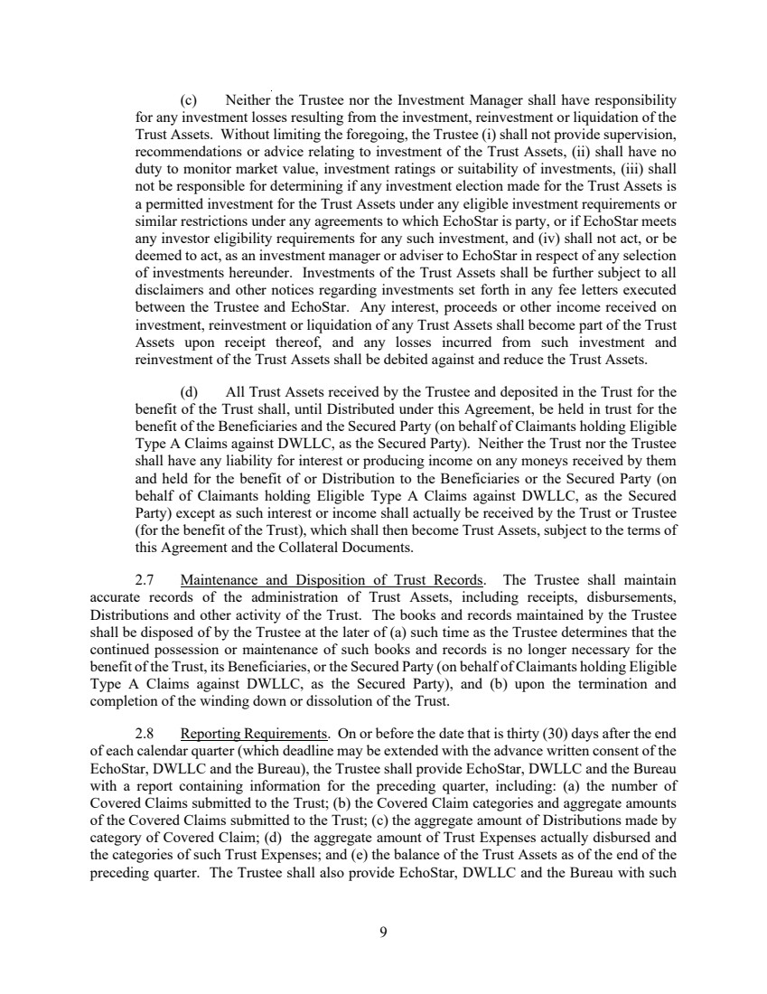 | 9 (c) Neither the Trustee nor the Investment Manager shall have responsibility for any investment losses resulting from the investment, reinvestment or liquidation of the Trust Assets. Without limiting the foregoing, the Trustee (i) shall not provide supervision, recommendations or advice relating to investment of the Trust Assets, (ii) shall have no duty to monitor market value, investment ratings or suitability of investments, (iii) shall not be responsible for determining if any investment election made for the Trust Assets is a permitted investment for the Trust Assets under any eligible investment requirements or similar restrictions under any agreements to which EchoStar is party, or if EchoStar meets any investor eligibility requirements for any such investment, and (iv) shall not act, or be deemed to act, as an investment manager or adviser to EchoStar in respect of any selection of investments hereunder. Investments of the Trust Assets shall be further subject to all disclaimers and other notices regarding investments set forth in any fee letters executed between the Trustee and EchoStar. Any interest, proceeds or other income received on investment, reinvestment or liquidation of any Trust Assets shall become part of the Trust Assets upon receipt thereof, and any losses incurred from such investment and reinvestment of the Trust Assets shall be debited against and reduce the Trust Assets. (d) All Trust Assets received by the Trustee and deposited in the Trust for the benefit of the Trust shall, until Distributed under this Agreement, be held in trust for the benefit of the Beneficiaries and the Secured Party (on behalf of Claimants holding Eligible Type A Claims against DWLLC, as the Secured Party). Neither the Trust nor the Trustee shall have any liability for interest or producing income on any moneys received by them and held for the benefit of or Distribution to the Beneficiaries or the Secured Party (on behalf of Claimants holding Eligible Type A Claims against DWLLC, as the Secured Party) except as such interest or income shall actually be received by the Trust or Trustee (for the benefit of the Trust), which shall then become Trust Assets, subject to the terms of this Agreement and the Collateral Documents. 2.7 Maintenance and Disposition of Trust Records. The Trustee shall maintain accurate records of the administration of Trust Assets, including receipts, disbursements, Distributions and other activity of the Trust. The books and records maintained by the Trustee shall be disposed of by the Trustee at the later of (a) such time as the Trustee determines that the continued possession or maintenance of such books and records is no longer necessary for the benefit of the Trust, its Beneficiaries, or the Secured Party (on behalf of Claimants holding Eligible Type A Claims against DWLLC, as the Secured Party), and (b) upon the termination and completion of the winding down or dissolution of the Trust. 2.8 Reporting Requirements. On or before the date that is thirty (30) days after the end of each calendar quarter (which deadline may be extended with the advance written consent of the EchoStar, DWLLC and the Bureau), the Trustee shall provide EchoStar, DWLLC and the Bureau with a report containing information for the preceding quarter, including: (a) the number of Covered Claims submitted to the Trust; (b) the Covered Claim categories and aggregate amounts of the Covered Claims submitted to the Trust; (c) the aggregate amount of Distributions made by category of Covered Claim; (d) the aggregate amount of Trust Expenses actually disbursed and the categories of such Trust Expenses; and (e) the balance of the Trust Assets as of the end of the preceding quarter. The Trustee shall also provide EchoStar, DWLLC and the Bureau with such
 | 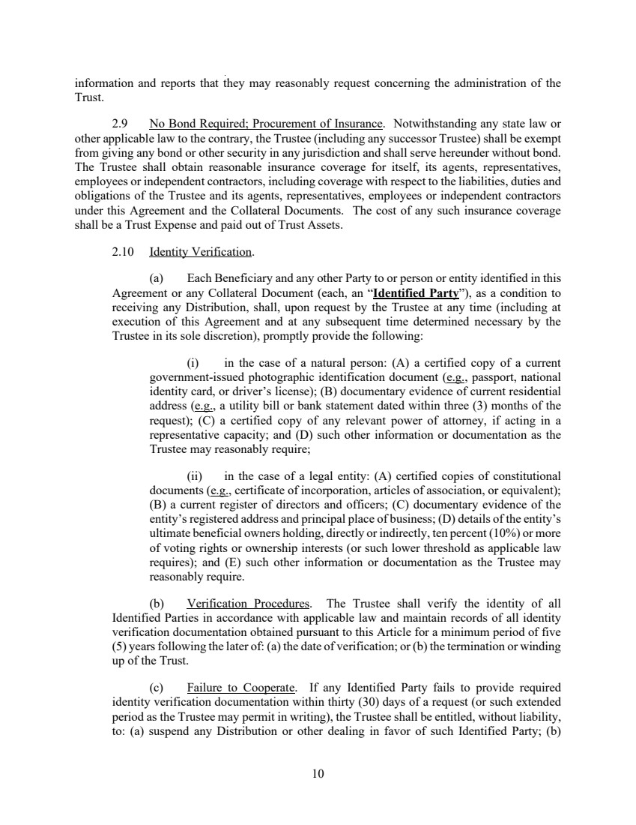 | 10 information and reports that they may reasonably request concerning the administration of the Trust. 2.9 No Bond Required; Procurement of Insurance. Notwithstanding any state law or other applicable law to the contrary, the Trustee (including any successor Trustee) shall be exempt from giving any bond or other security in any jurisdiction and shall serve hereunder without bond. The Trustee shall obtain reasonable insurance coverage for itself, its agents, representatives, employees or independent contractors, including coverage with respect to the liabilities, duties and obligations of the Trustee and its agents, representatives, employees or independent contractors under this Agreement and the Collateral Documents. The cost of any such insurance coverage shall be a Trust Expense and paid out of Trust Assets. 2.10 Identity Verification. (a) Each Beneficiary and any other Party to or person or entity identified in this Agreement or any Collateral Document (each, an “Identified Party”), as a condition to receiving any Distribution, shall, upon request by the Trustee at any time (including at execution of this Agreement and at any subsequent time determined necessary by the Trustee in its sole discretion), promptly provide the following: (i) in the case of a natural person: (A) a certified copy of a current government-issued photographic identification document (e.g., passport, national identity card, or driver’s license); (B) documentary evidence of current residential address (e.g., a utility bill or bank statement dated within three (3) months of the request); (C) a certified copy of any relevant power of attorney, if acting in a representative capacity; and (D) such other information or documentation as the Trustee may reasonably require; (ii) in the case of a legal entity: (A) certified copies of constitutional documents (e.g., certificate of incorporation, articles of association, or equivalent); (B) a current register of directors and officers; (C) documentary evidence of the entity’s registered address and principal place of business; (D) details of the entity’s ultimate beneficial owners holding, directly or indirectly, ten percent (10%) or more of voting rights or ownership interests (or such lower threshold as applicable law requires); and (E) such other information or documentation as the Trustee may reasonably require. (b) Verification Procedures. The Trustee shall verify the identity of all Identified Parties in accordance with applicable law and maintain records of all identity verification documentation obtained pursuant to this Article for a minimum period of five (5) years following the later of: (a) the date of verification; or (b) the termination or winding up of the Trust. (c) Failure to Cooperate. If any Identified Party fails to provide required identity verification documentation within thirty (30) days of a request (or such extended period as the Trustee may permit in writing), the Trustee shall be entitled, without liability, to: (a) suspend any Distribution or other dealing in favor of such Identified Party; (b)
 | 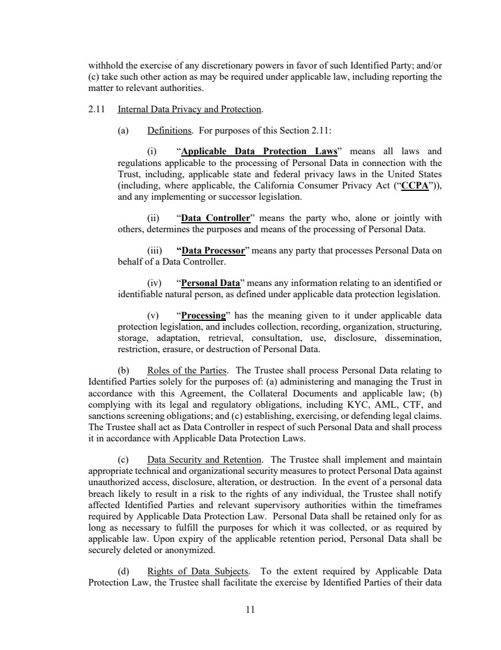 | 11 withhold the exercise of any discretionary powers in favor of such Identified Party; and/or (c) take such other action as may be required under applicable law, including reporting the matter to relevant authorities. 2.11 Internal Data Privacy and Protection. (a) Definitions. For purposes of this Section 2.11: (i) “Applicable Data Protection Laws” means all laws and regulations applicable to the processing of Personal Data in connection with the Trust, including, applicable state and federal privacy laws in the United States (including, where applicable, the California Consumer Privacy Act (“CCPA”)), and any implementing or successor legislation. (ii) “Data Controller” means the party who, alone or jointly with others, determines the purposes and means of the processing of Personal Data. (iii) “Data Processor” means any party that processes Personal Data on behalf of a Data Controller. (iv) “Personal Data” means any information relating to an identified or identifiable natural person, as defined under applicable data protection legislation. (v) “Processing” has the meaning given to it under applicable data protection legislation, and includes collection, recording, organization, structuring, storage, adaptation, retrieval, consultation, use, disclosure, dissemination, restriction, erasure, or destruction of Personal Data. (b) Roles of the Parties. The Trustee shall process Personal Data relating to Identified Parties solely for the purposes of: (a) administering and managing the Trust in accordance with this Agreement, the Collateral Documents and applicable law; (b) complying with its legal and regulatory obligations, including KYC, AML, CTF, and sanctions screening obligations; and (c) establishing, exercising, or defending legal claims. The Trustee shall act as Data Controller in respect of such Personal Data and shall process it in accordance with Applicable Data Protection Laws. (c) Data Security and Retention. The Trustee shall implement and maintain appropriate technical and organizational security measures to protect Personal Data against unauthorized access, disclosure, alteration, or destruction. In the event of a personal data breach likely to result in a risk to the rights of any individual, the Trustee shall notify affected Identified Parties and relevant supervisory authorities within the timeframes required by Applicable Data Protection Law. Personal Data shall be retained only for as long as necessary to fulfill the purposes for which it was collected, or as required by applicable law. Upon expiry of the applicable retention period, Personal Data shall be securely deleted or anonymized. (d) Rights of Data Subjects. To the extent required by Applicable Data Protection Law, the Trustee shall facilitate the exercise by Identified Parties of their data
 | 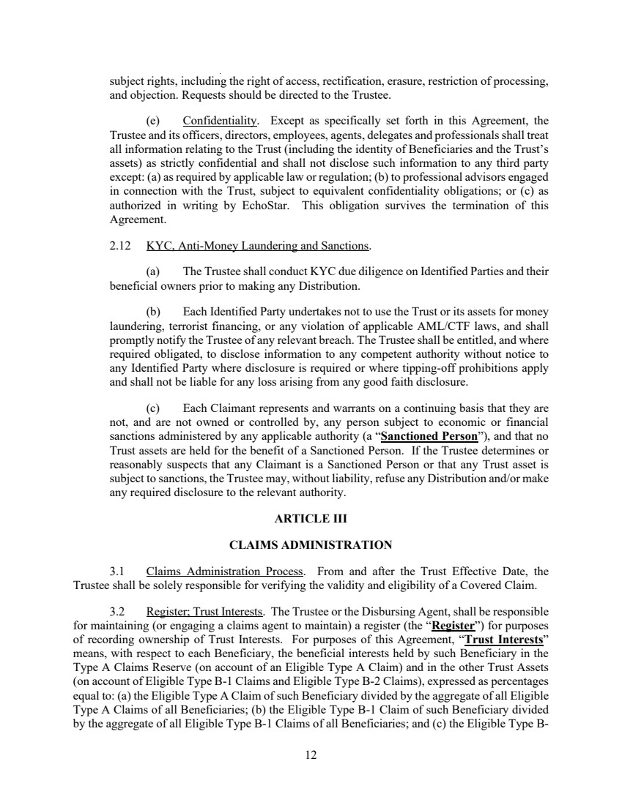 | 12 subject rights, including the right of access, rectification, erasure, restriction of processing, and objection. Requests should be directed to the Trustee. (e) Confidentiality. Except as specifically set forth in this Agreement, the Trustee and its officers, directors, employees, agents, delegates and professionals shall treat all information relating to the Trust (including the identity of Beneficiaries and the Trust’s assets) as strictly confidential and shall not disclose such information to any third party except: (a) as required by applicable law or regulation; (b) to professional advisors engaged in connection with the Trust, subject to equivalent confidentiality obligations; or (c) as authorized in writing by EchoStar. This obligation survives the termination of this Agreement. 2.12 KYC, Anti-Money Laundering and Sanctions. (a) The Trustee shall conduct KYC due diligence on Identified Parties and their beneficial owners prior to making any Distribution. (b) Each Identified Party undertakes not to use the Trust or its assets for money laundering, terrorist financing, or any violation of applicable AML/CTF laws, and shall promptly notify the Trustee of any relevant breach. The Trustee shall be entitled, and where required obligated, to disclose information to any competent authority without notice to any Identified Party where disclosure is required or where tipping-off prohibitions apply and shall not be liable for any loss arising from any good faith disclosure. (c) Each Claimant represents and warrants on a continuing basis that they are not, and are not owned or controlled by, any person subject to economic or financial sanctions administered by any applicable authority (a “Sanctioned Person”), and that no Trust assets are held for the benefit of a Sanctioned Person. If the Trustee determines or reasonably suspects that any Claimant is a Sanctioned Person or that any Trust asset is subject to sanctions, the Trustee may, without liability, refuse any Distribution and/or make any required disclosure to the relevant authority. ARTICLE III CLAIMS ADMINISTRATION 3.1 Claims Administration Process. From and after the Trust Effective Date, the Trustee shall be solely responsible for verifying the validity and eligibility of a Covered Claim. 3.2 Register; Trust Interests. The Trustee or the Disbursing Agent, shall be responsible for maintaining (or engaging a claims agent to maintain) a register (the “Register”) for purposes of recording ownership of Trust Interests. For purposes of this Agreement, “Trust Interests” means, with respect to each Beneficiary, the beneficial interests held by such Beneficiary in the Type A Claims Reserve (on account of an Eligible Type A Claim) and in the other Trust Assets (on account of Eligible Type B-1 Claims and Eligible Type B-2 Claims), expressed as percentages equal to: (a) the Eligible Type A Claim of such Beneficiary divided by the aggregate of all Eligible Type A Claims of all Beneficiaries; (b) the Eligible Type B-1 Claim of such Beneficiary divided by the aggregate of all Eligible Type B-1 Claims of all Beneficiaries; and (c) the Eligible Type B-
 | 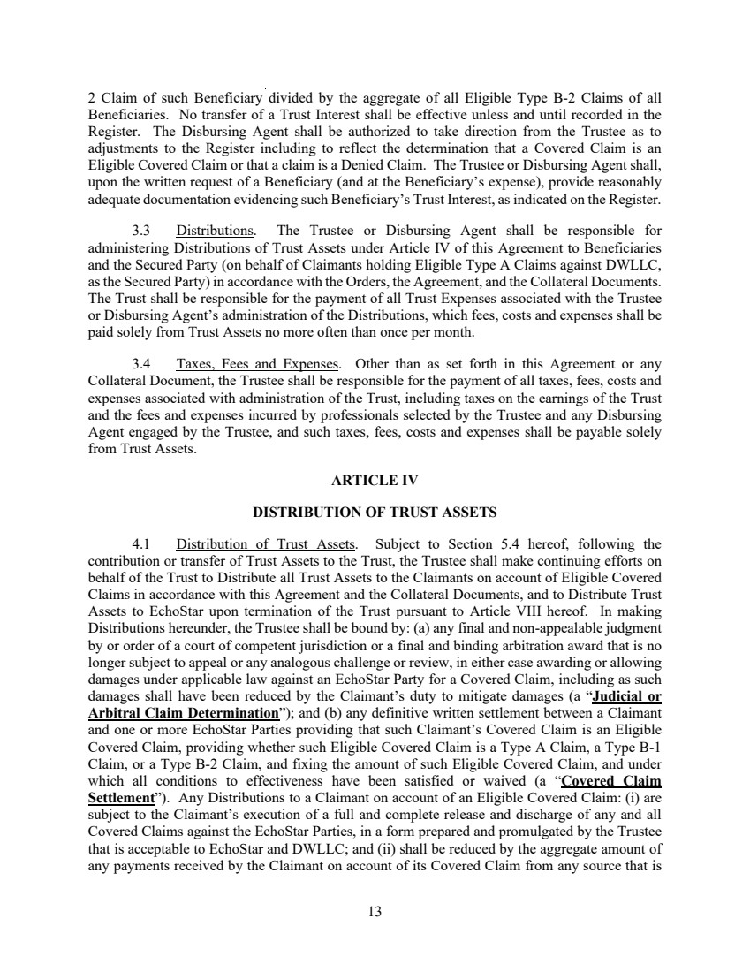 | 13 2 Claim of such Beneficiary divided by the aggregate of all Eligible Type B-2 Claims of all Beneficiaries. No transfer of a Trust Interest shall be effective unless and until recorded in the Register. The Disbursing Agent shall be authorized to take direction from the Trustee as to adjustments to the Register including to reflect the determination that a Covered Claim is an Eligible Covered Claim or that a claim is a Denied Claim. The Trustee or Disbursing Agent shall, upon the written request of a Beneficiary (and at the Beneficiary’s expense), provide reasonably adequate documentation evidencing such Beneficiary’s Trust Interest, as indicated on the Register. 3.3 Distributions. The Trustee or Disbursing Agent shall be responsible for administering Distributions of Trust Assets under Article IV of this Agreement to Beneficiaries and the Secured Party (on behalf of Claimants holding Eligible Type A Claims against DWLLC, as the Secured Party) in accordance with the Orders, the Agreement, and the Collateral Documents. The Trust shall be responsible for the payment of all Trust Expenses associated with the Trustee or Disbursing Agent’s administration of the Distributions, which fees, costs and expenses shall be paid solely from Trust Assets no more often than once per month. 3.4 Taxes, Fees and Expenses. Other than as set forth in this Agreement or any Collateral Document, the Trustee shall be responsible for the payment of all taxes, fees, costs and expenses associated with administration of the Trust, including taxes on the earnings of the Trust and the fees and expenses incurred by professionals selected by the Trustee and any Disbursing Agent engaged by the Trustee, and such taxes, fees, costs and expenses shall be payable solely from Trust Assets. ARTICLE IV DISTRIBUTION OF TRUST ASSETS 4.1 Distribution of Trust Assets. Subject to Section 5.4 hereof, following the contribution or transfer of Trust Assets to the Trust, the Trustee shall make continuing efforts on behalf of the Trust to Distribute all Trust Assets to the Claimants on account of Eligible Covered Claims in accordance with this Agreement and the Collateral Documents, and to Distribute Trust Assets to EchoStar upon termination of the Trust pursuant to Article VIII hereof. In making Distributions hereunder, the Trustee shall be bound by: (a) any final and non-appealable judgment by or order of a court of competent jurisdiction or a final and binding arbitration award that is no longer subject to appeal or any analogous challenge or review, in either case awarding or allowing damages under applicable law against an EchoStar Party for a Covered Claim, including as such damages shall have been reduced by the Claimant’s duty to mitigate damages (a “Judicial or Arbitral Claim Determination”); and (b) any definitive written settlement between a Claimant and one or more EchoStar Parties providing that such Claimant’s Covered Claim is an Eligible Covered Claim, providing whether such Eligible Covered Claim is a Type A Claim, a Type B-1 Claim, or a Type B-2 Claim, and fixing the amount of such Eligible Covered Claim, and under which all conditions to effectiveness have been satisfied or waived (a “Covered Claim Settlement”). Any Distributions to a Claimant on account of an Eligible Covered Claim: (i) are subject to the Claimant’s execution of a full and complete release and discharge of any and all Covered Claims against the EchoStar Parties, in a form prepared and promulgated by the Trustee that is acceptable to EchoStar and DWLLC; and (ii) shall be reduced by the aggregate amount of any payments received by the Claimant on account of its Covered Claim from any source that is
 | 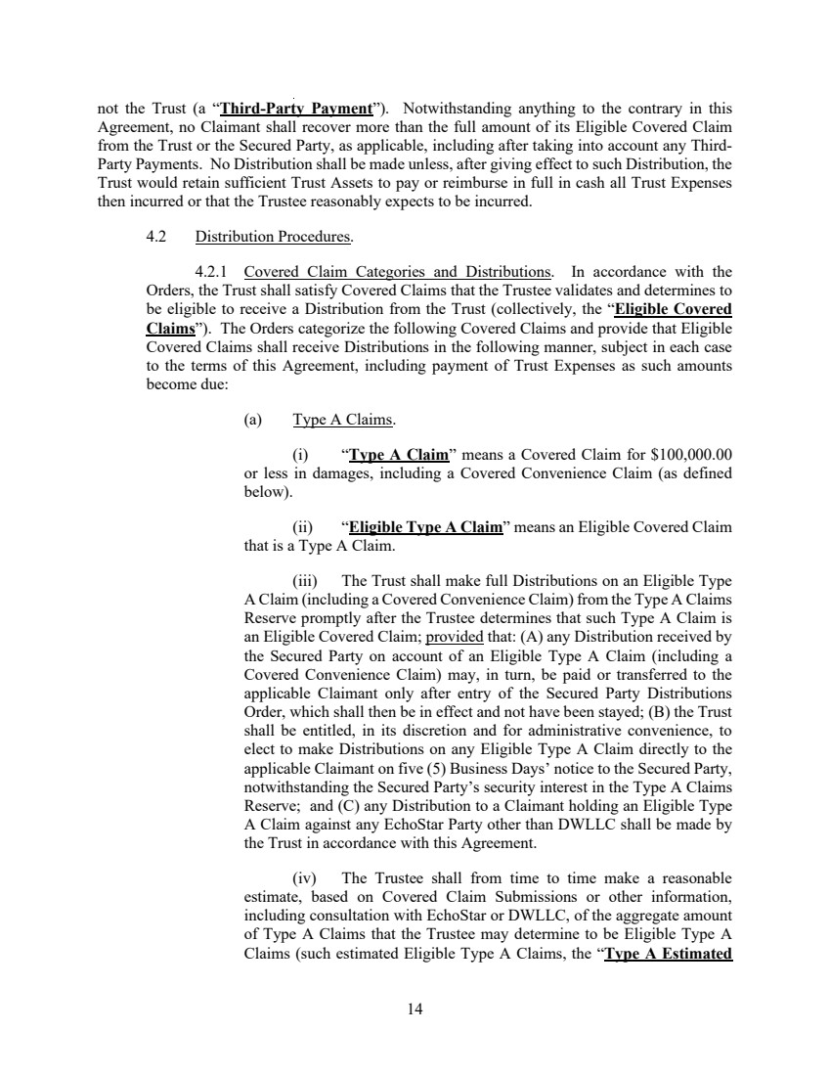 | 14 not the Trust (a “Third-Party Payment”). Notwithstanding anything to the contrary in this Agreement, no Claimant shall recover more than the full amount of its Eligible Covered Claim from the Trust or the Secured Party, as applicable, including after taking into account any Third-Party Payments. No Distribution shall be made unless, after giving effect to such Distribution, the Trust would retain sufficient Trust Assets to pay or reimburse in full in cash all Trust Expenses then incurred or that the Trustee reasonably expects to be incurred. 4.2 Distribution Procedures. 4.2.1 Covered Claim Categories and Distributions. In accordance with the Orders, the Trust shall satisfy Covered Claims that the Trustee validates and determines to be eligible to receive a Distribution from the Trust (collectively, the “Eligible Covered Claims”). The Orders categorize the following Covered Claims and provide that Eligible Covered Claims shall receive Distributions in the following manner, subject in each case to the terms of this Agreement, including payment of Trust Expenses as such amounts become due: (a) Type A Claims. (i) “Type A Claim” means a Covered Claim for $100,000.00 or less in damages, including a Covered Convenience Claim (as defined below). (ii) “Eligible Type A Claim” means an Eligible Covered Claim that is a Type A Claim. (iii) The Trust shall make full Distributions on an Eligible Type A Claim (including a Covered Convenience Claim) from the Type A Claims Reserve promptly after the Trustee determines that such Type A Claim is an Eligible Covered Claim; provided that: (A) any Distribution received by the Secured Party on account of an Eligible Type A Claim (including a Covered Convenience Claim) may, in turn, be paid or transferred to the applicable Claimant only after entry of the Secured Party Distributions Order, which shall then be in effect and not have been stayed; (B) the Trust shall be entitled, in its discretion and for administrative convenience, to elect to make Distributions on any Eligible Type A Claim directly to the applicable Claimant on five (5) Business Days’ notice to the Secured Party, notwithstanding the Secured Party’s security interest in the Type A Claims Reserve; and (C) any Distribution to a Claimant holding an Eligible Type A Claim against any EchoStar Party other than DWLLC shall be made by the Trust in accordance with this Agreement. (iv) The Trustee shall from time to time make a reasonable estimate, based on Covered Claim Submissions or other information, including consultation with EchoStar or DWLLC, of the aggregate amount of Type A Claims that the Trustee may determine to be Eligible Type A Claims (such estimated Eligible Type A Claims, the “Type A Estimated
 | 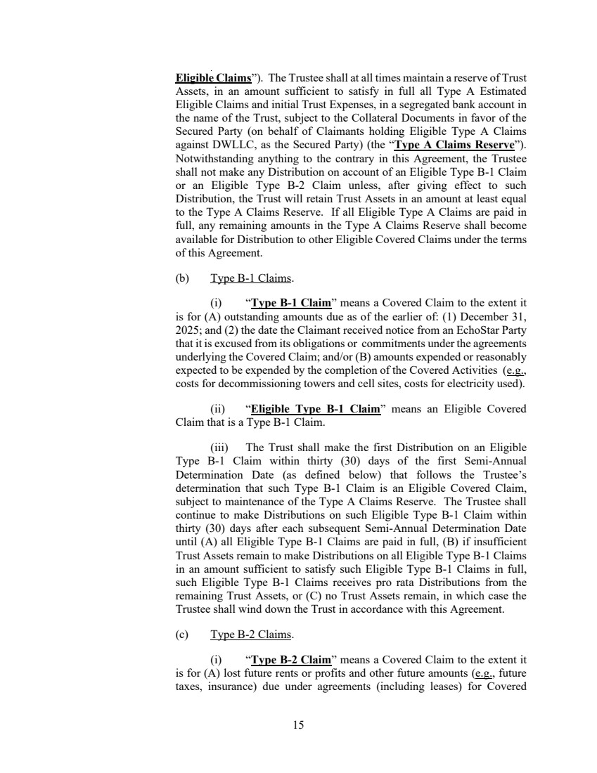 | 15 Eligible Claims”). The Trustee shall at all times maintain a reserve of Trust Assets, in an amount sufficient to satisfy in full all Type A Estimated Eligible Claims and initial Trust Expenses, in a segregated bank account in the name of the Trust, subject to the Collateral Documents in favor of the Secured Party (on behalf of Claimants holding Eligible Type A Claims against DWLLC, as the Secured Party) (the “Type A Claims Reserve”). Notwithstanding anything to the contrary in this Agreement, the Trustee shall not make any Distribution on account of an Eligible Type B-1 Claim or an Eligible Type B-2 Claim unless, after giving effect to such Distribution, the Trust will retain Trust Assets in an amount at least equal to the Type A Claims Reserve. If all Eligible Type A Claims are paid in full, any remaining amounts in the Type A Claims Reserve shall become available for Distribution to other Eligible Covered Claims under the terms of this Agreement. (b) Type B-1 Claims. (i) “Type B-1 Claim” means a Covered Claim to the extent it is for (A) outstanding amounts due as of the earlier of: (1) December 31, 2025; and (2) the date the Claimant received notice from an EchoStar Party that it is excused from its obligations or commitments under the agreements underlying the Covered Claim; and/or (B) amounts expended or reasonably expected to be expended by the completion of the Covered Activities (e.g., costs for decommissioning towers and cell sites, costs for electricity used). (ii) “Eligible Type B-1 Claim” means an Eligible Covered Claim that is a Type B-1 Claim. (iii) The Trust shall make the first Distribution on an Eligible Type B-1 Claim within thirty (30) days of the first Semi-Annual Determination Date (as defined below) that follows the Trustee’s determination that such Type B-1 Claim is an Eligible Covered Claim, subject to maintenance of the Type A Claims Reserve. The Trustee shall continue to make Distributions on such Eligible Type B-1 Claim within thirty (30) days after each subsequent Semi-Annual Determination Date until (A) all Eligible Type B-1 Claims are paid in full, (B) if insufficient Trust Assets remain to make Distributions on all Eligible Type B-1 Claims in an amount sufficient to satisfy such Eligible Type B-1 Claims in full, such Eligible Type B-1 Claims receives pro rata Distributions from the remaining Trust Assets, or (C) no Trust Assets remain, in which case the Trustee shall wind down the Trust in accordance with this Agreement. (c) Type B-2 Claims. (i) “Type B-2 Claim” means a Covered Claim to the extent it is for (A) lost future rents or profits and other future amounts (e.g., future taxes, insurance) due under agreements (including leases) for Covered
 | 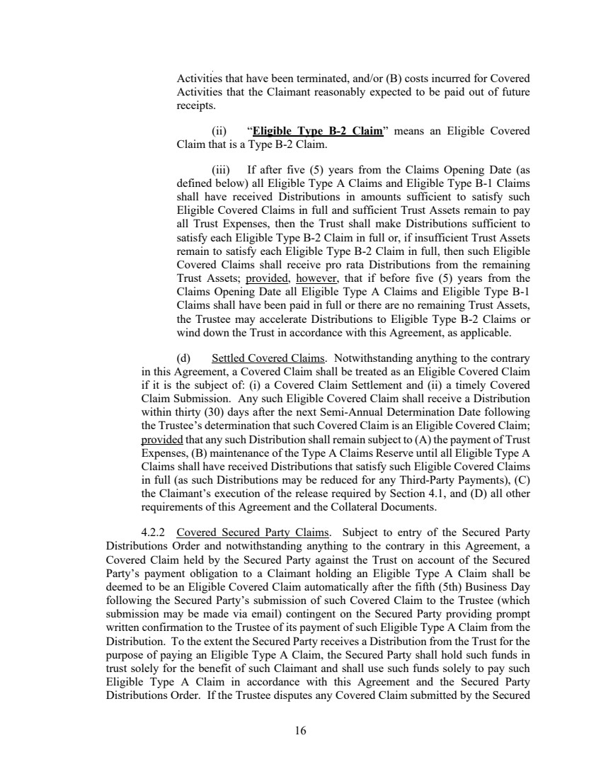 | 16 Activities that have been terminated, and/or (B) costs incurred for Covered Activities that the Claimant reasonably expected to be paid out of future receipts. (ii) “Eligible Type B-2 Claim” means an Eligible Covered Claim that is a Type B-2 Claim. (iii) If after five (5) years from the Claims Opening Date (as defined below) all Eligible Type A Claims and Eligible Type B-1 Claims shall have received Distributions in amounts sufficient to satisfy such Eligible Covered Claims in full and sufficient Trust Assets remain to pay all Trust Expenses, then the Trust shall make Distributions sufficient to satisfy each Eligible Type B-2 Claim in full or, if insufficient Trust Assets remain to satisfy each Eligible Type B-2 Claim in full, then such Eligible Covered Claims shall receive pro rata Distributions from the remaining Trust Assets; provided, however, that if before five (5) years from the Claims Opening Date all Eligible Type A Claims and Eligible Type B-1 Claims shall have been paid in full or there are no remaining Trust Assets, the Trustee may accelerate Distributions to Eligible Type B-2 Claims or wind down the Trust in accordance with this Agreement, as applicable. (d) Settled Covered Claims. Notwithstanding anything to the contrary in this Agreement, a Covered Claim shall be treated as an Eligible Covered Claim if it is the subject of: (i) a Covered Claim Settlement and (ii) a timely Covered Claim Submission. Any such Eligible Covered Claim shall receive a Distribution within thirty (30) days after the next Semi-Annual Determination Date following the Trustee’s determination that such Covered Claim is an Eligible Covered Claim; provided that any such Distribution shall remain subject to (A) the payment of Trust Expenses, (B) maintenance of the Type A Claims Reserve until all Eligible Type A Claims shall have received Distributions that satisfy such Eligible Covered Claims in full (as such Distributions may be reduced for any Third-Party Payments), (C) the Claimant’s execution of the release required by Section 4.1, and (D) all other requirements of this Agreement and the Collateral Documents. 4.2.2 Covered Secured Party Claims. Subject to entry of the Secured Party Distributions Order and notwithstanding anything to the contrary in this Agreement, a Covered Claim held by the Secured Party against the Trust on account of the Secured Party’s payment obligation to a Claimant holding an Eligible Type A Claim shall be deemed to be an Eligible Covered Claim automatically after the fifth (5th) Business Day following the Secured Party’s submission of such Covered Claim to the Trustee (which submission may be made via email) contingent on the Secured Party providing prompt written confirmation to the Trustee of its payment of such Eligible Type A Claim from the Distribution. To the extent the Secured Party receives a Distribution from the Trust for the purpose of paying an Eligible Type A Claim, the Secured Party shall hold such funds in trust solely for the benefit of such Claimant and shall use such funds solely to pay such Eligible Type A Claim in accordance with this Agreement and the Secured Party Distributions Order. If the Trustee disputes any Covered Claim submitted by the Secured
 | 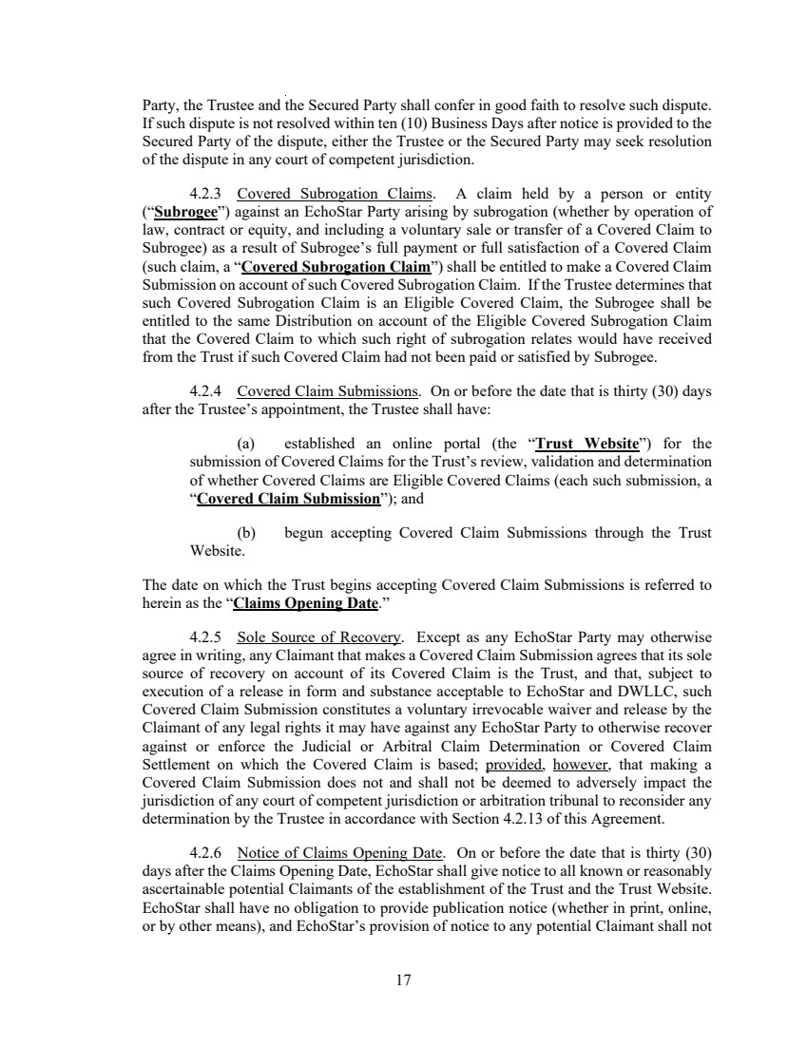 | 17 Party, the Trustee and the Secured Party shall confer in good faith to resolve such dispute. If such dispute is not resolved within ten (10) Business Days after notice is provided to the Secured Party of the dispute, either the Trustee or the Secured Party may seek resolution of the dispute in any court of competent jurisdiction. 4.2.3 Covered Subrogation Claims. A claim held by a person or entity (“Subrogee”) against an EchoStar Party arising by subrogation (whether by operation of law, contract or equity, and including a voluntary sale or transfer of a Covered Claim to Subrogee) as a result of Subrogee’s full payment or full satisfaction of a Covered Claim (such claim, a “Covered Subrogation Claim”) shall be entitled to make a Covered Claim Submission on account of such Covered Subrogation Claim. If the Trustee determines that such Covered Subrogation Claim is an Eligible Covered Claim, the Subrogee shall be entitled to the same Distribution on account of the Eligible Covered Subrogation Claim that the Covered Claim to which such right of subrogation relates would have received from the Trust if such Covered Claim had not been paid or satisfied by Subrogee. 4.2.4 Covered Claim Submissions. On or before the date that is thirty (30) days after the Trustee’s appointment, the Trustee shall have: (a) established an online portal (the “Trust Website”) for the submission of Covered Claims for the Trust’s review, validation and determination of whether Covered Claims are Eligible Covered Claims (each such submission, a “Covered Claim Submission”); and (b) begun accepting Covered Claim Submissions through the Trust Website. The date on which the Trust begins accepting Covered Claim Submissions is referred to herein as the “Claims Opening Date.” 4.2.5 Sole Source of Recovery. Except as any EchoStar Party may otherwise agree in writing, any Claimant that makes a Covered Claim Submission agrees that its sole source of recovery on account of its Covered Claim is the Trust, and that, subject to execution of a release in form and substance acceptable to EchoStar and DWLLC, such Covered Claim Submission constitutes a voluntary irrevocable waiver and release by the Claimant of any legal rights it may have against any EchoStar Party to otherwise recover against or enforce the Judicial or Arbitral Claim Determination or Covered Claim Settlement on which the Covered Claim is based; provided, however, that making a Covered Claim Submission does not and shall not be deemed to adversely impact the jurisdiction of any court of competent jurisdiction or arbitration tribunal to reconsider any determination by the Trustee in accordance with Section 4.2.13 of this Agreement. 4.2.6 Notice of Claims Opening Date. On or before the date that is thirty (30) days after the Claims Opening Date, EchoStar shall give notice to all known or reasonably ascertainable potential Claimants of the establishment of the Trust and the Trust Website. EchoStar shall have no obligation to provide publication notice (whether in print, online, or by other means), and EchoStar’s provision of notice to any potential Claimant shall not
 | 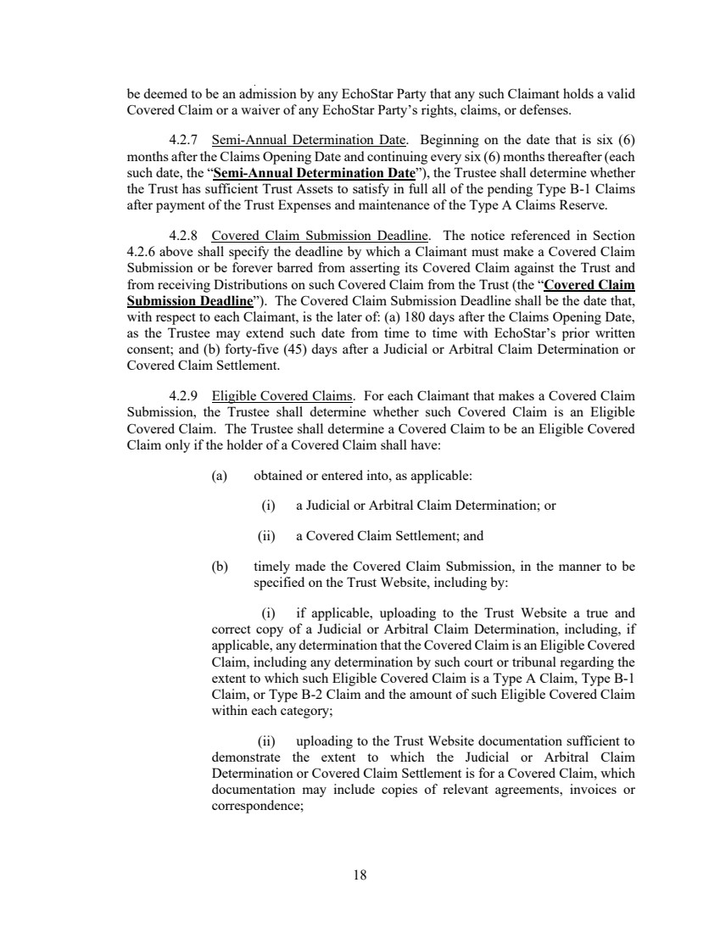 | 18 be deemed to be an admission by any EchoStar Party that any such Claimant holds a valid Covered Claim or a waiver of any EchoStar Party’s rights, claims, or defenses. 4.2.7 Semi-Annual Determination Date. Beginning on the date that is six (6) months after the Claims Opening Date and continuing every six (6) months thereafter (each such date, the “Semi-Annual Determination Date”), the Trustee shall determine whether the Trust has sufficient Trust Assets to satisfy in full all of the pending Type B-1 Claims after payment of the Trust Expenses and maintenance of the Type A Claims Reserve. 4.2.8 Covered Claim Submission Deadline. The notice referenced in Section 4.2.6 above shall specify the deadline by which a Claimant must make a Covered Claim Submission or be forever barred from asserting its Covered Claim against the Trust and from receiving Distributions on such Covered Claim from the Trust (the “Covered Claim Submission Deadline”). The Covered Claim Submission Deadline shall be the date that, with respect to each Claimant, is the later of: (a) 180 days after the Claims Opening Date, as the Trustee may extend such date from time to time with EchoStar’s prior written consent; and (b) forty-five (45) days after a Judicial or Arbitral Claim Determination or Covered Claim Settlement. 4.2.9 Eligible Covered Claims. For each Claimant that makes a Covered Claim Submission, the Trustee shall determine whether such Covered Claim is an Eligible Covered Claim. The Trustee shall determine a Covered Claim to be an Eligible Covered Claim only if the holder of a Covered Claim shall have: (a) obtained or entered into, as applicable: (i) a Judicial or Arbitral Claim Determination; or (ii) a Covered Claim Settlement; and (b) timely made the Covered Claim Submission, in the manner to be specified on the Trust Website, including by: (i) if applicable, uploading to the Trust Website a true and correct copy of a Judicial or Arbitral Claim Determination, including, if applicable, any determination that the Covered Claim is an Eligible Covered Claim, including any determination by such court or tribunal regarding the extent to which such Eligible Covered Claim is a Type A Claim, Type B-1 Claim, or Type B-2 Claim and the amount of such Eligible Covered Claim within each category; (ii) uploading to the Trust Website documentation sufficient to demonstrate the extent to which the Judicial or Arbitral Claim Determination or Covered Claim Settlement is for a Covered Claim, which documentation may include copies of relevant agreements, invoices or correspondence;
 | 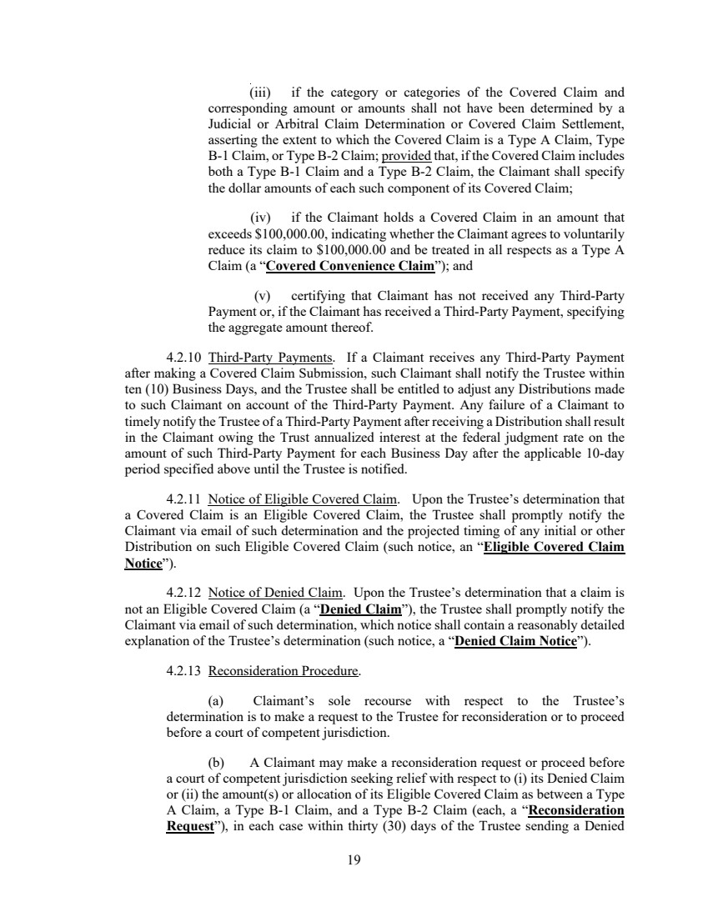 | 19 (iii) if the category or categories of the Covered Claim and corresponding amount or amounts shall not have been determined by a Judicial or Arbitral Claim Determination or Covered Claim Settlement, asserting the extent to which the Covered Claim is a Type A Claim, Type B-1 Claim, or Type B-2 Claim; provided that, if the Covered Claim includes both a Type B-1 Claim and a Type B-2 Claim, the Claimant shall specify the dollar amounts of each such component of its Covered Claim; (iv) if the Claimant holds a Covered Claim in an amount that exceeds $100,000.00, indicating whether the Claimant agrees to voluntarily reduce its claim to $100,000.00 and be treated in all respects as a Type A Claim (a “Covered Convenience Claim”); and (v) certifying that Claimant has not received any Third-Party Payment or, if the Claimant has received a Third-Party Payment, specifying the aggregate amount thereof. 4.2.10 Third-Party Payments. If a Claimant receives any Third-Party Payment after making a Covered Claim Submission, such Claimant shall notify the Trustee within ten (10) Business Days, and the Trustee shall be entitled to adjust any Distributions made to such Claimant on account of the Third-Party Payment. Any failure of a Claimant to timely notify the Trustee of a Third-Party Payment after receiving a Distribution shall result in the Claimant owing the Trust annualized interest at the federal judgment rate on the amount of such Third-Party Payment for each Business Day after the applicable 10-day period specified above until the Trustee is notified. 4.2.11 Notice of Eligible Covered Claim. Upon the Trustee’s determination that a Covered Claim is an Eligible Covered Claim, the Trustee shall promptly notify the Claimant via email of such determination and the projected timing of any initial or other Distribution on such Eligible Covered Claim (such notice, an “Eligible Covered Claim Notice”). 4.2.12 Notice of Denied Claim. Upon the Trustee’s determination that a claim is not an Eligible Covered Claim (a “Denied Claim”), the Trustee shall promptly notify the Claimant via email of such determination, which notice shall contain a reasonably detailed explanation of the Trustee’s determination (such notice, a “Denied Claim Notice”). 4.2.13 Reconsideration Procedure. (a) Claimant’s sole recourse with respect to the Trustee’s determination is to make a request to the Trustee for reconsideration or to proceed before a court of competent jurisdiction. (b) A Claimant may make a reconsideration request or proceed before a court of competent jurisdiction seeking relief with respect to (i) its Denied Claim or (ii) the amount(s) or allocation of its Eligible Covered Claim as between a Type A Claim, a Type B-1 Claim, and a Type B-2 Claim (each, a “Reconsideration Request”), in each case within thirty (30) days of the Trustee sending a Denied
 | 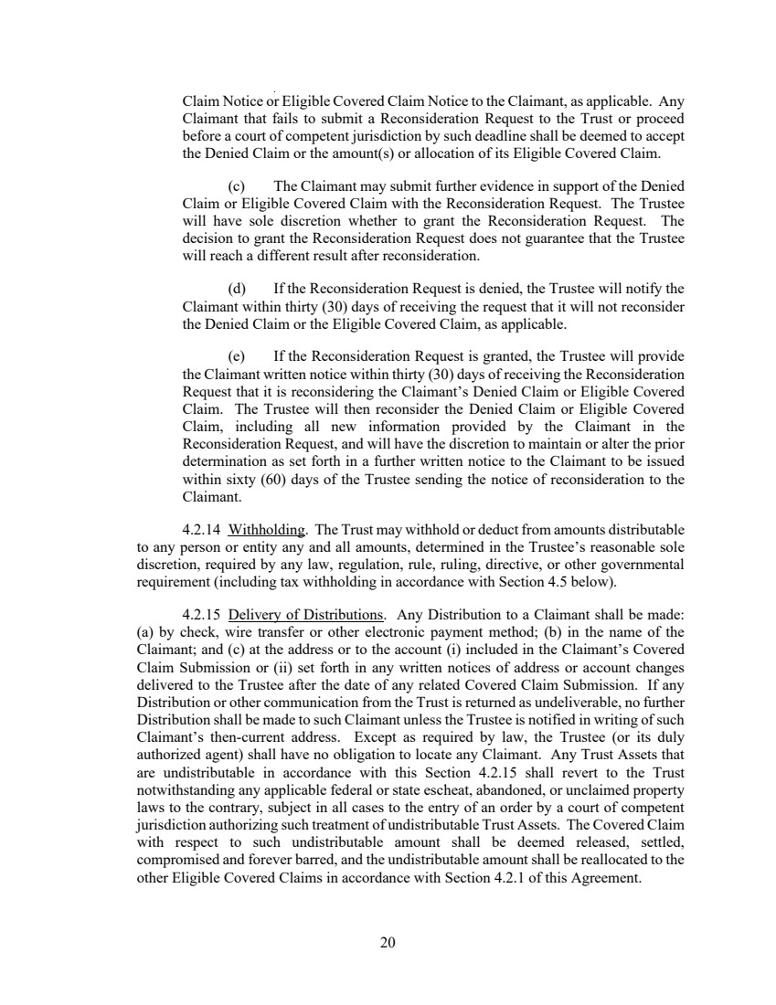 | 20 Claim Notice or Eligible Covered Claim Notice to the Claimant, as applicable. Any Claimant that fails to submit a Reconsideration Request to the Trust or proceed before a court of competent jurisdiction by such deadline shall be deemed to accept the Denied Claim or the amount(s) or allocation of its Eligible Covered Claim. (c) The Claimant may submit further evidence in support of the Denied Claim or Eligible Covered Claim with the Reconsideration Request. The Trustee will have sole discretion whether to grant the Reconsideration Request. The decision to grant the Reconsideration Request does not guarantee that the Trustee will reach a different result after reconsideration. (d) If the Reconsideration Request is denied, the Trustee will notify the Claimant within thirty (30) days of receiving the request that it will not reconsider the Denied Claim or the Eligible Covered Claim, as applicable. (e) If the Reconsideration Request is granted, the Trustee will provide the Claimant written notice within thirty (30) days of receiving the Reconsideration Request that it is reconsidering the Claimant’s Denied Claim or Eligible Covered Claim. The Trustee will then reconsider the Denied Claim or Eligible Covered Claim, including all new information provided by the Claimant in the Reconsideration Request, and will have the discretion to maintain or alter the prior determination as set forth in a further written notice to the Claimant to be issued within sixty (60) days of the Trustee sending the notice of reconsideration to the Claimant. 4.2.14 Withholding. The Trust may withhold or deduct from amounts distributable to any person or entity any and all amounts, determined in the Trustee’s reasonable sole discretion, required by any law, regulation, rule, ruling, directive, or other governmental requirement (including tax withholding in accordance with Section 4.5 below). 4.2.15 Delivery of Distributions. Any Distribution to a Claimant shall be made: (a) by check, wire transfer or other electronic payment method; (b) in the name of the Claimant; and (c) at the address or to the account (i) included in the Claimant’s Covered Claim Submission or (ii) set forth in any written notices of address or account changes delivered to the Trustee after the date of any related Covered Claim Submission. If any Distribution or other communication from the Trust is returned as undeliverable, no further Distribution shall be made to such Claimant unless the Trustee is notified in writing of such Claimant’s then-current address. Except as required by law, the Trustee (or its duly authorized agent) shall have no obligation to locate any Claimant. Any Trust Assets that are undistributable in accordance with this Section 4.2.15 shall revert to the Trust notwithstanding any applicable federal or state escheat, abandoned, or unclaimed property laws to the contrary, subject in all cases to the entry of an order by a court of competent jurisdiction authorizing such treatment of undistributable Trust Assets. The Covered Claim with respect to such undistributable amount shall be deemed released, settled, compromised and forever barred, and the undistributable amount shall be reallocated to the other Eligible Covered Claims in accordance with Section 4.2.1 of this Agreement.
 | 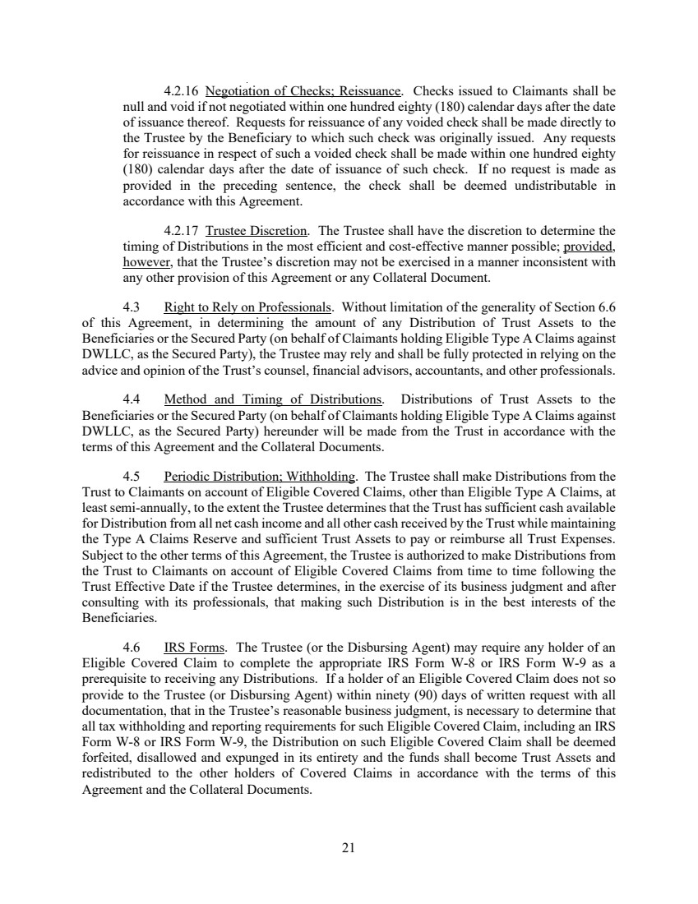 | 21 4.2.16 Negotiation of Checks; Reissuance. Checks issued to Claimants shall be null and void if not negotiated within one hundred eighty (180) calendar days after the date of issuance thereof. Requests for reissuance of any voided check shall be made directly to the Trustee by the Beneficiary to which such check was originally issued. Any requests for reissuance in respect of such a voided check shall be made within one hundred eighty (180) calendar days after the date of issuance of such check. If no request is made as provided in the preceding sentence, the check shall be deemed undistributable in accordance with this Agreement. 4.2.17 Trustee Discretion. The Trustee shall have the discretion to determine the timing of Distributions in the most efficient and cost-effective manner possible; provided, however, that the Trustee’s discretion may not be exercised in a manner inconsistent with any other provision of this Agreement or any Collateral Document. 4.3 Right to Rely on Professionals. Without limitation of the generality of Section 6.6 of this Agreement, in determining the amount of any Distribution of Trust Assets to the Beneficiaries or the Secured Party (on behalf of Claimants holding Eligible Type A Claims against DWLLC, as the Secured Party), the Trustee may rely and shall be fully protected in relying on the advice and opinion of the Trust’s counsel, financial advisors, accountants, and other professionals. 4.4 Method and Timing of Distributions. Distributions of Trust Assets to the Beneficiaries or the Secured Party (on behalf of Claimants holding Eligible Type A Claims against DWLLC, as the Secured Party) hereunder will be made from the Trust in accordance with the terms of this Agreement and the Collateral Documents. 4.5 Periodic Distribution; Withholding. The Trustee shall make Distributions from the Trust to Claimants on account of Eligible Covered Claims, other than Eligible Type A Claims, at least semi-annually, to the extent the Trustee determines that the Trust has sufficient cash available for Distribution from all net cash income and all other cash received by the Trust while maintaining the Type A Claims Reserve and sufficient Trust Assets to pay or reimburse all Trust Expenses. Subject to the other terms of this Agreement, the Trustee is authorized to make Distributions from the Trust to Claimants on account of Eligible Covered Claims from time to time following the Trust Effective Date if the Trustee determines, in the exercise of its business judgment and after consulting with its professionals, that making such Distribution is in the best interests of the Beneficiaries. 4.6 IRS Forms. The Trustee (or the Disbursing Agent) may require any holder of an Eligible Covered Claim to complete the appropriate IRS Form W-8 or IRS Form W-9 as a prerequisite to receiving any Distributions. If a holder of an Eligible Covered Claim does not so provide to the Trustee (or Disbursing Agent) within ninety (90) days of written request with all documentation, that in the Trustee’s reasonable business judgment, is necessary to determine that all tax withholding and reporting requirements for such Eligible Covered Claim, including an IRS Form W-8 or IRS Form W-9, the Distribution on such Eligible Covered Claim shall be deemed forfeited, disallowed and expunged in its entirety and the funds shall become Trust Assets and redistributed to the other holders of Covered Claims in accordance with the terms of this Agreement and the Collateral Documents.
 | 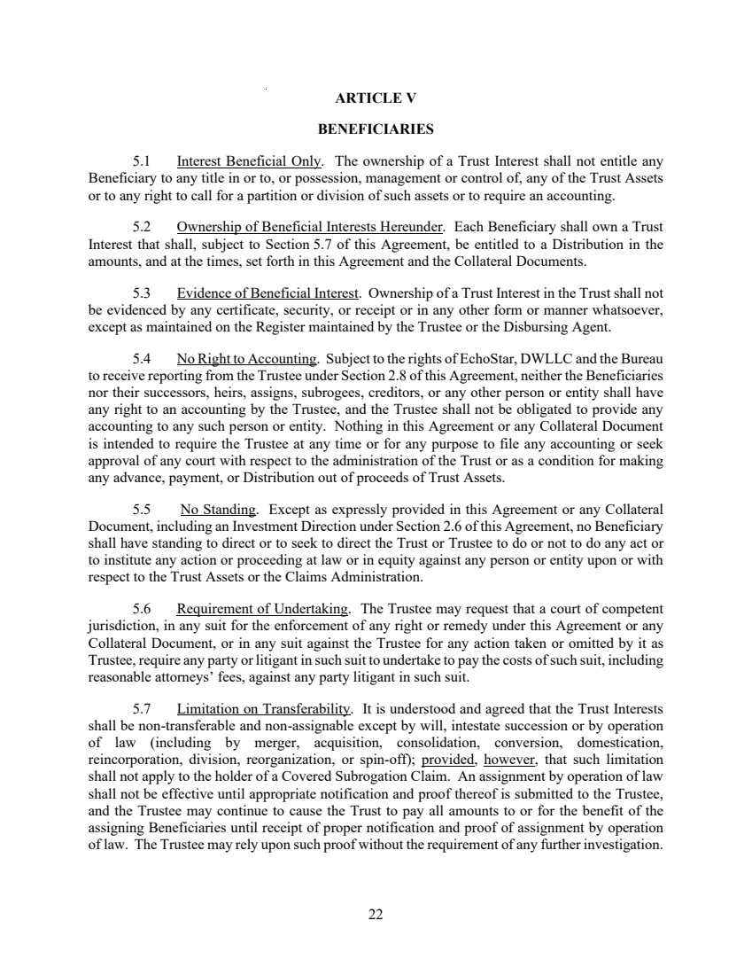 | 22 ARTICLE V BENEFICIARIES 5.1 Interest Beneficial Only. The ownership of a Trust Interest shall not entitle any Beneficiary to any title in or to, or possession, management or control of, any of the Trust Assets or to any right to call for a partition or division of such assets or to require an accounting. 5.2 Ownership of Beneficial Interests Hereunder. Each Beneficiary shall own a Trust Interest that shall, subject to Section 5.7 of this Agreement, be entitled to a Distribution in the amounts, and at the times, set forth in this Agreement and the Collateral Documents. 5.3 Evidence of Beneficial Interest. Ownership of a Trust Interest in the Trust shall not be evidenced by any certificate, security, or receipt or in any other form or manner whatsoever, except as maintained on the Register maintained by the Trustee or the Disbursing Agent. 5.4 No Right to Accounting. Subject to the rights of EchoStar, DWLLC and the Bureau to receive reporting from the Trustee under Section 2.8 of this Agreement, neither the Beneficiaries nor their successors, heirs, assigns, subrogees, creditors, or any other person or entity shall have any right to an accounting by the Trustee, and the Trustee shall not be obligated to provide any accounting to any such person or entity. Nothing in this Agreement or any Collateral Document is intended to require the Trustee at any time or for any purpose to file any accounting or seek approval of any court with respect to the administration of the Trust or as a condition for making any advance, payment, or Distribution out of proceeds of Trust Assets. 5.5 No Standing. Except as expressly provided in this Agreement or any Collateral Document, including an Investment Direction under Section 2.6 of this Agreement, no Beneficiary shall have standing to direct or to seek to direct the Trust or Trustee to do or not to do any act or to institute any action or proceeding at law or in equity against any person or entity upon or with respect to the Trust Assets or the Claims Administration. 5.6 Requirement of Undertaking. The Trustee may request that a court of competent jurisdiction, in any suit for the enforcement of any right or remedy under this Agreement or any Collateral Document, or in any suit against the Trustee for any action taken or omitted by it as Trustee, require any party or litigant in such suit to undertake to pay the costs of such suit, including reasonable attorneys’ fees, against any party litigant in such suit. 5.7 Limitation on Transferability. It is understood and agreed that the Trust Interests shall be non-transferable and non-assignable except by will, intestate succession or by operation of law (including by merger, acquisition, consolidation, conversion, domestication, reincorporation, division, reorganization, or spin-off); provided, however, that such limitation shall not apply to the holder of a Covered Subrogation Claim. An assignment by operation of law shall not be effective until appropriate notification and proof thereof is submitted to the Trustee, and the Trustee may continue to cause the Trust to pay all amounts to or for the benefit of the assigning Beneficiaries until receipt of proper notification and proof of assignment by operation of law. The Trustee may rely upon such proof without the requirement of any further investigation.
 | 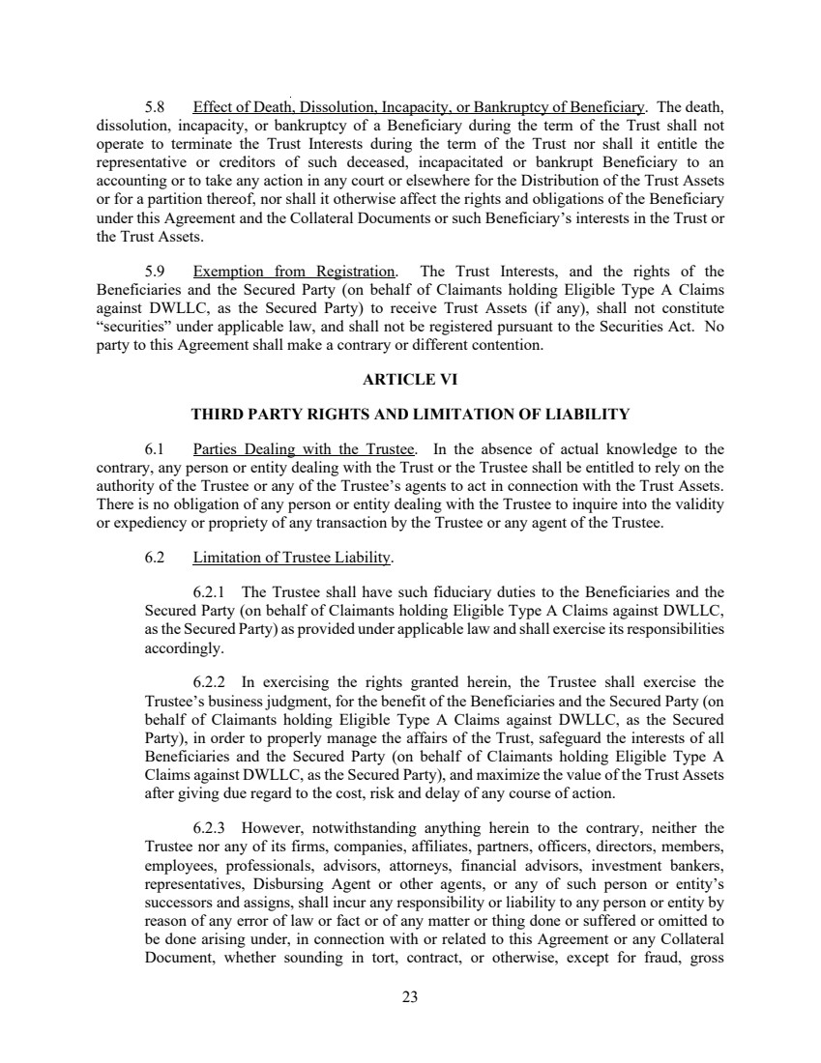 | 23 5.8 Effect of Death, Dissolution, Incapacity, or Bankruptcy of Beneficiary. The death, dissolution, incapacity, or bankruptcy of a Beneficiary during the term of the Trust shall not operate to terminate the Trust Interests during the term of the Trust nor shall it entitle the representative or creditors of such deceased, incapacitated or bankrupt Beneficiary to an accounting or to take any action in any court or elsewhere for the Distribution of the Trust Assets or for a partition thereof, nor shall it otherwise affect the rights and obligations of the Beneficiary under this Agreement and the Collateral Documents or such Beneficiary’s interests in the Trust or the Trust Assets. 5.9 Exemption from Registration. The Trust Interests, and the rights of the Beneficiaries and the Secured Party (on behalf of Claimants holding Eligible Type A Claims against DWLLC, as the Secured Party) to receive Trust Assets (if any), shall not constitute “securities” under applicable law, and shall not be registered pursuant to the Securities Act. No party to this Agreement shall make a contrary or different contention. ARTICLE VI THIRD PARTY RIGHTS AND LIMITATION OF LIABILITY 6.1 Parties Dealing with the Trustee. In the absence of actual knowledge to the contrary, any person or entity dealing with the Trust or the Trustee shall be entitled to rely on the authority of the Trustee or any of the Trustee’s agents to act in connection with the Trust Assets. There is no obligation of any person or entity dealing with the Trustee to inquire into the validity or expediency or propriety of any transaction by the Trustee or any agent of the Trustee. 6.2 Limitation of Trustee Liability. 6.2.1 The Trustee shall have such fiduciary duties to the Beneficiaries and the Secured Party (on behalf of Claimants holding Eligible Type A Claims against DWLLC, as the Secured Party) as provided under applicable law and shall exercise its responsibilities accordingly. 6.2.2 In exercising the rights granted herein, the Trustee shall exercise the Trustee’s business judgment, for the benefit of the Beneficiaries and the Secured Party (on behalf of Claimants holding Eligible Type A Claims against DWLLC, as the Secured Party), in order to properly manage the affairs of the Trust, safeguard the interests of all Beneficiaries and the Secured Party (on behalf of Claimants holding Eligible Type A Claims against DWLLC, as the Secured Party), and maximize the value of the Trust Assets after giving due regard to the cost, risk and delay of any course of action. 6.2.3 However, notwithstanding anything herein to the contrary, neither the Trustee nor any of its firms, companies, affiliates, partners, officers, directors, members, employees, professionals, advisors, attorneys, financial advisors, investment bankers, representatives, Disbursing Agent or other agents, or any of such person or entity’s successors and assigns, shall incur any responsibility or liability to any person or entity by reason of any error of law or fact or of any matter or thing done or suffered or omitted to be done arising under, in connection with or related to this Agreement or any Collateral Document, whether sounding in tort, contract, or otherwise, except for fraud, gross
 | 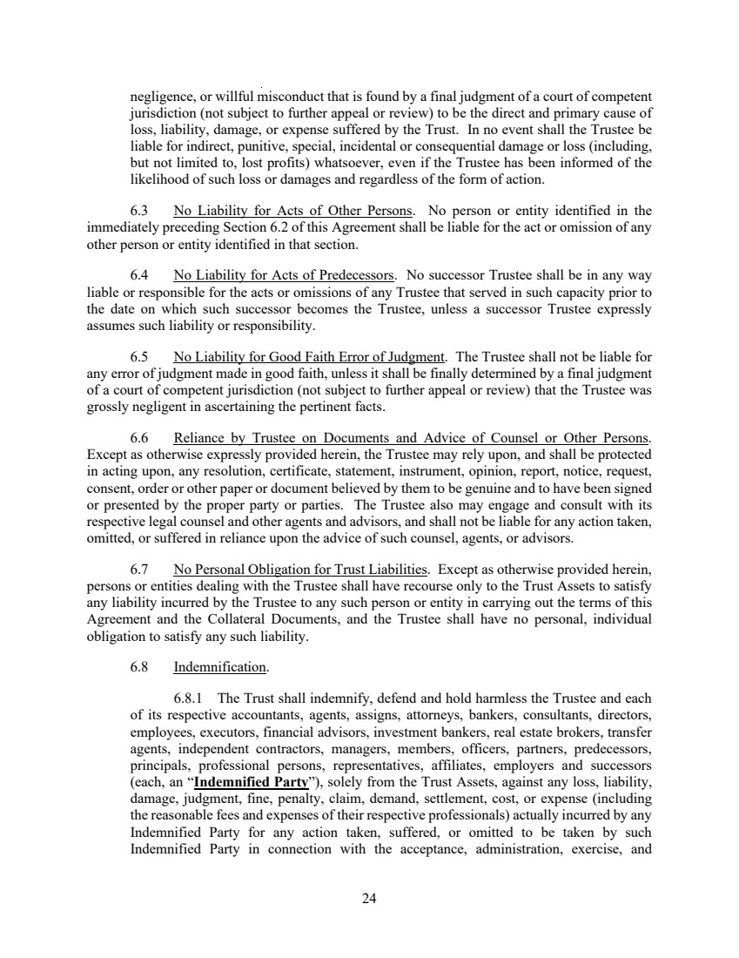 | 24 negligence, or willful misconduct that is found by a final judgment of a court of competent jurisdiction (not subject to further appeal or review) to be the direct and primary cause of loss, liability, damage, or expense suffered by the Trust. In no event shall the Trustee be liable for indirect, punitive, special, incidental or consequential damage or loss (including, but not limited to, lost profits) whatsoever, even if the Trustee has been informed of the likelihood of such loss or damages and regardless of the form of action. 6.3 No Liability for Acts of Other Persons. No person or entity identified in the immediately preceding Section 6.2 of this Agreement shall be liable for the act or omission of any other person or entity identified in that section. 6.4 No Liability for Acts of Predecessors. No successor Trustee shall be in any way liable or responsible for the acts or omissions of any Trustee that served in such capacity prior to the date on which such successor becomes the Trustee, unless a successor Trustee expressly assumes such liability or responsibility. 6.5 No Liability for Good Faith Error of Judgment. The Trustee shall not be liable for any error of judgment made in good faith, unless it shall be finally determined by a final judgment of a court of competent jurisdiction (not subject to further appeal or review) that the Trustee was grossly negligent in ascertaining the pertinent facts. 6.6 Reliance by Trustee on Documents and Advice of Counsel or Other Persons. Except as otherwise expressly provided herein, the Trustee may rely upon, and shall be protected in acting upon, any resolution, certificate, statement, instrument, opinion, report, notice, request, consent, order or other paper or document believed by them to be genuine and to have been signed or presented by the proper party or parties. The Trustee also may engage and consult with its respective legal counsel and other agents and advisors, and shall not be liable for any action taken, omitted, or suffered in reliance upon the advice of such counsel, agents, or advisors. 6.7 No Personal Obligation for Trust Liabilities. Except as otherwise provided herein, persons or entities dealing with the Trustee shall have recourse only to the Trust Assets to satisfy any liability incurred by the Trustee to any such person or entity in carrying out the terms of this Agreement and the Collateral Documents, and the Trustee shall have no personal, individual obligation to satisfy any such liability. 6.8 Indemnification. 6.8.1 The Trust shall indemnify, defend and hold harmless the Trustee and each of its respective accountants, agents, assigns, attorneys, bankers, consultants, directors, employees, executors, financial advisors, investment bankers, real estate brokers, transfer agents, independent contractors, managers, members, officers, partners, predecessors, principals, professional persons, representatives, affiliates, employers and successors (each, an “Indemnified Party”), solely from the Trust Assets, against any loss, liability, damage, judgment, fine, penalty, claim, demand, settlement, cost, or expense (including the reasonable fees and expenses of their respective professionals) actually incurred by any Indemnified Party for any action taken, suffered, or omitted to be taken by such Indemnified Party in connection with the acceptance, administration, exercise, and
 | 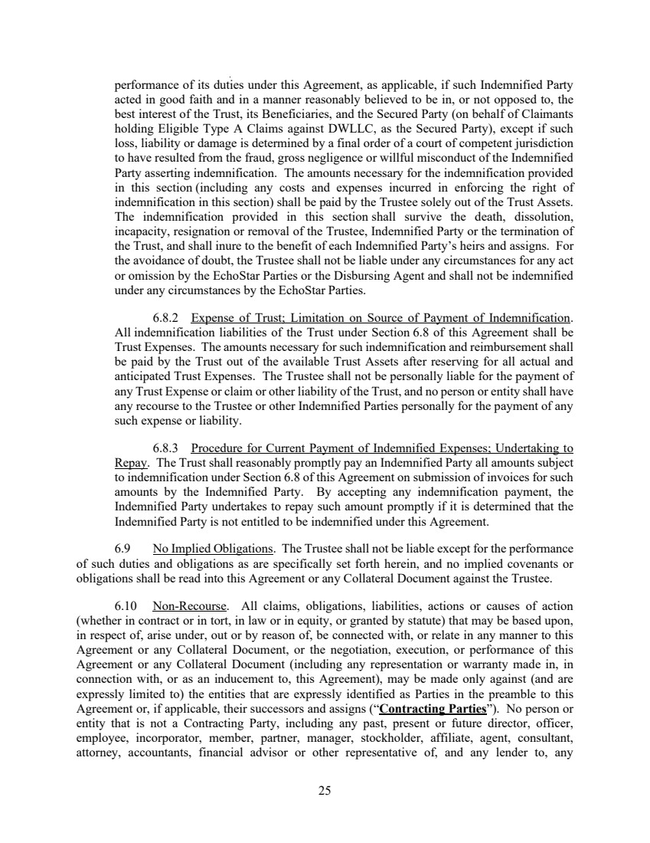 | 25 performance of its duties under this Agreement, as applicable, if such Indemnified Party acted in good faith and in a manner reasonably believed to be in, or not opposed to, the best interest of the Trust, its Beneficiaries, and the Secured Party (on behalf of Claimants holding Eligible Type A Claims against DWLLC, as the Secured Party), except if such loss, liability or damage is determined by a final order of a court of competent jurisdiction to have resulted from the fraud, gross negligence or willful misconduct of the Indemnified Party asserting indemnification. The amounts necessary for the indemnification provided in this section (including any costs and expenses incurred in enforcing the right of indemnification in this section) shall be paid by the Trustee solely out of the Trust Assets. The indemnification provided in this section shall survive the death, dissolution, incapacity, resignation or removal of the Trustee, Indemnified Party or the termination of the Trust, and shall inure to the benefit of each Indemnified Party’s heirs and assigns. For the avoidance of doubt, the Trustee shall not be liable under any circumstances for any act or omission by the EchoStar Parties or the Disbursing Agent and shall not be indemnified under any circumstances by the EchoStar Parties. 6.8.2 Expense of Trust; Limitation on Source of Payment of Indemnification. All indemnification liabilities of the Trust under Section 6.8 of this Agreement shall be Trust Expenses. The amounts necessary for such indemnification and reimbursement shall be paid by the Trust out of the available Trust Assets after reserving for all actual and anticipated Trust Expenses. The Trustee shall not be personally liable for the payment of any Trust Expense or claim or other liability of the Trust, and no person or entity shall have any recourse to the Trustee or other Indemnified Parties personally for the payment of any such expense or liability. 6.8.3 Procedure for Current Payment of Indemnified Expenses; Undertaking to Repay. The Trust shall reasonably promptly pay an Indemnified Party all amounts subject to indemnification under Section 6.8 of this Agreement on submission of invoices for such amounts by the Indemnified Party. By accepting any indemnification payment, the Indemnified Party undertakes to repay such amount promptly if it is determined that the Indemnified Party is not entitled to be indemnified under this Agreement. 6.9 No Implied Obligations. The Trustee shall not be liable except for the performance of such duties and obligations as are specifically set forth herein, and no implied covenants or obligations shall be read into this Agreement or any Collateral Document against the Trustee. 6.10 Non-Recourse. All claims, obligations, liabilities, actions or causes of action (whether in contract or in tort, in law or in equity, or granted by statute) that may be based upon, in respect of, arise under, out or by reason of, be connected with, or relate in any manner to this Agreement or any Collateral Document, or the negotiation, execution, or performance of this Agreement or any Collateral Document (including any representation or warranty made in, in connection with, or as an inducement to, this Agreement), may be made only against (and are expressly limited to) the entities that are expressly identified as Parties in the preamble to this Agreement or, if applicable, their successors and assigns (“Contracting Parties”). No person or entity that is not a Contracting Party, including any past, present or future director, officer, employee, incorporator, member, partner, manager, stockholder, affiliate, agent, consultant, attorney, accountants, financial advisor or other representative of, and any lender to, any
 | 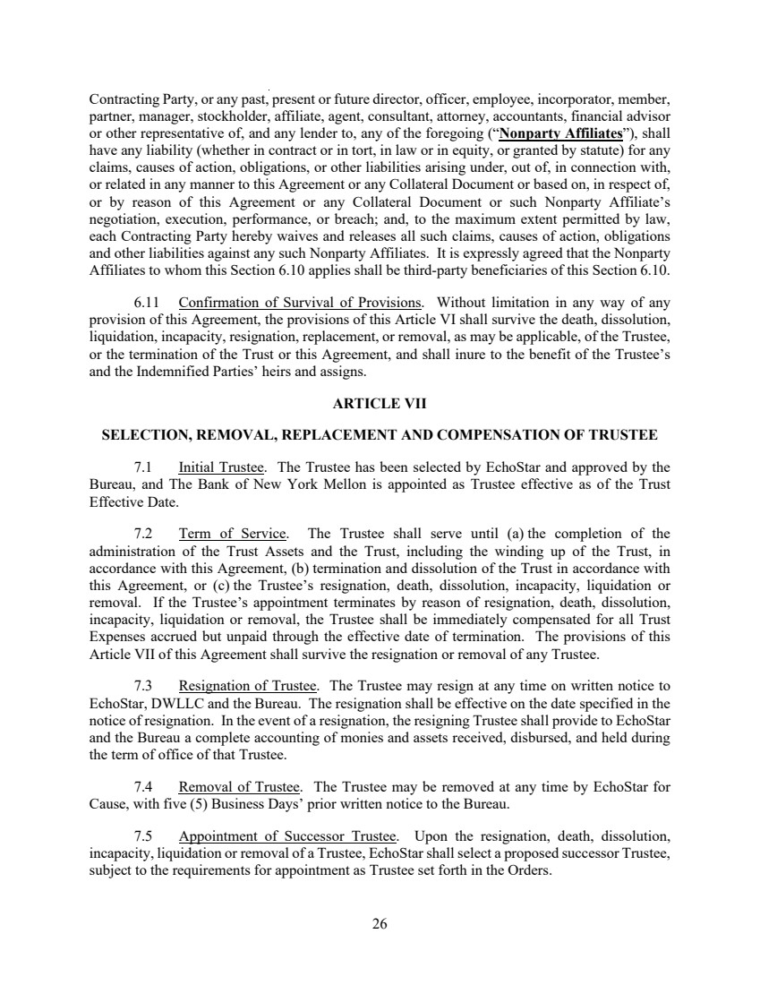 | 26 Contracting Party, or any past, present or future director, officer, employee, incorporator, member, partner, manager, stockholder, affiliate, agent, consultant, attorney, accountants, financial advisor or other representative of, and any lender to, any of the foregoing (“Nonparty Affiliates”), shall have any liability (whether in contract or in tort, in law or in equity, or granted by statute) for any claims, causes of action, obligations, or other liabilities arising under, out of, in connection with, or related in any manner to this Agreement or any Collateral Document or based on, in respect of, or by reason of this Agreement or any Collateral Document or such Nonparty Affiliate’s negotiation, execution, performance, or breach; and, to the maximum extent permitted by law, each Contracting Party hereby waives and releases all such claims, causes of action, obligations and other liabilities against any such Nonparty Affiliates. It is expressly agreed that the Nonparty Affiliates to whom this Section 6.10 applies shall be third-party beneficiaries of this Section 6.10. 6.11 Confirmation of Survival of Provisions. Without limitation in any way of any provision of this Agreement, the provisions of this Article VI shall survive the death, dissolution, liquidation, incapacity, resignation, replacement, or removal, as may be applicable, of the Trustee, or the termination of the Trust or this Agreement, and shall inure to the benefit of the Trustee’s and the Indemnified Parties’ heirs and assigns. ARTICLE VII SELECTION, REMOVAL, REPLACEMENT AND COMPENSATION OF TRUSTEE 7.1 Initial Trustee. The Trustee has been selected by EchoStar and approved by the Bureau, and The Bank of New York Mellon is appointed as Trustee effective as of the Trust Effective Date. 7.2 Term of Service. The Trustee shall serve until (a) the completion of the administration of the Trust Assets and the Trust, including the winding up of the Trust, in accordance with this Agreement, (b) termination and dissolution of the Trust in accordance with this Agreement, or (c) the Trustee’s resignation, death, dissolution, incapacity, liquidation or removal. If the Trustee’s appointment terminates by reason of resignation, death, dissolution, incapacity, liquidation or removal, the Trustee shall be immediately compensated for all Trust Expenses accrued but unpaid through the effective date of termination. The provisions of this Article VII of this Agreement shall survive the resignation or removal of any Trustee. 7.3 Resignation of Trustee. The Trustee may resign at any time on written notice to EchoStar, DWLLC and the Bureau. The resignation shall be effective on the date specified in the notice of resignation. In the event of a resignation, the resigning Trustee shall provide to EchoStar and the Bureau a complete accounting of monies and assets received, disbursed, and held during the term of office of that Trustee. 7.4 Removal of Trustee. The Trustee may be removed at any time by EchoStar for Cause, with five (5) Business Days’ prior written notice to the Bureau. 7.5 Appointment of Successor Trustee. Upon the resignation, death, dissolution, incapacity, liquidation or removal of a Trustee, EchoStar shall select a proposed successor Trustee, subject to the requirements for appointment as Trustee set forth in the Orders.
 | 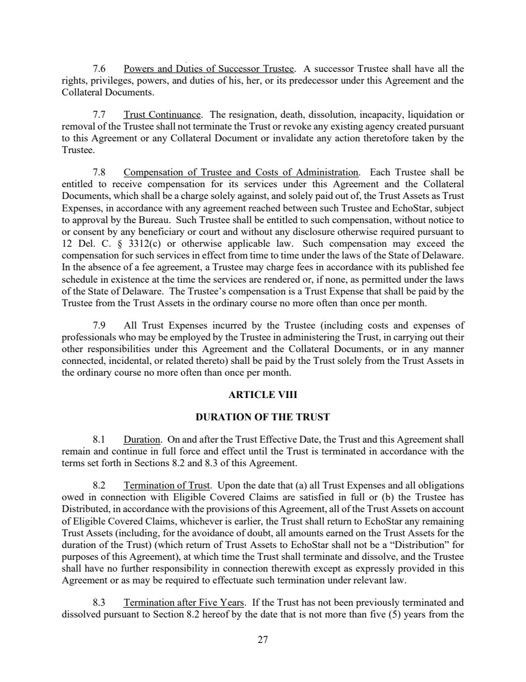 | 27 7.6 Powers and Duties of Successor Trustee. A successor Trustee shall have all the rights, privileges, powers, and duties of his, her, or its predecessor under this Agreement and the Collateral Documents. 7.7 Trust Continuance. The resignation, death, dissolution, incapacity, liquidation or removal of the Trustee shall not terminate the Trust or revoke any existing agency created pursuant to this Agreement or any Collateral Document or invalidate any action theretofore taken by the Trustee. 7.8 Compensation of Trustee and Costs of Administration. Each Trustee shall be entitled to receive compensation for its services under this Agreement and the Collateral Documents, which shall be a charge solely against, and solely paid out of, the Trust Assets as Trust Expenses, in accordance with any agreement reached between such Trustee and EchoStar, subject to approval by the Bureau. Such Trustee shall be entitled to such compensation, without notice to or consent by any beneficiary or court and without any disclosure otherwise required pursuant to 12 Del. C. § 3312(c) or otherwise applicable law. Such compensation may exceed the compensation for such services in effect from time to time under the laws of the State of Delaware. In the absence of a fee agreement, a Trustee may charge fees in accordance with its published fee schedule in existence at the time the services are rendered or, if none, as permitted under the laws of the State of Delaware. The Trustee’s compensation is a Trust Expense that shall be paid by the Trustee from the Trust Assets in the ordinary course no more often than once per month. 7.9 All Trust Expenses incurred by the Trustee (including costs and expenses of professionals who may be employed by the Trustee in administering the Trust, in carrying out their other responsibilities under this Agreement and the Collateral Documents, or in any manner connected, incidental, or related thereto) shall be paid by the Trust solely from the Trust Assets in the ordinary course no more often than once per month. ARTICLE VIII DURATION OF THE TRUST 8.1 Duration. On and after the Trust Effective Date, the Trust and this Agreement shall remain and continue in full force and effect until the Trust is terminated in accordance with the terms set forth in Sections 8.2 and 8.3 of this Agreement. 8.2 Termination of Trust. Upon the date that (a) all Trust Expenses and all obligations owed in connection with Eligible Covered Claims are satisfied in full or (b) the Trustee has Distributed, in accordance with the provisions of this Agreement, all of the Trust Assets on account of Eligible Covered Claims, whichever is earlier, the Trust shall return to EchoStar any remaining Trust Assets (including, for the avoidance of doubt, all amounts earned on the Trust Assets for the duration of the Trust) (which return of Trust Assets to EchoStar shall not be a “Distribution” for purposes of this Agreement), at which time the Trust shall terminate and dissolve, and the Trustee shall have no further responsibility in connection therewith except as expressly provided in this Agreement or as may be required to effectuate such termination under relevant law. 8.3 Termination after Five Years. If the Trust has not been previously terminated and dissolved pursuant to Section 8.2 hereof by the date that is not more than five (5) years from the
 | 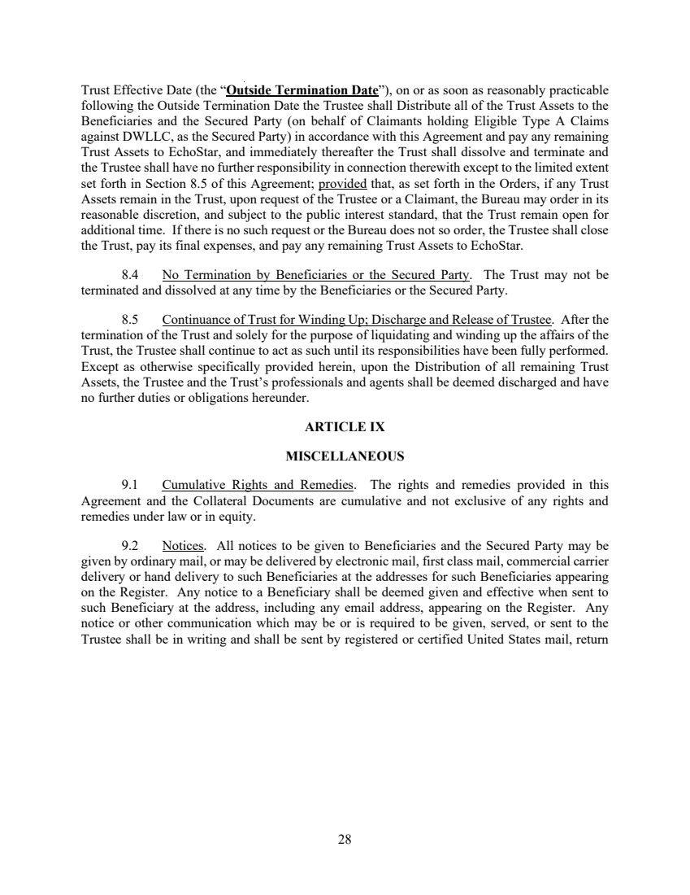 | 28 Trust Effective Date (the “Outside Termination Date”), on or as soon as reasonably practicable following the Outside Termination Date the Trustee shall Distribute all of the Trust Assets to the Beneficiaries and the Secured Party (on behalf of Claimants holding Eligible Type A Claims against DWLLC, as the Secured Party) in accordance with this Agreement and pay any remaining Trust Assets to EchoStar, and immediately thereafter the Trust shall dissolve and terminate and the Trustee shall have no further responsibility in connection therewith except to the limited extent set forth in Section 8.5 of this Agreement; provided that, as set forth in the Orders, if any Trust Assets remain in the Trust, upon request of the Trustee or a Claimant, the Bureau may order in its reasonable discretion, and subject to the public interest standard, that the Trust remain open for additional time. If there is no such request or the Bureau does not so order, the Trustee shall close the Trust, pay its final expenses, and pay any remaining Trust Assets to EchoStar. 8.4 No Termination by Beneficiaries or the Secured Party. The Trust may not be terminated and dissolved at any time by the Beneficiaries or the Secured Party. 8.5 Continuance of Trust for Winding Up; Discharge and Release of Trustee. After the termination of the Trust and solely for the purpose of liquidating and winding up the affairs of the Trust, the Trustee shall continue to act as such until its responsibilities have been fully performed. Except as otherwise specifically provided herein, upon the Distribution of all remaining Trust Assets, the Trustee and the Trust’s professionals and agents shall be deemed discharged and have no further duties or obligations hereunder. ARTICLE IX MISCELLANEOUS 9.1 Cumulative Rights and Remedies. The rights and remedies provided in this Agreement and the Collateral Documents are cumulative and not exclusive of any rights and remedies under law or in equity. 9.2 Notices. All notices to be given to Beneficiaries and the Secured Party may be given by ordinary mail, or may be delivered by electronic mail, first class mail, commercial carrier delivery or hand delivery to such Beneficiaries at the addresses for such Beneficiaries appearing on the Register. Any notice to a Beneficiary shall be deemed given and effective when sent to such Beneficiary at the address, including any email address, appearing on the Register. Any notice or other communication which may be or is required to be given, served, or sent to the Trustee shall be in writing and shall be sent by registered or certified United States mail, return
 | 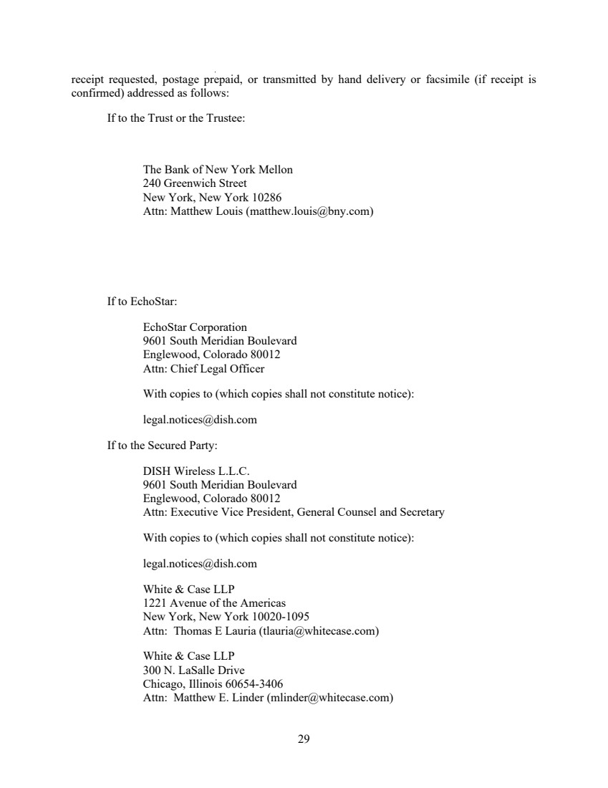 | 29 receipt requested, postage prepaid, or transmitted by hand delivery or facsimile (if receipt is confirmed) addressed as follows: If to the Trust or the Trustee: The Bank of New York Mellon 240 Greenwich Street New York, New York 10286 Attn: Matthew Louis (matthew.louis@bny.com) If to EchoStar: EchoStar Corporation 9601 South Meridian Boulevard Englewood, Colorado 80012 Attn: Chief Legal Officer With copies to (which copies shall not constitute notice): legal.notices@dish.com If to the Secured Party: DISH Wireless L.L.C. 9601 South Meridian Boulevard Englewood, Colorado 80012 Attn: Executive Vice President, General Counsel and Secretary With copies to (which copies shall not constitute notice): legal.notices@dish.com White & Case LLP 1221 Avenue of the Americas New York, New York 10020-1095 Attn: Thomas E Lauria (tlauria@whitecase.com) White & Case LLP 300 N. LaSalle Drive Chicago, Illinois 60654-3406 Attn: Matthew E. Linder (mlinder@whitecase.com)
 | 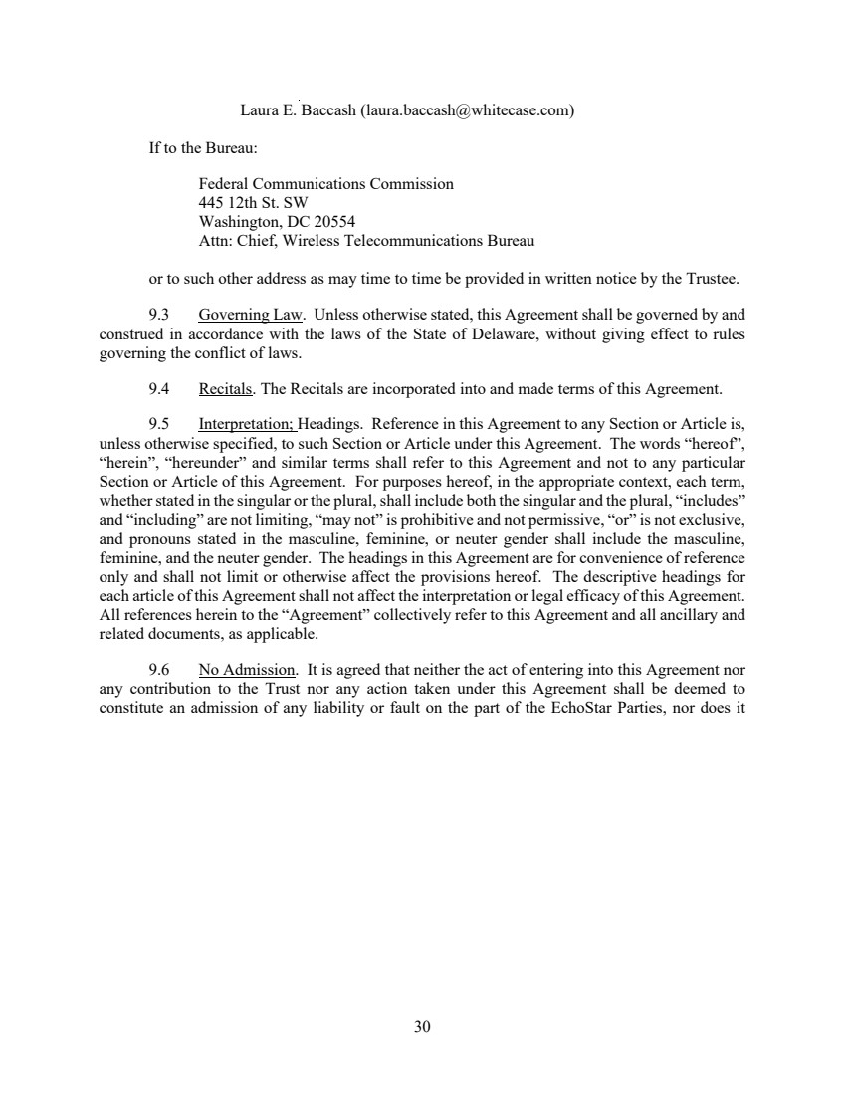 | 30 Laura E. Baccash (laura.baccash@whitecase.com) If to the Bureau: Federal Communications Commission 445 12th St. SW Washington, DC 20554 Attn: Chief, Wireless Telecommunications Bureau or to such other address as may time to time be provided in written notice by the Trustee. 9.3 Governing Law. Unless otherwise stated, this Agreement shall be governed by and construed in accordance with the laws of the State of Delaware, without giving effect to rules governing the conflict of laws. 9.4 Recitals. The Recitals are incorporated into and made terms of this Agreement. 9.5 Interpretation; Headings. Reference in this Agreement to any Section or Article is, unless otherwise specified, to such Section or Article under this Agreement. The words “hereof”, “herein”, “hereunder” and similar terms shall refer to this Agreement and not to any particular Section or Article of this Agreement. For purposes hereof, in the appropriate context, each term, whether stated in the singular or the plural, shall include both the singular and the plural, “includes” and “including” are not limiting, “may not” is prohibitive and not permissive, “or” is not exclusive, and pronouns stated in the masculine, feminine, or neuter gender shall include the masculine, feminine, and the neuter gender. The headings in this Agreement are for convenience of reference only and shall not limit or otherwise affect the provisions hereof. The descriptive headings for each article of this Agreement shall not affect the interpretation or legal efficacy of this Agreement. All references herein to the “Agreement” collectively refer to this Agreement and all ancillary and related documents, as applicable. 9.6 No Admission. It is agreed that neither the act of entering into this Agreement nor any contribution to the Trust nor any action taken under this Agreement shall be deemed to constitute an admission of any liability or fault on the part of the EchoStar Parties, nor does it
 | 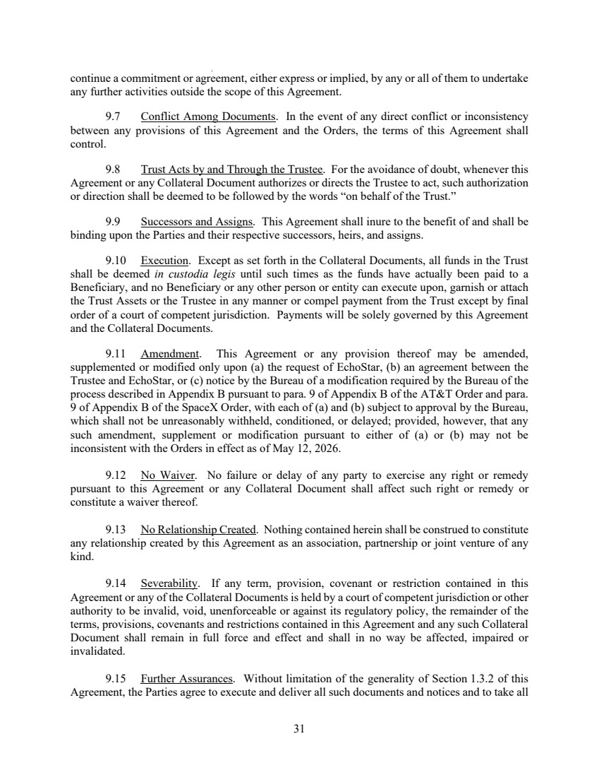 | 31 continue a commitment or agreement, either express or implied, by any or all of them to undertake any further activities outside the scope of this Agreement. 9.7 Conflict Among Documents. In the event of any direct conflict or inconsistency between any provisions of this Agreement and the Orders, the terms of this Agreement shall control. 9.8 Trust Acts by and Through the Trustee. For the avoidance of doubt, whenever this Agreement or any Collateral Document authorizes or directs the Trustee to act, such authorization or direction shall be deemed to be followed by the words “on behalf of the Trust.” 9.9 Successors and Assigns. This Agreement shall inure to the benefit of and shall be binding upon the Parties and their respective successors, heirs, and assigns. 9.10 Execution. Except as set forth in the Collateral Documents, all funds in the Trust shall be deemed in custodia legis until such times as the funds have actually been paid to a Beneficiary, and no Beneficiary or any other person or entity can execute upon, garnish or attach the Trust Assets or the Trustee in any manner or compel payment from the Trust except by final order of a court of competent jurisdiction. Payments will be solely governed by this Agreement and the Collateral Documents. 9.11 Amendment. This Agreement or any provision thereof may be amended, supplemented or modified only upon (a) the request of EchoStar, (b) an agreement between the Trustee and EchoStar, or (c) notice by the Bureau of a modification required by the Bureau of the process described in Appendix B pursuant to para. 9 of Appendix B of the AT&T Order and para. 9 of Appendix B of the SpaceX Order, with each of (a) and (b) subject to approval by the Bureau, which shall not be unreasonably withheld, conditioned, or delayed; provided, however, that any such amendment, supplement or modification pursuant to either of (a) or (b) may not be inconsistent with the Orders in effect as of May 12, 2026. 9.12 No Waiver. No failure or delay of any party to exercise any right or remedy pursuant to this Agreement or any Collateral Document shall affect such right or remedy or constitute a waiver thereof. 9.13 No Relationship Created. Nothing contained herein shall be construed to constitute any relationship created by this Agreement as an association, partnership or joint venture of any kind. 9.14 Severability. If any term, provision, covenant or restriction contained in this Agreement or any of the Collateral Documents is held by a court of competent jurisdiction or other authority to be invalid, void, unenforceable or against its regulatory policy, the remainder of the terms, provisions, covenants and restrictions contained in this Agreement and any such Collateral Document shall remain in full force and effect and shall in no way be affected, impaired or invalidated. 9.15 Further Assurances. Without limitation of the generality of Section 1.3.2 of this Agreement, the Parties agree to execute and deliver all such documents and notices and to take all
 | 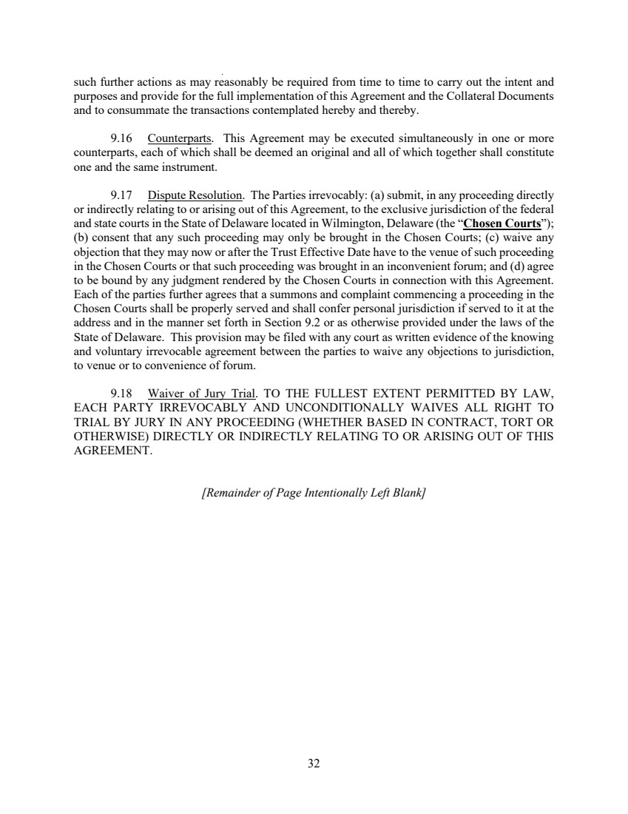 | 32 such further actions as may reasonably be required from time to time to carry out the intent and purposes and provide for the full implementation of this Agreement and the Collateral Documents and to consummate the transactions contemplated hereby and thereby. 9.16 Counterparts. This Agreement may be executed simultaneously in one or more counterparts, each of which shall be deemed an original and all of which together shall constitute one and the same instrument. 9.17 Dispute Resolution. The Parties irrevocably: (a) submit, in any proceeding directly or indirectly relating to or arising out of this Agreement, to the exclusive jurisdiction of the federal and state courts in the State of Delaware located in Wilmington, Delaware (the “Chosen Courts”); (b) consent that any such proceeding may only be brought in the Chosen Courts; (c) waive any objection that they may now or after the Trust Effective Date have to the venue of such proceeding in the Chosen Courts or that such proceeding was brought in an inconvenient forum; and (d) agree to be bound by any judgment rendered by the Chosen Courts in connection with this Agreement. Each of the parties further agrees that a summons and complaint commencing a proceeding in the Chosen Courts shall be properly served and shall confer personal jurisdiction if served to it at the address and in the manner set forth in Section 9.2 or as otherwise provided under the laws of the State of Delaware. This provision may be filed with any court as written evidence of the knowing and voluntary irrevocable agreement between the parties to waive any objections to jurisdiction, to venue or to convenience of forum. 9.18 Waiver of Jury Trial. TO THE FULLEST EXTENT PERMITTED BY LAW, EACH PARTY IRREVOCABLY AND UNCONDITIONALLY WAIVES ALL RIGHT TO TRIAL BY JURY IN ANY PROCEEDING (WHETHER BASED IN CONTRACT, TORT OR OTHERWISE) DIRECTLY OR INDIRECTLY RELATING TO OR ARISING OUT OF THIS AGREEMENT. [Remainder of Page Intentionally Left Blank]
 | 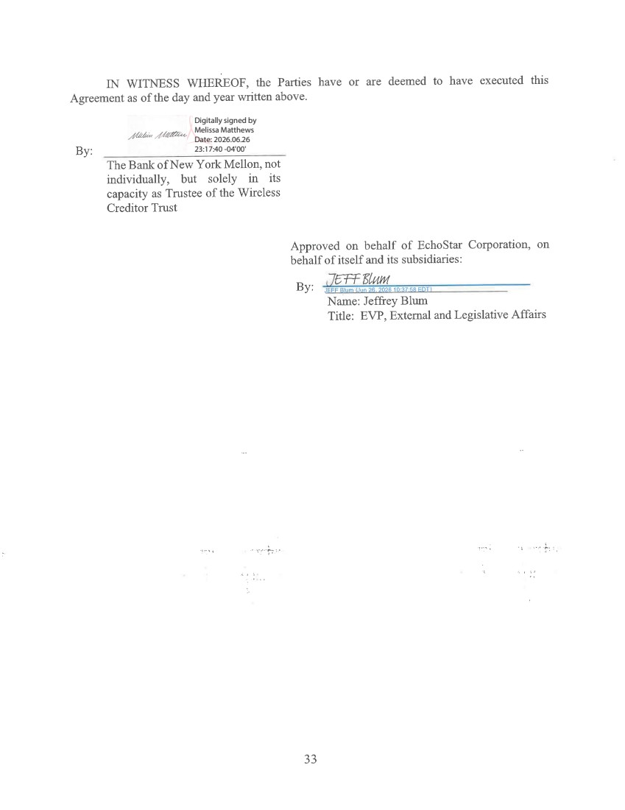 | Digitally signed by Melissa Matthews Date: 2026.06.26 23:17:40 -04'00'
 | 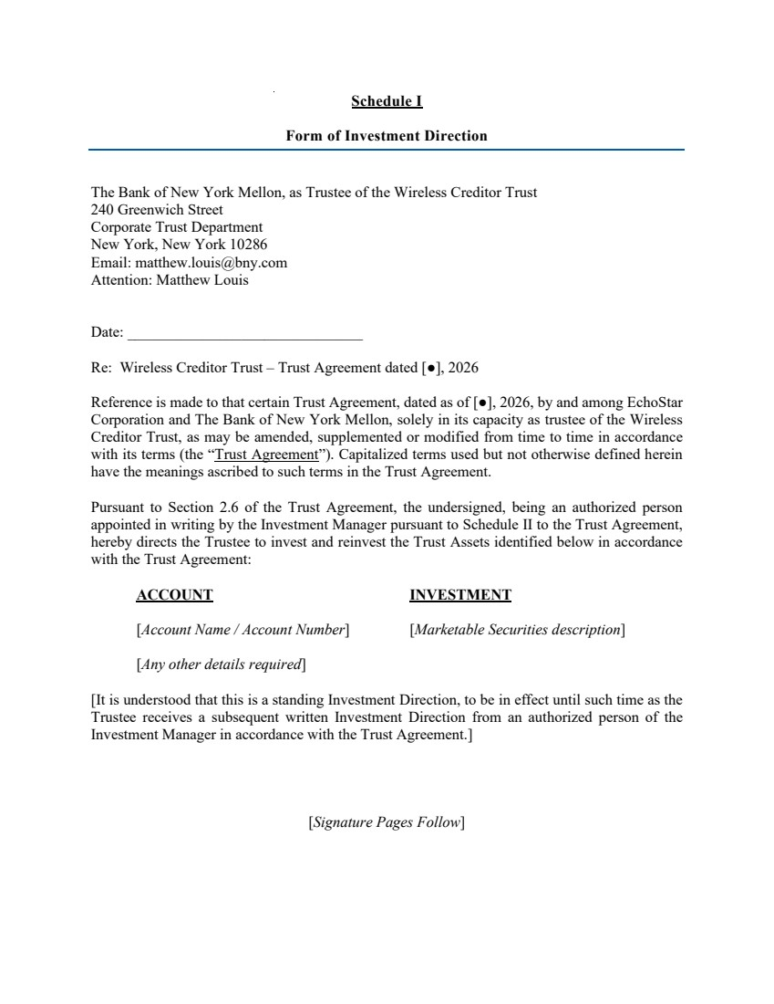 | Schedule I Form of Investment Direction The Bank of New York Mellon, as Trustee of the Wireless Creditor Trust 240 Greenwich Street Corporate Trust Department New York, New York 10286 Email: matthew.louis@bny.com Attention: Matthew Louis Date: _______________________________ Re: Wireless Creditor Trust – Trust Agreement dated [●], 2026 Reference is made to that certain Trust Agreement, dated as of [●], 2026, by and among EchoStar Corporation and The Bank of New York Mellon, solely in its capacity as trustee of the Wireless Creditor Trust, as may be amended, supplemented or modified from time to time in accordance with its terms (the “Trust Agreement”). Capitalized terms used but not otherwise defined herein have the meanings ascribed to such terms in the Trust Agreement. Pursuant to Section 2.6 of the Trust Agreement, the undersigned, being an authorized person appointed in writing by the Investment Manager pursuant to Schedule II to the Trust Agreement, hereby directs the Trustee to invest and reinvest the Trust Assets identified below in accordance with the Trust Agreement: ACCOUNT INVESTMENT [Account Name / Account Number] [Marketable Securities description] [Any other details required] [It is understood that this is a standing Investment Direction, to be in effect until such time as the Trustee receives a subsequent written Investment Direction from an authorized person of the Investment Manager in accordance with the Trust Agreement.] [Signature Pages Follow]
 |  | FOR AND ON BEHALF OF THE INVESTMENT MANAGER: By: ________________________________ Name: Title:
 | 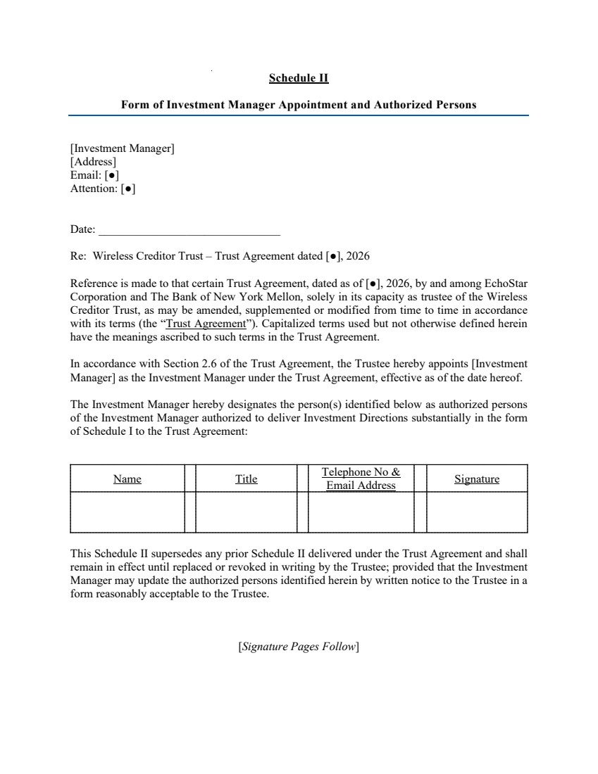 | Schedule II Form of Investment Manager Appointment and Authorized Persons [Investment Manager] [Address] Email: [●] Attention: [●] Date: _______________________________ Re: Wireless Creditor Trust – Trust Agreement dated [●], 2026 Reference is made to that certain Trust Agreement, dated as of [●], 2026, by and among EchoStar Corporation and The Bank of New York Mellon, solely in its capacity as trustee of the Wireless Creditor Trust, as may be amended, supplemented or modified from time to time in accordance with its terms (the “Trust Agreement”). Capitalized terms used but not otherwise defined herein have the meanings ascribed to such terms in the Trust Agreement. In accordance with Section 2.6 of the Trust Agreement, the Trustee hereby appoints [Investment Manager] as the Investment Manager under the Trust Agreement, effective as of the date hereof. The Investment Manager hereby designates the person(s) identified below as authorized persons of the Investment Manager authorized to deliver Investment Directions substantially in the form of Schedule I to the Trust Agreement: Name Title Telephone No & Email Address Signature This Schedule II supersedes any prior Schedule II delivered under the Trust Agreement and shall remain in effect until replaced or revoked in writing by the Trustee; provided that the Investment Manager may update the authorized persons identified herein by written notice to the Trustee in a form reasonably acceptable to the Trustee. [Signature Pages Follow]
 | 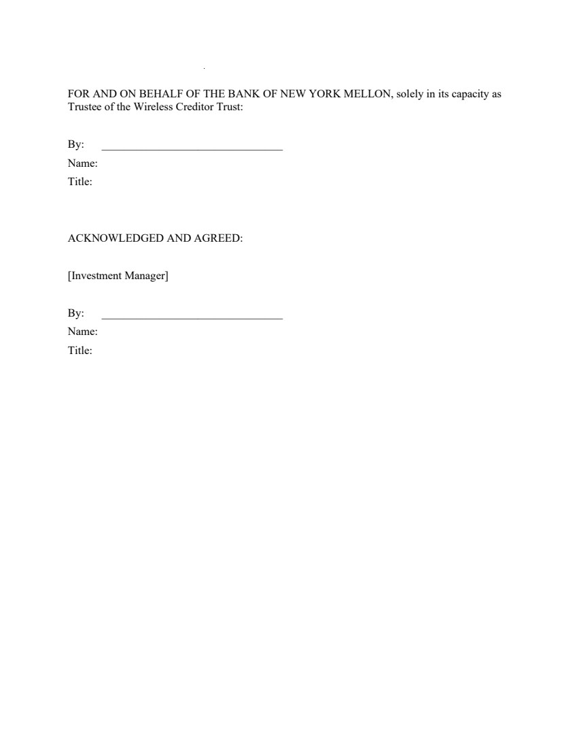 | FOR AND ON BEHALF OF THE BANK OF NEW YORK MELLON, solely in its capacity as Trustee of the Wireless Creditor Trust: By: ________________________________ Name: Title: ACKNOWLEDGED AND AGREED: [Investment Manager] By: ________________________________ Name: Title:
 | 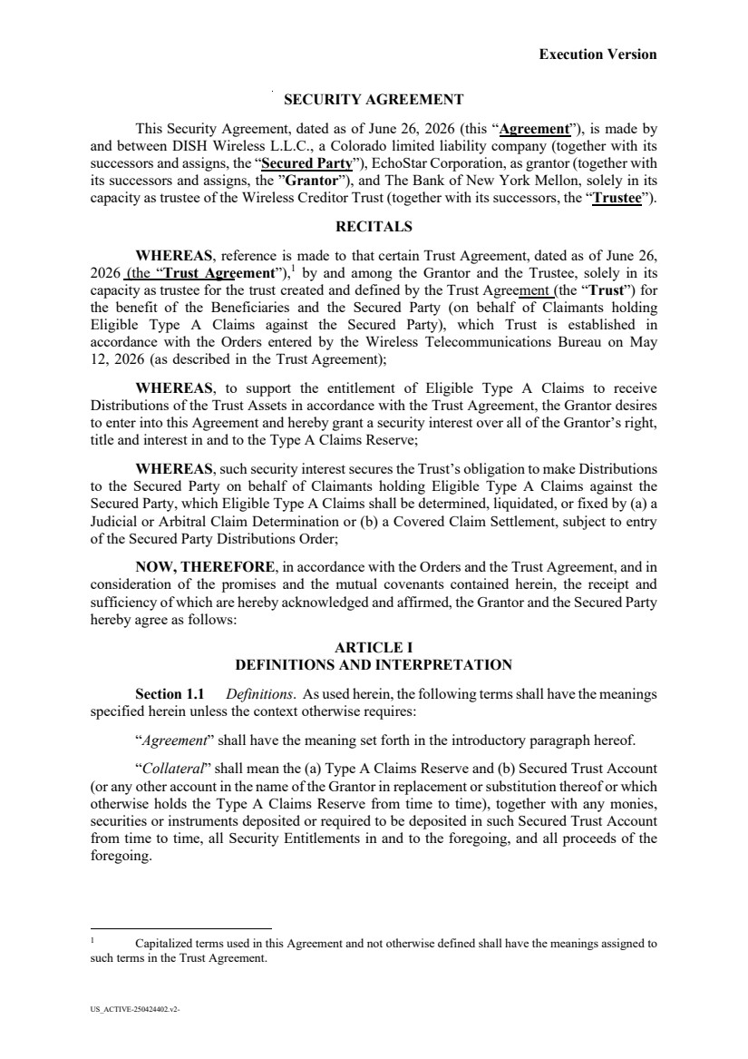 | Execution Version US_ACTIVE-250424402.v2- SECURITY AGREEMENT This Security Agreement, dated as of June 26, 2026 (this “Agreement”), is made by and between DISH Wireless L.L.C., a Colorado limited liability company (together with its successors and assigns, the “Secured Party”), EchoStar Corporation, as grantor (together with its successors and assigns, the ”Grantor”), and The Bank of New York Mellon, solely in its capacity as trustee of the Wireless Creditor Trust (together with its successors, the “Trustee”). RECITALS WHEREAS, reference is made to that certain Trust Agreement, dated as of June 26, 2026 (the “Trust Agreement”), 1 by and among the Grantor and the Trustee, solely in its capacity as trustee for the trust created and defined by the Trust Agreement (the “Trust”) for the benefit of the Beneficiaries and the Secured Party (on behalf of Claimants holding Eligible Type A Claims against the Secured Party), which Trust is established in accordance with the Orders entered by the Wireless Telecommunications Bureau on May 12, 2026 (as described in the Trust Agreement); WHEREAS, to support the entitlement of Eligible Type A Claims to receive Distributions of the Trust Assets in accordance with the Trust Agreement, the Grantor desires to enter into this Agreement and hereby grant a security interest over all of the Grantor’s right, title and interest in and to the Type A Claims Reserve; WHEREAS, such security interest secures the Trust’s obligation to make Distributions to the Secured Party on behalf of Claimants holding Eligible Type A Claims against the Secured Party, which Eligible Type A Claims shall be determined, liquidated, or fixed by (a) a Judicial or Arbitral Claim Determination or (b) a Covered Claim Settlement, subject to entry of the Secured Party Distributions Order; NOW, THEREFORE, in accordance with the Orders and the Trust Agreement, and in consideration of the promises and the mutual covenants contained herein, the receipt and sufficiency of which are hereby acknowledged and affirmed, the Grantor and the Secured Party hereby agree as follows: ARTICLE I DEFINITIONS AND INTERPRETATION Section 1.1 Definitions. As used herein, the following terms shall have the meanings specified herein unless the context otherwise requires: “Agreement” shall have the meaning set forth in the introductory paragraph hereof. “Collateral” shall mean the (a) Type A Claims Reserve and (b) Secured Trust Account (or any other account in the name of the Grantor in replacement or substitution thereof or which otherwise holds the Type A Claims Reserve from time to time), together with any monies, securities or instruments deposited or required to be deposited in such Secured Trust Account from time to time, all Security Entitlements in and to the foregoing, and all proceeds of the foregoing. 1 Capitalized terms used in this Agreement and not otherwise defined shall have the meanings assigned to such terms in the Trust Agreement.
 | 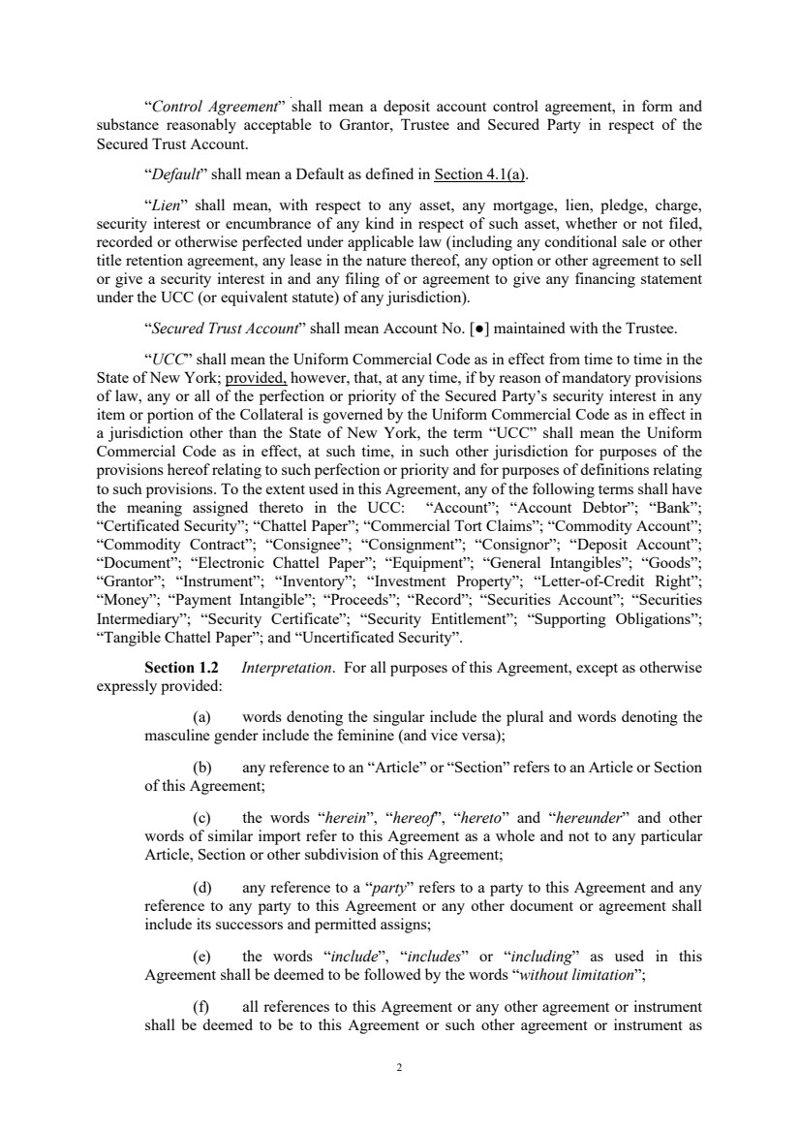 | 2 “Control Agreement” shall mean a deposit account control agreement, in form and substance reasonably acceptable to Grantor, Trustee and Secured Party in respect of the Secured Trust Account. “Default” shall mean a Default as defined in Section 4.1(a). “Lien” shall mean, with respect to any asset, any mortgage, lien, pledge, charge, security interest or encumbrance of any kind in respect of such asset, whether or not filed, recorded or otherwise perfected under applicable law (including any conditional sale or other title retention agreement, any lease in the nature thereof, any option or other agreement to sell or give a security interest in and any filing of or agreement to give any financing statement under the UCC (or equivalent statute) of any jurisdiction). “Secured Trust Account” shall mean Account No. [●] maintained with the Trustee. “UCC” shall mean the Uniform Commercial Code as in effect from time to time in the State of New York; provided, however, that, at any time, if by reason of mandatory provisions of law, any or all of the perfection or priority of the Secured Party’s security interest in any item or portion of the Collateral is governed by the Uniform Commercial Code as in effect in a jurisdiction other than the State of New York, the term “UCC” shall mean the Uniform Commercial Code as in effect, at such time, in such other jurisdiction for purposes of the provisions hereof relating to such perfection or priority and for purposes of definitions relating to such provisions. To the extent used in this Agreement, any of the following terms shall have the meaning assigned thereto in the UCC: “Account”; “Account Debtor”; “Bank”; “Certificated Security”; “Chattel Paper”; “Commercial Tort Claims”; “Commodity Account”; “Commodity Contract”; “Consignee”; “Consignment”; “Consignor”; “Deposit Account”; “Document”; “Electronic Chattel Paper”; “Equipment”; “General Intangibles”; “Goods”; “Grantor”; “Instrument”; “Inventory”; “Investment Property”; “Letter-of-Credit Right”; “Money”; “Payment Intangible”; “Proceeds”; “Record”; “Securities Account”; “Securities Intermediary”; “Security Certificate”; “Security Entitlement”; “Supporting Obligations”; “Tangible Chattel Paper”; and “Uncertificated Security”. Section 1.2 Interpretation. For all purposes of this Agreement, except as otherwise expressly provided: (a) words denoting the singular include the plural and words denoting the masculine gender include the feminine (and vice versa); (b) any reference to an “Article” or “Section” refers to an Article or Section of this Agreement; (c) the words “herein”, “hereof”, “hereto” and “hereunder” and other words of similar import refer to this Agreement as a whole and not to any particular Article, Section or other subdivision of this Agreement; (d) any reference to a “party” refers to a party to this Agreement and any reference to any party to this Agreement or any other document or agreement shall include its successors and permitted assigns; (e) the words “include”, “includes” or “including” as used in this Agreement shall be deemed to be followed by the words “without limitation”; (f) all references to this Agreement or any other agreement or instrument shall be deemed to be to this Agreement or such other agreement or instrument as
 | 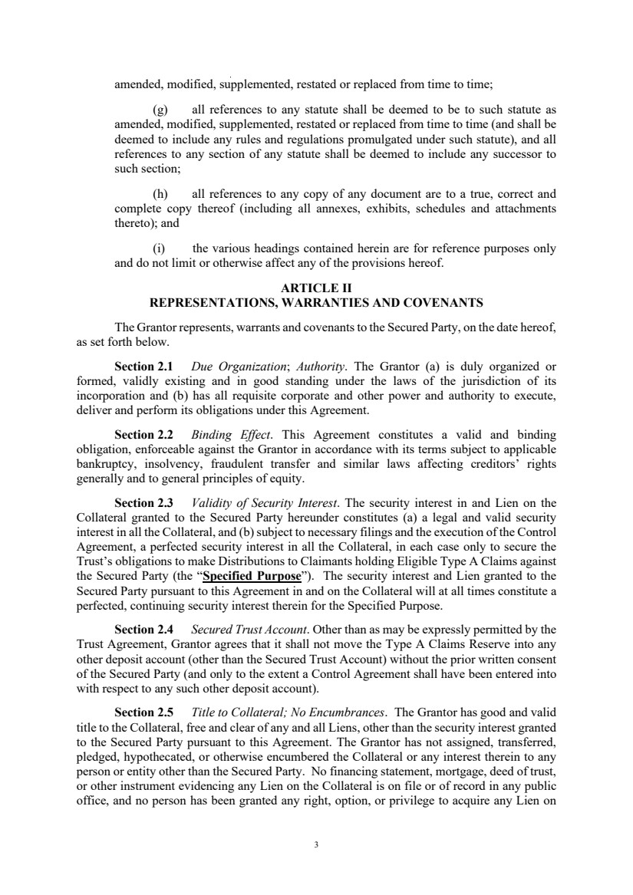 | 3 amended, modified, supplemented, restated or replaced from time to time; (g) all references to any statute shall be deemed to be to such statute as amended, modified, supplemented, restated or replaced from time to time (and shall be deemed to include any rules and regulations promulgated under such statute), and all references to any section of any statute shall be deemed to include any successor to such section; (h) all references to any copy of any document are to a true, correct and complete copy thereof (including all annexes, exhibits, schedules and attachments thereto); and (i) the various headings contained herein are for reference purposes only and do not limit or otherwise affect any of the provisions hereof. ARTICLE II REPRESENTATIONS, WARRANTIES AND COVENANTS The Grantor represents, warrants and covenants to the Secured Party, on the date hereof, as set forth below. Section 2.1 Due Organization; Authority. The Grantor (a) is duly organized or formed, validly existing and in good standing under the laws of the jurisdiction of its incorporation and (b) has all requisite corporate and other power and authority to execute, deliver and perform its obligations under this Agreement. Section 2.2 Binding Effect. This Agreement constitutes a valid and binding obligation, enforceable against the Grantor in accordance with its terms subject to applicable bankruptcy, insolvency, fraudulent transfer and similar laws affecting creditors’ rights generally and to general principles of equity. Section 2.3 Validity of Security Interest. The security interest in and Lien on the Collateral granted to the Secured Party hereunder constitutes (a) a legal and valid security interest in all the Collateral, and (b) subject to necessary filings and the execution of the Control Agreement, a perfected security interest in all the Collateral, in each case only to secure the Trust’s obligations to make Distributions to Claimants holding Eligible Type A Claims against the Secured Party (the “Specified Purpose”). The security interest and Lien granted to the Secured Party pursuant to this Agreement in and on the Collateral will at all times constitute a perfected, continuing security interest therein for the Specified Purpose. Section 2.4 Secured Trust Account. Other than as may be expressly permitted by the Trust Agreement, Grantor agrees that it shall not move the Type A Claims Reserve into any other deposit account (other than the Secured Trust Account) without the prior written consent of the Secured Party (and only to the extent a Control Agreement shall have been entered into with respect to any such other deposit account). Section 2.5 Title to Collateral; No Encumbrances. The Grantor has good and valid title to the Collateral, free and clear of any and all Liens, other than the security interest granted to the Secured Party pursuant to this Agreement. The Grantor has not assigned, transferred, pledged, hypothecated, or otherwise encumbered the Collateral or any interest therein to any person or entity other than the Secured Party. No financing statement, mortgage, deed of trust, or other instrument evidencing any Lien on the Collateral is on file or of record in any public office, and no person has been granted any right, option, or privilege to acquire any Lien on
 | 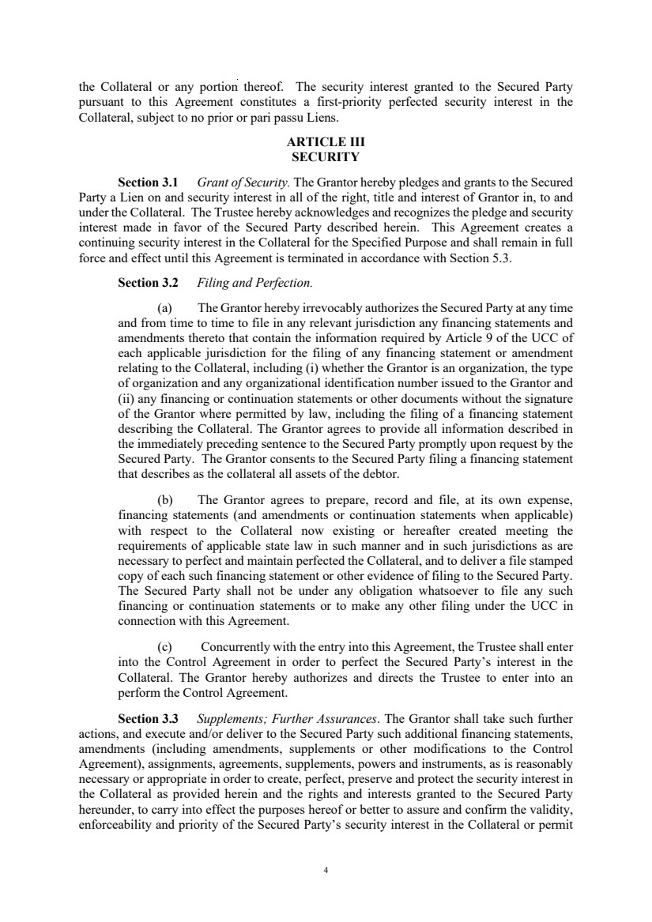 | 4 the Collateral or any portion thereof. The security interest granted to the Secured Party pursuant to this Agreement constitutes a first-priority perfected security interest in the Collateral, subject to no prior or pari passu Liens. ARTICLE III SECURITY Section 3.1 Grant of Security. The Grantor hereby pledges and grants to the Secured Party a Lien on and security interest in all of the right, title and interest of Grantor in, to and under the Collateral. The Trustee hereby acknowledges and recognizes the pledge and security interest made in favor of the Secured Party described herein. This Agreement creates a continuing security interest in the Collateral for the Specified Purpose and shall remain in full force and effect until this Agreement is terminated in accordance with Section 5.3. Section 3.2 Filing and Perfection. (a) The Grantor hereby irrevocably authorizes the Secured Party at any time and from time to time to file in any relevant jurisdiction any financing statements and amendments thereto that contain the information required by Article 9 of the UCC of each applicable jurisdiction for the filing of any financing statement or amendment relating to the Collateral, including (i) whether the Grantor is an organization, the type of organization and any organizational identification number issued to the Grantor and (ii) any financing or continuation statements or other documents without the signature of the Grantor where permitted by law, including the filing of a financing statement describing the Collateral. The Grantor agrees to provide all information described in the immediately preceding sentence to the Secured Party promptly upon request by the Secured Party. The Grantor consents to the Secured Party filing a financing statement that describes as the collateral all assets of the debtor. (b) The Grantor agrees to prepare, record and file, at its own expense, financing statements (and amendments or continuation statements when applicable) with respect to the Collateral now existing or hereafter created meeting the requirements of applicable state law in such manner and in such jurisdictions as are necessary to perfect and maintain perfected the Collateral, and to deliver a file stamped copy of each such financing statement or other evidence of filing to the Secured Party. The Secured Party shall not be under any obligation whatsoever to file any such financing or continuation statements or to make any other filing under the UCC in connection with this Agreement. (c) Concurrently with the entry into this Agreement, the Trustee shall enter into the Control Agreement in order to perfect the Secured Party’s interest in the Collateral. The Grantor hereby authorizes and directs the Trustee to enter into an perform the Control Agreement. Section 3.3 Supplements; Further Assurances. The Grantor shall take such further actions, and execute and/or deliver to the Secured Party such additional financing statements, amendments (including amendments, supplements or other modifications to the Control Agreement), assignments, agreements, supplements, powers and instruments, as is reasonably necessary or appropriate in order to create, perfect, preserve and protect the security interest in the Collateral as provided herein and the rights and interests granted to the Secured Party hereunder, to carry into effect the purposes hereof or better to assure and confirm the validity, enforceability and priority of the Secured Party’s security interest in the Collateral or permit
 | 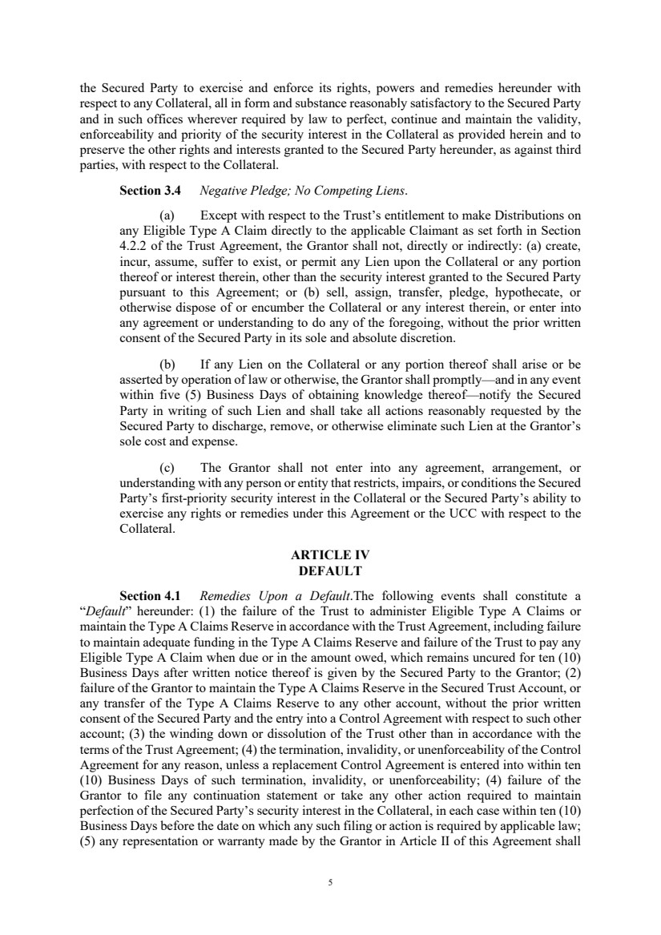 | 5 the Secured Party to exercise and enforce its rights, powers and remedies hereunder with respect to any Collateral, all in form and substance reasonably satisfactory to the Secured Party and in such offices wherever required by law to perfect, continue and maintain the validity, enforceability and priority of the security interest in the Collateral as provided herein and to preserve the other rights and interests granted to the Secured Party hereunder, as against third parties, with respect to the Collateral. Section 3.4 Negative Pledge; No Competing Liens. (a) Except with respect to the Trust’s entitlement to make Distributions on any Eligible Type A Claim directly to the applicable Claimant as set forth in Section 4.2.2 of the Trust Agreement, the Grantor shall not, directly or indirectly: (a) create, incur, assume, suffer to exist, or permit any Lien upon the Collateral or any portion thereof or interest therein, other than the security interest granted to the Secured Party pursuant to this Agreement; or (b) sell, assign, transfer, pledge, hypothecate, or otherwise dispose of or encumber the Collateral or any interest therein, or enter into any agreement or understanding to do any of the foregoing, without the prior written consent of the Secured Party in its sole and absolute discretion. (b) If any Lien on the Collateral or any portion thereof shall arise or be asserted by operation of law or otherwise, the Grantor shall promptly—and in any event within five (5) Business Days of obtaining knowledge thereof—notify the Secured Party in writing of such Lien and shall take all actions reasonably requested by the Secured Party to discharge, remove, or otherwise eliminate such Lien at the Grantor’s sole cost and expense. (c) The Grantor shall not enter into any agreement, arrangement, or understanding with any person or entity that restricts, impairs, or conditions the Secured Party’s first-priority security interest in the Collateral or the Secured Party’s ability to exercise any rights or remedies under this Agreement or the UCC with respect to the Collateral. ARTICLE IV DEFAULT Section 4.1 Remedies Upon a Default.The following events shall constitute a “Default” hereunder: (1) the failure of the Trust to administer Eligible Type A Claims or maintain the Type A Claims Reserve in accordance with the Trust Agreement, including failure to maintain adequate funding in the Type A Claims Reserve and failure of the Trust to pay any Eligible Type A Claim when due or in the amount owed, which remains uncured for ten (10) Business Days after written notice thereof is given by the Secured Party to the Grantor; (2) failure of the Grantor to maintain the Type A Claims Reserve in the Secured Trust Account, or any transfer of the Type A Claims Reserve to any other account, without the prior written consent of the Secured Party and the entry into a Control Agreement with respect to such other account; (3) the winding down or dissolution of the Trust other than in accordance with the terms of the Trust Agreement; (4) the termination, invalidity, or unenforceability of the Control Agreement for any reason, unless a replacement Control Agreement is entered into within ten (10) Business Days of such termination, invalidity, or unenforceability; (4) failure of the Grantor to file any continuation statement or take any other action required to maintain perfection of the Secured Party’s security interest in the Collateral, in each case within ten (10) Business Days before the date on which any such filing or action is required by applicable law; (5) any representation or warranty made by the Grantor in Article II of this Agreement shall
 | 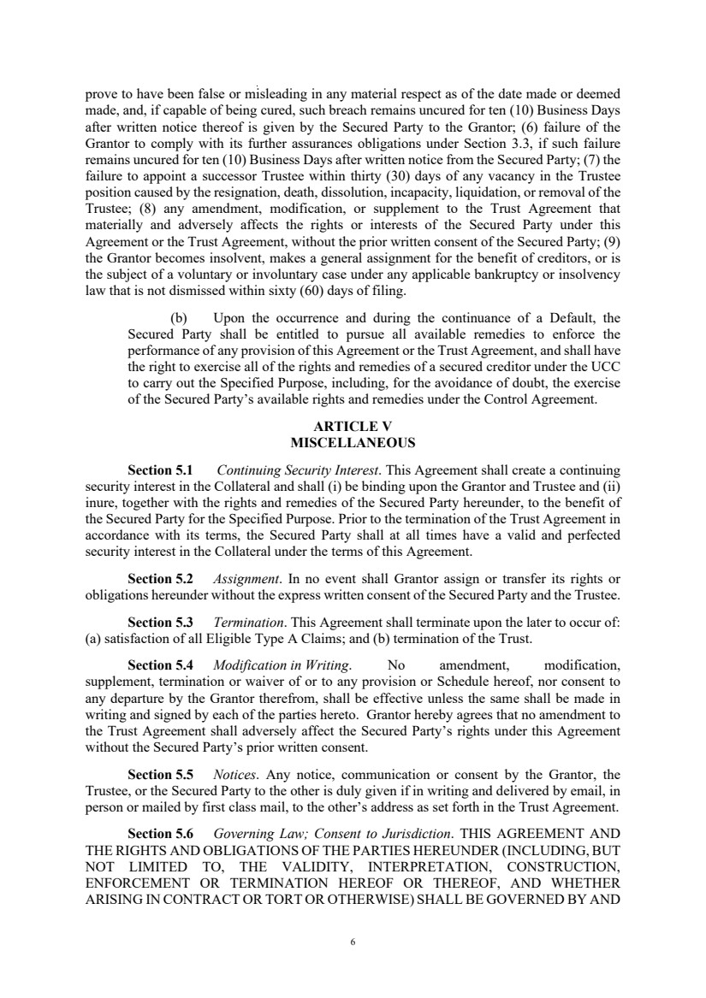 | 6 prove to have been false or misleading in any material respect as of the date made or deemed made, and, if capable of being cured, such breach remains uncured for ten (10) Business Days after written notice thereof is given by the Secured Party to the Grantor; (6) failure of the Grantor to comply with its further assurances obligations under Section 3.3, if such failure remains uncured for ten (10) Business Days after written notice from the Secured Party; (7) the failure to appoint a successor Trustee within thirty (30) days of any vacancy in the Trustee position caused by the resignation, death, dissolution, incapacity, liquidation, or removal of the Trustee; (8) any amendment, modification, or supplement to the Trust Agreement that materially and adversely affects the rights or interests of the Secured Party under this Agreement or the Trust Agreement, without the prior written consent of the Secured Party; (9) the Grantor becomes insolvent, makes a general assignment for the benefit of creditors, or is the subject of a voluntary or involuntary case under any applicable bankruptcy or insolvency law that is not dismissed within sixty (60) days of filing. (b) Upon the occurrence and during the continuance of a Default, the Secured Party shall be entitled to pursue all available remedies to enforce the performance of any provision of this Agreement or the Trust Agreement, and shall have the right to exercise all of the rights and remedies of a secured creditor under the UCC to carry out the Specified Purpose, including, for the avoidance of doubt, the exercise of the Secured Party’s available rights and remedies under the Control Agreement. ARTICLE V MISCELLANEOUS Section 5.1 Continuing Security Interest. This Agreement shall create a continuing security interest in the Collateral and shall (i) be binding upon the Grantor and Trustee and (ii) inure, together with the rights and remedies of the Secured Party hereunder, to the benefit of the Secured Party for the Specified Purpose. Prior to the termination of the Trust Agreement in accordance with its terms, the Secured Party shall at all times have a valid and perfected security interest in the Collateral under the terms of this Agreement. Section 5.2 Assignment. In no event shall Grantor assign or transfer its rights or obligations hereunder without the express written consent of the Secured Party and the Trustee. Section 5.3 Termination. This Agreement shall terminate upon the later to occur of: (a) satisfaction of all Eligible Type A Claims; and (b) termination of the Trust. Section 5.4 Modification in Writing. No amendment, modification, supplement, termination or waiver of or to any provision or Schedule hereof, nor consent to any departure by the Grantor therefrom, shall be effective unless the same shall be made in writing and signed by each of the parties hereto. Grantor hereby agrees that no amendment to the Trust Agreement shall adversely affect the Secured Party’s rights under this Agreement without the Secured Party’s prior written consent. Section 5.5 Notices. Any notice, communication or consent by the Grantor, the Trustee, or the Secured Party to the other is duly given if in writing and delivered by email, in person or mailed by first class mail, to the other’s address as set forth in the Trust Agreement. Section 5.6 Governing Law; Consent to Jurisdiction. THIS AGREEMENT AND THE RIGHTS AND OBLIGATIONS OF THE PARTIES HEREUNDER (INCLUDING, BUT NOT LIMITED TO, THE VALIDITY, INTERPRETATION, CONSTRUCTION, ENFORCEMENT OR TERMINATION HEREOF OR THEREOF, AND WHETHER ARISING IN CONTRACT OR TORT OR OTHERWISE) SHALL BE GOVERNED BY AND
 | 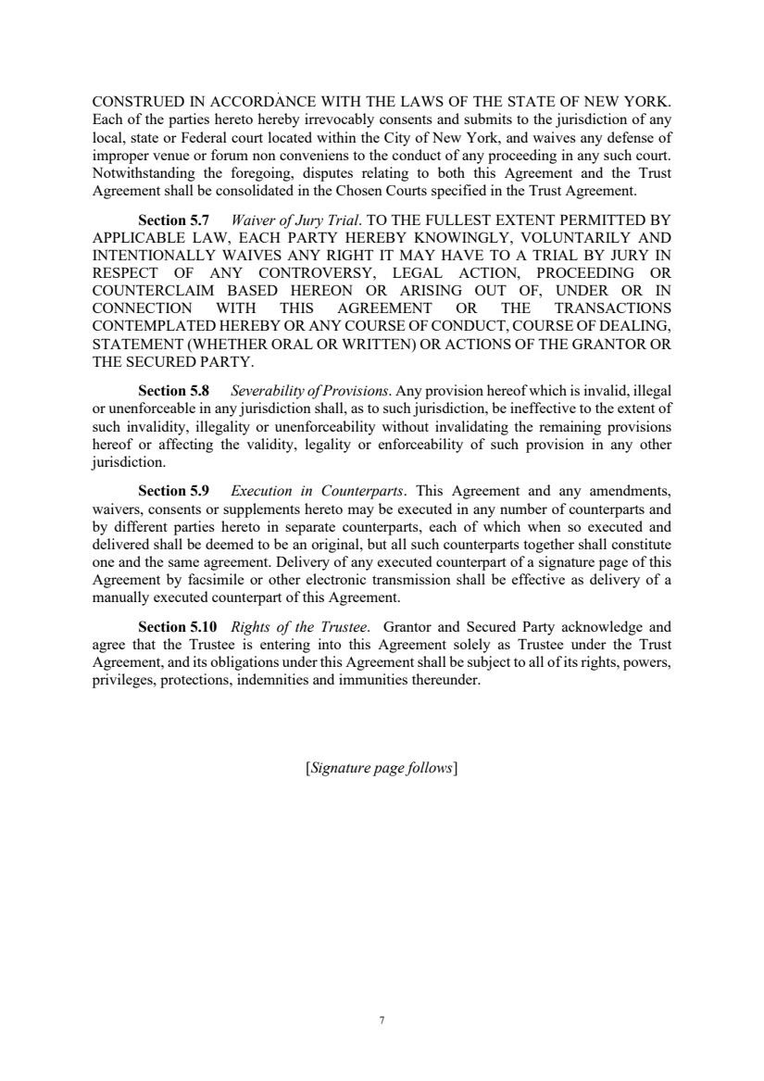 | 7 CONSTRUED IN ACCORDANCE WITH THE LAWS OF THE STATE OF NEW YORK. Each of the parties hereto hereby irrevocably consents and submits to the jurisdiction of any local, state or Federal court located within the City of New York, and waives any defense of improper venue or forum non conveniens to the conduct of any proceeding in any such court. Notwithstanding the foregoing, disputes relating to both this Agreement and the Trust Agreement shall be consolidated in the Chosen Courts specified in the Trust Agreement. Section 5.7 Waiver of Jury Trial. TO THE FULLEST EXTENT PERMITTED BY APPLICABLE LAW, EACH PARTY HEREBY KNOWINGLY, VOLUNTARILY AND INTENTIONALLY WAIVES ANY RIGHT IT MAY HAVE TO A TRIAL BY JURY IN RESPECT OF ANY CONTROVERSY, LEGAL ACTION, PROCEEDING OR COUNTERCLAIM BASED HEREON OR ARISING OUT OF, UNDER OR IN CONNECTION WITH THIS AGREEMENT OR THE TRANSACTIONS CONTEMPLATED HEREBY OR ANY COURSE OF CONDUCT, COURSE OF DEALING, STATEMENT (WHETHER ORAL OR WRITTEN) OR ACTIONS OF THE GRANTOR OR THE SECURED PARTY. Section 5.8 Severability of Provisions. Any provision hereof which is invalid, illegal or unenforceable in any jurisdiction shall, as to such jurisdiction, be ineffective to the extent of such invalidity, illegality or unenforceability without invalidating the remaining provisions hereof or affecting the validity, legality or enforceability of such provision in any other jurisdiction. Section 5.9 Execution in Counterparts. This Agreement and any amendments, waivers, consents or supplements hereto may be executed in any number of counterparts and by different parties hereto in separate counterparts, each of which when so executed and delivered shall be deemed to be an original, but all such counterparts together shall constitute one and the same agreement. Delivery of any executed counterpart of a signature page of this Agreement by facsimile or other electronic transmission shall be effective as delivery of a manually executed counterpart of this Agreement. Section 5.10 Rights of the Trustee. Grantor and Secured Party acknowledge and agree that the Trustee is entering into this Agreement solely as Trustee under the Trust Agreement, and its obligations under this Agreement shall be subject to all of its rights, powers, privileges, protections, indemnities and immunities thereunder. [Signature page follows]
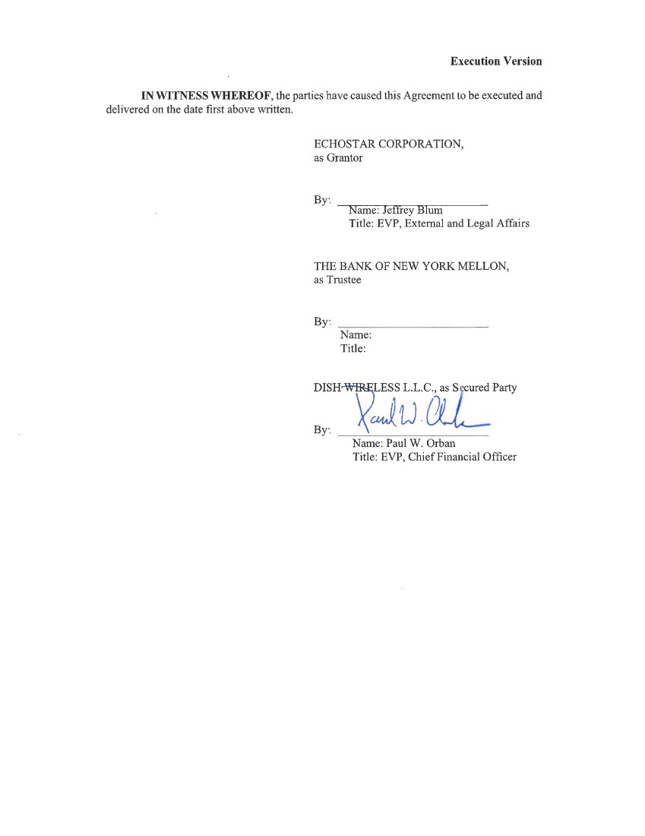
 | 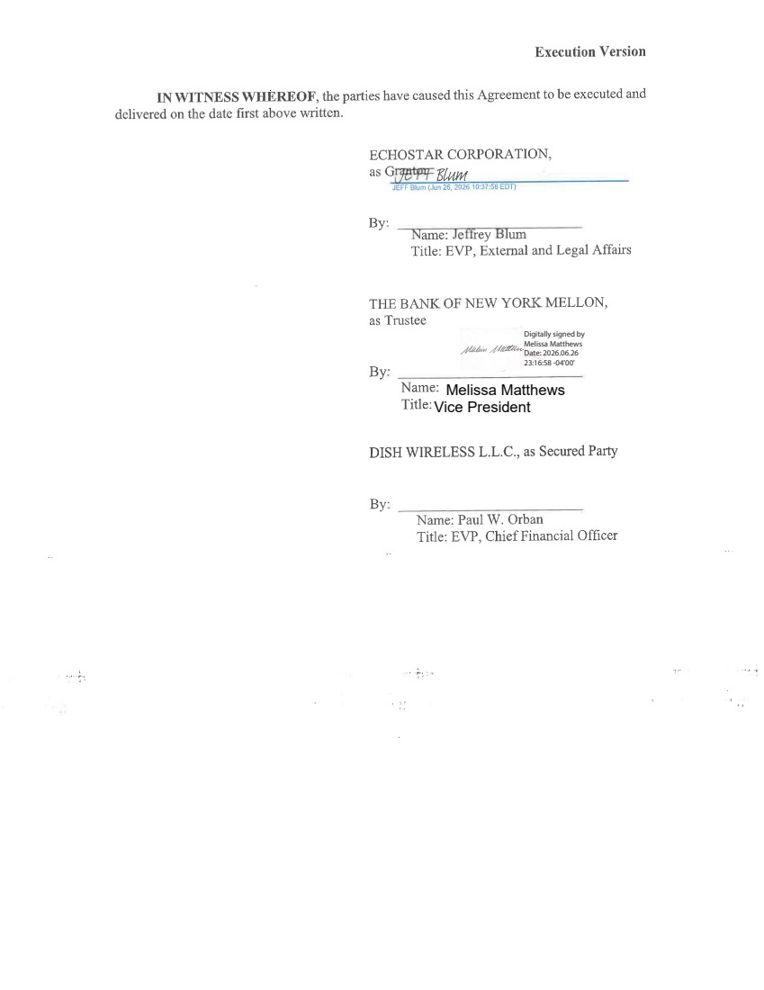 | Melissa Matthews Vice President Digitally signed by Melissa Matthews Date: 2026.06.26 23:16:58 -04'00'

